CREATIVE ARTS

AWARD RECEIVED
National 2

The National 2 Creative Arts course is assessed as pass or fail.

ENTRY LEVEL – What do I need to do it?
This course is suitable for all learners with an interest in the creative arts. It takes account of the needs of all learners by providing sufficient flexibility to enable learners to achieve in different ways and at a different pace.

COURSE CONTENT –What will I learn?
The course consists of a mandatory unit and a choice of two optional units. The mandatory unit is called Developing Skills in Creative Arts and it is designed to enable the learner to develop an awareness of the subject through participation in a range of creative activities such as ceramics, collage, drawing, jewellery, modelling, music, painting, photography and sculpture.

Learners can choose two from the following three units:
Working with Images, Graphics and Sound – the general aim of this unit is to develop the learner’s skills in using images, graphics and sound such as photographs, film, lettering, cartoons, music, sound and computer-aided design creatively. The learner will be encouraged to use media and technologies when developing their ideas and producing their work.
Creating Materials for Performance – learners will develop skills in creating original work which could subsequently be used for performance such as music, song, stage props and scenery by using a variety of techniques and processes.
Creating Materials for Display – learners will develop skills in producing creative work for display such as painting, drawing, ceramics, jewellery and sculpture by using a variety of materials, techniques and processes.

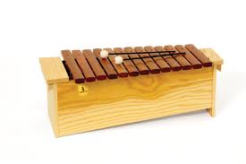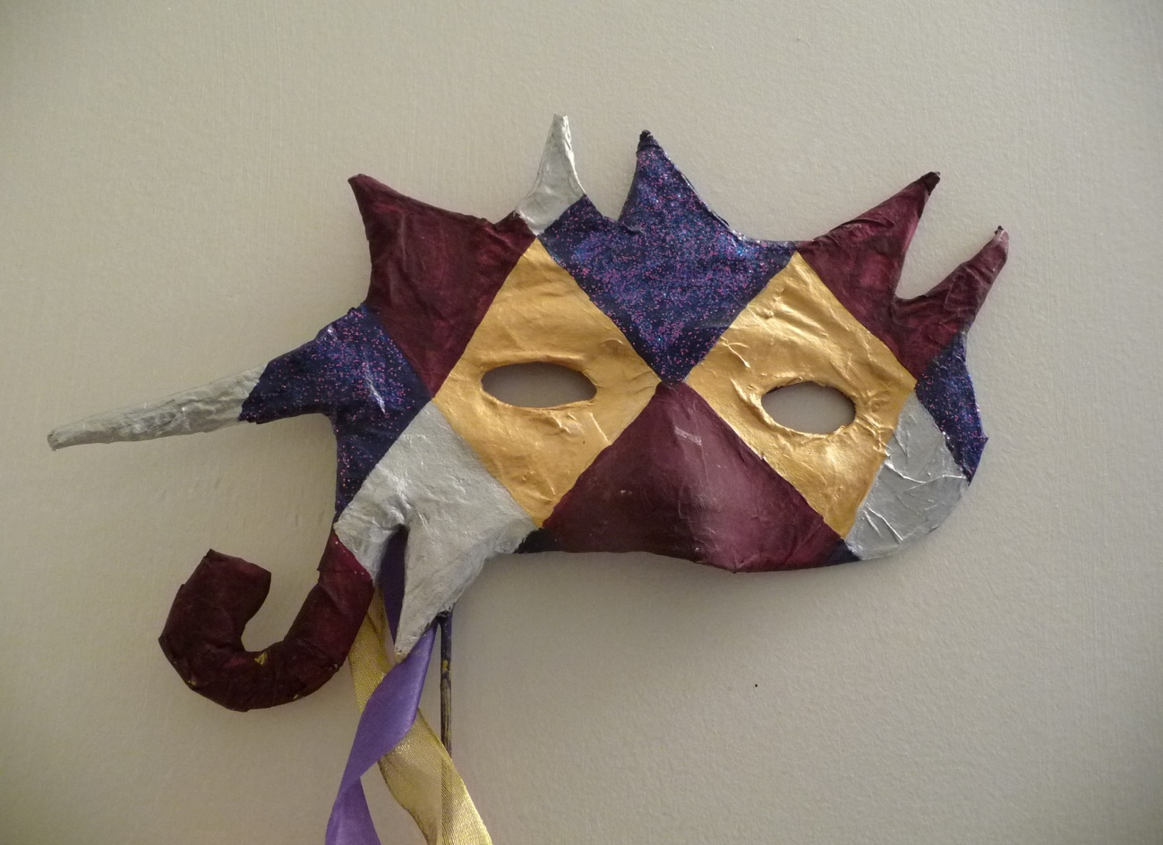

TEACHING METHODS – What will I do?
The learner might choose to:

Make a collage which involves:
♦ selecting and using skills and techniques as appropriate
♦ working with a variety of materials (including cutting/adapting as appropriate)
♦ working to a design they have created

Make a necklace which involves:
♦ selecting and using skills/techniques/equipment/materials as appropriate
♦ working to a design they have created
♦ producing and wearing the finished necklace
Create music to be used at a Burns’ Night celebration which involves:
♦ creating a piece of music to accompany the entrance of the haggis
♦ creating a music playlist to be used for dancing at the event

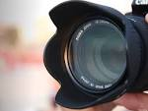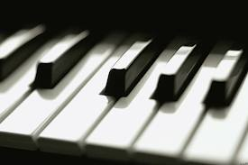

ASSESSMENT
To achieve the National 2 Creative Arts course, learners must pass all of the required units.

HOMEWORK
N/A

PROGRESSION IN THE SENIOR PHASE
Successful completion of the National 2 course may lead to National 3 in either Art & Design, Drama or Music.

COSTS
N/A

