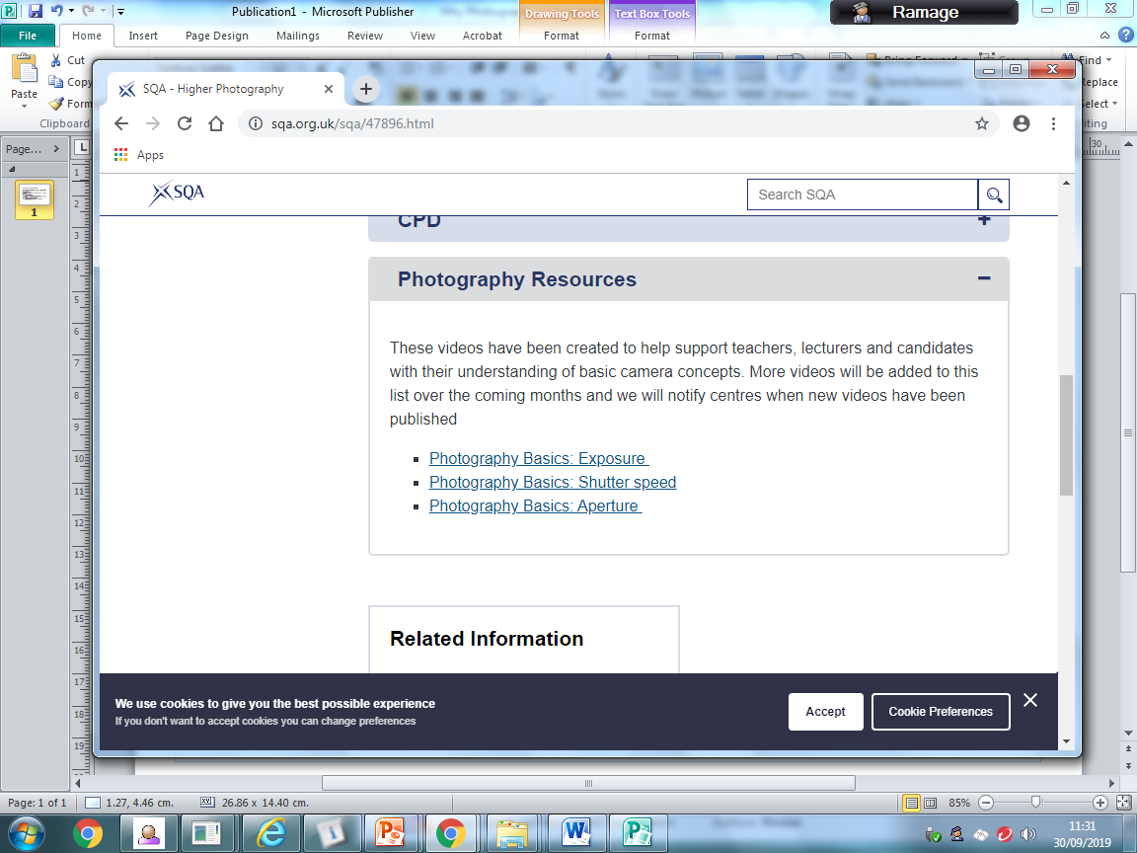

Essentially Photography is a crash Higher as there is no Nat 5 progression. Nat 5/Higher Art and Design students have developed key skills and terminology that will transfer. If a student has not taken art before they may find the course more challenging.

What can I do to support my child?

One of the main requirements of the photography course is project management. Students have to lead and develop their own individualised project showcasing great technical, creative and time management skills. The project will culminate in the selection and production of a set of 8 photographs.

Students need to:

• Meet the deadline dates detailed in the attached file

• Plan ahead for any known periods of absence to ensure they are up to date with their project

• Study and revise notes from theory lessons to help consolidate key vocabulary and practical skills

• Back up all work onto OneDrive (free access to cloud based storage through their school Glow account)

• Look at past papers, course outlines and help videos on the SQA website (there is now a resources section)

• Problem solve—there will be occasions where photo shoots will be completed

outwith class time and where I am not there for help. YouTube is an excellent

resource to utilise if any technical issues occur.

HIGHER **Photography**

Follow us on Twitter @PhotographyPHS

The most useful resource is our art department SharePoint. The Photography section is filled with examples and help sheets.

There is also a folder containing all the PowerPoints with our theory lesson content.

|  |  |
| --- | --- |
| **Date** | **What should be complete?** |
| 18th October | NPA Unit 1 – Understanding Photography |
| 22nd November | Project Planning Section Complete |
| 23rd December | Shoot 1 Complete |
| 31st January | Shoot 2 Complete |
| 28th February | Shoot 3&4 Complete (Midpoint Review) |
| 21ST March | Shoot 5&6 Complete |
| 18th April | Shoot 7&8 |
| SQA EXAM DIET BEGINS 26th April | Photography Higher Paper 28th April 09:00 - 10:00 |
| 2nd May | Shoot 9 and/or 10(these shoots are negotiable depending on variety of images available for final selection) |
| 20th May | Select final 8 Images  Evaluation  Final Submission of Project  Presented in A3 folder with all appropriate SQA Documents complete |