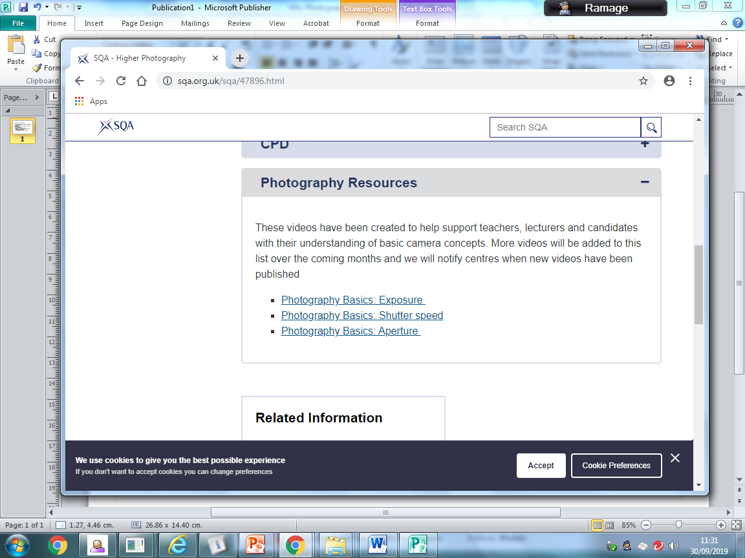

The National Progression Award in Photography (Level 5) consists of 4 mandatory units of work; Understanding Photography, Photographing People, Photographing Places and Working with Photographs. Completion of all 4 is required for the course award however; students can complete a selection as standalone units if appropriate.

What can I do to support my child?

The course provides a strong technical and skills based progression for moving onto the Higher Photography course. It runs concurrently with the Higher course for practical and technical lessons.

Students need to:

• Meet the deadline dates detailed in the attached file

• Plan ahead for any known periods of absence to ensure they are up to date with their project

• Study and revise notes from theory lessons to help consolidate key vocabulary and practical skills

• Back up all work onto OneDrive (free access to cloud based storage through their school Glow account)

• Use the Resource section on the SQA Higher Photography page for useful help videos (highly relevant for NPA too)

• Problem solve—there will be occasions where photo shoots will be completed

outwith class time and where I am not there for help. YouTube is an excellent

resource to utilise if any technical issues occur.

NPA Level 5 **Photography**

Follow us on Twitter @PhotographyPHS

The most useful resource is our art department SharePoint. The photography section is filled with examples and help sheets for Higher and NPA.

There is also a folder containing all the PowerPoints with our theory lesson content.

|  |  |
| --- | --- |
| **Date** | **What should be complete?** |
| 18th October | Unit 1 Complete  ‘Understanding Photography’ |
| 23rd December | Unit 2 Complete  ‘Photographing Places’ |
| 11th February | Unit 3 Complete  ‘Photographing People’ |
| PRELIM DIET |  |
| 31st March | Unit 4 Complete  ‘Working with Photographs’ |
| 26th April  SQA EXAM DIET BEGINS ON 26th April | Evaluation  Final Submission of Project  Presented in A3 folder with all appropriate SQA Documents complete |