PHOTOGRAPHY

AWARD RECEIVED – HIGHER

IS PHOTOGRAPHY FOR ME?
It is important to remember that this is a crash Higher as there is no National 5 to progress from. There is a strong technical and academic focus to the course with lots of specific vocabulary and theory to learn. You need to manage your own individual project so planning, organisational and time management skills are very important. In addition, must have a genuine interest and enthusiasm for photography.

It is a fantastic opportunity to develop your creative skills, see the world from new perspectives and share your thoughts and ideas. You have the opportunity to explore a photographic genre of your choice and develop your understanding of image making. It is extremely rewarding and will provide you with a great skills base for your future study/work.

Please note that some universities do not accept a qualification in Higher Photography when considering course entry requirements. Please check with specific universities first.

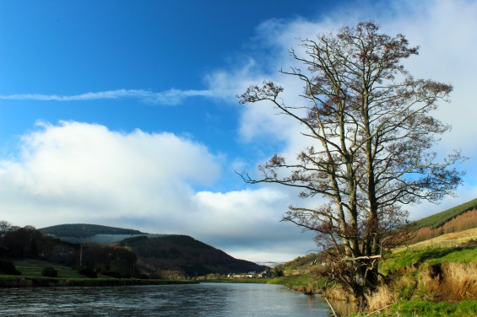
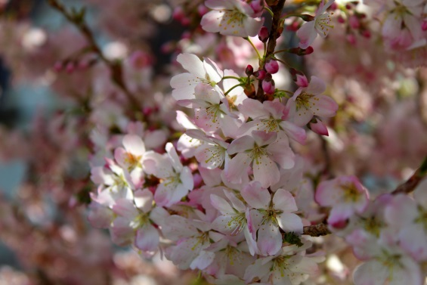
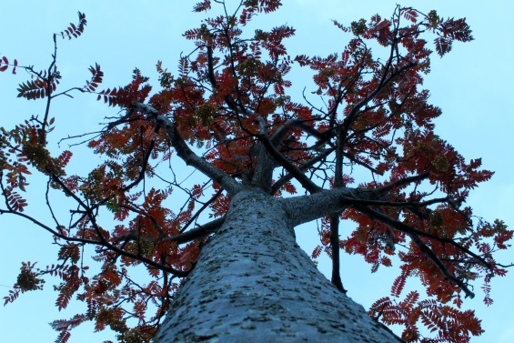
ENTRY LEVEL
N5 pass at A or B level in Art and Design

Learners would benefit from having some or all of the following skills and knowledge before starting this Course:

- a working knowledge of composition and the visual elements
- basic camera skills

PURPOSE AND AIM

- communicate personal thoughts, feelings and ideas using photography
- develop technical and creative skills through using photographic media, techniques and processes
- develop knowledge and understanding of a range of photographic practices
- develop skills in problem solving, critical thinking and reflective practise
- develop an understanding of the impact of social, cultural, historical and scientific influences on photographers’ work and practice
- become critically self-reflective autonomous learners

COURSE ASSESSMENT

The Course assessment will consist of two Components: a project and a question paper.

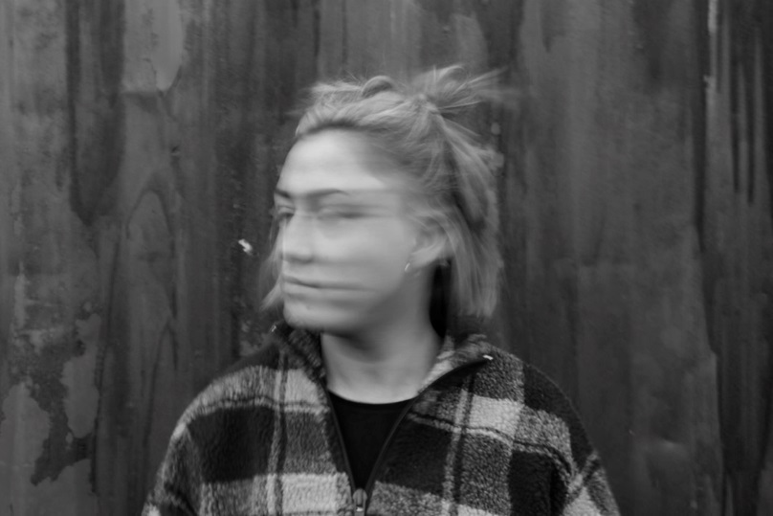
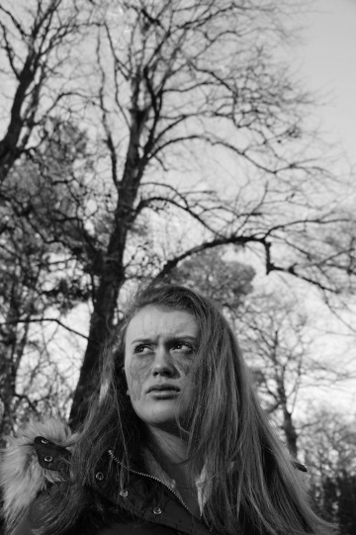
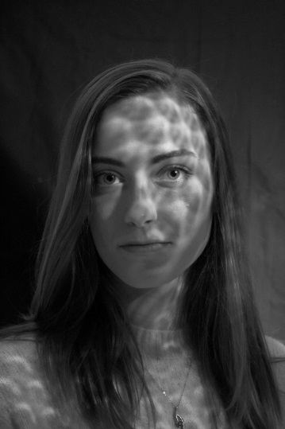
PROJECT

The project will have three Sections:

1. Planning, research and investigation (20 marks)
2. Development and production (70 marks)
3. Evaluation (10 marks)

The purpose of this project is to assess your ability to develop creative and technical skills within a negotiated photography project.

Each project is individual and personally selected by the learner with guidance from their teacher.

- applying knowledge and understanding of the properties of light and image formation
- applying knowledge and understanding of camera controls and a range of photographic techniques and processes
- investigating and analysing the major historical, scientific, social, and cultural factors influencing photographers and their work
- producing investigative research for photography, and planning, shooting, printing and developing photographs
- exploring and experimenting with a range of photographic media, manipulation techniques and processes
- producing and presenting creative and technically proficient photographs
- effectively managing and storing photographic images
- critical self-reflecting and evaluating

This project represents 100 marks (77% of the overall marks) and will be complete throughout the year. This allows learners the opportunity to develop, reflect on and revise their photographic work before it is presented for external assessment/marking. Some aspects of the work may be completed outside class time.
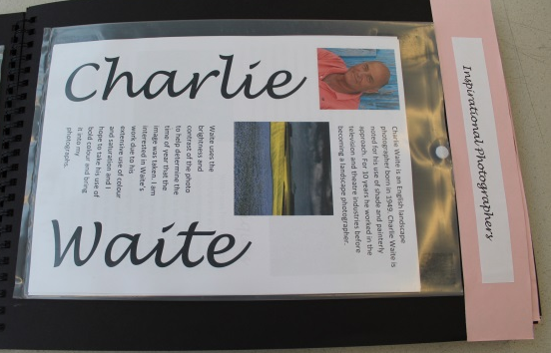
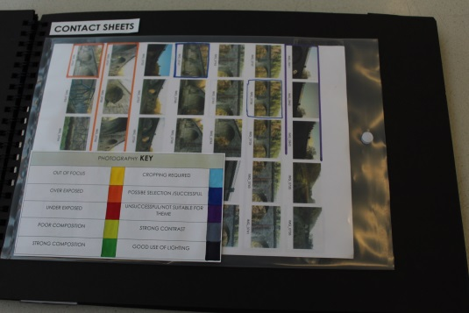
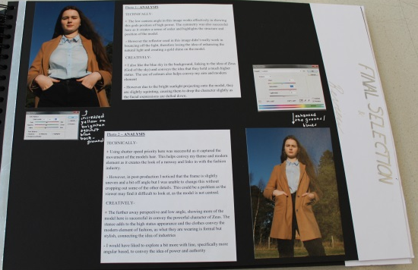

QUESTION PAPER 30 marks

The question paper assesses candidates’ knowledge and understanding of photographic work and practice.

The question paper has a total mark allocation of 30 marks. This is 23% of the overall marks for the course assessment.

The question paper has two sections.

Section 1: Multiple choice

This section has 10 marks. It contains 10 multiple-choice questions. Candidates answer all questions and have 1 hour to complete the paper.

Section 2: Analysis
This section has 20 marks. It contains two questions which ask candidates to critically analyse two unseen photographic images from a range of genres and styles. Candidates answer both questions.

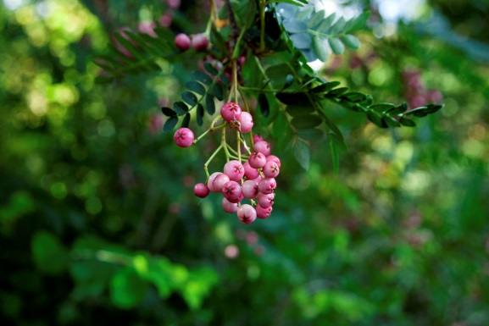
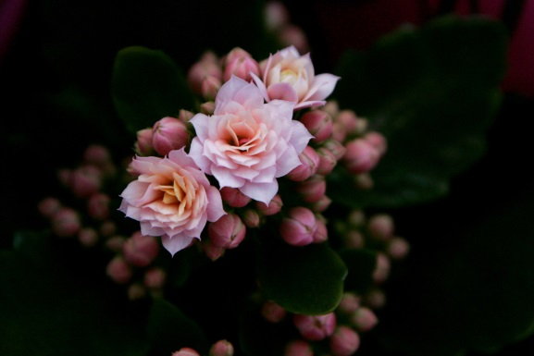
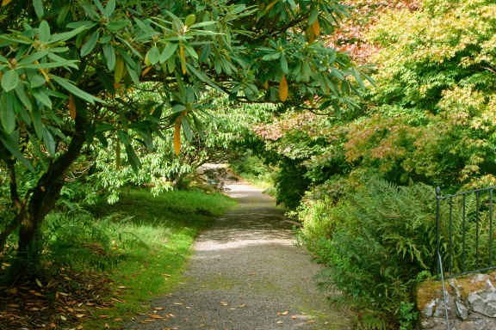

HOMEWORK
Homework assignments focus on helping students consolidate knowledge and skills and will normally develop any on-going classwork.

EXTENDED READING AND VIEWING Students are expected to engage with:
- practical photographic practice out with class time
- aids such as YouTube to help with problem solving when out of class time
- current developments in the Photography industry

PROGRESSION
After Higher Photography, students can progress to qualifications such as Advanced Higher Art and Design or the Portfolio Preparation course for application to a variety of further education courses.

COSTS
£20

This will help to facilitate specialised materials required for final presentation of coursework, printing of folio pieces and the production of their final 12 photographic images.

