

**PHS Parent Council**

**15 May 2024**

**Peebles High School**

**Attendees**

|  |  |
| --- | --- |
| Ellie Johnstone, PC Chair (Chair) | Claire Barrett, PC Secretary |
| Kevin Ryalls, Interim Head Teacher (Head) | Dawn Johnstone, PC Comms Lead |
|  | Alex Corbishley – PC Survey |

6 parents joined the Parent Council meeting. ***Parent comments and questions are shown in bold italics*** *with answers given below.*

Updated Action tracker is at the end of these minutes.

# Chair’s Update

SBC have again cancelled the PC Chairs meeting with no explanation – however they have invited all PC Chairs to a Parent Council Fair on 13th June at Inspire, Tweedbank, so I’ll report back on what that event achieves.

 I spoke as part of the recent PHS presentation to SBC’s Education Committee regarding follow up actions after the external inspection. The Committee Chair thanked the Parent Council for their efforts and noted the high level of knowledge in relation to our school community.

 The PC inbox is receiving far fewer admin-related enquiries and I have received a couple of suggestions that I’ll cover in AOB.

Alex Corbishley gave the following update on the University Aspirations Group:

* Many thanks to Ruth Doherty who is stepping down from the group. Ruth is a Professor of Atmospheric Sciences at the University of Edinburgh and founded the group a number of years ago to support young people at PHS wishing to apply for courses with an October UCAS deadline. We are hugely grateful for her tireless input over the years.
* The group would be appreciative of any support that members of our community are able to provide. We would particularly welcome support from anyone with a background in dentistry, mathematics/engineering/ physics and the humanities.
* Last year PHS put forward one applicant for veterinary medicine, two for Cambridge, two for Oxford and three for medicine. All the veterinary and medicine applicants were successful and half the Oxbridge applicants were successful. This is an impressive success rate, but is a relatively low rate of applications for these prestigious programmes given the school’s headline academic performance and catchment area.
* Mairi Stark and Alex Corbishley will be going to speak to the new S6 cohort on 3rd June to encourage them to be ambitious with their University applications. We are also looking for a suitable lunchtime before the summer break where we can talk to potentially interested S6 pupils.
* We would like to hear from the school what work it is undertaking to support its high achieving S3/4/5 pupils to be ambitious with their University applications. Particularly those young people who are LEAPS eligible ([https://www.leapsonline.org/](https://gbr01.safelinks.protection.outlook.com/?url=https%3A%2F%2Fwww.leapsonline.org%2F&data=05%7C02%7Cclaire.barrett%40sose.scot%7C74f1056dffb448707b6108dc7b12cabd%7Cdb66fb25d59949e9aa620abe6e0cef9c%7C0%7C0%7C638520567883610406%7CUnknown%7CTWFpbGZsb3d8eyJWIjoiMC4wLjAwMDAiLCJQIjoiV2luMzIiLCJBTiI6Ik1haWwiLCJXVCI6Mn0%3D%7C0%7C%7C%7C&sdata=ScX%2BAhauOJP8XGSMigktyOMiQVZYmeYYJsCIKmEdy6U%3D&reserved=0))

There was a discussion about LEAPS, the school needs to identify these young people – school has a better tracking system now that can identify LEAPS eligible young people. And could target those young people, and perhaps write to those parents.

There was a discussion around the speaker at this year’s prize giving, who could be inspirational for all young people, not just those attending prize giving - could this be made accessible to all? The Head agreed this was a good point, and we could be thinking aboutinspirational speakers for assemblies.

Chair is attending the Plan for Peebles consultation – please email if there’s anything you would like raised.

# Headteacher’s Update

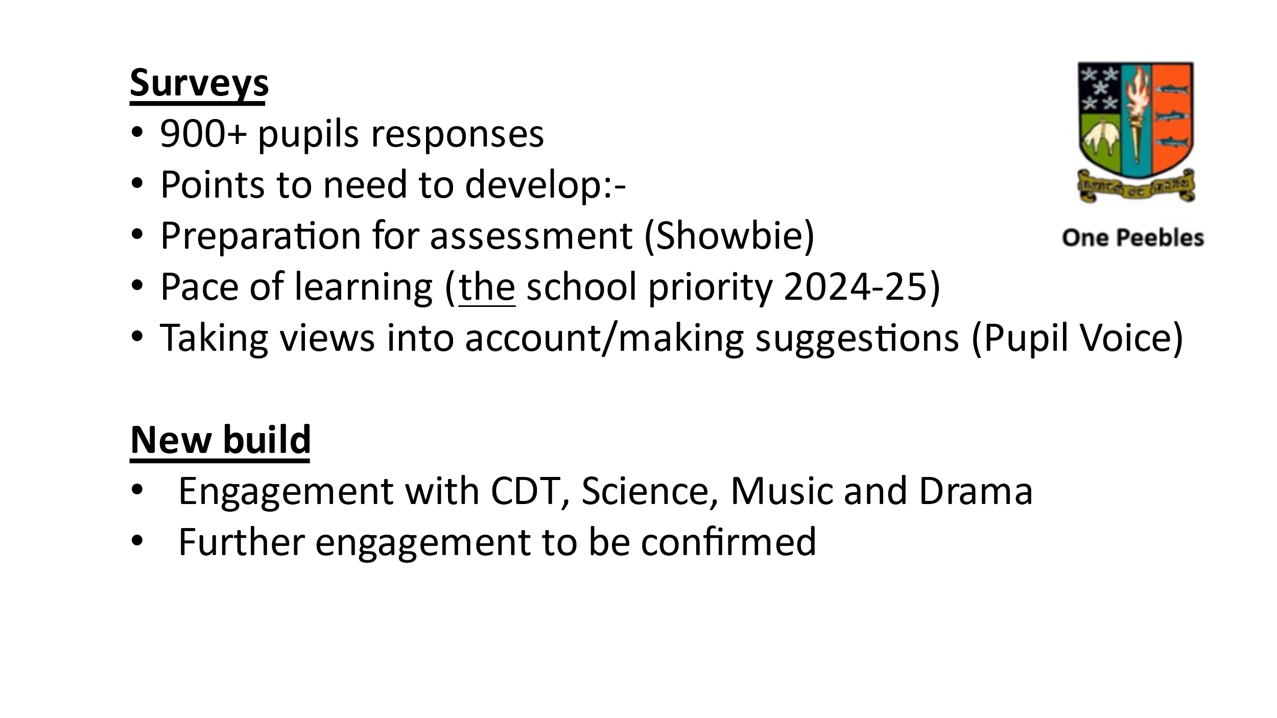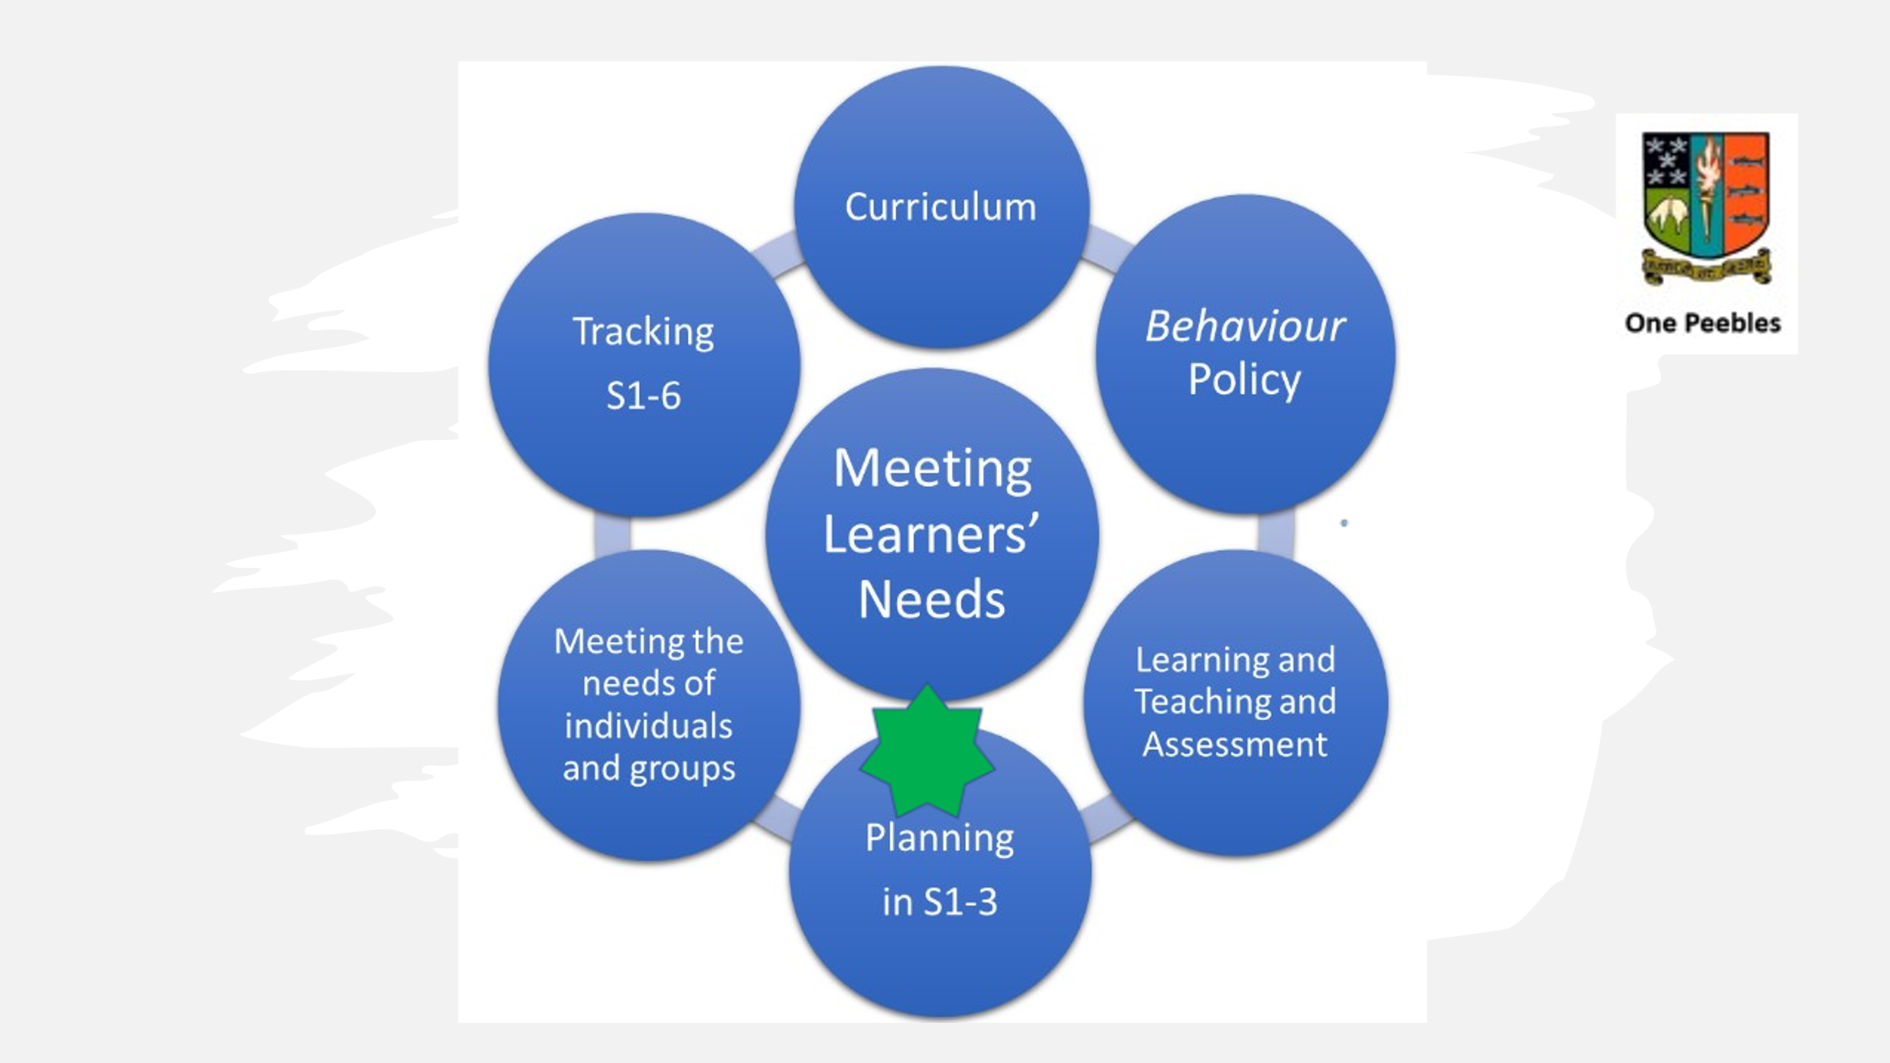Head shared ‘One Peebles’ presentation which was shared with staff at the recent Inset day and the Education Subcommittee (referred to above). See below:

Re Pupil Voice - once a month pupils are invited to put questions to the Head and they are answered. They can be on any topic around the school.

We are working on lots of different things all the time, as additional focus areas, as well as ‘the job’. Eg Planning in S1 – 3 including differentiation within classes.

***How did consistency of the learning experience show in the survey?***

I’ve still to really look at all the results. The focus is on empowering the middle leadership at the moment.

New Build - we have asked for bike storage. We’re getting a 400m running track on the other side of Craigerne Lane, rugby pitches.

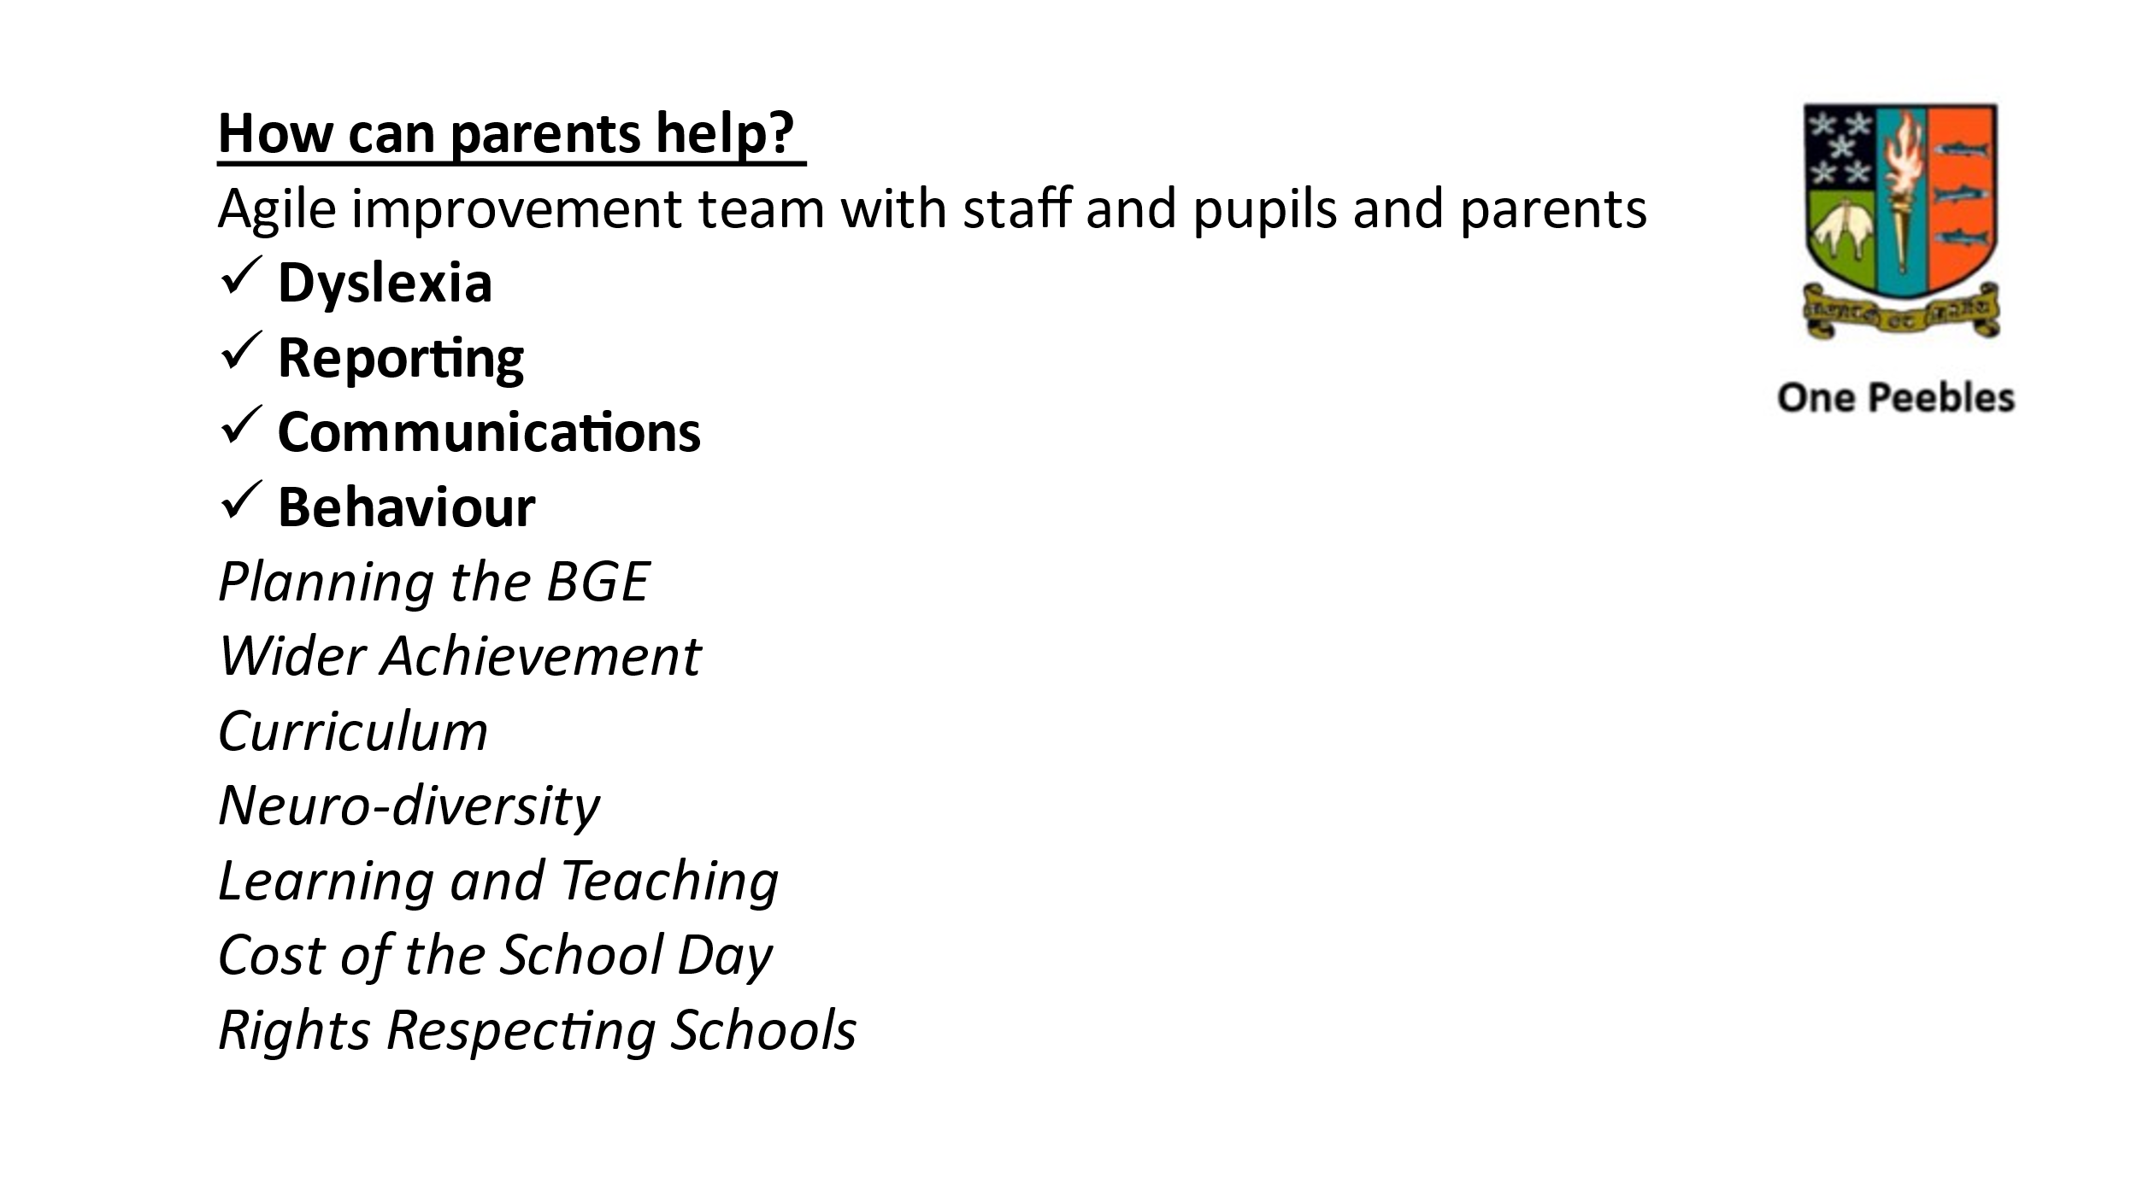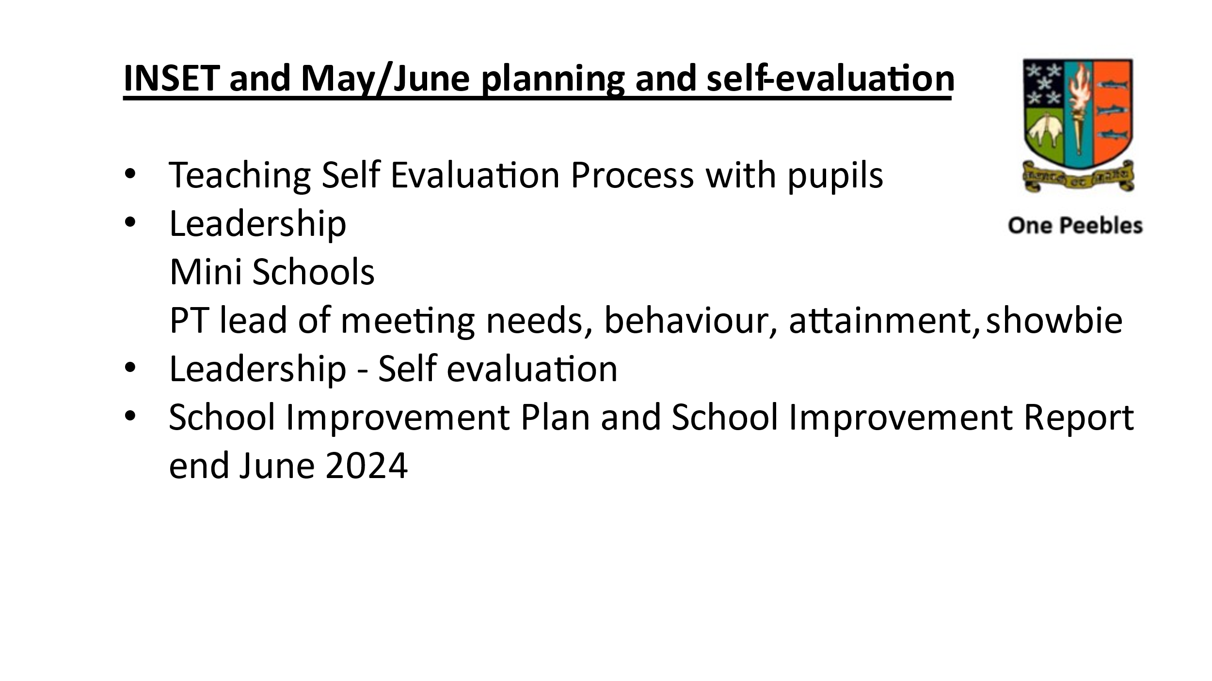

At the Inset Day we discussed how parents can be involved (‘How can parents help?’ above)

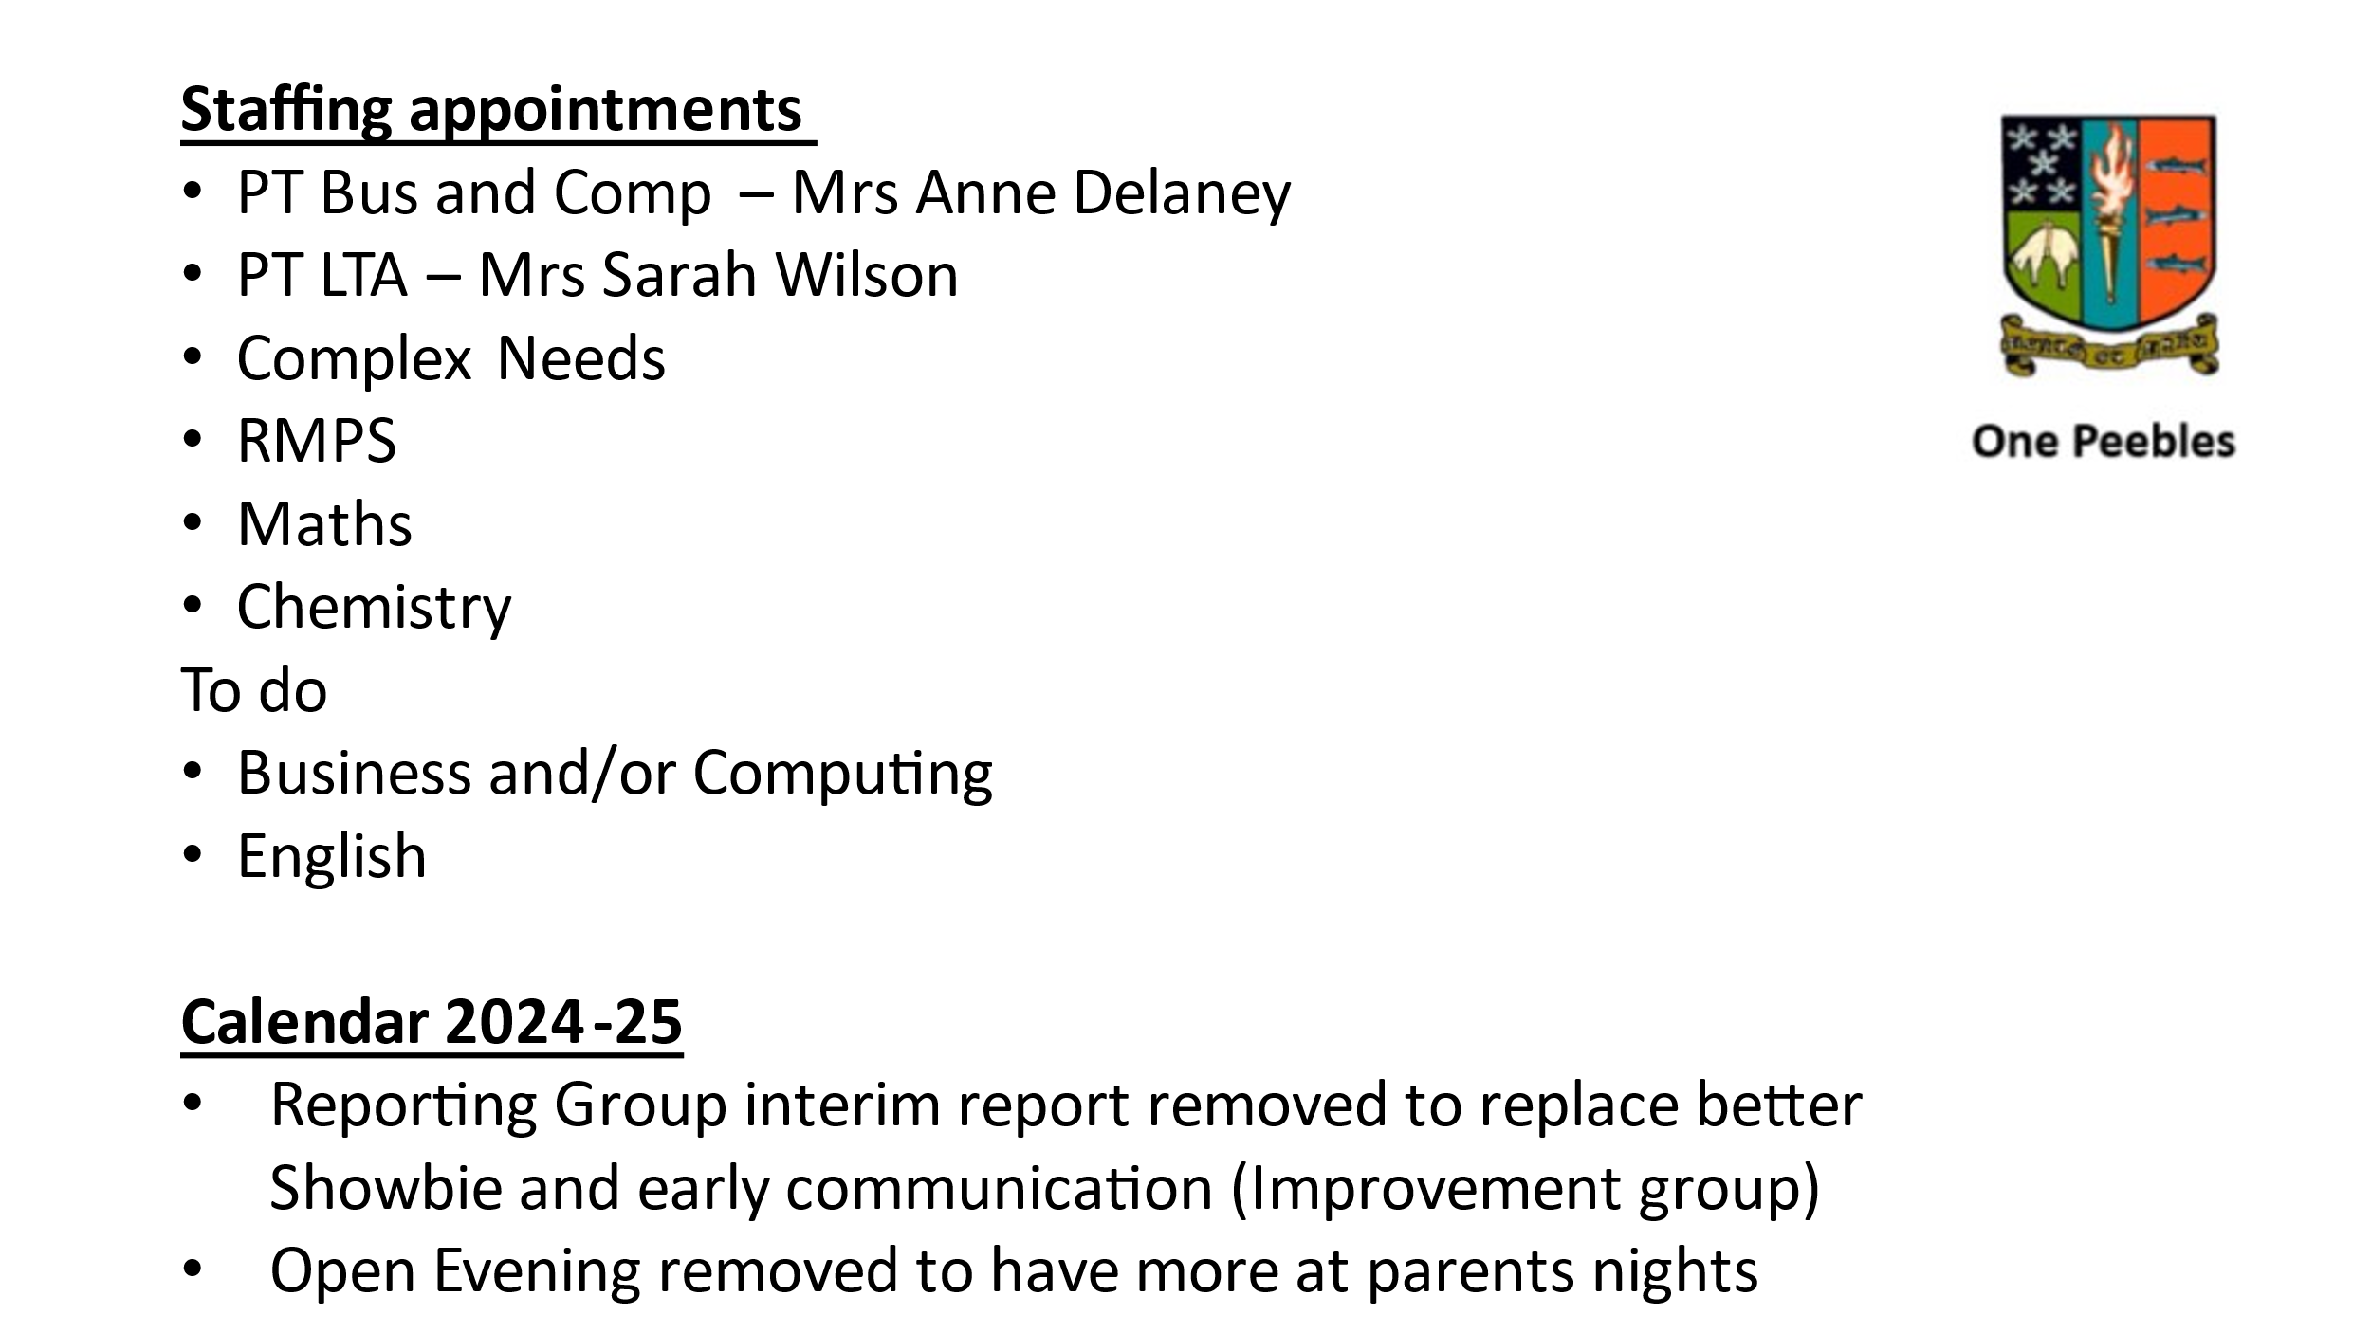

There is a new course being offered we are excited about: Mountain Biking Level 5 for S5 and S6.

***Parents don’t know what the Levels mean***

We can put an explanation of the levels on the website. S1 – 3 reports will have grades on them next year. Planning in S1 – 3 (BGE) will consist of teachers doing planning sheets, and having a more holistic approach.

Action – Explanation of Education Levels to be put on school website

There was a discussion around levels, reporting and Showbie. Parents want to know what level their child is working at, should they be at that level, what do they need to do to improve, consistency of feedback on Showbie, evaluated by teacher (not pupil).

***S2 reports – physics was missing and we have not yet had reporting on physics?***

Yes I’ll look into that.

***Re the behaviour policy – have you noticed an improvement?***

There is good feedback from pupils, staff, calmer, nicer atmosphere, more relaxed. So yes, anecdotally. I’m certain it’s better, we need to never take our eye off it. Do we need consistency in classes, yes. There is better guidance on consequences of bad behaviour. There are exclusions and detentions. Nobody leaves without their dignity intact.

***Timetables – if young people haven’t got the subjects they chose, have they been notified? Worth communicating that?***

Yes, they have been. We will let all know that they have their choices.

# Parent Council Survey

Alex Corbishley presented the results of the PC survey (see appendix)

Parent response was much lower this year. Context of the history of this survey was discussed. At the time it was introduced, there was more engagement of parents at PC meetings as they were online. There was some frustration around trying to get data from the school that was not shared (it was obtained through a FOI request).

The Head appreciated the fact the survey was done as the data is useful. Would be interested to see the free text. The school should give you this information so the PC shouldn’t need to do this. Recognition we need to be wary of parents (and pupils) being ‘over-surveyed’ (HMI survey; SBC survey; PC survey)

Future Planning – there was discussion around when we run this survey again (March is same time as SBC survey). Maybe we use it at a point in time, not necessarily March? Head would prefer not to run this survey; staff are wary of the PC survey, and I am not sure if they have been followed up with staff. We need to build bridges between teachers & parents. The relationship we have with PC is vital. Recognition from Head that the school needs to get better at telling parents if young people are struggling earlier on in the year, so no surprises at report/parents nights.

There was discussion around communications home from various teachers/subjects to Mr Ryalls. Head would like to know where best practice is in the school – parents to feedback, eg where a teacher communicates something well.

There was a general discussion around PC meetings - the parent forum is here and willing to help. Head agreed that teachers feel the same, need to bridge that gap. When Senior Student Council attended it was great – there has not been a history of many teachers attending PC meetings - could different teachers attend to showcase/celebrate something they are doing in class?

The meeting closed at: 9.20pm

Next Meeting: AGM, 12 June .

**Appendix – PHS Parent Experience Survey 2024**

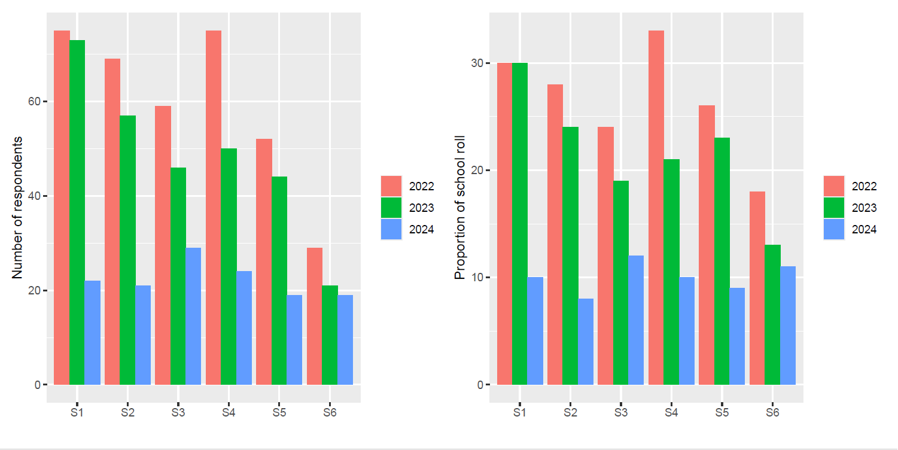

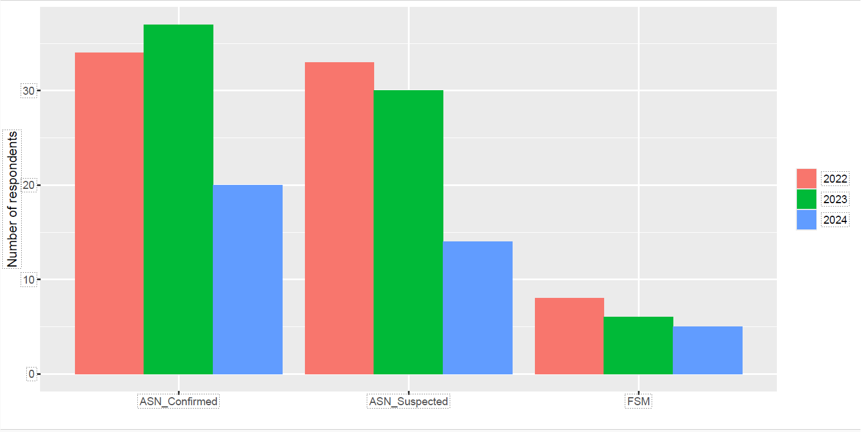

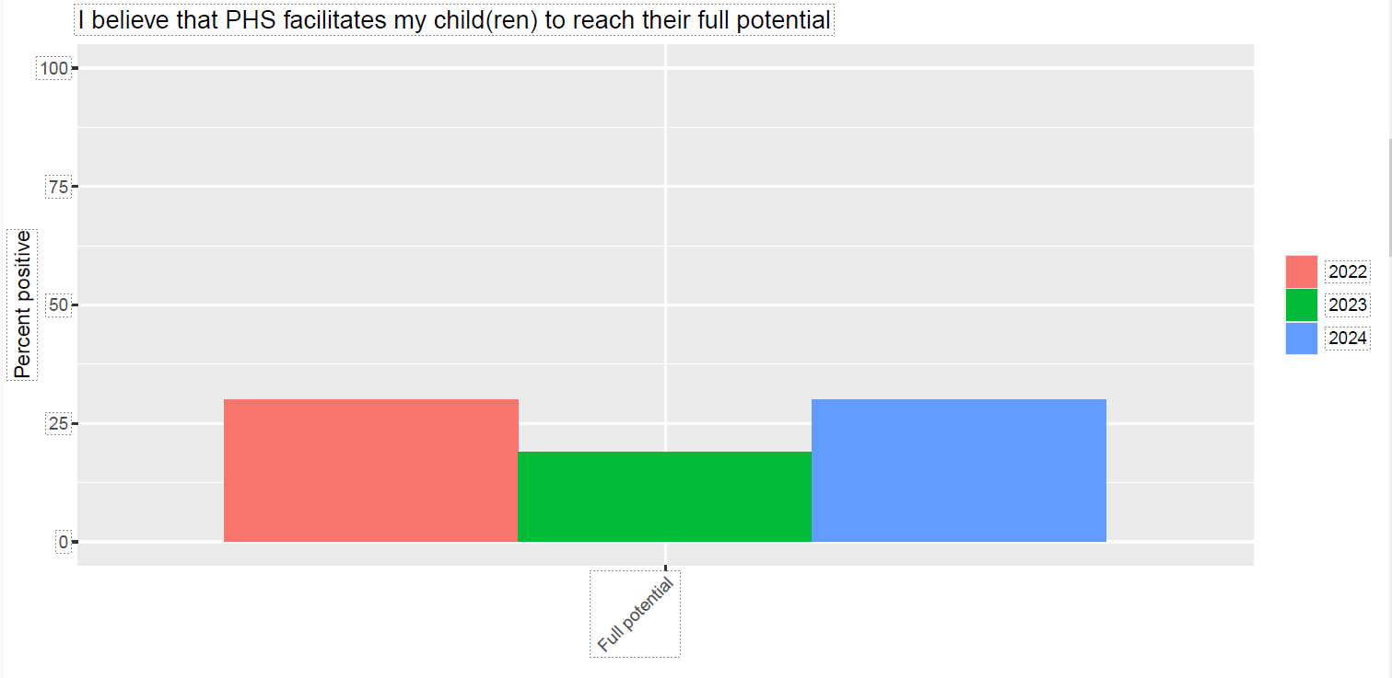

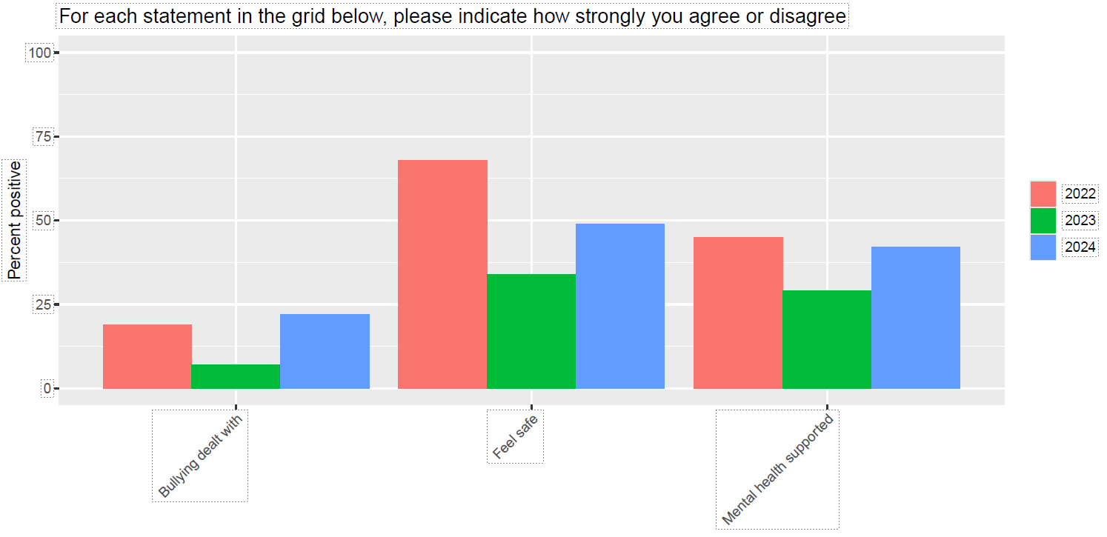

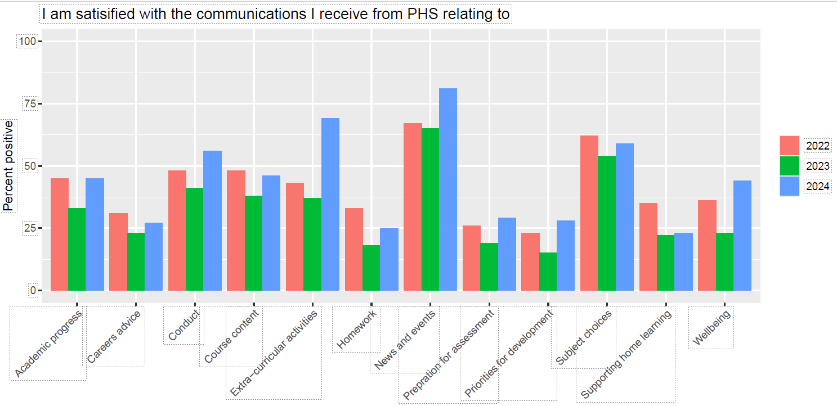

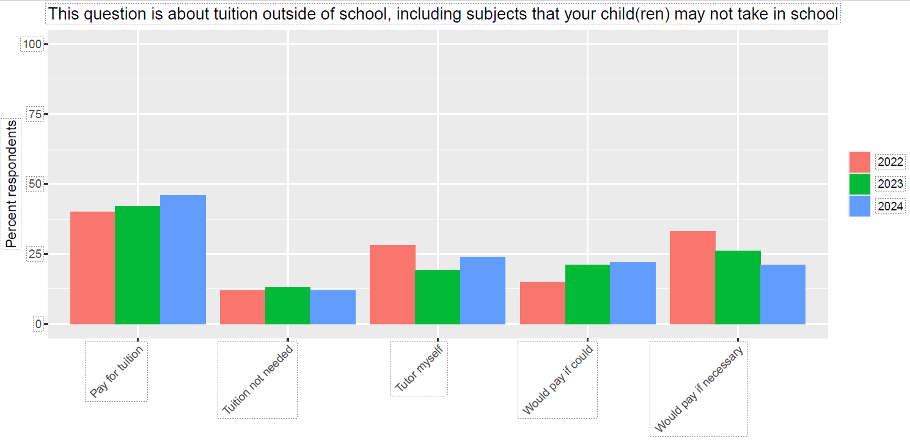

**Parent Council Action tracker 2023/24**

|  |  |  |  |  |
| --- | --- | --- | --- | --- |
| **Meeting** | **Item/Issue** | **Action** | **Who** | **Update** |
| May 24 | Parents unsure about SCQF levels | Explanation of Education Levels to be put on school website | Head | Included in HT Update 7 June |
| May 24 | Promotion of University Aspiration group | PC to promote on PHS Parents Facebook page | PC (Comms Lead) |  |
| Apr 24 | Sites banned on iPads, restricting research | Head to take up with Paul Graham (Inspire Learning) | Sarah | Paul Graham confirmed school can ask for websites and apps – subject to approval. |
| Jan 24 | Previous actions prior to K Ryalls joining as HT | PC Chair & Head to go over outstanding actions from previous PC meetings. | PC Chair/Head | CLOSED May 24: Included in this tracker |
| Jan 24 | Sites banned on iPads, restricting research | Chair will bring up at PC Chairs meeting to see how other schools get around this. | PC Chair | Awaiting meeting with SBC and will put to next Chairs meeting. |
| Jan 24 | Communications plan | Head requested Alex Corbishley speak with the school Business Manager  Parents to come forward if interested in working in the group to help improve Communications | Head/A Corbishley/Business Manager  Parents feedback | CLOSED  Alex & Business Manager have been put in touch.  Parents & Head worked up Communication Policy – see April Minutes for detail.  May 24: Now published. |
| Jan 24 | Anti-bullying policy | Parents to feedback on anti-bullying policy when it is issued by Mrs Moretta | Parents feedback | CLOSED  Policy emailed to parents 4th March for feedback.  Feedback has been received.  May 24: Now published. |
| Jan 24 | Curriculum choice points | Parents asked to see the previous work/survey results | PC will put link on front page of phsparents website | May 24: Superseded by latest survey which compares results |
| Jan 24 | My young person’s S2 CDT class is touring the school looking for a classroom | Parent to advise Head the detail of this | Parent/Head | CLOSED  May 24: Dealt with. |
| Jan 24 | Parents’ nights timing | Parents get in touch if interested in working with school on reviewing parents nights. | Parents/J Lee | CLOSED  See April Minutes Headteacher update  May 24: We have parental input around reporting, dyslexia, S6 course choice, behaviour, communications |
| Nov 23 | Use of mobile phones in school | Mr Wilson/Ellie Johnstone to form a sub group of parents and staff to look at this new mobile phone policy. | Head/PC Chair | CLOSED  May 24: In Behaviour Policy – phones not in use in classes |
| Nov 23 | Could the 2G pitch be kept open at social times | Mr Wilson to speak to Mr McMordie & the prefects to discuss if they could monitor the 2G at social times. | Head/Mr McMordie | May 24: Not available just now, concentrating on inside school |
| Nov 23 | New 3G pitch requires boots not standard trainers | Mr Wilson will check with PE dept if there are enough boots in all sizes, to loan out to pupils for use on 3G pitch. | Headteacher | CLOSED  May 24: Live Borders Policy |
| Nov 23 | Toilets – could we split them 3 ways for S1/S2, S3/4, S5/6 ? | Mr Wilson to think about this suggestion of allocating the 3 areas of toilets to specific year groups, as it hadn’t been looked at that way before. | Headteacher | CLOSED  May 24: Superseded by new policy incl portacabins and huts toilets |
| Nov 23 | Noisy building work around exam time | Mr Lee – notify BAM of exam dates and schedule noisy work outwith these times. | Mr Lee | CLOSED  May 24: In hand, exams in hall |
| Nov 23 | Family sessions on exam prep/revision | Mr Lee to look at running information session(s) for families for preparing for exams | Mr Lee | May 24: We can build into calendar next year |

**Please get in touch around any of the issues raised at** [**phspc@outlook.com**](mailto:phspc@outlook.com)

**____________________________________________________________________________________**

**Helpful Info/Reminders**

**Parent Council Meeting Dates for 2023/24**

Wednesday 13 September 2023 – in person

Wednesday 15 November 2023

Wednesday 24 January 2024

Wednesday 20 March 2024 Meeting postponed to 17 April

Wednesday 24 April 2024 Meeting cancelled, per above

Wednesday 15 May 2024 New meeting date, due to rearranging above dates

Wednesday 12 June 2024 (AGM)

**Post Holders**

Chair – Ellie Johnstone

Vice Chair – Tristan Compton

Secretary - Claire Barrett

Communications Officer – Dawn Johnstone

Equalities Lead - Lorraine Murray

Event Coordinator – Gillian Moran

Friends of Peebles High School SCIO representative -

Property Working Group Lead – Tristan Compton

Taskforce Coordinator – post vacant

We welcome interested parents & careers on the Parent Council as general members or working group members. We simply ask that you try to attend meetings regularly. If you would like to be an ordinary member or join a specific working group, please email your details to**:** [**phspc@outlook.com**](mailto:phspc@outlook.com)

Any parent or carer interested in supporting the Friends of PHS charity with running fundraising activities should get in touch at <mailto:FriendsofPHS@outlook.com>

**Website: phsparents.org.uk**

**Facebook: PHS Parents –** can contact us via Messenger

**Twitter:** @PHSparents @PeeblesHigh