Peebles High School January Newsletter 31st Jan 2024

Dear Parent Carer

Welcome to our January 2014 Newsletter.
I would like to thank my new colleagues, our parents, carers and partners and most importantly our fantastic young people for the warm welcome extended to me since my arrival. This newsletter is about celebrating and recognising some of the wonderful things that go on in our school. Our young people and staff do so much to contribute to our school and community. I hope you enjoy and please also visit Peebles High School (facebook.com).
Kevin Ryalls
Headteacher

Assemblies – January



During the month of January we focused on the protected characteristic of Disability and young people learned about physical disability during assemblies.
Mrs Moretta talked about what we mean by physical disability, what causes a physical disability and what the effects of physical disability are. She explained to young people what they can do to support their physically disabled peers including how we can keep everyone safe in school and the importance of a calm, quiet building. We can all show empathy and compassion for others and be inclusive by seeing beyond the disability.

Two videos were shared on year group Teams after the assemblies –
https://youtu.be/CL8GMxRW_5Y?si=JVNxY5eO-djX3pLV
'Stop telling me I'm speeding in my wheelchair!' - BBC Ideas

‘You Said, We Did’ - Mrs Moretta shares details of the number of bullying incidents recorded each month during assemblies. The reason for this is to reassure young people that if we know about bullying behaviour happening in school, we will always do something about it. Mrs Moretta also shares details of the number of compassion merits awarded to young people who go out of their way to be kind to others. In December there were 9 bullying incidents recorded and 32 compassion merits issued. S2 have been awarded the most compassion merits.

Swimming Success

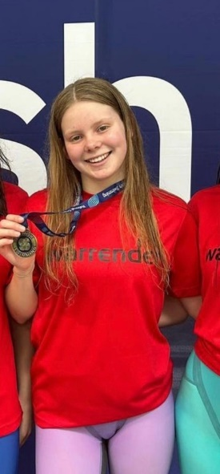
Ashleigh Drake in S5 was part of the Warrender relay team that won the 4 x 50m mixed medley relay at the Scottish National Short Course Championships at the Royal Commonwealth Pool in December. Ashleigh anchored the team and they set new Scottish National Junior Relay Team and Scottish Junior Club Relay Team records. Well done Ashleigh!
Journalism collaboration with Reuter’s Stephen Grey
Friday the 12th January saw the start of our collaboration with Reuter’s Stephen Grey. The online meeting was really interesting and with over 30 years journalistic experience Stephen will be a huge support to us. He has broken some really big stories like the Ghost Plane: The True Story of the CIA Torture Program. Stephen will be supporting the class in exploring a range of topics that have been individually selected for research as part of our main project. If any parents or carers are able to offer support in this regard please contact Ms Ness on gw20nessjennifer@glow.sch.uk – please find the list of topics below:
- Importance of foodbanks.
- Increased cycle training for young people in Scottish schools.
- Increased demand for foodbanks.
- Equality in competitive swimming. (focusing on disability)
- Impact of World Championship cycling competition on Scotland and its venues.
- Key issues and concerns for the 2024 election.
- Gender recognition policy and support for schools.
- Loss of language teaching in schools and universities.Issues around provision for deaf children in schools.
- Net zero and climate action in the south of Scotland.
- Positive impact of community gardens.
- Decline in NHS provision.
- Pressures on NHS.
- Greyhound racing.
- Expansion of free school meals.
- Supporting those with disability back into work

Ms Ness

Model United Nations
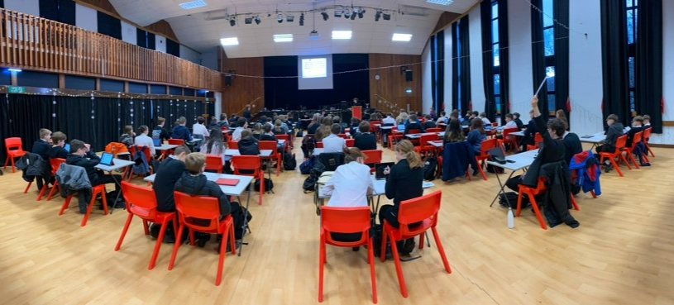

The annual PHS conference was held on Monday 18th December with over 80 students from S1-S6 attending. Topics debated included how to tackle child soldiers and how to protect endangered species. Students also responded to an emergency scenario in the afternoon. Congratulations to all those who took part – particularly those who spoke during the debates for the first time.

- Best delegation: Kelsie Brain and Cara Anderson
- Commended delegation: Aran Clark and Lochie Quayle
- Commended delegation: Donald Meldrum and Will McNeilly
- Best junior delegate: Faith Salmond
- Best senior delegate: Thomas Whitehead
- Best contribution to the emergency debate: Toby Haslam

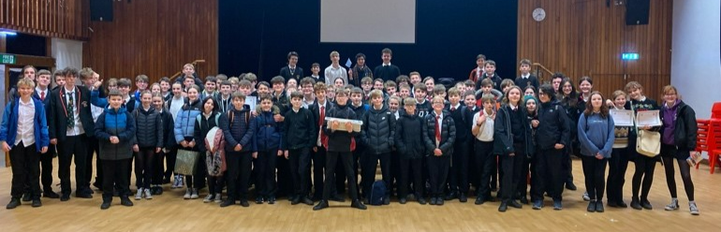

Prefect of the Month

This month’s prefect of the month is Sophie Noble. Sophie received numerous nominations from both staff and students for her hard work and effort whilst on duty. Well done Sophie! Keep up the good work.

Meet the Senior Student Council
Thomas Hilton
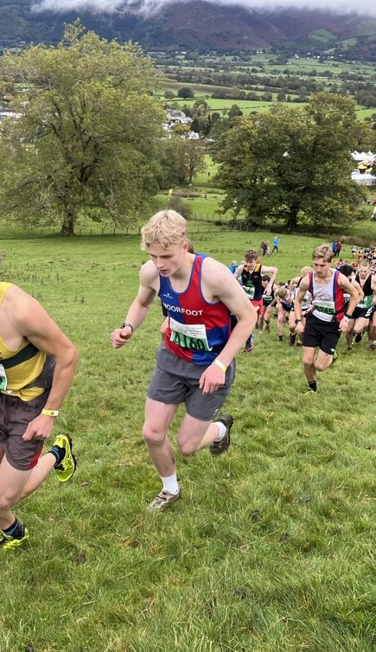

I am studying Advanced Higher English, Photography, PE and legal studies. Next year I want to race my bike through the summer in Europe. Outside of school I enjoy Spending time outside, riding my bike and a bit of running.

SSC gave me the opportunity to work with a group of like minded people to improve my own education, not only this but it’s allowed for new and exiting opportunities to come up only available for the SSC that I was able to take part in.

Meet the SSC
Kitty Volino
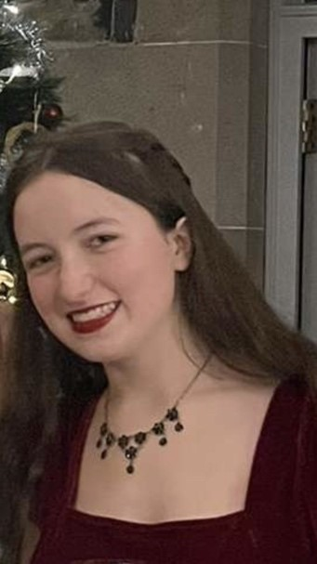

This year , I'm studying Advanced Higher English , Music, and Drama as well as N5 Italian. In the future , I hope to further pursue my love of English literature and the Classical world. Eventually I'd love to have the opportunity to work in a museum or archive.

In my spare time , I volunteer at the Trimontium Trust in Melrose where I've had the privilege to go on archaeological digs and fieldwalking. I'm also involved in multiple of school's music groups; the orchestra, string orchestra, and guitar group.

What I have enjoyed most about the SSC is being able to develop and form friendships with my fellow council members.

Debate Club
Rory Clark and Charlie Franklin-White (S6) have progressed to round 3 (the semi-final) in the Donald Dewar Memorial Competition. They fought off some impressive competitors from Craigmount High School and St Andrew's & St Bride's High School as they proposed the motion 'This House Would Legalise Assisted Suicide'. Congratulations to both on an amazing performance!

Creative Arts Exhibition
Students from our creative arts class held a wonderful exhibition during the music Christmas concert in December. The work they have produced is part of a unit called ‘Textiles for Display’. The students have experimented with a range of materials and each created a bag and t-shirt design. Well done to Chloe, Ellen, Harley and Kate!
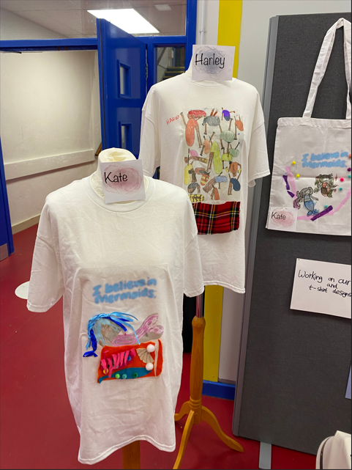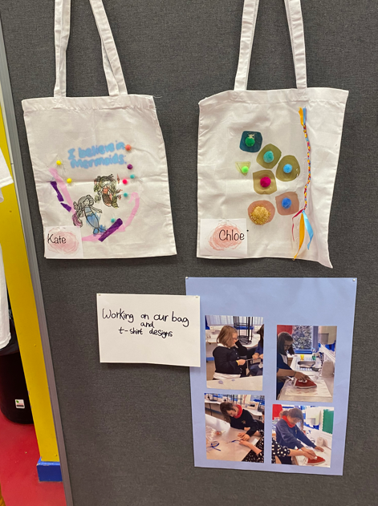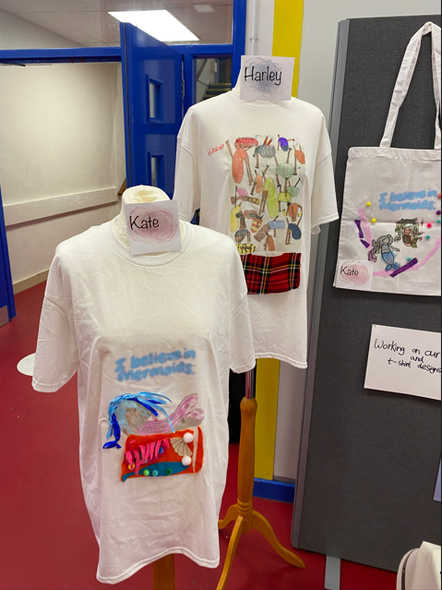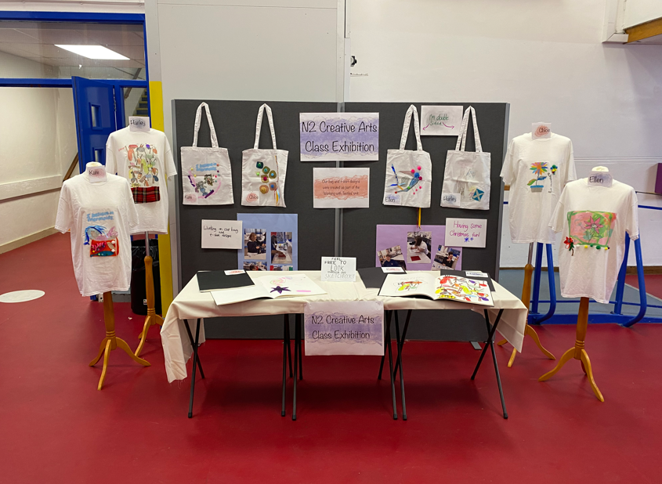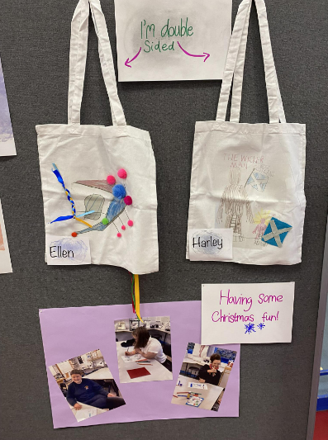

Accessibility Tools
Senior pupils (Inspire ambassadors) were working with S1 pupils on the use of accessibility tools on their iPads. These tools can be used at home and in the classrooms to enhance pupil learning. The inspire ambassadors helped prepare the materials for this leaning experience and worked very well with small groups of S1 pupils. The S1 pupils were fabulous and very engaged with our senior pupils.
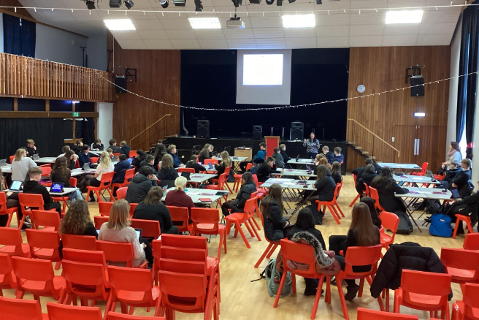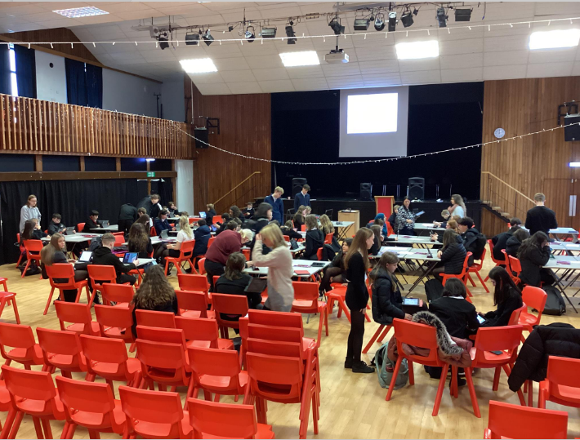

PSE Focus
This month, we have been preparing our S1 and S3 classes to make their course choices for next year. Our school website has lots of great information about the many courses on offer, as well as links to websites like My World of Work which gives information about future careers - https://blogs.glowscotland.org.uk/sb/phscoursechoice/
We have also introduced our S3 classes to the exciting Work Experience opportunity coming up in May. Please check your emails and look for one from Mrs Boyd which details the process to signing up to a placement. Should young people also complete the logbook, they can achieve an SQA award!
Our S2 classes have continued to use the https://rshp.scot/ resources to learn about relationships.
With the prelims on, our senior classes have been quite quiet. This has been a great opportunity to talk to those in class about future pathways. We look forward to seeing everyone back in class in February.

