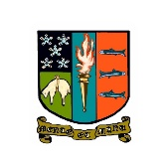

**October/November Newsletter**

Dear Parent Carers, Pupils and Staff,

Welcome to the latest edition of our school newsletter. It is a pleasure to share with you both some of what has been going on in school recently, and some of our upcoming events. Happy reading.

Campbell Wilson

Rector

**Premier League Football**

On 21st October, 48 S1-S5 pupils enjoyed a day out at St James’s Park to experience a great match between Newcastle and Crystal Palace. Our pupils enjoyed the chance to attend an English Premier League match and witness lots of goals, with Newcastle the 4-0 victors.

[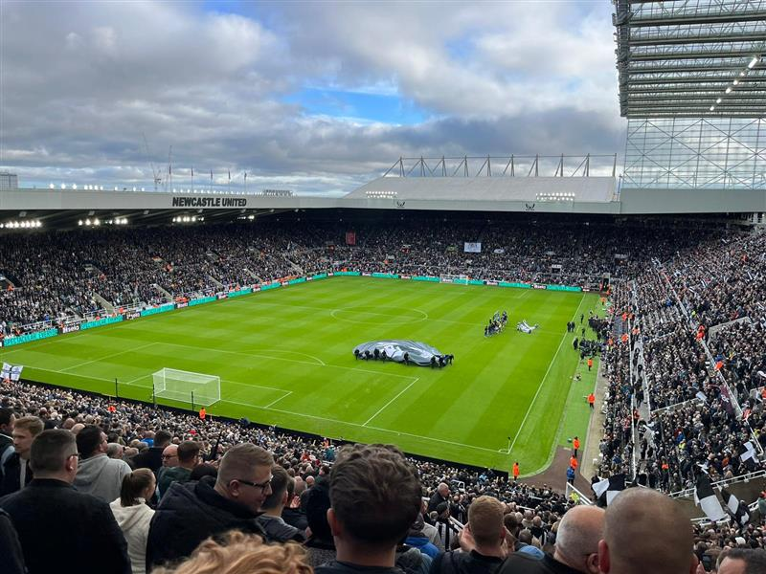](https://eu-prod.asyncgw.teams.microsoft.com/v1/objects/0-weu-d16-4ba8ccce625381c8503916895e3ec21a/views/imgo)[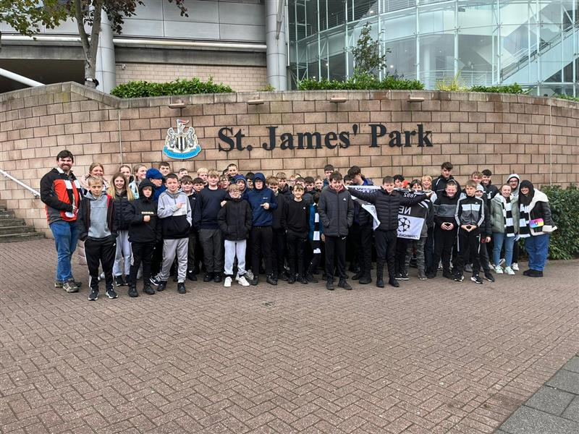](https://eu-prod.asyncgw.teams.microsoft.com/v1/objects/0-weu-d16-e76ea27a9df34f81d202830e150276f9/views/imgo)

**Geography Trip – Sorrento, Italy**

39 S5/6 Geography students went to Sorrento, Italy from 1st-5th October 2023.  We packed lots into our trip, including walking up Mount Vesuvius (which kindly didn’t erupt) and visiting Pompeii and Herculaneum.  We day-tripped to the Island of Capris and viewed the iconic limestone scenery as well as enjoying some Mediterranean beach time.  We also visited a supervolcano, Campi Flegri, which was experiencing minor tremors during our visit.  Students enjoyed experiencing Italian food and culture, learning how to make gelato and pizza, and viewing Mediterranean farming practices.  It was great to reinstate the Geography abroad trip offering.  Well done to all students for being model ambassadors of PHS, as well as clearing Sorrento out of gelato!

**Higher Geography Fieldwork**

Higher Geography students conducted a day of local Physical Geography fieldwork in preparation for their Added Value assignment.   Pupils investigated different ecosystems around Haylodge and Cademuir, measuring a variety of soil and water-based factors.  It was nice to be able to learn in the outdoors, something that was temporarily removed from the syllabus due to Covid-19.  Well done for all your hard work, Higher Geographers!

**Boxing Success**

Sam Brown in S3 has had sporting success in boxing. He took gold in a Titled Boxing Fight, which means he is now Scottish Development Champion for his age and weight category. This is a significant achievement, well done Sam, your hard work and determination has paid off!

**Remembrance**

PHS Senior Student Council presenting at the Remembrance Assemblies.
On Friday 10th November, our Senior Student Council (SSC) led poignant remembrance assemblies for all year groups. Supported by Mrs MacIver and joined by Rev. Jefferson who represented our chaplaincy team, our S6 pupils led our reflections on the sacrifices that are made in times of war. A bagpipe lament introduced the two minutes silence which was observed perfectly by all. Our assemblies ended with pupils writing notes of thanks on red hearts, which our S6 pupils used to create poppies to be displayed around our school.

On Sunday 12th November, our Head Team represented the school at our community’s Remembrance Service.

**S2 STEM Day (Science, Technology, Engineering and Mathematics)**

On 1st November, S2 pupils enjoyed our annual STEM day, an event designed to promoted education and careers in STEM. Supported by our business partners Evolution and delivered by PPMABest, our pupils developed, amongst others, teamwork and problem-solving skills in two STEM challenges.

On 2nd November, pupils and their families attended our Careers Event. We welcomed over 60 exhibitors from education and business to support our learners to consider career pathways. We are grateful for the work of DYW Borders, particularly Helen Philips, School Coordinator for Peebles, and our Parent Council for making this event such a success.

**Respectful Relationships and Anti-Bullying**

Scottish Borders Council has issued the new Respectful Relationships policy which all schools will adopt.  As part of this, there are new posters around the school informing young people of what steps will be taken when they report a bullying concern.

**Christmas Dance Tickets**

Tickets for the S1/2 and S3/4 Christmas Dances are now available to buy on ParentPay - £2! These are sold on a first come, first served basis until the day of the dance.

S1/2 - Wednesday 6TH December (PHS 7-9PM)

S3/4 - Thursday 7TH December (PHS 7-9.30PM)

S5/6 - Monday 18TH December (TIMINGS AND VENUE TBC)

A £2 charge will be added on ParentPay from Friday 1st December and parents of pupils who want to attend should pay the charge. No physical tickets are supplied – those that have paid will be on the list at the door.

**Assemblies**

We had two assemblies in October and one in November.

Bullying and Equalities

In our first assembly, Mrs Moretta shared the things that have been done to tackle bullying in the school.  This was in response to a significant number of young people stating that they did not feel safe.  Mrs Moretta shared data on the bullying incidents that had been recorded since the start of term and what had been done about these.  She then spoke about how some young people experience bullying because of their perceived differences.  We are going to raise awareness of equalities and the protected characteristics this session by having equalities focus months.  There was a clear message that everyone in our school community should feel that they belong, that we are all different and we should accept and celebrate our differences.  There is nothing wrong with the young people who feel different, it is the mindset of others that needs to change.  Mrs Moretta showed a video at the end of the assembly which reiterated this message, check it out here - <https://youtu.be/YM8UzTadJ7A>

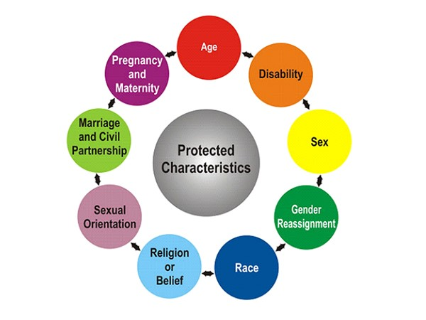

Equalities Assembly

During October we focused on Neurodiversity.  Mrs Moretta led assembly with input from Miss Geddes and Mrs Bell and young people learned that neurodiversity means that our brains work differently and we use our senses to process information differently. Neurodiversity involves a range of conditions and young people learned what they can look like.  Being neurodiverse does not mean the same as low intelligence, it means that some people’s brain processes information differently – not better or worse, just different and that is ok!  We explored the strengths and challenges young people who are neurodiverse may have and can appreciate that no two neurodiverse people are the same.  Young people heard what school can do to support neurodiverse young people and what neurotypical young people can do to support their neurodiverse peers.

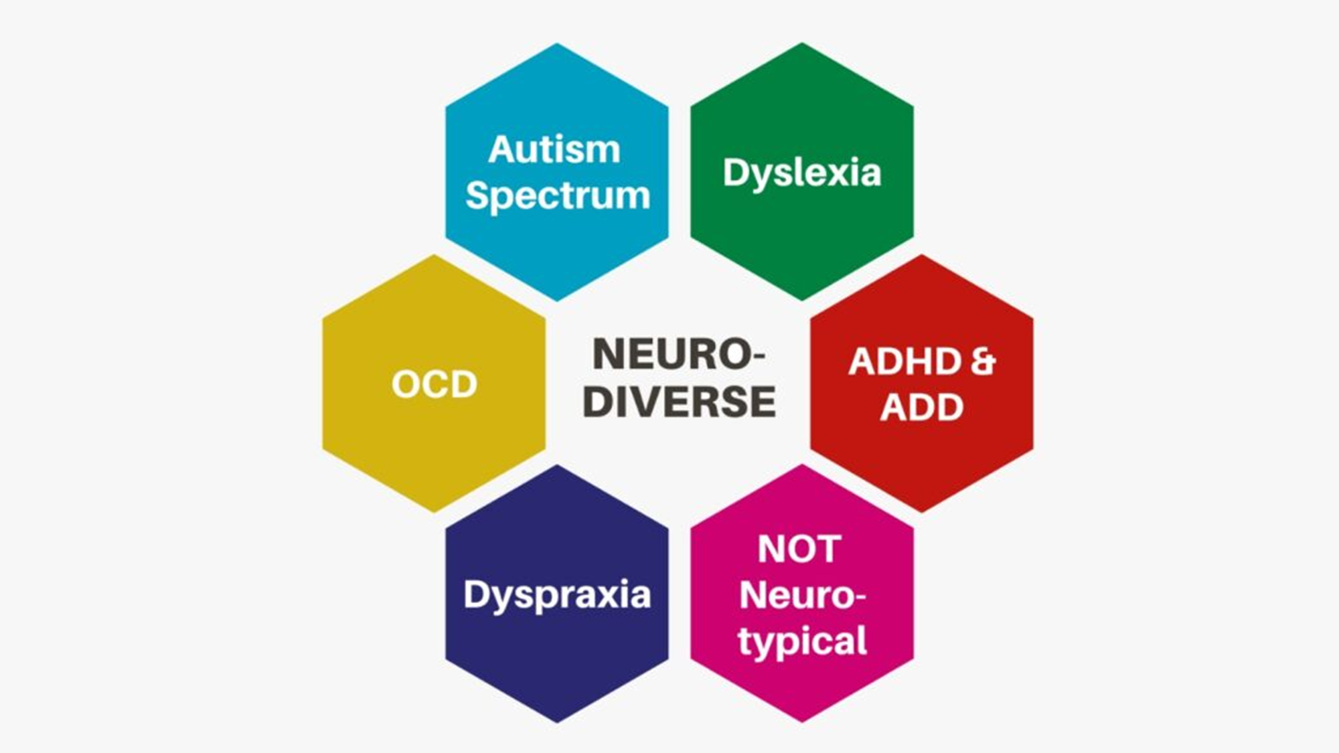

Our most recent assembly was particularly special because it was led by Jess Stennett in S5. The protected characteristic focus for November was Sex. Jess told us about White Ribbon Day – an international day of awareness where everyone but particularly men and boys show their commitment to ending violence against women and girls. Jess passionately spoke about men/boys being allies and showing support for their female peers by calling out inappropriate behaviour such as sexist messages on group chats and harassment. We watched the ‘That Guy’ video which came from a Police Scotland campaign to prevent violence against women. The video encourages men to be a ‘mate’ instead of ‘that guy’. You can view the video using this link - <https://youtu.be/pC-Gs7_oBRE?si=oXn4h2ZVxUG-U69I>



**Key Dates:**

**6th December: Advanced Higher Modern Studies Conference**

**6th December: S1/2 Christmas Dance (7pm-9pm)**

**6th December: Hockey Scottish Cup Quarter Final (12-2pm)**

**7th December: S3/4 Christmas Dance (7pm-9:30pm)**

**7th December: Schools Cup Netball - Senior 2 vs North Berwick HS (4pm-5pm)**

**11th-15th December: S4-6 Prelims (Block 1)**

**18th December: Model UN Conference (see sign-up details in Pupil Bulletin)**

**18th December: S5/6 Christmas Dance (8pm-10pm)**

**19th-20th December: Music Christmas Concert rehearsals (various ensembles throughout school day)**

**20th December: Christmas Concert (7pm)**

**21st December: Christmas Service, led by Senior Student Council (Period 7)**

**21st December: Last day of term**

Our full calendar for session 2023/24 is available to view on our website: <https://blogs.glowscotland.org.uk/sb/peebleshighschool/calendar/>