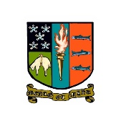

**Parent/Carer Newsletter 10 31st August 2023**

Dear Parents, Carers, Pupils and Staff,

We are delighted to share our August Newsletter with you, celebrating successes and key information from the school community. For the first time we will be sharing this newsletter with staff and pupils as well as parents and carers. Here’s to a fantastic academic session to come and we wish you all a prosperous month to come.

**Teaching & Learning: Questioning Enquiry**

Staff at Peebles High School are undertaking a research enquiry this year on questioning. This will aid them in further developing their skills in this aspect of their teaching, as well as learning from their peers and input and feedback from students. Several staff will be trialling the use of the well-renowned video recording software IRIS Connect. IRIS Connect gives teachers the opportunity to record classroom-based teaching and learning using their App and Discovery Kit. All videos are securely transferred to the teacher's personal, password protected account on their cloud-based platform.

This will help to further enhance the teaching and learning experience across the school for all of our young people.

|  |  |
| --- | --- |
| **Springwood Road, Peebles, EH45 9HB 01721 720 291 Email:** [**PeeblesHS@scotborders.gov.uk**](mailto:PeeblesHS@scotborders.gov.uk) **Website:** [**https://blogs.glowscotland.org.uk/sb/peebleshighschool**](https://blogs.glowscotland.org.uk/sb/peebleshighschool) **Twitter: @peebleshigh** |  |

**Young STEM Leader Award**

S6 students who have an interest in STEM subjects (Science, Technology, and Engineering & Maths) have the opportunity join the Young STEM Leader Team. This award is offered at level 6 in Peebles High School and allows young people to develop leadership, communication and employability skills. Mrs Minto and Dr Harkness look forward to working with the group this year, some of whom will be available at the Open Evening on Tuesday 5th September in the Fresher’s Fair promoting the S1 STEM Club.

[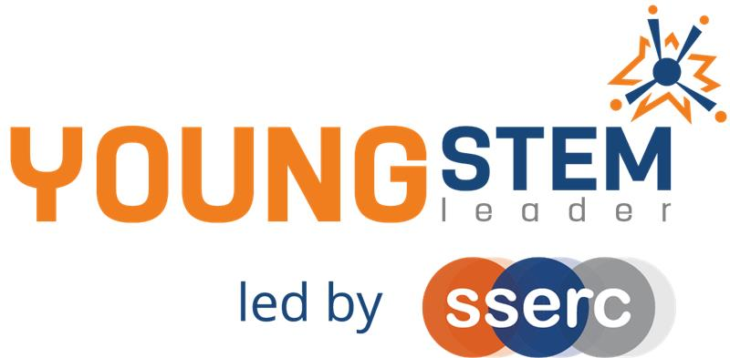](https://eu-prod.asyncgw.teams.microsoft.com/v1/objects/0-weu-d21-3b3ddf5ced5b00331cc72df329119ee8/views/imgo)

**Medical society**

It was an absolute pleasure to welcome three of our current S5 pupils to our first Biology & Chemistry Faculty Meeting of 2023-24. Emaan, Kieran and Lucy shared with us their vision for establishing a pupil led Peebles High School Medical Society. Great evidence of metaskills in action-self management, social intelligence and innovation. Can’t wait to see this initiative take off!

[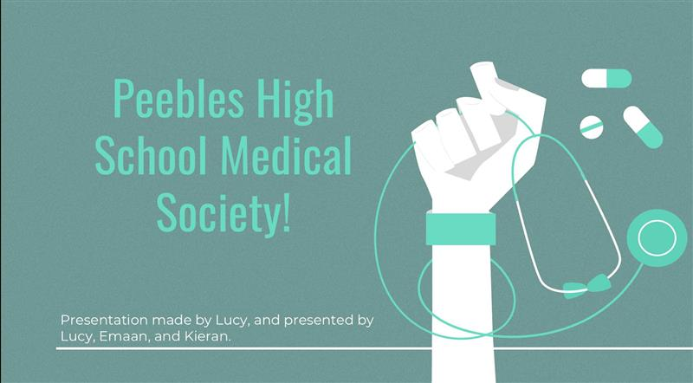](https://eu-prod.asyncgw.teams.microsoft.com/v1/objects/0-weu-d14-3a0f0a2905806db1eed4821229a06bf6/views/imgo)

**Sporting Success**

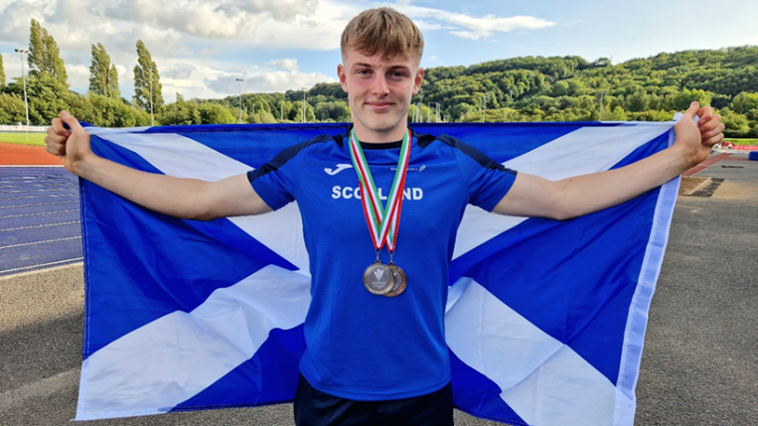

Congratulations is in order for Louis Whyte, S6. At 16 years old, making his Scotland U20s Athletics International debut in Cardiff, Louis won Silver in Long Jump (his longest jump of the year at 7.09m) and Bronze in Triple Jump.

If that wasn't enough challenge, Louis also committed to compete at the U17 English Athletics National Championships, travelling to Birmingham for the Long Jump in the same weekend. Louis achieved a jump of 7.02m in the final round to win Silver.

One to watch for the future, the school is very proud of his success. Well done Louis!

|  |  |
| --- | --- |
|  |  |
|  |

**S6 trip to London**

New S6 students visited London at the end of June 2023. They visited Parliament where they met David Mundell MP and Lord Purvis of Tweeddale. Mr Mundell organised for PHS students to visit Downing Street and to take pictures at the iconic door to 10 Downing Street. During the trip students also went on the London Eye, visited the Imperial War Museum and enjoyed a performance of Mamma Mia!

|  |
| --- |
|  |
|  |
|  |

**Potato Harvesting**

These are the harvested potatoes and photos of Mr Andreou’s S2 class.

The S2 scientists planted seed potatoes on the school allotment plots last term and have managed to harvest them in August. The students have taken them home and shared the extras with staff members. Sunflowers, tomatoes and peas have also been grown as we learned about horticulture.

|  |  |
| --- | --- |
|  |  |
|  |
|  |

**PSE Lessons**

All year groups started the session with a settling-in lesson and, where relevant, were given the opportunity to change their course choices. S1-S4 are now working through the Young Minds Matter lessons which focus on ways to improve your mental health. S5 and S6 classes are focusing on future pathways and writing applications before moving on to the Relationships, Sexual Health and Parenthood (RSHP) lessons - <https://rshp.scot/>

**Donations of Stud Boots**

Great news that our new artificial pitch is nearly ready for use. One of the ways we have been told to keep the surface playable for as long as possible is to allow only stud boots onto the surface. Most young people will be able to comply with this but for those that struggle either through finances or organisation we are going to build a stock of stud boots in the school. If you have any good condition stud boots that your young person may have grown out of or no longer use we would love to give them a purpose, please bring any donations to the office or sports hall. All sizes welcome. Thanks in advance.

Thank you for reading and we look forward to sharing all exciting developments with you in the September Newsletter.

**Key Dates:**

4th September - Pupil Parliament nominations open

5th September – Assemblies (P1 S2, P2 S5/6, P4 S4, P5 S3, P6 S1)

5th September - Open Evening (5pm-7pm)

7th September – S5/6 Attitude Matters 1

11th - 15th September – Germany Music Exchange

11th - 15th September - Student Parliament Elections

13th September – Parent Council Meeting (7pm-8:30pm)

14th September – S5/6 Attitude Matters 2

21st September – S1 Settling In Report issued

Our full calendar for session 2023/24 is available to view on our website: <https://blogs.glowscotland.org.uk/sb/peebleshighschool/calendar/>