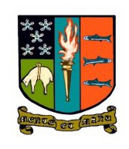

PEEBLES HIGH SCHOOL
C A M P B E L L W I L S O N , H E A D T E A C H E R
Parent/Carer Newsletter 7 28th April 2023
Dear Parent Carer
Welcome to the June issue of our monthly Newsletter. I trust that you and your family are well and looking forward to the new school session with optimism and positivity. This session has un- doubtedly been a very busy and challenging one for our community but we are reaching the point when we are able to draw breath slightly and reflect on improvements we have made and decide on improvement priorities for the coming session. I want to start by signposting communications that you can expect in the next few weeks. This session, our Parent Council chair, Sarah Duncan, set up and led a working group to review our school’s approach to uniform and revise our policy.
In April I met with the group of parents, young people and staff to hear their recommendations and I will be writing to all families by the end of May to outline the changes we are implementing following this valuable piece of work. The new policy will be implemented in August immediately
after the summer holiday. Until then I ask that you continue to support us by ensuring your child adheres to our current policy. Another policy we have spent a great deal of time reviewing this
session is our behaviour policy. Post Covid, behaviour in our community has been more challenging than in previous sessions and our staff are keen to respond positively to this challenge by sup- porting all of our young people to feel safe and encouraging all to give their very best at all times. Again, you will receive a separate communication on changes to our policy and approaches
to supporting positive behaviour before the end of May. Please look out for these important com- munications soon and enjoy the rest of this month’s Newsletter. The S6 Graduation ceremony at the Eastgate Theatre was a particularly joyous occasion and I take this opportunity to repeat my best wishes to our graduating S6 and hope that they are able to meet the challenge quoted on
their graduation certificates this year:

"I encourage you to live with life. Be courageous, adventurous. Give us a tomorrow, more than we deserve."
Maya Angelou, American memoirist, poet, civil rights activist, all-round inspiration!
Campbell Wilson
Key Dates
01/05/23 May Day holiday 02/05/23 Staff in-service day
03/05/23 Start of wellbeing indicator
focus month - ‘Included’

08/05/23 Public holiday (King’s coronation)

S p r i n g w o o d R o a d , P e e b l e s , E H 4 5 9 H B 0 1 7 2 1 7 2 0 2 9 1
E m a i l : P e e b l e s H S @ s c o t b o r d e r s . g o v . u k
W e b s i t e : h t t p s : / / b l o g s . g l o w s c o t l a n d . o r g . u k / s b / p e e b l e s h i g h s c h o o l
T w i t t e r : @ p e e b l e s h i g h

Update from Pastoral

PEEBLES HIGH SCHOOL
C A M P B E L L W I L S O N , H E A D T E A C H E R

This month in PSE, we have covered the following topics:
S1-4 - Mental Health using the Young Minds Matter Resources and Relationships using the
Relationships, Sexual Health and Parenthood (RSHP) resources.
S5+6 - Future Pathways (we have had a number of speakers in to speak to young people about various options post school), Homophobia, and Exam Preparation.

Fire Skills Programme

On 29th & 30th March, 9 young people from S3 and S5 undertook a 2 day Fireskills Pro-
gramme at Peebles Fire Station, facilitated by Scottish Fire & Rescue Service (SFRS)
personnel. Young people learned about water and fire safety; CPR, defibrillators & general first aid; and had the opportunity to operate fire hoses and do fire drills, whist developing their teamwork, communication and leadership skills. They also experienced a simulation of what it is like to be in a smoke-filled, confined space.
It is hoped to develop this partnership further in order to offer courses over 5 days in future. A huge thanks to SFRS for their time and input; and also to the young people
themselves, whose behaviour, commitment and positivity were a credit to themselves and the school.
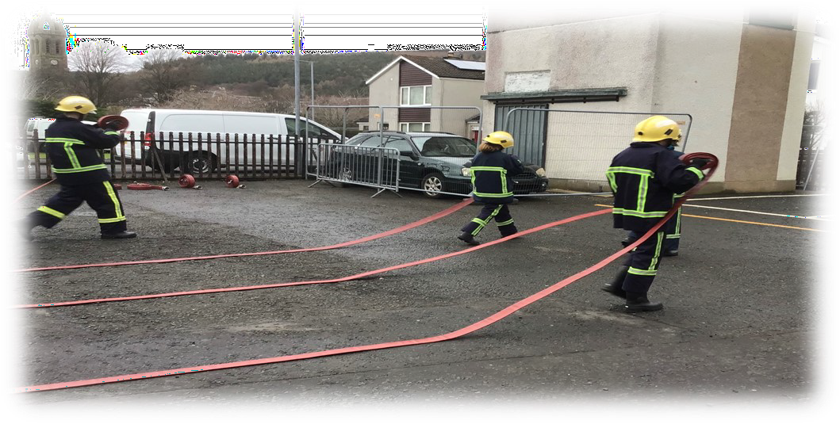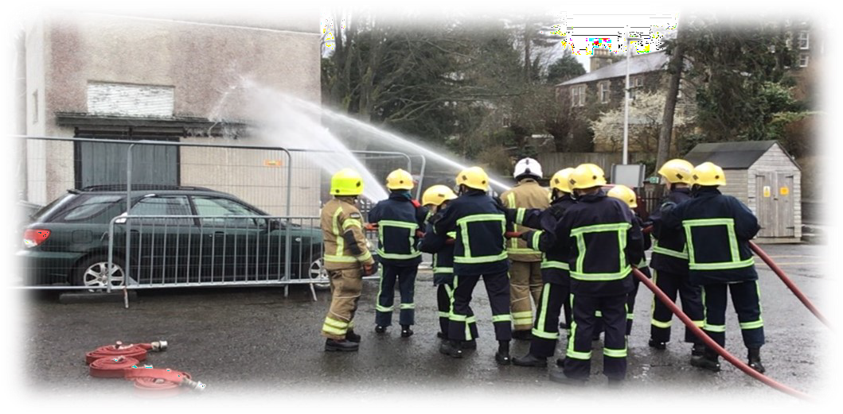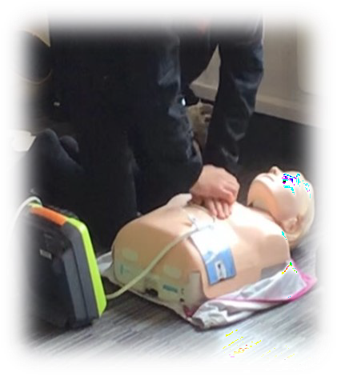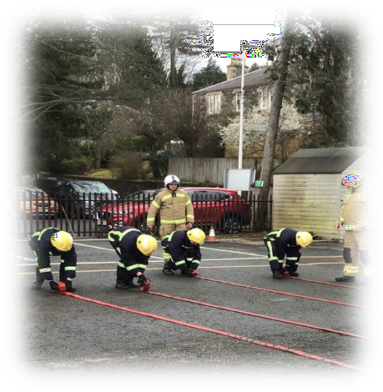

PEEBLES HIGH SCHOOL
C A M P B E L L W I L S O N , H E A D T E A C H E R
Showbie Trials
PHS are currently trialling "Showbie", an app that allows parents/carers to view key pieces of their child's work. We are keen to improve communication of pupils' progress and next steps in learning and Showbie has great potential for this. If your child has been involved in the trial, you should have received a group call inviting them to join Showbie and give feedback. Thank you to everyone who have responded to the group call so far. If you have been invited to join Showbie but have not yet tried to do so, it would be great if you could.

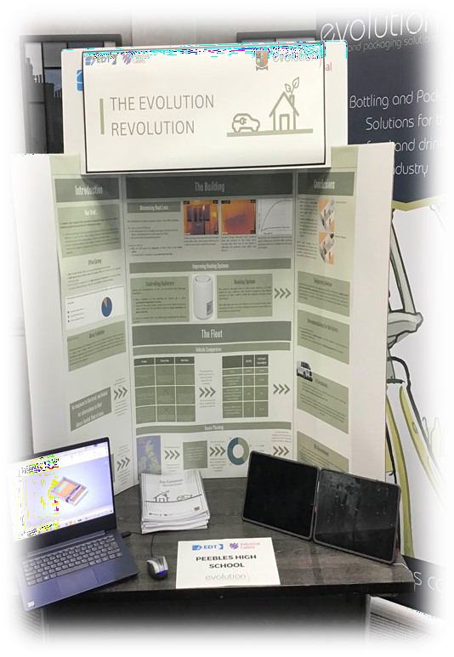
EDT Industrial Cadets Gold Award
Alexandra Crichton, Isla Ferguson, Rhyanna Heggison and Gemma Watson completed the Engineering Development Trust Industrial Cadets Gold
Award. The 20-week project collaborating with a local STEM company end- ed with a conference day where students presented in front of Industry
and academia experts. This is a photo of the students’ poster display and final report. The students received excellent feedback from the judges and company! They have also gained a SCQF Level 6 Young STEM Leader Award due to their efforts. Well done team!

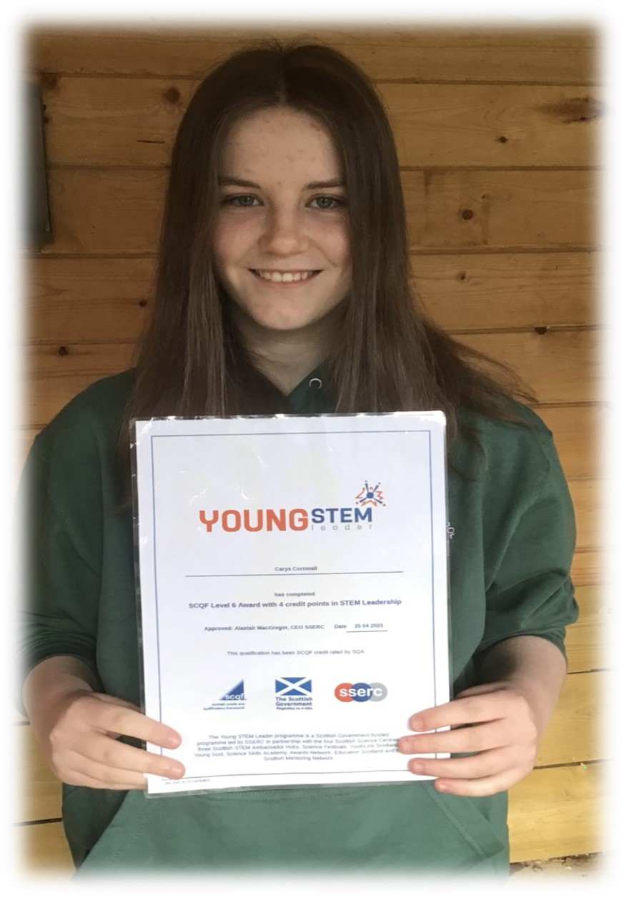


Young STEM Leader Programme
Carys Cornwall 6M3 has earned a Young STEM
Leader Level 6 Award. She completed initial training with Dr Harkness and followed this up with volun- teering in the S1 STEM Club. She led sessions on
making pH indicators, strawbee construction and a very popular reflection and refraction session. Her log book was exemplary and shows she has a great understanding of the importance and challenges in STEM. Carys fulfilled all the requirements of the YSLP and was an excellent role model for our S1s. For more details on YSLP go to https:// www.youngstemleader.scot/

Assemblies

PEEBLES HIGH SCHOOL
C A M P B E L L W I L S O N , H E A D T E A C H E R

Our monthly assemblies include a wellbeing focus and we use the Getting It Right For Every Child (GIRFEC) wellbeing indicators to highlight the importance of wellbeing. In January we talked about ‘Achieving’ and how
learning something new can improve our wellbeing. In February we looked at ‘Safe’ and discussed the ef- fects of bullying on our wellbeing. In March we covered ‘Responsible’ and related this to behaviour and how we treat others and the impact of this on wellbeing. Mrs Moretta shares our data on how many bul- lying incidents are recorded each month and how these are dealt with. Our next wellbeing assembly will focus on ‘Included’ and how feeling a part of our school community and having a sense of belonging im-

proves the wellbeing of our young people.


Congratulations to Rhyanna Heggison, S6 who has been accepted for the prestigious
Strathclyde University Space School in June.

Sunflower Classroom Work Experience
What a fantastic welcome our young people were given at the start of their work experience at Peebles Hydro. We are learning to set the tables and work with new people in a very different environment to school!
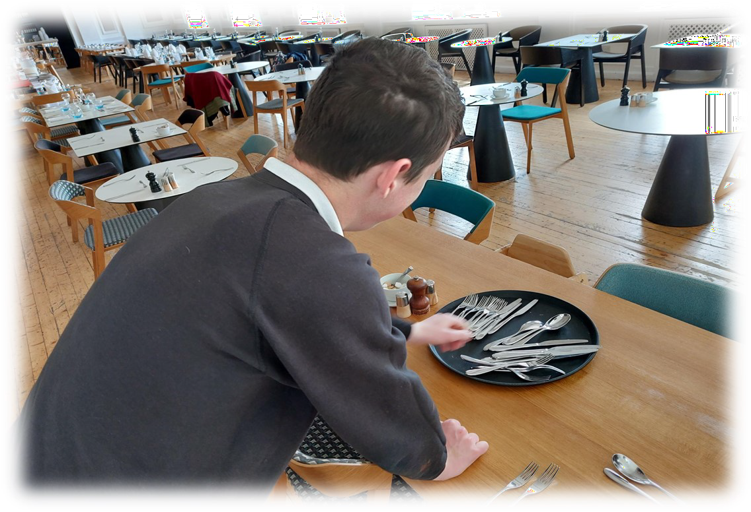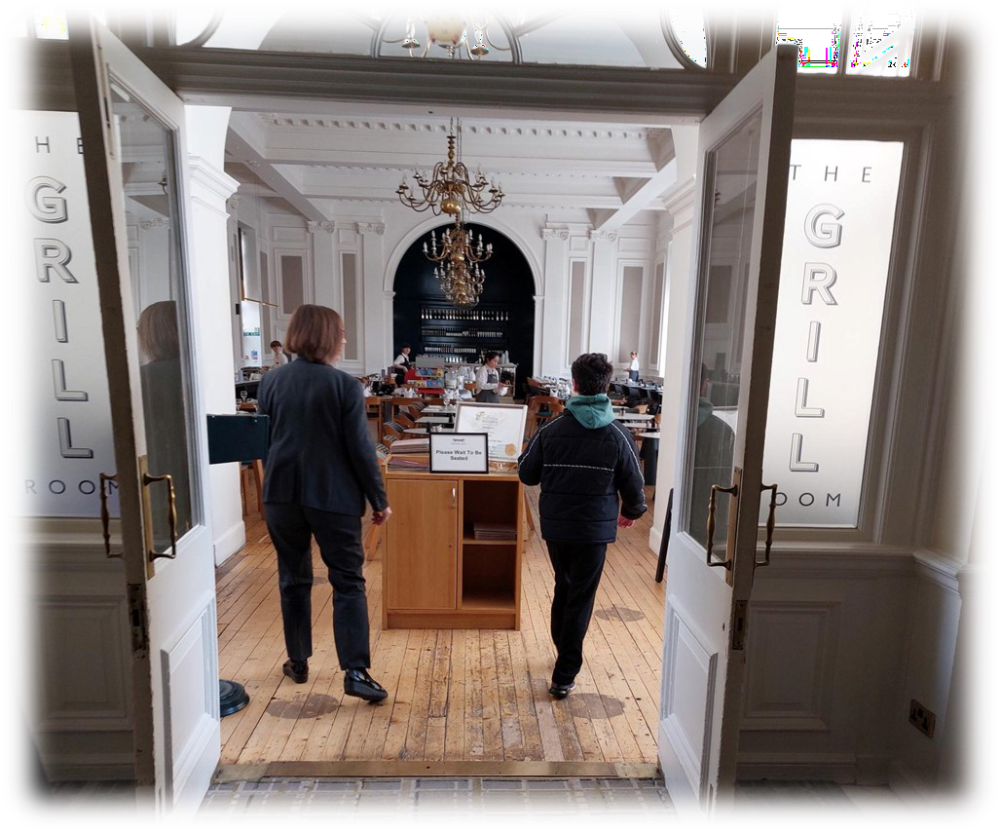

S6 Graduation

PEEBLES HIGH SCHOOL
C A M P B E L L W I L S O N , H E A D T E A C H E R

We said farewell to our wonderful S6 young people last Friday and celebrated in style at the Eastgate Theatre. Christina and Rio’s speeches went down well, as did the buffet and of course social dancing. Thank you to the young people, staff and Eastgate Theatre for making the send off such a happy and memorable day.
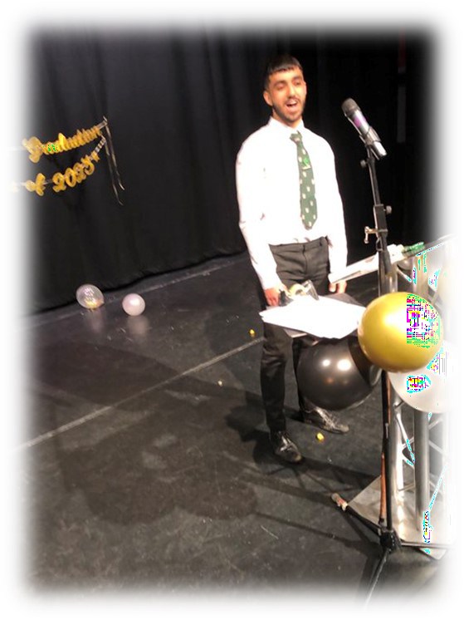
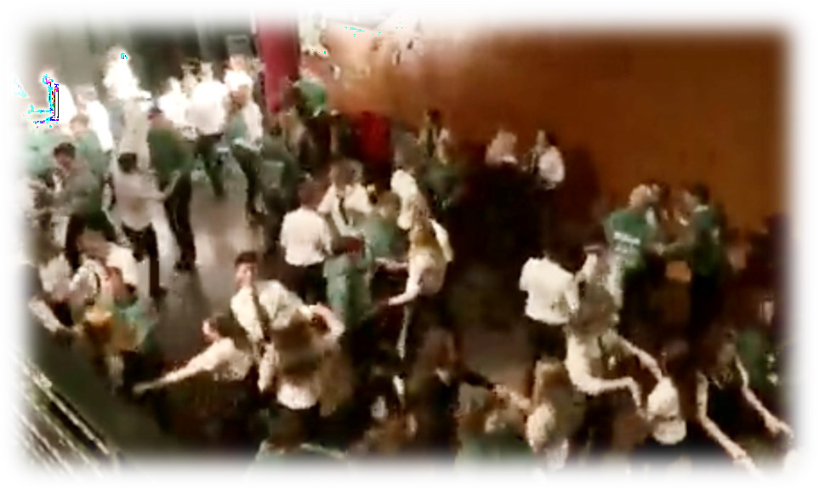
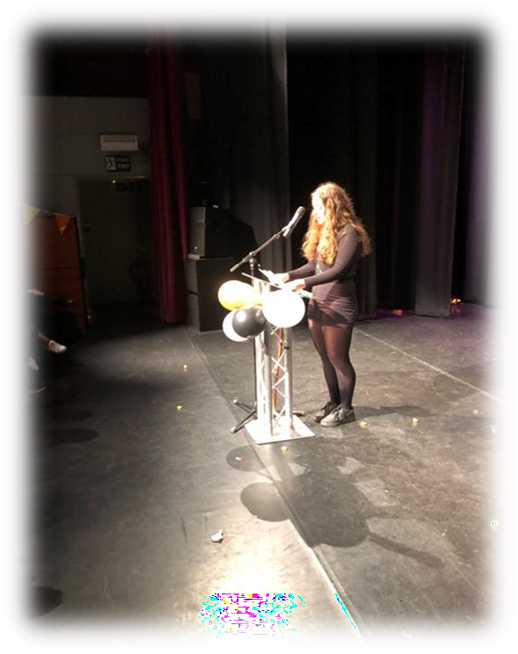
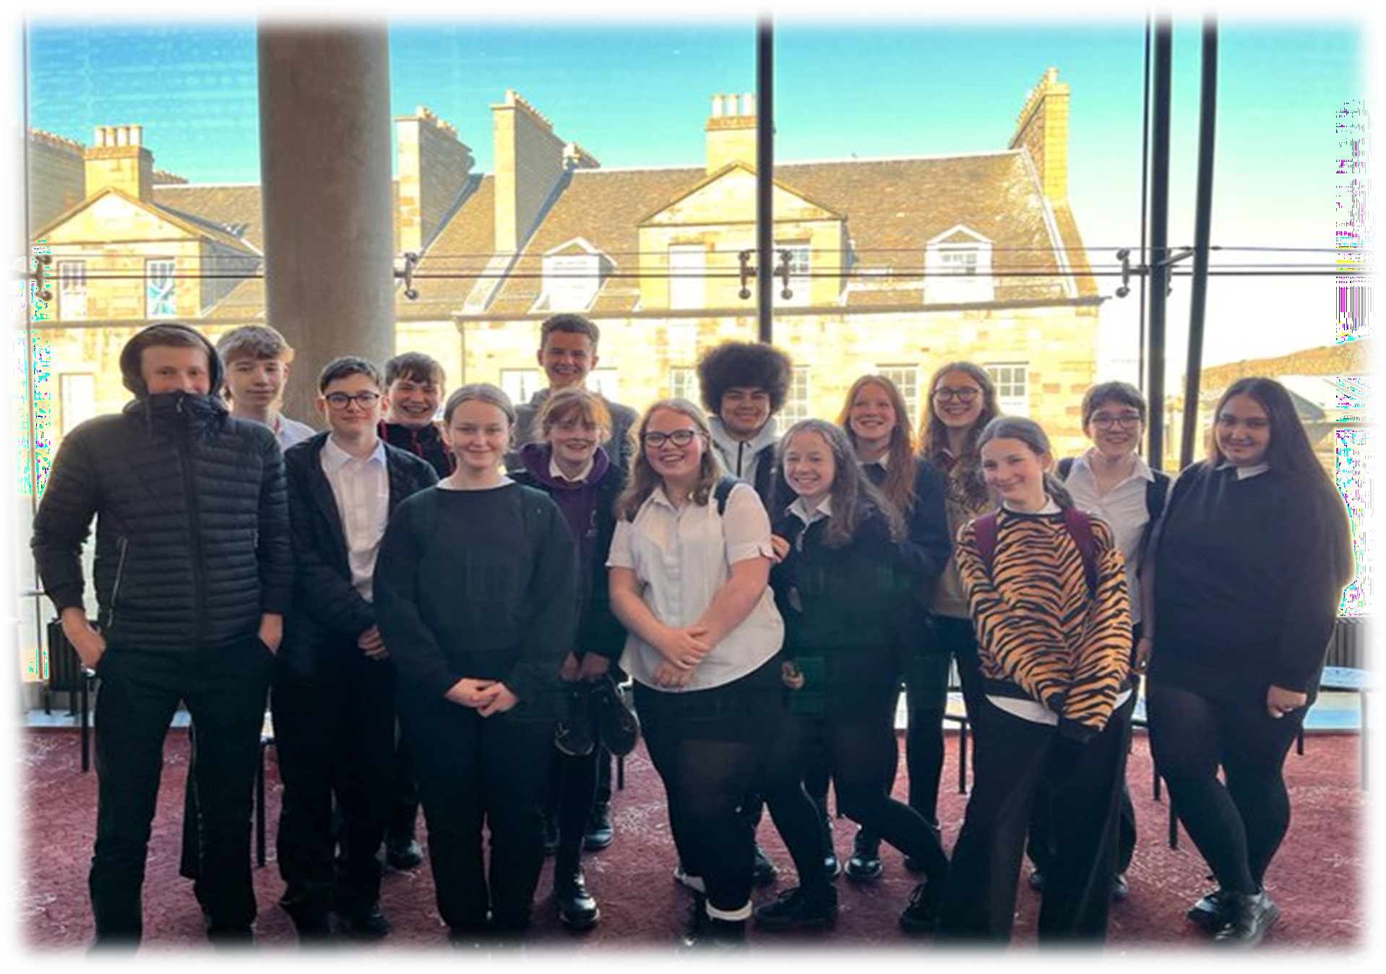
Drama Trip
Our N5 class enjoyed a visit to the Festival Theatre to watch The Ocean at the End of the Lane.

Success in Sport

PEEBLES HIGH SCHOOL
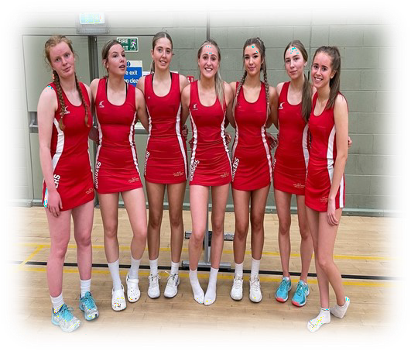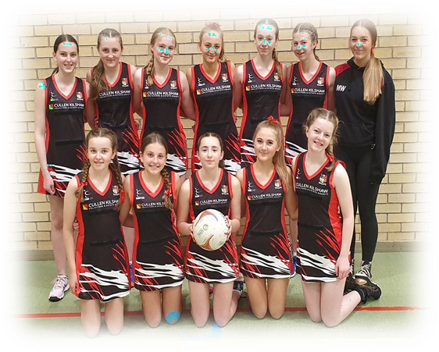C A M P B E L L W I L S O N , H E A D T E A C H E R

There has been lots of achievements to celebrate recently in hockey, rugby and netball in particular. In the last tourna- ments of the season, the senior girls won the Duns Hockey 7s and the S1 and S2 boys won the South Rugby 7s.
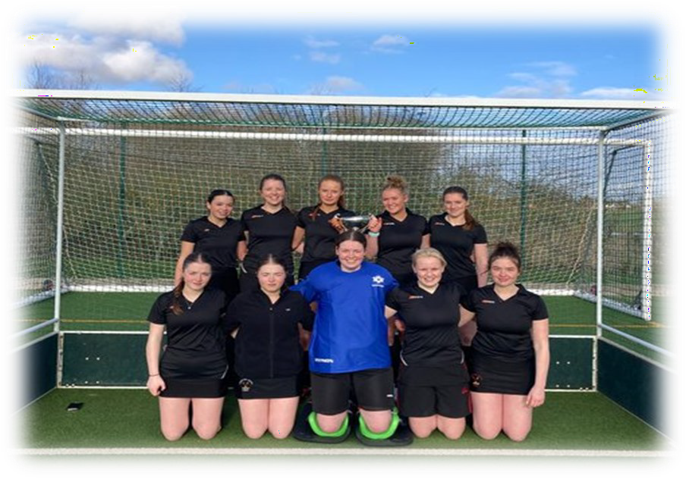
In Netball, our senior girls made up the entire Borders district team which travelled to Dundee to take part in the district finals. With only 7 players they beat Lanarkshire, Aberdeen, East Renfrew-
shire and Angus and drew against Glasgow. They placed in the top four U17 district teams in Scotland, well done girls!

Not to be outdone, our S2 girls reached the final of the Scottish Schools Championship and were un- lucky to just lose out 24-26 to Fettes Col-
lege. They played some lovely netball and taking part in a national final was a fantastic experience for all twelve girls.

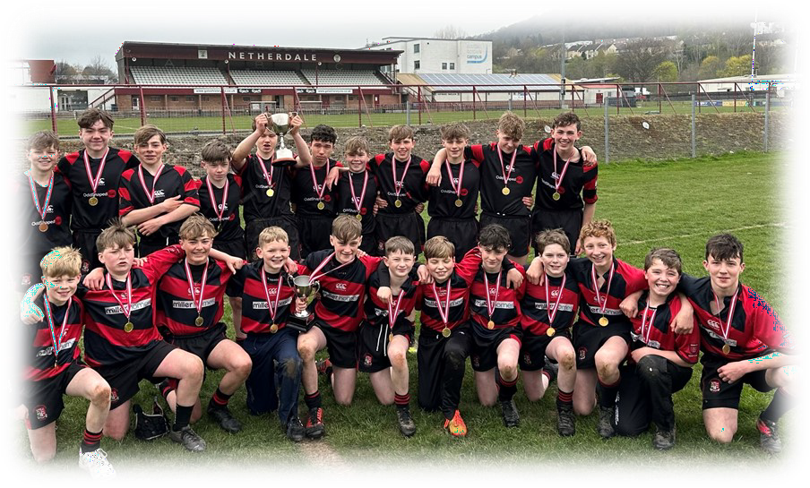
And finally, our staff got into the spirit too! They dusted off their boots and took on our seniors in hockey and football. It was a 2-0 win for the staff at the hockey with Mr Harkness
being awarded staff player of the match and the senior boys were victorious in the football with a 4-2 win. Great fun had by all, until the next day when it proved challenging for some staff to walk!
