

PEEBLES HIGH SCHOOL

C A M P B E L L W I L S O N , H E A D T E A C H E R

**Parent/Carer Newsletter 6, 28th February 2023**

Welcome to Peebles High School’s February Parental Newsletter. I trust you enjoyed the mid*-*term break and that you and your family are both feeling positive about spring arriving soon, and the work we are doing as a school to ensure all of our young people attain to their potential and enjoy their learning and time in school. For our current S6 there are only a few weeks left of school until their graduation on Friday 21st April.

# Parent Voice

Thank you to those of you who completed our recent surveys on the school vision and newsletters. Your feedback on the newsletter was broadly positive. I am pleased to hear that it is leading to some small improvements in your perception of our communication as a school. I am looking forward to meeting with our Parent Council this week to further hear Par- ents’ voices and share what we have been doing to improve PHS. Please be assured that your responses to surveys and contributions to our meetings are hugely influential in informing the direction of travel in our school.

# Easter School

Uptake for Easter School in 2021 and 2022 was particularly high, no doubt as a result of the concern families had about the impact of Covid on learning. Due to the impact of the strikes, there will be similar concerns this year. Mr Lee is pull- ing together a timetable of Easter School over this week and next and will publish our Easter study support offer for the two weeks of holiday in April as soon as possible. There will be a busy programme over both weeks of the holiday.

# SBC Review

In early November, I wrote to inform you about the SBC review of our school that had taken place. While the school was praised for our recent improvements in Learning and Teaching and our very good attainment and outcomes for young people, concerns were highlighted in relation to some other areas of our school. The review team of senior education staff from Scottish Borders Council committed to returning to our school this session with an expectation of seeing im- provements in the number of young people feeling safe in school, the leadership of the school and in our provision for

young people with additional support needs, particularly those with severe and complex needs.

# Pupil Safety

We have worked hard since the initial review to ensure young people are safe and feel safe at all times in our school. Straight away we made some physical improvements to our toilets to ensure they offer appropriate privacy. We have also increased the number of staff on duty at social times, with a particular focus on toilet areas and our main social areas during intervals and lunches. Mrs Moretta has led a group of young people to review our anti—bullying strategies and myself and Mr Reid have led a large working group of staff and young people to review our Positive Behaviour Policy, the foundation of which is our agreement on the need for all young people, parents and staff to work together to ensure everyone feels safe in our school. We are committed to the ongoing raising of standards in this area and the improve- ments we have witnessed to date are heartening for the future.



S p r i n g w o o d R o a d , P e e b l e s , E H 4 5 9 H B 0 1 7 2 1 7 2 0 2 9 1

E m a i l : P e e b l e s H S @ s c o t b o r d e r s . g o v . u k

W e b s i t e : h t t p s : / / b l o g s . g l o w s c o t l a n d . o r g . u k / s b / p e e b l e s h i g h s c h o o l

T w i t t e r : @ p e e b l e s h i g h

# Leadership

An improved budget settlement this year has allowed us to make key appointments in our school that have undoubtedly led to improved optimism and provision in the leadership of our school. The appointments of Karen Mooney and Alasdair Reid to the Senior Leadership Team has undoubtedly contributed to a return of rigour to ensure high standards within their respective remits of Learning & Teaching and Curriculum as well as having given me more capacity to give my time and focus to lead the improvements we require to make. It has been particularly exciting to augment the extended leadership in our school to include new leadership opportunities for staff in the shape of four new Principal Teacher positions in key strategic areas. This initiative has seen the following appointments:

Lynsey Walker as PT Wider Achievement James McMordie as PT Student Leadership Kirsty Wylie as PT data

And Gavin Harkness as PT Teaching & Learning

Having able staff to lead in these areas will be important for our school going forward.

# Provision for young people with Additional Needs

The review team were keen for us to improve the environment and curriculum for young people with severe and com- plex needs and we are confident of the progress made in this area of our school with our most vulnerable young people enjoying a more appropriate curriculum and a more calm and nurturing environment. We have also adapted the curricu- lum for a number of young people who sometimes struggle to engage in school and this has led to increased attendance and engagement in this targeted group.

# Communication

Our new parental newsletter has been key to starting the process of keeping you better informed about the life of our school. Feedback you have provided will inform the content and frequency of this communication going forward.

Parents favoured a monthly (rather than fortnightly) newsletter so we have settled on there being a Parental Newslet- ter monthly henceforth.

# SBC Review Next Step

SBC have instructed me to share the survey issued in October again so that the results can inform their judgement of improvements made to date. The review team plan to revisit our school on 8th and 9th March and I would be very grate- ful if you could support this process by completing the survey again: <https://www.surveymonkey.co.uk/r/2ZNT7QV>

Best wishes

Campbell Wilson

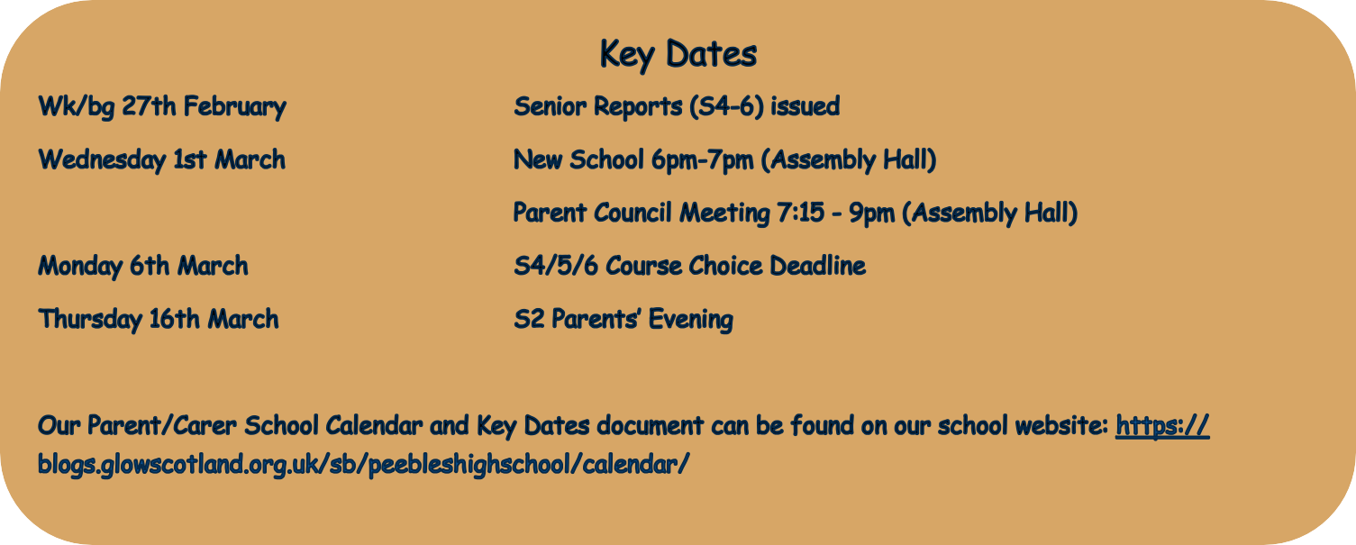

# Student Parliament New School Engagement

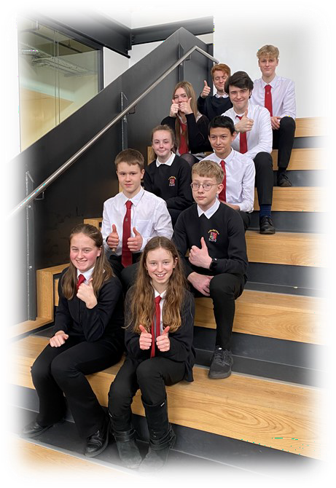Ten members of the student parliament visited the Jedburgh Campus on the

10th February. They were joined by students from Hawick High School and Galashiels Academy.

PHS students had the opportunity to meet Jedburgh students to ask questions about their new campus before getting a tour. The Student Parliament will meet with local councillors in March to discuss a wide range of local issues, including plans for the new school.

Ailish, S1, said: “W*e got to meet a friendly group of pupils who shared what it is like to attend Jedburgh Campus. We had a tour around the school and got to see what our school is going to look like. I found it interesting that even though it was open plan, you could hardly hear the*

*other classes. I also was interested in the layout - I thought it looked quite pretty.*

Thomas, S5, said: *"What really interested me was the smaller learning spaces, some were closed off and a few were designed for smaller meetings. This is something that i would look forward to within the new school. They were warm, silent and a place where young people could really focus on their learning - something that I feel Peebles High School currently could do with. We saw pupils actively using these areas along with teachers too, showing that they are benefi- cial to the schools learning approach."*

*Mr McMordie*

# Spectacular Skiing

***Netball Success***

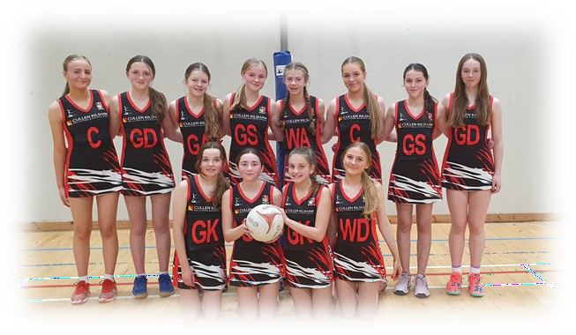Congratulations to our S2 netball team who beat Fettes College (the reigning champs) this week to progress to the quarter finals of the Scottish Schools Cup.

Good luck in the next round! Ms Watterson

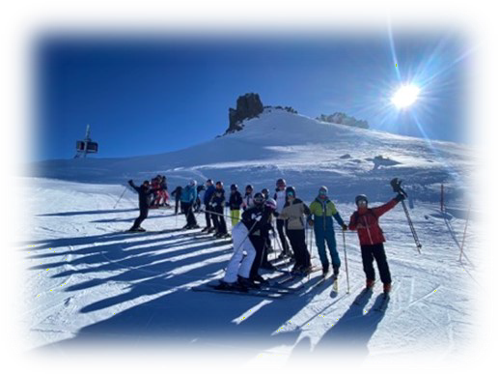Earlier this month, over 70 senior pupils and staff took on the slopes in France and Italy as our annual ski trip returned. This trip, which caters to all levels of ability, was a great suc- cess!

# S1 Art Skills Blossom

S1 artists have been working on posters in celebration of Chinese New Year, a festival that celebrates the beginning of a new year on the traditional lunisolar Chinese calen-

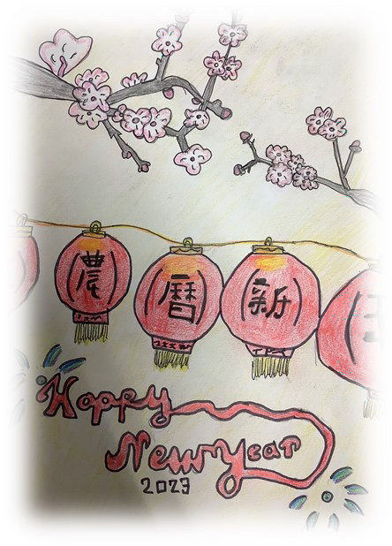dar. Miss Roper has been so impressed by her pupils’

# Bringing Learning

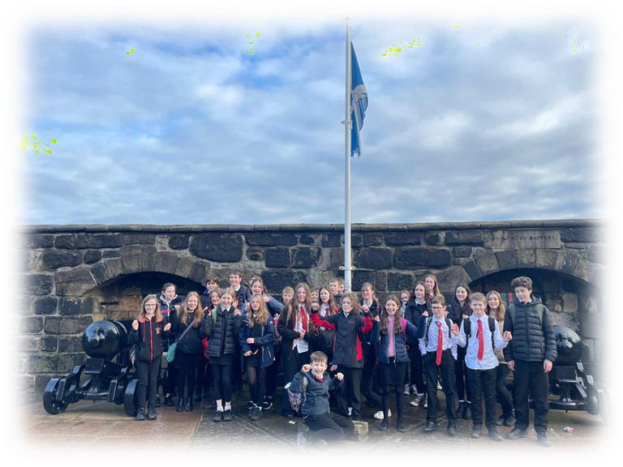**to Life**

Some lucky S1 pupils

have had the opportuni- ty to engage in learning experiences outside of school recently, thanks to our Social Subjects department. Pupils have enjoyed such experienc-

es as trips to Edinburgh Castle, and Dynamic Earth, and a visit to the Scottish Parliament.