

# PEEBLES HIGH SCHOOL

C A M P B E L L W I L S O N , H E A D T E A C H E R

**Parent/Carer Newsletter 5, 31st January**

Welcome to the fifth edition of our recently introduced newsletter, designed to improve communication with our parent and carer community. As per the ini- tial newsletter back in November, I promised I would seek feedback on our newsletters so that they can better reflect your preferences for meaningful communication and would be very grateful if you could spare a few minutes to complete a short survey [(click here)](https://www.surveymonkey.co.uk/r/ZQSN8MR) to give your feedback. I will let our com- munity know by spring of the approach we will take for continuous improve- ment to our communication going forward.

I am grateful to those parents and carers who completed our recent survey on our school vision and to those that were able to join us online at our consulta- tion events 23rd*-*25th of January. Young people and staff were also able to

share their views on our vision this month. We have lots to reflect on as we continue to work on further articulating our vision, as we strive to develop the shared understanding required for our vision to underpin our work. I will share details of our progress in the coming weeks. #mentemanucorde

I hope that the remaining content of this newsletter gives you a flavour of the life and work of our school.

Best wishes

### Mr Reid, Depute Headteacher

I am delighted to intro- duce myself as the new- est member of PHS Senior Leadership

Team. Growing up in the Borders, I have spent my teaching career in Edinburgh schools, and the last 6 years working in Wester Hailes High

Campbell Wilson Headteacher

## Key Dates

School as Head of Eng- lish and Languages. I am

31/01/23 Distribution of S1 Reports begins



S p r i n g w o o d R o a d , P e e b l e s , E H 4 5 9 H B 0 1 7 2 1 7 2 0 2 9 1

E m a i l : P e e b l e s H S @ s c o t b o r d e r s . g o v . u k

W e b s i t e : h t t p s : / / b l o g s . g l o w s c o t l a n d . o r g . u k / s b / p e e b l e s h i g h s c h o o l

T w i t t e r : @ p e e b l e s h i g h

02/02/23 All Senior Phase pupils return from study leave

02/02/23 Public Engagement Session on new HS building *-* click [link](https://www.scotborders.gov.uk/news/article/4394/details_for_february_peebles_high_school_engagement_sessions_confirmed) for details

07/02/23 S3 Course Choice deadline (note change from original date of 03/02/23)

08/02/23 Senior Course Choice Information Evening

looking forward to en- gaging with my new Timetable and Curricu- lum remit and ensuring that the needs of all

pupils in our school com-

munity are met.

# PEEBLES HIGH SCHOOL

C A M P B E L L W I L S O N , H E A D T E A C H E R

**Sunflower Space Burns Supper**

On 25th January, pupils and staff in our Sunflower Space en- joyed a Burns Supper. Ms Haldane was full of praise for the pu- pils’ engagement in preparing and experiencing this event.

### S6 Burns Supper

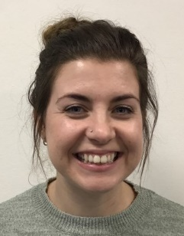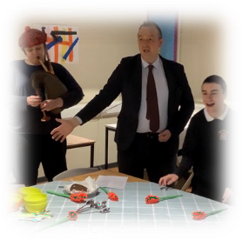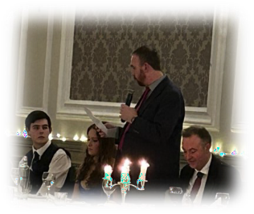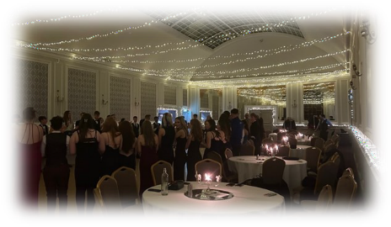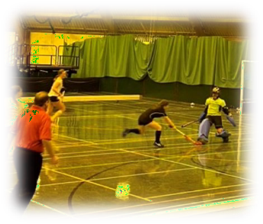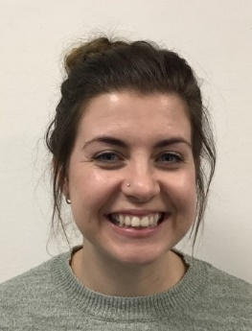

S p r i n g w o o d R o a d , P e e b l e s , E H 4 5 9 H B 0 1 7 2 1 7 2 0 2 9 1

E m a i l : P e e b l e s H S @ s c o t b o r d e r s . g o v . u k

W e b s i t e : h t t p s : / / b l o g s . g l o w s c o t l a n d . o r g . u k / s b / p e e b l e s h i g h s c h o o l

T w i t t e r : @ p e e b l e s h i g h

On Thursday 26th of January, S6 pupils and staff gath- ered at Peebles Hydro for our Burns Supper. Our Senior Student Council organised this successful event which saw Mr Wilson offer the ‘Address tae the Haggis’, Mr Charles deliver a thoughtful ‘Immortal Memory’, and members of our Head Team, Fraser Carlotti and Isla Drysdale, deliv-

ered the ‘Toast tae the Lassies’ and the ‘Reply frae the Lassies’. Our senior pupils then danced the night away, with Mr Renwick leading our ceilidh dancing and a rousing rendition of ‘Auld Lang Syne’ at the end of the night. A great night was had by

all!

### Scottish Schools Indoor Hockey Finals

Our Senior Girls Hockey Team did us proud in the Scottish Schools Indoor Hockey tournament this week- end at the Bells Centre in Fife. The team produced

some great hockey and claimed 6th place.

### STEM-tacular

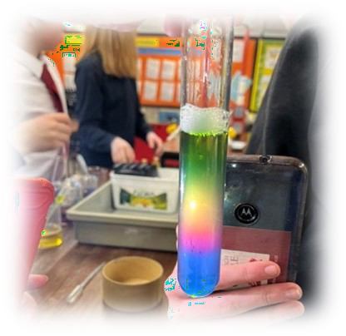It’s been a busy start of term for our S1 STEMers. They’ve met the challenge of creating their own Cartesian diver and experimented with density. Mrs Minto reports that these budding scientists have shown great tenacity and problem*-* solving skills. Well done!

### Ms Catriona Cameron, Teacher of Support for Learning

Hi I’m Ms. Cameron, and I’m working in the Sup- port for Learning de-

partment. I'm really ex- cited to be working at

Peebles High School and looking forward to get- ting to know everyone!