



# PEEBLES HIGH SCHOOL

C A M P B E L L W I L S O N , H E A D T E A C H E R

### 

Dear Parent Carer

Welcome to the penultimate Newsletter before the Summer holidays and the last News of session 2022/23 from Peebles High School. As well as all of the normal news to report on this edition, we have important updates on School Policy to share:

**Peebles High School Positive Behaviour Policy**

The Scottish Borders Council review of our school in October 2022 highlighted that a significant number of young people were not feeling safe at all times in our school. While there were several factors influencing this unwelcome change in our school, our approach to behaviour was highlighted as a key area for improvement. This work was rightly prioritised and several changes were implemented in February of this year. Since February we have all been working to the principle and agreement that **“All staff, parents and young people will work together to make everyone feel safe at Peebles High School”**.This focus earlier in the session has led to definite improvements and more frequent use of temporary exclusion to re-establish the highest expectations for all. None of us want to exclude young people from our school but we have committed to a relentless focus on everyone feeling safe and this unwanted side-effect has been necessary. From the start of the new timetable on Monday 5th June, we will be implementing our new policy in full and it is important that you are aware of some procedural changes: In order to ensure we are always aiming to give first attention to best conduct, we are re-introducing praise text messages to give teachers a meaningful and simple method to praise the vast majority of young people who are meeting our expectations every day. There are seven categories of praise texts: 3 to align with the three behaviours (be Polite; be Prepared; be Productive) and 4 to align with our school values (Compassion, Wisdom Integrity and Justice). We know that in giving our first attention to best conduct our young people will feel more valued for the very high standards of behaviour that the vast majority display every day. Text messages will normally be sent out the day after being issued by teachers. We are also introducing more consistent staff actions around tackling inappropriate use of mobile phones in class and supporting our behaviour approaches with helpful posters and clearer expectations of rights and responsibilities. We will continue to exercise a lower tolerance of unsafe behaviour and are confident that recent improvements in school behaviour will continue and *all* of our young people will feel safe at all times in school. Any parents that would like to hear more about this initiative are welcome to come to our school on Wednesday 28th June at 6:30pm.

**School Uniform:**

This session, the Parent Council led a review of our school uniform. In April, a group of parents, pupils and staff presented their recommendations for changes to our policy for adopting in August 2023 to the school. The new uniform policy has been agreed following the recommendations of the group and, once we have finalised clear images to support the policy, we will communicate this new policy to you. Key to the brief given to the group was that it should be affordable and not make any current uniform redundant. The group delivered on both these points. The changes allow for a little more flexibility and choice but it is not radically different from our current policy. The new policy will be detailed fully in a separate communication in June and will be implemented in August. Please help us to ensure that we start the new session on Monday the 5th of June with everyone wearing full school uniform.

Campbell Wilson

**Parent/Carer Newsletter 8 - June 2023**



S p r i n g w o o d R o a d , P e e b l e s , E H 4 5 9 H B 0 1 7 2 1 7 2 0 2 9 1

E m a i l : P e e b l e s H S @ s c o t b o r d e r s . g o v . u k

W e b s i t e : h t t p s : / / b l o g s . g l o w s c o t l a n d . o r g . u k / s b / p e e b l e s h i g h s c h o o l

T w i t t e r : @ p e e b l e s h i g h





# PEEBLES HIGH SCHOOL

C A M P B E L L W I L S O N , H E A D T E A C H E R

### 



S p r i n g w o o d R o a d , P e e b l e s , E H 4 5 9 H B 0 1 7 2 1 7 2 0 2 9 1

E m a i l : P e e b l e s H S @ s c o t b o r d e r s . g o v . u k

W e b s i t e : h t t p s : / / b l o g s . g l o w s c o t l a n d . o r g . u k / s b / p e e b l e s h i g h s c h o o l

T w i t t e r : @ p e e b l e s h i g h

**School Uniform:**

This session, the Parent Council led a review of our school uniform. In April, a group of parents, pupils and staff presented their recommendations for changes to our policy for adopting in August 2023 to the school. The new uniform policy has been agreed following the recommendations of the group and, once we have finalised clear images to support the policy, we will communicate this new policy to you. Key to the brief given to the group was that it should be affordable and not make any current uniform redundant. The group delivered on both these points. The changes allow for a little more flexibility and choice but it is not radically different from our current policy. The new policy will be detailed fully in a separate communication in June and will be implemented in August. Please help us to ensure that we start the new session on Monday the 5th of June with everyone wearing full school uniform.

Campbell Wilson

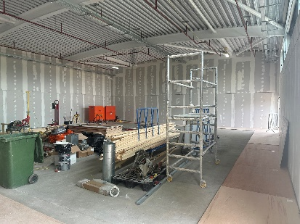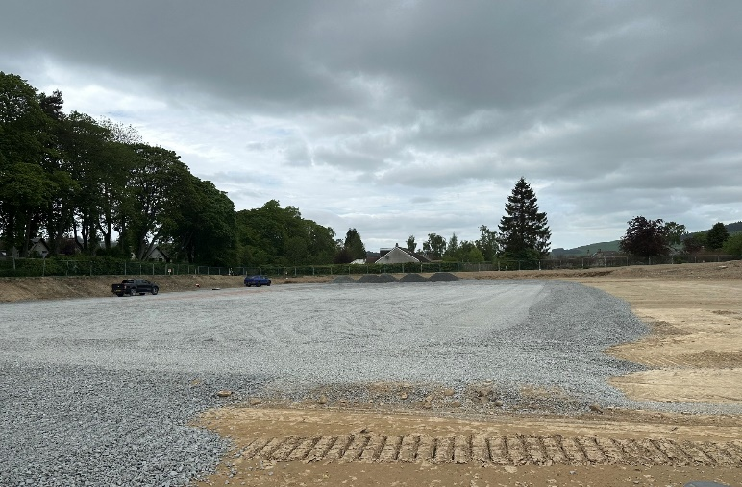

**Key Dates**

**2nd June S1 Residential returns**

**5th June Start of new timetables,**

**Extended House time for online Head Teacher assembly**

**6th June In person assemblies**

**Active month and Water safety**

**Parent council AGM 19.00 online**

**8th June School Sports Day**

**9th June S6 Induction day**

**29th June Last day of term**

Peebles HS new Physical Education facilities are nearing completion. The new all weather pitch has had its base hardcore put in place and the new gymnasium and changing rooms are taking shape ready for the new session in August.





# PEEBLES HIGH SCHOOL

C A M P B E L L W I L S O N , H E A D T E A C H E R

### C:\Users\jlee\AppData\Local\Microsoft\Windows\INetCache\Content.Outlook\GYF8VGB8\IMG_1643.jpg

S1 and S2 rugby squads achieved a remarkable double last month as both teams returned victorious from the Annual South Schools rugby Sevens tournaments.



S p r i n g w o o d R o a d , P e e b l e s , E H 4 5 9 H B 0 1 7 2 1 7 2 0 2 9 1

E m a i l : P e e b l e s H S @ s c o t b o r d e r s . g o v . u k

W e b s i t e : h t t p s : / / b l o g s . g l o w s c o t l a n d . o r g . u k / s b / p e e b l e s h i g h s c h o o l

T w i t t e r : @ p e e b l e s h i g h

**House Locations and Arrangements for Timetable Distribution**

-          Cademuir – LRC

-          Dunrig – Assembly Hall

-          Meldon – Assembly Hall

**Current S1/New S2 Distribution**

* We aim to distribute timetables for S1s via Showbie. In addition, S1 timetables will be distributed in House Time classes from Monday next week.

**Current S2 & S3/New S3 & S4 Distribution**

* These will be distributed via House Time classes from Friday morning

**Current S4 & S5/New S5 & S6 Distribution**

* These will be distributed on Friday during the following slots in three zones (Cademuir – LRC; Dunrig – Assembly Hall; Meldon – Assembly Hall)
  + - Friday 8:30 – end of House Time once pupils have registered
    - Friday breaktime
    - Friday 13:20 – 13:30

Following this, timetables will be available in House Time on Monday.





# PEEBLES HIGH SCHOOL

C A M P B E L L W I L S O N , H E A D T E A C H E R

### Image

**Social Subject Battlefields**

A week of tunnels, trenches, cemeteries, spectacular memorials and reflection with an absolutely fantastic group of young people.



S p r i n g w o o d R o a d , P e e b l e s , E H 4 5 9 H B 0 1 7 2 1 7 2 0 2 9 1

E m a i l : P e e b l e s H S @ s c o t b o r d e r s . g o v . u k

W e b s i t e : h t t p s : / / b l o g s . g l o w s c o t l a n d . o r g . u k / s b / p e e b l e s h i g h s c h o o l

T w i t t e r : @ p e e b l e s h i g h

S3 WORK PLACEMENT PROGRAMME

May saw the welcome return of the S3 Work Placement Programme after a gap of 4 years. 138 students took part in a week long placement with 72 different employers from a wide range of industry sectors; Hospitality & Events, Engineering, Agriculture, Construction, Education, Retail, Finance, Design, Sport & Leisure and Digital. Most stayed locally but a few adventurous headed further afield to Annan, Scone, Inverness and even Wales. A huge thank you to all our hosts, particularly those who hosted several students over the month. As well as developing key skills for learning, life and work and raising awareness of real life working environment, students who have successfully completed their placement will also gain their SQA Work Placement Award. It has been lovely hearing from them all how they got on. A snippet of their reflections:







# PEEBLES HIGH SCHOOL

C A M P B E L L W I L S O N , H E A D T E A C H E R

### C:\Users\jlee\AppData\Local\Microsoft\Windows\INetCache\Content.Outlook\GYF8VGB8\IMG_3023.jpg

S1, 2 and 3 rugby squads had the pleasure of hosting our twin French town of Hendaye near Biarritz this month.



S p r i n g w o o d R o a d , P e e b l e s , E H 4 5 9 H B 0 1 7 2 1 7 2 0 2 9 1

E m a i l : P e e b l e s H S @ s c o t b o r d e r s . g o v . u k

W e b s i t e : h t t p s : / / b l o g s . g l o w s c o t l a n d . o r g . u k / s b / p e e b l e s h i g h s c h o o l

T w i t t e r : @ p e e b l e s h i g h

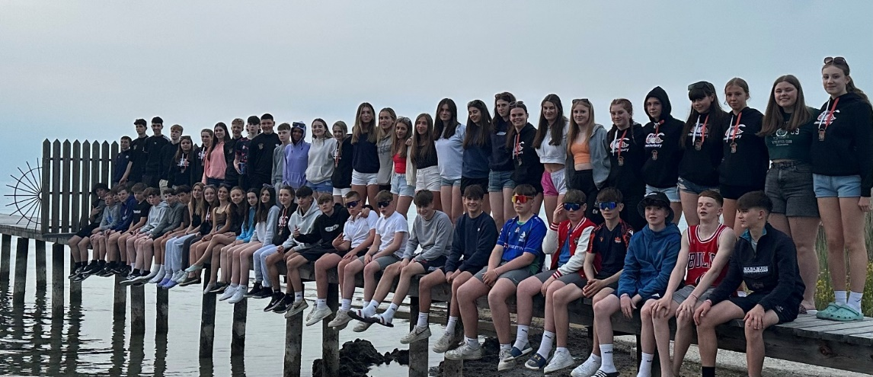

Peebles HS S3 rugby and hockey squads have just returned from a very enjoyable tour to the North of Italy. As well as matches versus Valpollicella RFC, Asti RFC and Riva Hockey the squads enjoyed cultural trips to beautiful Verona and spent a fun day at Gardaland Theme Park. There was a fair amount of beach volleyball played too and lots of power walks on the shores of Lake Garda. The players returned with some fabulous team building experiences and exposure to some much appreciated Italian sun!





# PEEBLES HIGH SCHOOL

C A M P B E L L W I L S O N , H E A D T E A C H E R

### 

**Young STEM Leader Programme**

Congratulations to S6 student Ashley Smith for achieving a Young STEM Leader Level 6 Award. Ashley committed fully to the Leadership and STEM awareness training from Dr Harkness and then went on to support S1 Science classes. With this award Ashley can register with the Scottish STEM Ambassador network to further develop her leadership and continue to spread her enthusiasm for STEM beyond PHS.

**LEADERSHIP LEVEL 6 AWARDS - TWEED READS**

Well done to Freya Compton, Kirsten Duncan, Iona Kerr and Chloe Smith who successfully completed their Level 6 Leadership Award, using their work with Tweed Reads this session as their focus. They did a tonne of work, particularly in those first tough couple of terms and their reflective reports show an insightful understanding of leadership, their own actions and motivations. The award is well-earned. Bravo, girls!



S p r i n g w o o d R o a d , P e e b l e s , E H 4 5 9 H B 0 1 7 2 1 7 2 0 2 9 1

E m a i l : P e e b l e s H S @ s c o t b o r d e r s . g o v . u k

W e b s i t e : h t t p s : / / b l o g s . g l o w s c o t l a n d . o r g . u k / s b / p e e b l e s h i g h s c h o o l

T w i t t e r : @ p e e b l e s h i g h

During the month of May, our wellbeing focus was on the wellbeing indicator ‘Included’.  In our monthly assembly, young people learned how being included links to wellbeing, how to include others and how to develop the confidence to get included.  They also learned about the detrimental effect excluding others can have on their wellbeing and how this is a form of bullying.  We highlighted the fact that everyone is different and that doesn’t make anyone unworthy of friendship, we should always treat others with kindness and respect.

Young people told us that they want to be told about bullying incidents in school and actions taken to address these.  Mrs Moretta shares this information during assemblies.

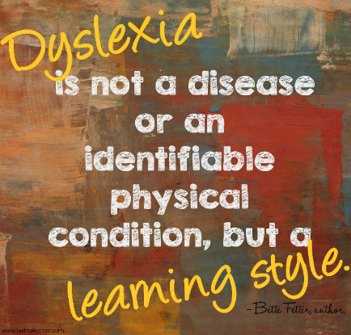

Dyslexia Support Group

Mrs Ramage (Principal Teacher of Support for Learning) and Mrs Moretta (DHT Pupil Support) are working with parents to raise the awareness and improve the learning experience of young people who have dyslexia.  This will be one of the priorities in the school improvement plan for next session.