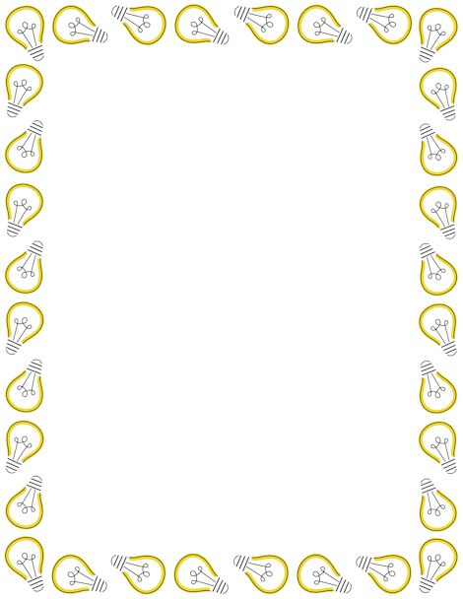

The Inventors Café

**Choose one starter, one main course and one dessert from the selection below.** If you want to try a different dish, ask your waitress (Mrs Smith, Mrs Stevenson or Mrs Wallace)

**Menu**

**Starters**

* I can design a new invention which would help me in some way at school. I will draw my invention and label the main parts.
* Make a collage (using magazines, catalogues, etc) of different things which use electricity and sort them into mains powered and battery powered.
* I can paint a portrait of one of the inventors we are finding out about at school (Alexander Graham Bell, John Logie Baird, Thomas Edison and Tim Berners Lee)
* I can make a model of a telephone (from the past or present) using recycled materials.

**Main courses**

* I can write an imaginary diary entry based on a new invention that I have created (minimum 15 lines)
* I can choose an inventor (past or present) and find out 10 facts about this inventor. I can display this in a poster/ powerpoint.
* I can create a play script between Alexander Graham Bell and his friend after he has just invented the telephone.
* I can use question words to write a list of 10 questions that I would like to ask an inventor. I will choose an inventor and find out answers to these questions.

**Desserts**

* Make a timeline of important inventors in chronological order.
* Label a World map (your teacher can provide you with this if needed) with inventors’ names and their inventions in the country where they were created.
* Count how many electrical items are in each room of your house and display this information in a table or a graph.

**All ‘dishes’ must be completed on/before Thursday 6th December 2018**

Children will share their homework with the rest of the diners the following week.