P7 Home Learning 1.03.21-12.3.21
Hello Primary 7
Here are the Home Learning tasks for the week beginning 1st March and the week beginning the 8th March. Please remember all the documents you might need can also be found in the Files section of your class Team. If you are having difficulty accessing something please email your teacher and we will be happy to help you.
Mrs Little and Mrs Brown

Enter copy of Timetable here

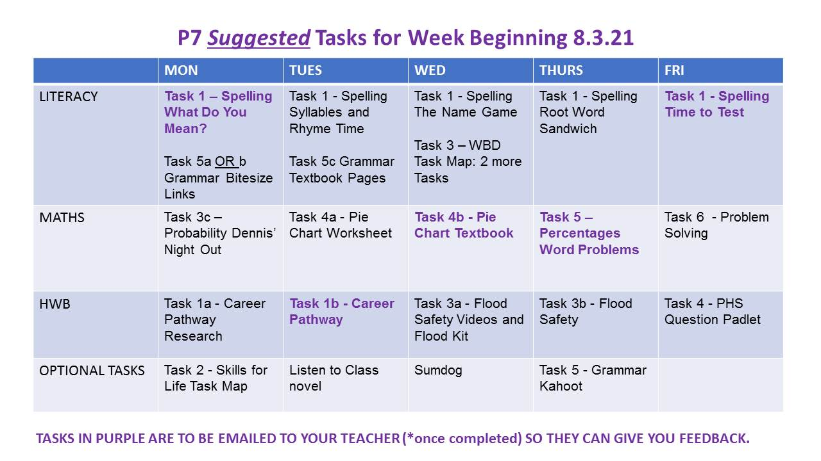
Please note: There is a lot of important teaching in the Videos which are in the Online version of this Sway. Please email your teacher if you cannot access these.

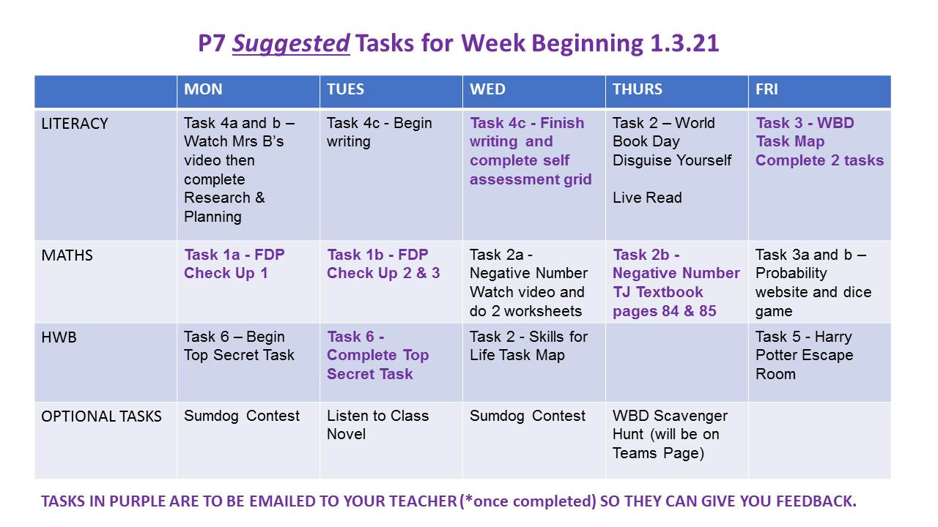

Literacy

Task One: Spelling **Mon & Fri tasks to be submitted to teacher**
Spellavator Wars!
You've now all had a go at this format and it will stay the same for this next set of home learning tasks.
Remember, we won't be competing against each other like in class, instead Brown Bear will have a go and you can try and beat his score each day. You can also record your score and try to beat it the next time we do the game.
There is a Spellavator task for each day of the week, Mon-Friday. Although this Sway last for longer than one week, we are only giving you one week's worth of Spellavator and have spread it over the whole time in our suggested timetable. Please try not to complete them all in one day as the purpose of the spelling is to practise the words little and often.
Follow the instructions on the video for that day to help you. We still expect you to lay your work out neatly and have left the example picture for you to see.
You will be asked to check your answers with a dictionary and you can find one online. No cheating and checking the dictionary beforehand!
The sound this week is phoneme/grapheme f, ff, gh and ph. You will find the words below.
This week’s words are:
thief froth fluffy difficult tough trough
amphibian pharmacy emphasis
Monday | What do you mean?  Write the spelling words in your jotter. Put each of the spelling words in a sentence to show you know what it means.  Try to include a variety of interesting adjectives, verbs and conjunctions.  You score one point if you can use the word correctly. Check the definitions on an online dictionary website to make sure you have used them correctly. Keep a note of your score.  Please submit your sentences to your teacher by email.
Tuesday | Syllables  Write the spelling words in your jotter.  Write beside each word the amount of syllables.  You do not need to submit this to your teacher. It is just to help you chunk the word and make it easier to spell.  Rhyme Time  Get a one minute timer on your iPad. For each spelling word, give yourself one minute to find as many rhyming words as you can. If you think any of the root words rhyme you can group them together.  You do not need to send this to your teacher. Give yourself one point for each word you find. Record your score and add it to yesterday’s score.

Wednesday | The Name Game  Write each word in your jotter. Beside each word name the type of word it is. It could be - noun, adjective, proper noun, pronoun, verb, adverb, conjunction, preposition, determiner…  Check your answers with a dictionary when you are finished. Give yourself one point for each correct answer. You do not need to send this to your teacher.
Thursday | Root Word Sandwich  Get your one minute timer back on your iPad. Give yourself one minute for each word. Grow it as many times as you can in that one minute.  Think about what prefixes and suffixes you can use on either side of the root word.  You do not need to send this to your teacher. Give yourself one point for every correct word. You might need to check your answers in a dictionary. Record your score.
Friday | Time to Test  Without looking at your work from the rest of the week, spell each root word and write one growth word you can for each root word (try to choose the most impressive one you can spell correctly). I will now read the root words for you. You can pause the video to give you time to write each word.  You score one point for a correct root word and one point for a correct growth word.  Email your teacher with your Friday test results. Add up your overall score and compare it with Brown Bear’s. Did you beat him?

Task Two: World Book Day Disguise
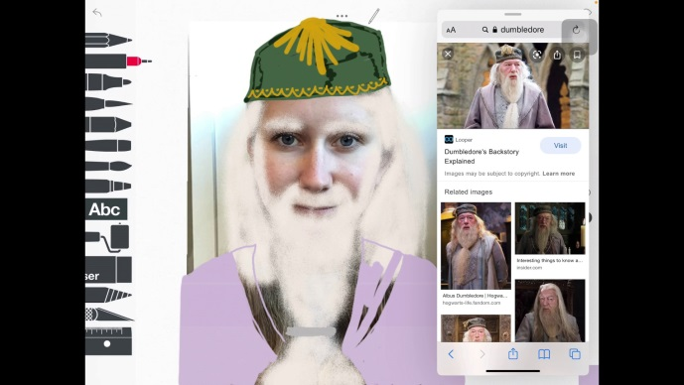
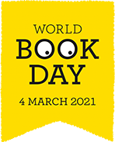
It is World Book Day on Thursday 4th March. We thought it would be fun to set you a special World Book Day task. Your task is to choose a character from a book you have read and disguise yourself as this character. You might want to dress up as the character (if you have the resources at home) or you might want to use the Sketches School app to draw a disguise over a photo of you. There is an example of how you can do this in Sketches School in the video.
Please send your teacher a photo of you disguised as your character and we will share them on the Teams page or in a Kahoot so other people can guess who is behind the character disguise.

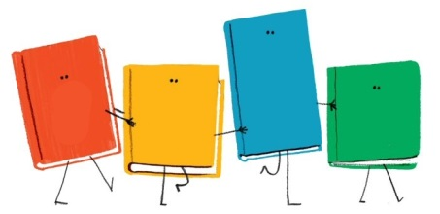
Task Three: World Book Day Task Map **Some tasks be submitted to teacher**
As it is World Book Day this week we have some related Reading activities for you and this time they are based on Non-Fiction texts.
Read BOTH texts and then choose which activities to complete from the task map.
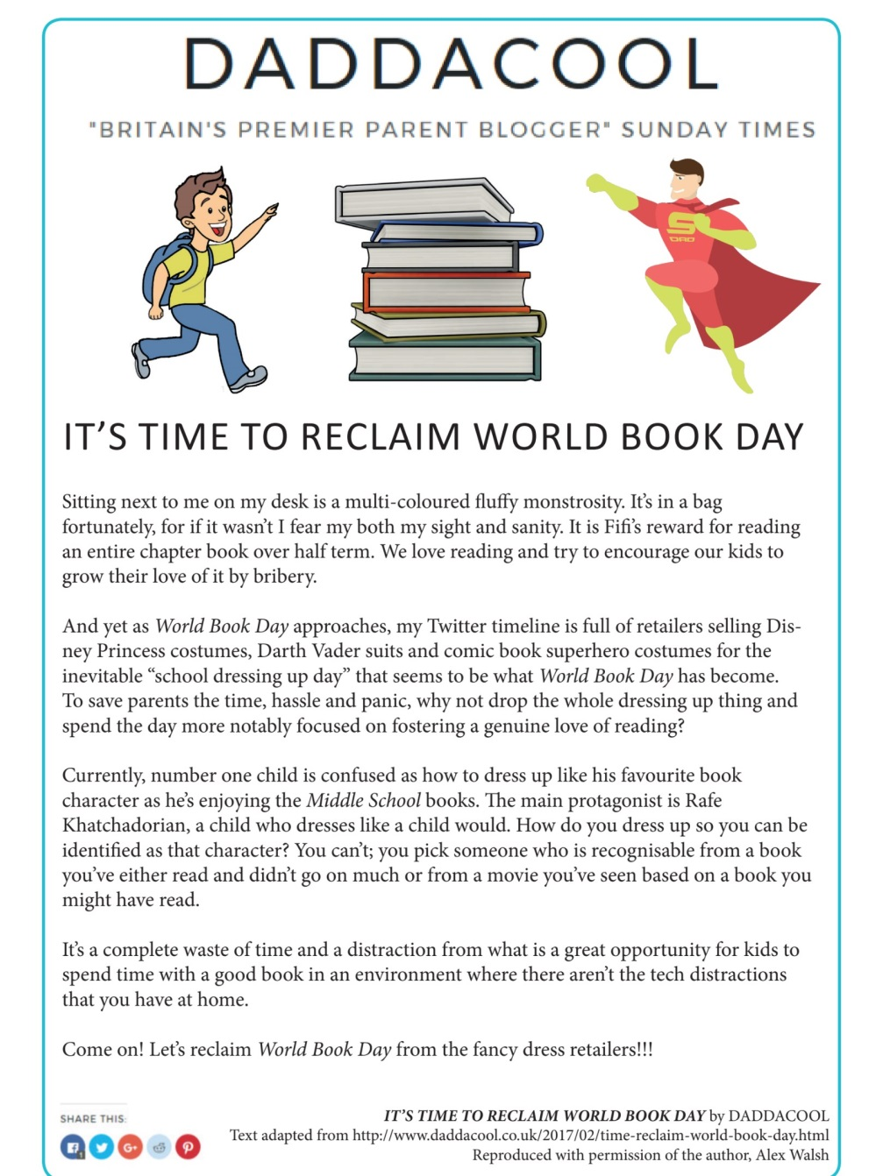
**Please complete at least 2 tasks from the task map and send them to your teacher for feedback**
All three documents are pictured below but they are also available to download from the Files section of your class Team.

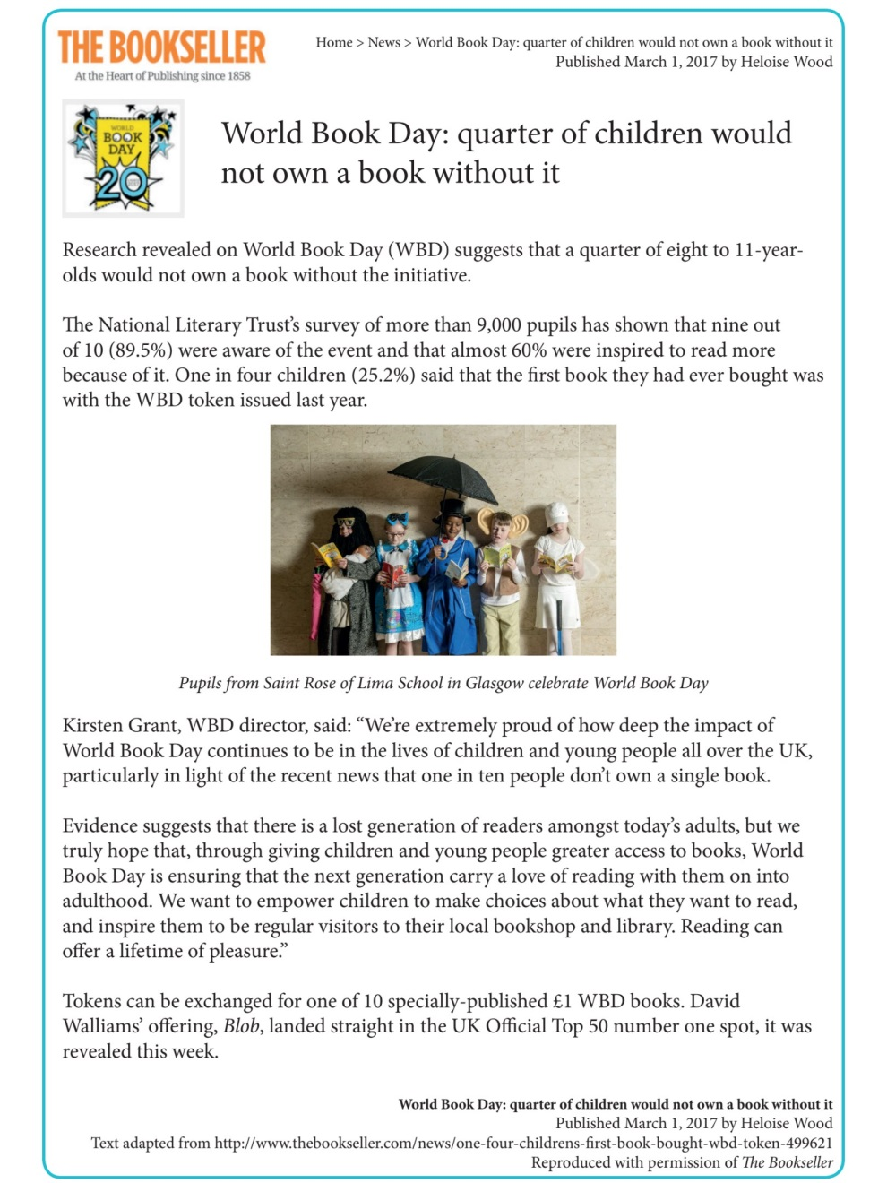
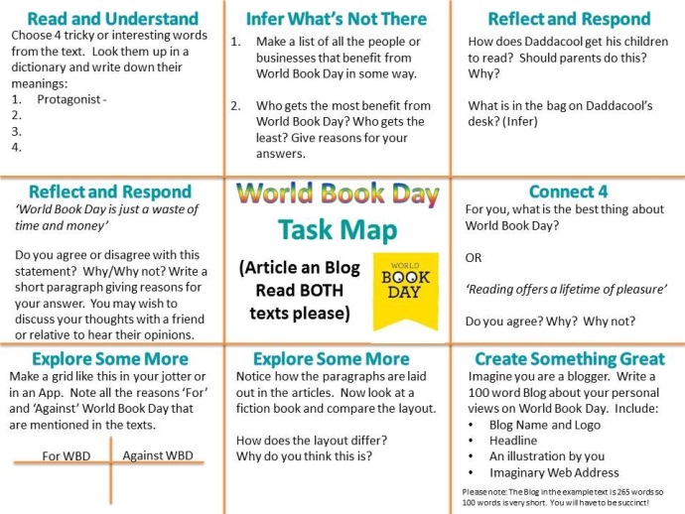

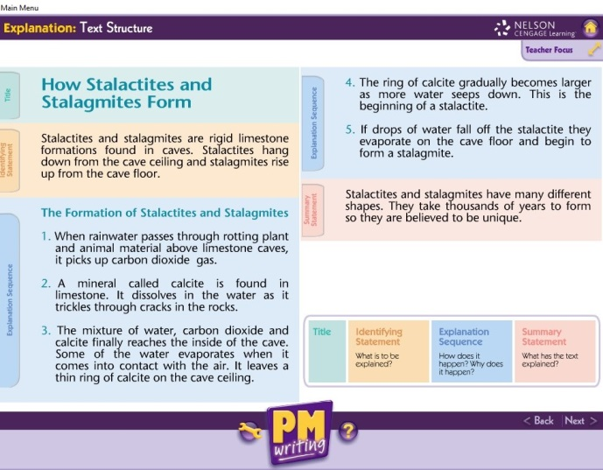
Task Four: Explanation Writing **Some tasks to be submitted to teacher**
In the last Sway we had a go at writing our own Explanation Text. We had to think about the structure (Title, Identifying Statement, Explanation Sequence and Summary Statement) and also the different language features of an Explanation text.
Here is the sample explanation text as a reminder of what an Explanation Text looks like.
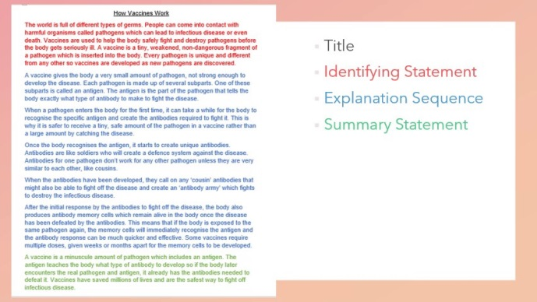
Your topic for your next piece of explanation writing is going to be vaccinations. You are going to write an explanation text all about how vaccines work. Please watch the How Vaccines Work Video which talks you through how this might look.
Task 4a - Research for your own Explanation Text
- Research the topic to find out more about how vaccinations work.
- Take notes under suitable headings (Remember: we did this last Block for our Information Reports).
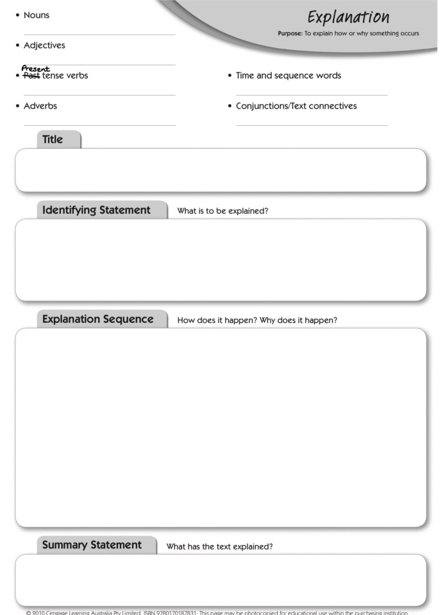
Task 4b - Planning your Explanation Text
Use the Planning sheet to plan your writing. Remember just to make notes at this stage - not full sentences.
The planning sheet can be found in the Files section of your Class Team. Remember Mrs Little did an example in the last Sway and that is there for you to look at.
Task 4c - Writing your Explanation Text
- Use your Planning Page to Write your text.
- Remember to follow the structure, write in the present tense and include appropriate punctuation and vocabulary.
- Choose one of the Self-Assessment Grids below to evaluate your work before you submit it (also available in Files).
**Please submit your finished piece of Writing and Self-Assessment grid to your teacher for Feedback**
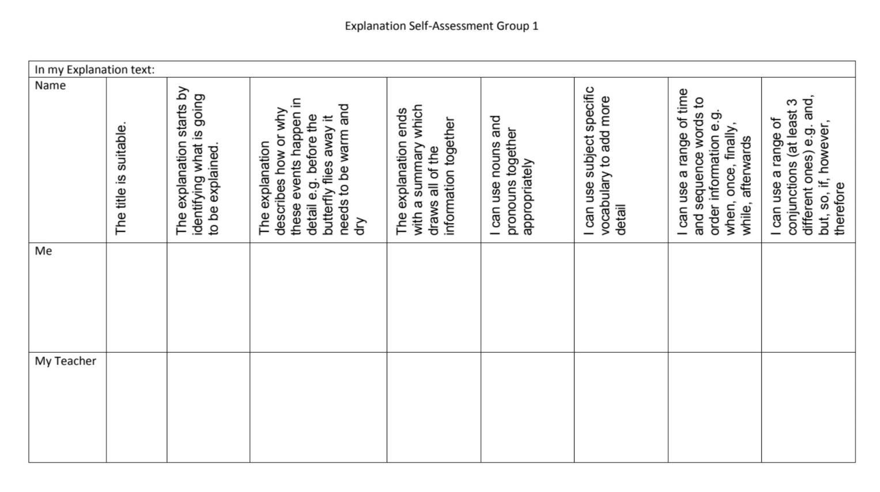
Please email your teacher if your need Group 2 or 3 criteria grid

Task Five : Grammar **To submit to teacher please**Direct Speech
In the last Sway you were asked to use Speech marks in some of the Grammar work. It became apparent that many of you have either forgotten, or are unsure, how to write Direct Speech. This is going to change!
Use the links in the Sway to learn about or refresh your memory about the rules for Direct Speech.
Choose EITHER:
Task 5a) Revision Direct and Indirect Speech Watch the two Videos in this link, read the text below them and then have a go at the 3 Activities on the BBC Webpage.
OR
Task 5b) Extension Direct Speech - Introducing Reporting Clauses Watch the video in this link, read the text below it and then take the quiz.
**The next part to be submitted to your teacher for Feedback please**
Task 5c) Complete the two Textbook pages pictured below. Please complete them as you would in your jotter in school and do not write on the textbook pages. You will find a copy of these in the Literacy Section of Files on your Class Team page, General channel.
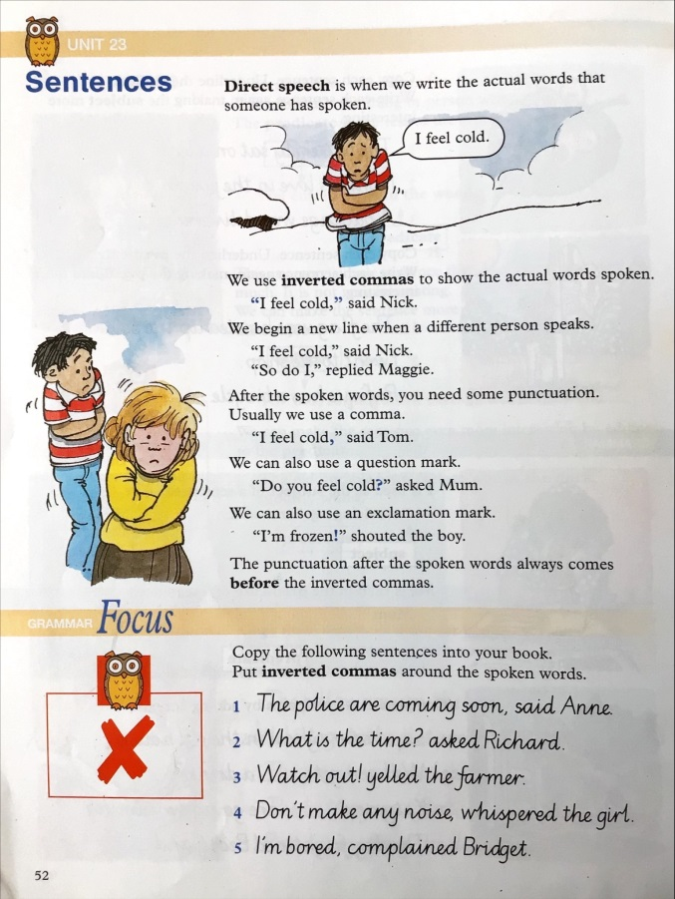
**Please email your completed work to your teacher for feedback**
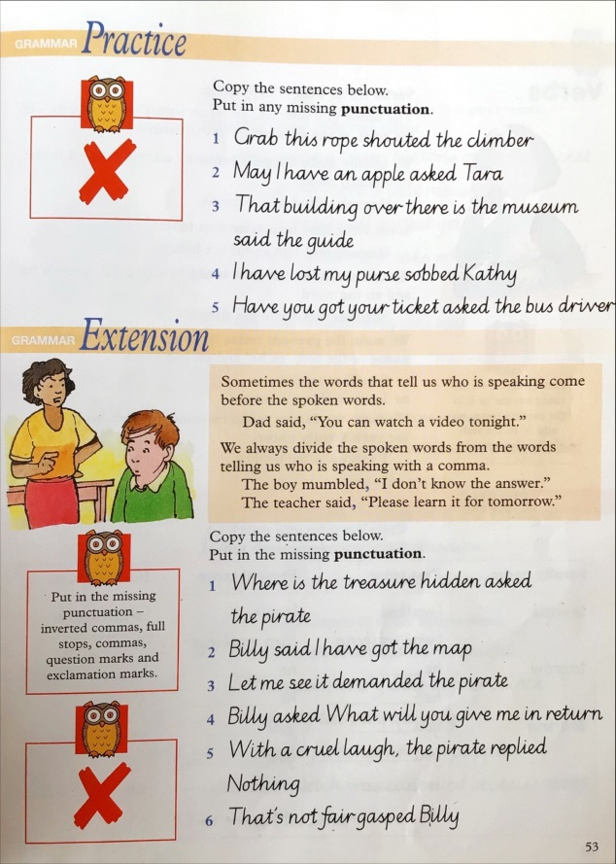
Optional Extension: Think you have the hang of it now? Try this Kahoot! to check you understand which punctuation marks to use and where they go in the dialogue Punctuation Dialogue Kahoot

Numeracy

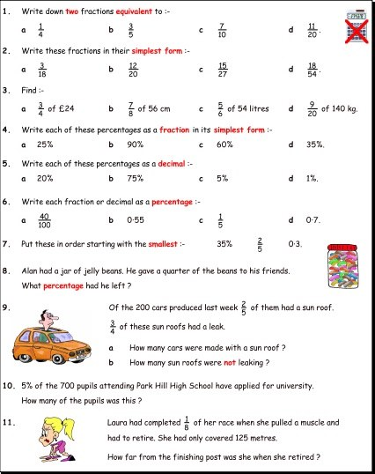
Task One: FDP Check-Up **To be submitted to teacher**

We are coming to the end of our learning on Fractions, Decimals and Percentages (FDP) but as with all number work, FDP pops up across lots of different areas of maths so it is likely that you will be revisiting the learning soon. This task is a check-up to help you and your teacher see how much of the learning you have remembered and what still needs to be revised. As we are trying to see how much you have learnt, we ask that you don't get help from adults/family at home and just miss out questions that you are not sure about. You can ask an adult to read the question out loud to you if that would help you. Take your time, and try your best.

Task 1 Part A - Check up 1 **Please email to your teacher**

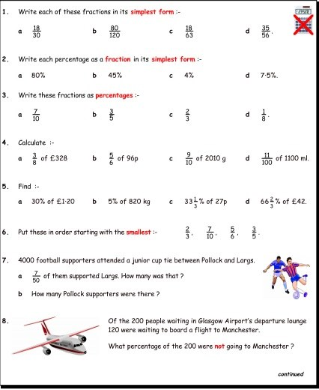
Task 1 Part B - Check Up 2 & 3 **Please email to your teacher**
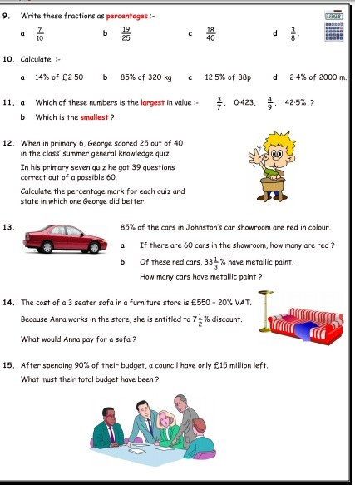

Task Two: Negative Numbers

We are going to continue looking at Negative Numbers.

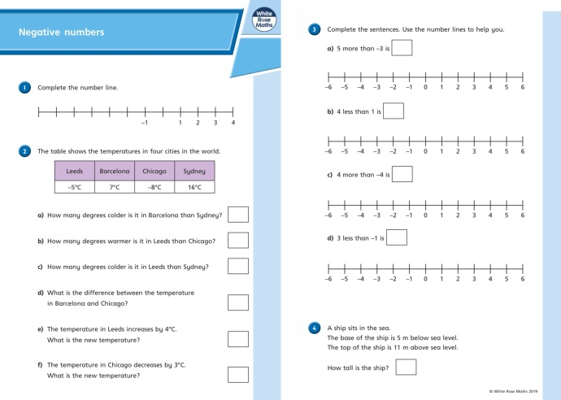
Task 2a) Watch the Negative Numbers teaching video and complete the worksheets. If you can't play the embedded video, ask your teacher to email you a link.
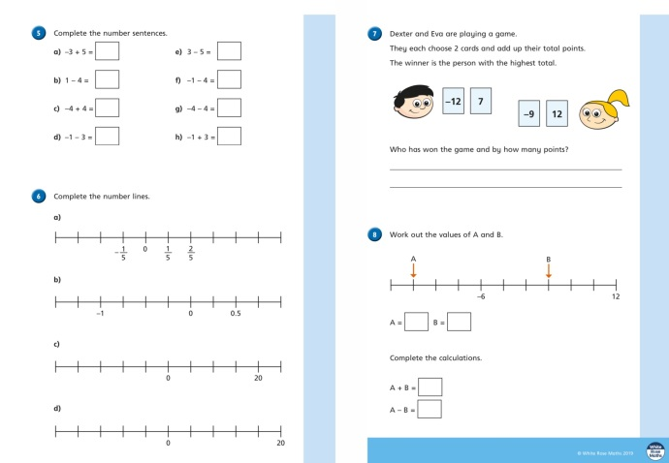

Task 2b) Now we are going to look at adding and subtracting negative numbers. The image of a thermometer really helps you understand going up when adding and down when subtracting as it is a Vertical numberline rather than a horizontal one. However, when adding a negative number you also move down . What happens when you subtract a negative number? Please use the thermometers in the textbook pictures to help you.
Make sure you read all the information in the boxes on the following textbook pages before you attempt the questions.
The TJ pages are also available in the Files section of your class Team.
**Please submit this textbook work to your teacher for feedback**
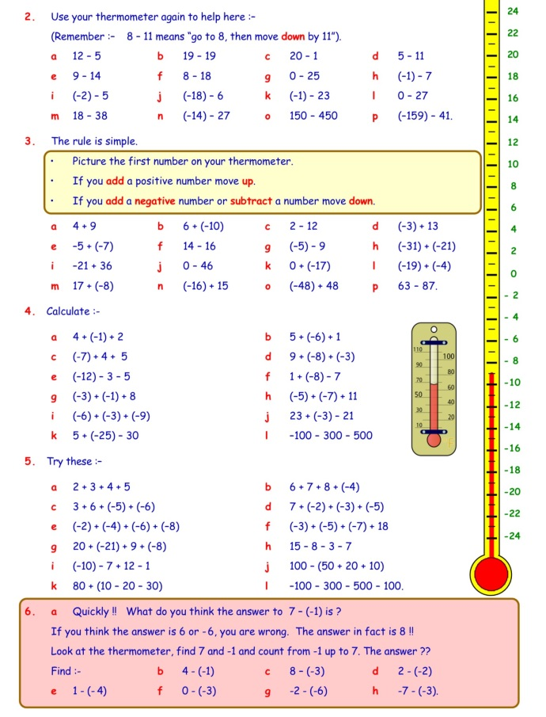
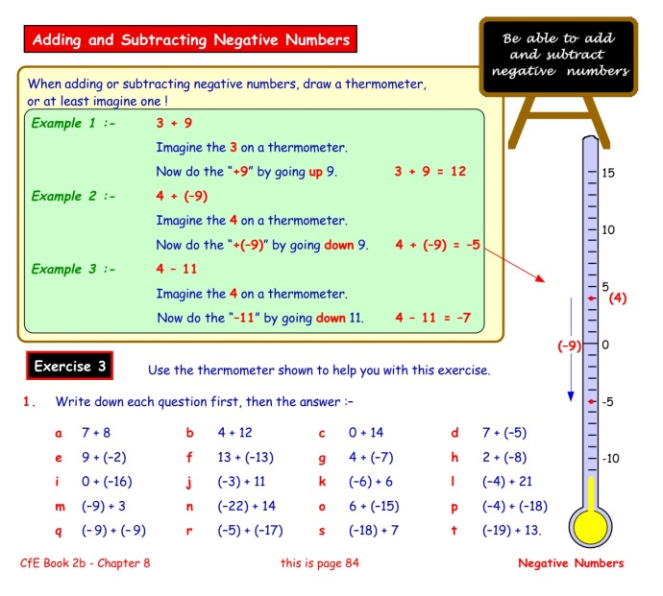

Task Three: Probability
You have learnt about probability before. P7A did some probability before Christmas and P7B have covered it with Mrs Scott in a previous year. There are a lot of different ways that probability can be described or explained. This link will take you to a webpage which will give you a reminder about what probability means and the different terms that can be used to describe probability. Click on the link in the sway for probability webpage or ask your teacher to email you the link.
Part A -
Click the link in the Sway to go to the BBC Bitesize Website and watch the video on probability. Try the tasks and guess the probability. Once you are confident, take the quiz and see how you get on.
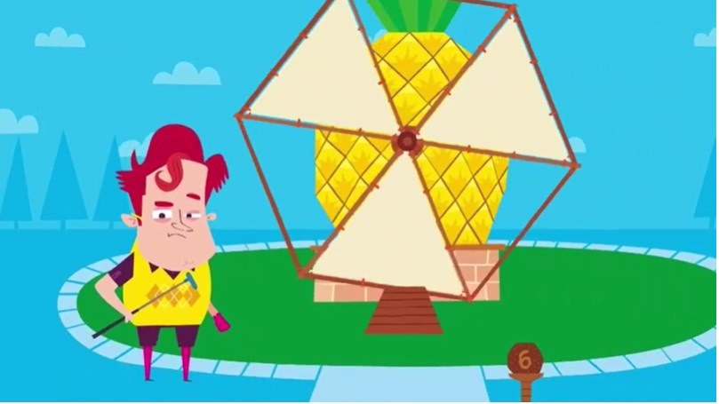
Part B - Putting It To The Test Experiment
You will need 3 dice. You can access interactive dice using the link on the Sway.
Here are four statements -
- If you throw two dice, you are likely to see a six on one of them.
- It is easier to throw a six with three dice than it is with two dice.
- It is easier to get a total of eight or more with two dice than it is to get a total of eleven or more with three dice.
- If you throw one dice, it is more difficult to throw a six than any other number.
- Consider each statement and decide whether you think they are true or false.
- Test each statement 20 times.
- Record your results.
- Do you still agree with your original predictions, why?

Part C - Dennis' Night Out Tree Diagram
Read the information on each image and complete the tree diagrams when asked. Tree diagrams help to find all possible outcomes. In probability all the possible outcomes are called Sample Spaces.
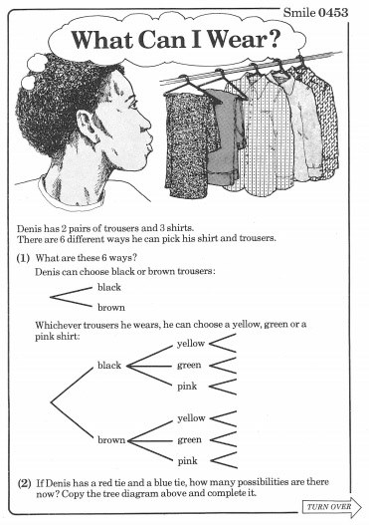
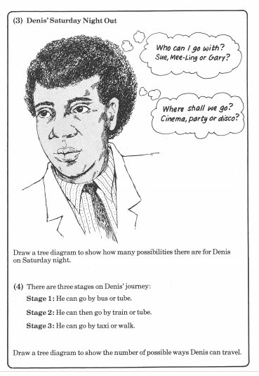

Task Four: Data Analysis **Part B to submit to teacher**
Part A) Interpreting Fraction Pie Charts
Just as we said for task 1, you can never really escape FDP! Your knowledge of fractions and percentages is going to help you with this work.
Watch the Reading & Interpreting Pie Charts video and complete the tasks within it. Then complete the worksheet using what you have learnt in the video. When you have completed this part of the task, email your teacher and we will send you the answer sheet.
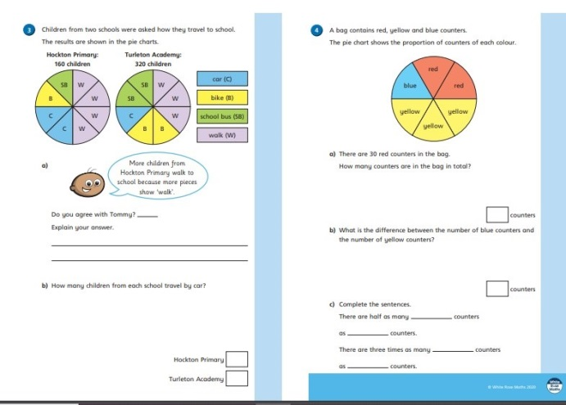
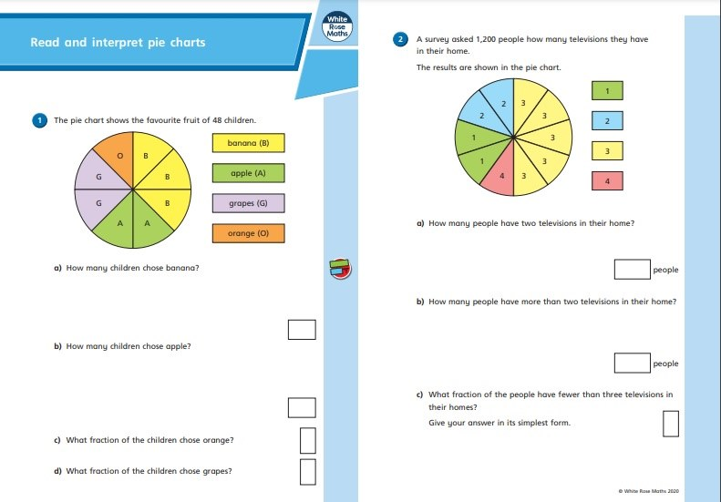

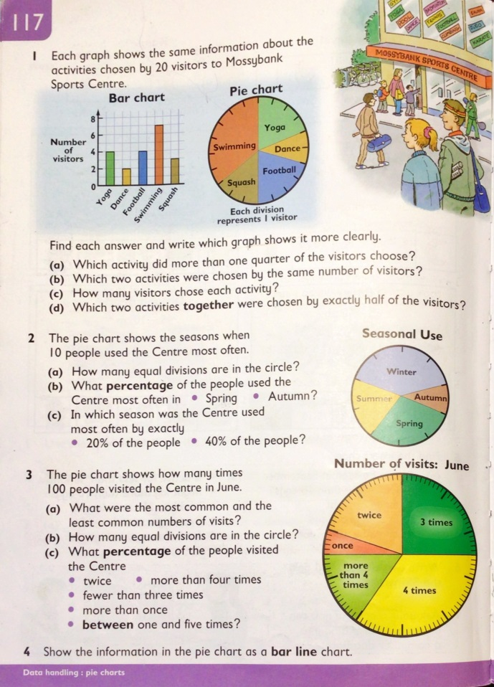
Part B) Interpreting Percentage Pie Charts **To be Submitted to teacher please**
Play Easy as Pie 1 on Education City to see how fractions and percentages can be used on a pie chart.
Complete the textbook page on pie charts. Remember if there are 10 segments of the pie chart and 3 are coloured red, that will equal 30%. If there are 100 segments on the pie chart and 3 are coloured red, that will equal 3%.

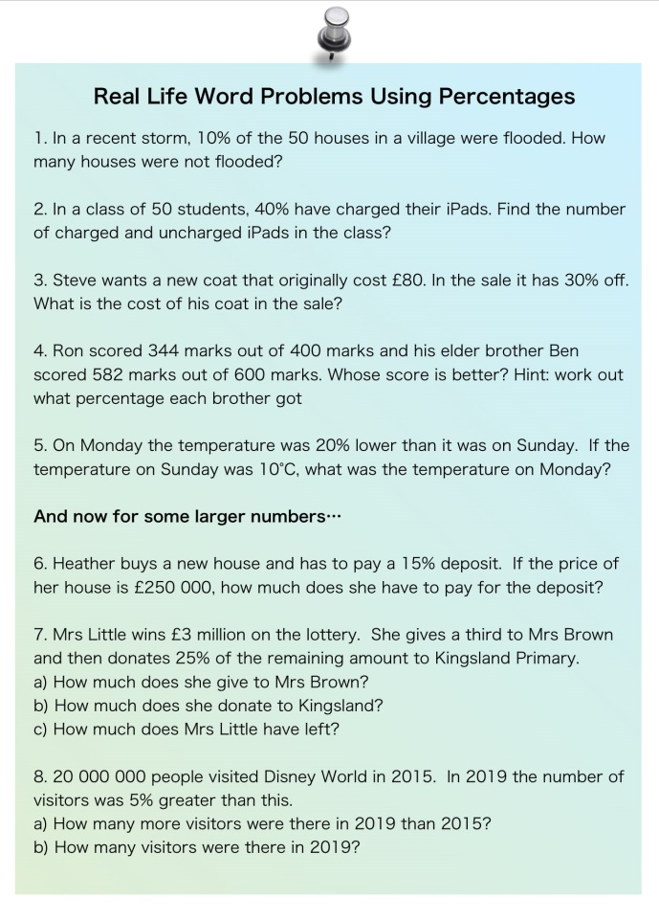
Task Five: Percentages - Word Problems **To hand in please**

Guess what? That’s right...more FDP! This task gives you examples of when you will need to understand percentages in real life. Read the questions carefully and decide what percentage you have to find in each one.

Please do not write on this sheet but set your work out neatly like you would in your jotters. There is a sample page of Squared Paper in Files if you would like to use it. Please show your working and remember £ signs etc.

**Email this task to your teacher for feedback please**
.

Task Six: Problem Solving
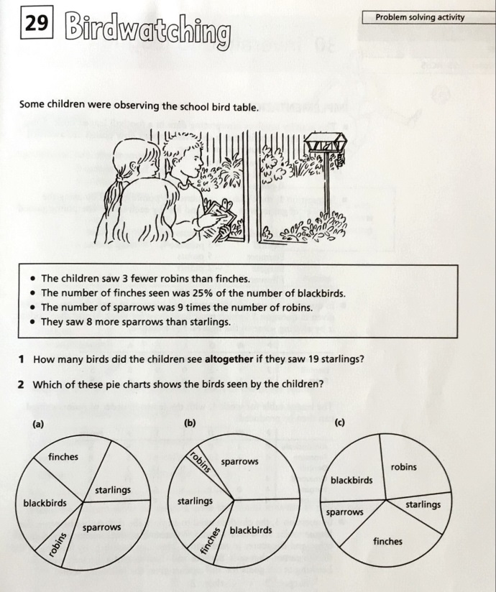
BirdwatchingRead ALL the clues before you attempt to answer the questions. Possible strategies: Reason logically, work systematically, work backwards

Health and Wellbeing

Task One: Career Pathways **Task B to be submitted to teacher**
Part A -
As you will have found out when you interviewed a successful person, it is not an easy road to a goal and it takes a lot of hard work. This task will encourage you to think about the steps you might have to take to reach a career goal.
Choose a career/job you are interested in having when you are older. You might have a few in mind or none at all - just choose a career/job that you would like to know more about at the moment.
Carry out some research to see what kind of skills and knowledge are essential for the job. Here are some questions to help you.
- Does this job require any specific qualifications?
- Does this job require specialist training?
- What personal qualities does this job require?
- Can you go straight into this job or do you need another job first?
- What previous experience is needed for this job?
Remember that all jobs are different and some jobs require more practical experience and qualifications whilst others require you to have more academic experience and studies. This doesn't mean that one job is better than another.
Part B - **To be submitted to Teacher please**
Using the findings from your research you are going to create a career pathway where you highlight the steps you might need to take to get into the career of your choice. It is important to remember that there are usually many different routes into a career and these routes suit different people. Today you are highlighting just one of the possible routes into the career you have chosen.
You can either use the template provided or create your own. You do not have to fill each section as some jobs will have more steps than others.
We have created one as an example. You will see I have added some other options at the side of the career pathway as additional options.

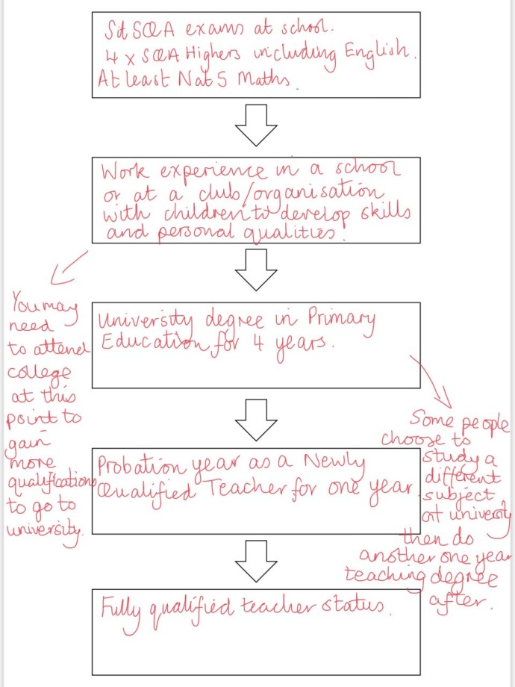
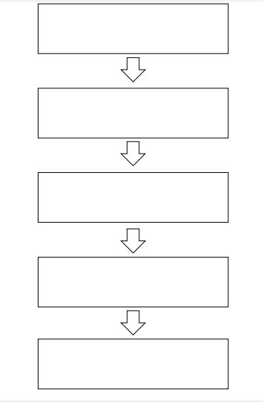

Task Two: Life Skills Task Map
Literacy and Numeracy are important parts of your Education but there are also basic skills in life that everyone needs to learn. Challenge yourself to learn some household skills which will not only benefit you but those around you will be grateful too so you will 'Make a Difference' in your house.
You can use the Skills for Life Task Map link on the Sway to explore the numbers on the Interactive Task map to get some ideas you could try. There are short videos to watch and links to other websites. Please discuss any tasks with the adults at home before you attempt them.
There is also a written Skills for Life Task Map in the files section (pictured here) if you cannot access the interactive one.
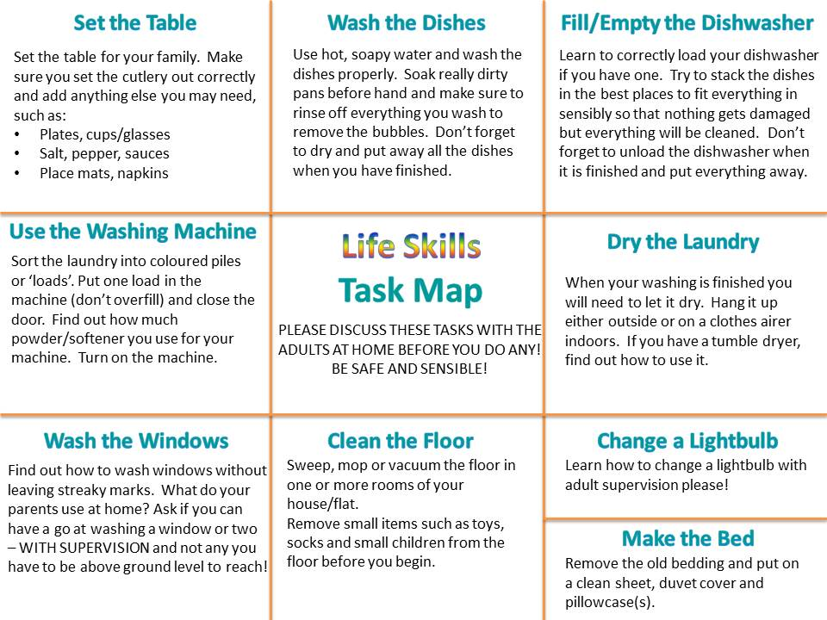

Task Three: Keeping Myself Safe - Flood Safety
Part A) Watch the videos from the SEPA (Scottish Environment Protection Agency) Website.
Once you have watched the three videos. Write a list of what needs to go in an emergency flood kit. Keep the list somewhere safe in your house so it is easy to find should you ever need it.
Part B) This game helps you remember everything you need. You will need to print off the board or screenshot the board and use mark up to draw your counter on the screen. You can use this interactive dice if you don't have a dice at home. It is possible to play yourself but might be more fun as a competition against someone in your house.

Task Four: Transition to PHS
We've been talking about Transition to High School during our recent Keep Connected Sessions and in Individual phone calls with your teachers. You may have questions after the Transition meeting for P7s and their families or after taking the Virtual tour so we have created a special space for you to post questions and find answers.
The question page is on a Padlet and can be accessed on the Sway. We will also share a link to this on our P7 Blog so we can keep coming back to it next term. You can post an anonymous question anytime you think of one and we will enlist the help of our colleagues at the High School to help answer them where necessary.
Please note, just like the Class Blog, the questions you post will be moderated and will not show up straight away.

Task Five: World Book Day - Hogwarts Escape Room
We'd love to take you to a real Escape Room to check out your Problem Solving Skills but, as that is not possible, we thought we'd let you have a go at a digital one! To celebrate World Book Day it is based on the world of Harry Potter but you don't need to have read the books to take part.
Good Luck! Click here to enter the Hogwarts Digital Escape Room!

Task Six: Top Secret Task **To be submitted to Teacher**
We have a Top Secret mission for you this week. For security reasons we cannot post details of the task here! All will be explained by email and in our Keep Connected Sessions.
**When you have completed your Top Secret mission, please email it to your teacher**

