P7 Home Learning 8.02.21-26.2.21
Hello Primary 7
This Sway contains two weeks of tasks as usual. However, because of the February Holiday you will have three weeks to complete the tasks - from Monday 8th February to Friday 26th February. Our suggested timetable below will help you organise your time but remember you can do the tasks in any order. We will go over the suggested tasks each day in our Keeping Connected Sessions.
This presentation has lots of sound/video files and some links to other sites to help make the learning as clear as possible. Please be patient and allow time for each thing to load before clicking on the next.
Mrs Little and Mrs Brown
Suggested Timetable – Monday 8th Feb until Friday 19th Feb
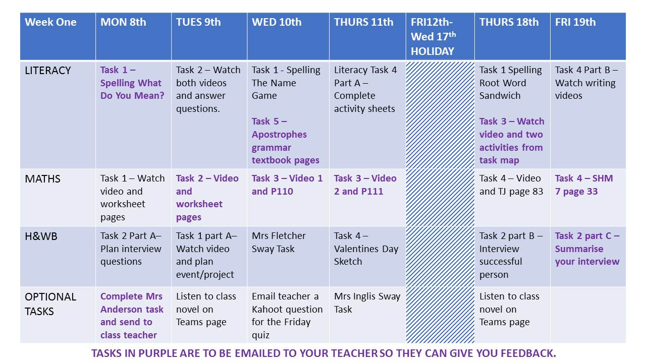
Suggested Timetable – Monday 22nd Feb until Friday 26th Feb
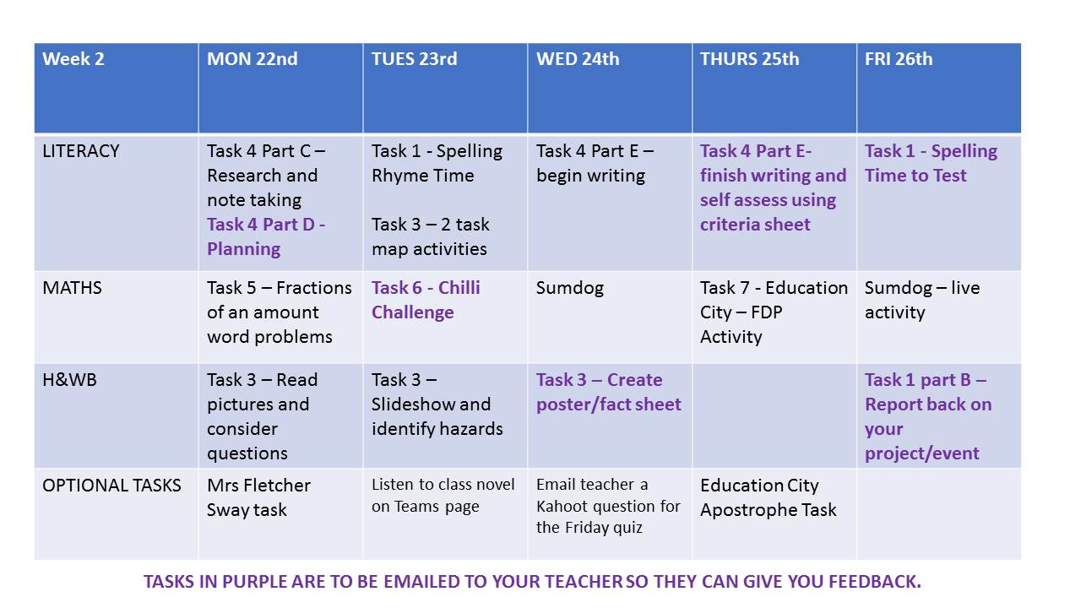
Please note: There is a lot of important teaching in the Videos which are in the Online version of this Sway. Please email your teacher if you cannot access these.

Literacy

Task One: Spelling **Mon & Fri tasks to be submitted to teacher**
Spellavator Wars!
You've now all had a go at this format and it will stay the same for this next set of home learning tasks. Remember, we won't be competing against each other like in class, instead Brown Bear will have a go and you can try and beat his score each day. You can also record your score and try to beat it the next time we do the game.
There is a Spellavator task for each day of the week, Mon-Friday. Although this Sway last for longer than one week, we are only giving you one week's worth of Spellavator and have spread it over the whole time in our suggested timetable. Please try not to complete them all in one day as the purpose of the spelling is to practise the words little and often.
Follow the instructions on the video for that day to help you or see the table below. We still expect you to lay your work out neatly and have left the example picture for you to see.
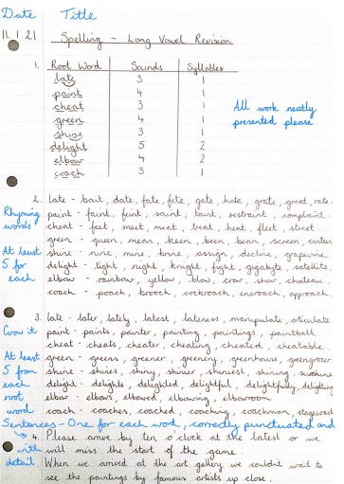
You will be asked to check your answers with a dictionary. You can find one online of you need to. No cheating and checking the dictionary beforehand!
The sound this week is phoneme/grapheme th and wh.
This week’s words are:
path rhythm thirst thorn
mouth thumb thank whistle wheeze
Monday | What do you mean?  Write the spelling words in your jotter. Put each of the spelling words in a sentence to show you know what it means.  Try to include a variety of interesting adjectives, verbs and conjunctions.  You score one point if you can use the word correctly. Check the definitions on an online dictionary website to make sure you have used them correctly. Keep a note of your score.  Please submit your sentences to your teacher by email.
Tuesday | Syllables  Write the spelling words in your jotter.  Write beside each word the amount of syllables.  You do not need to submit this to your teacher. It is just to help you chunk the word and make it easier to spell.  Rhyme Time  Get a one minute timer on your iPad. For each spelling word, give yourself one minute to find as many rhyming words as you can. If you think any of the root words rhyme you can group them together.  You do not need to send this to your teacher. Give yourself one point for each word you find. Record your score and add it to yesterday’s score.

Wednesday | The Name Game  Write each word in your jotter. Beside each word name the type of word it is. It could be - noun, adjective, proper noun, pronoun, verb, adverb, conjunction, preposition, determiner…  Check your answers with a dictionary when you are finished. Give yourself one point for each correct answer. You do not need to send this to your teacher.
Thursday | Root Word Sandwich  Get your one minute timer back on your iPad. Give yourself one minute for each word. Grow it as many times as you can in that one minute.  Think about what prefixes and suffixes you can use on either side of the root word.  You do not need to send this to your teacher. Give yourself one point for every correct word. You might need to check your answers in a dictionary. Record your score.
Friday | Time to Test  Without looking at your work from the rest of the week, spell each root word and write one growth word you can for each root word (try to choose the most impressive one you can spell correctly). I will now read the root words for you. You can pause the video to give you time to write each word.  You score one point for a correct root word and one point for a correct growth word.  Email your teacher with your Friday test results. Add up your overall score and compare it with Brown Bear’s. Did you beat him?

Task Two: Types of Questions - Understanding the Task Map
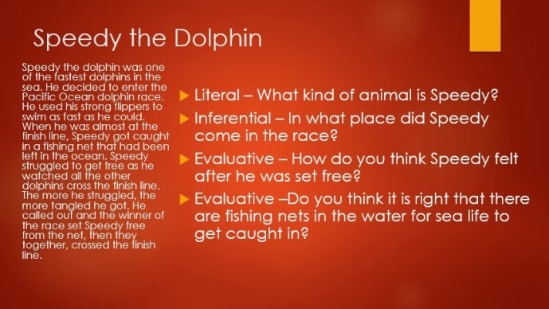
When we read and explore a text we might be asked different types of questions about it. Watch the Types of Questions video to find out about different types of questions. The video is also saved in files on Teams if it is easier to access there.

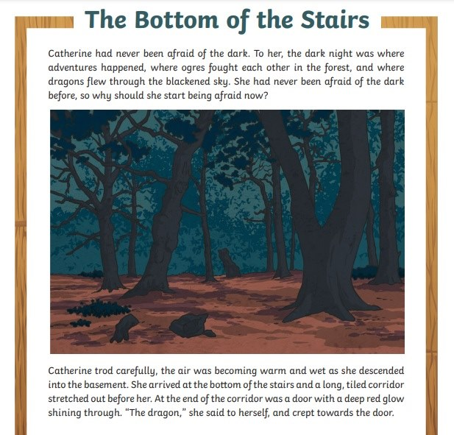
Your task is to read this short text (also available in files on Teams) and answer the following questions. Can you identify what type of question each questions is? Remember here, hidden, head, heart to help you.
1. What does Catherine imagine happens in the dark?
2. Why might Catherine have been too hot in the basement?
3. How would you have felt going down the stairs into the basement?
4. Why would Catherine need to creep towards the open door?
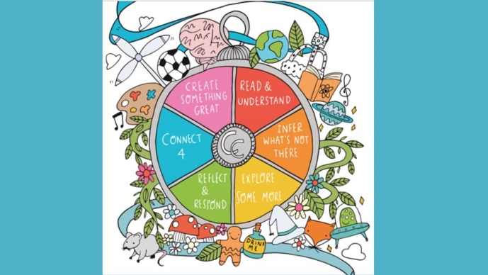
We are going to focus on answering different types of questions using a task map. The task map will focus on a text and the questions/tasks will all be about the text. Some questions/tasks will be literal, some will be inferential, and some will be evaluative. We hope that as you get better at this, you might even create and set task maps for each other. Watch the Task Map Question Types video which explains a little bit more about task maps. This video is also saved in files on Teams in case it is easier to access there.

Task Three: Home Sweet Home Task Map **To submit to teacher**
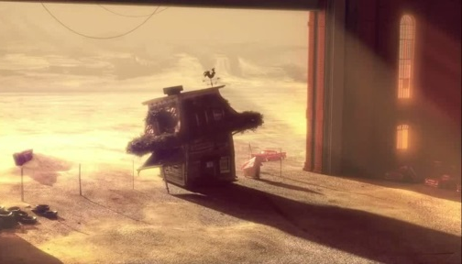
The task map is all about an animation called Home Sweet Home. It is directed by Pierre Clenet, Alejandro Diaz, Romain Mazevet and Stéphane Paccolat.
Home Sweet Home can be accessed by clicking here or by watching the embedded video. Please ask your teacher to email you the link if you have trouble accessing it.
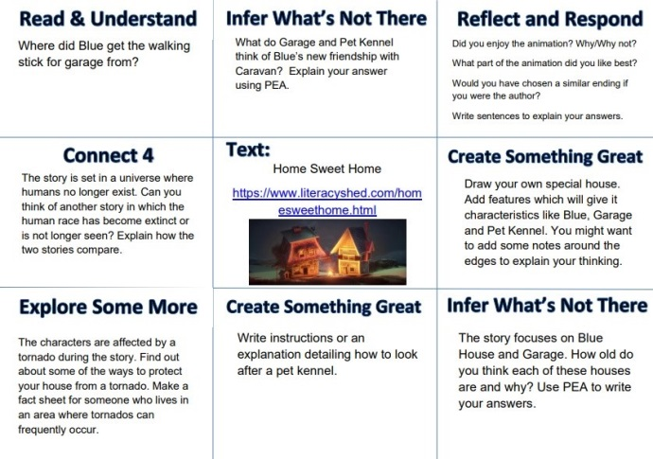
You might want to watch the Home Sweet Home video several times before starting the task map. You do not have to complete all the tasks in the task map so you can choose the tasks that you would like to complete - we will set the amount of tasks in the suggested timetable. Please complete the answers with detail and evidence from the text. Use Point, Evidence, Analysis (PEA) where you think it is appropriate. The task map is also saved in Files on Teams or ask your teacher to email you a copy.

Task Four: Explanation Writing **Some tasks to be submitted to teacher**
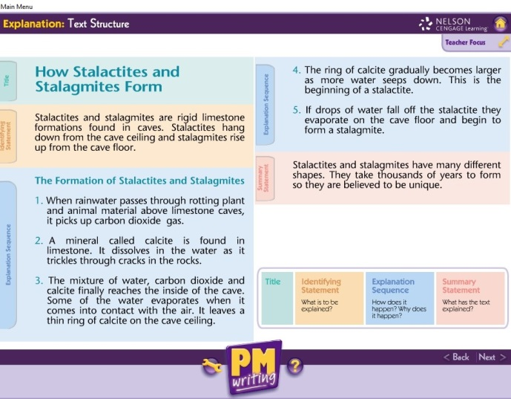
In the last Sway we explored an example of an Explanation text. We looked at the purpose (to explain how or why something occurs), the structure (Title, Identifying Statement, Explanation Sequence and Summary Statement) and also the different language features of an Explanation text.
Here is the sample explanation text as a reminder. You may wish to use it to help you complete task 4a.
Task 4a - Explanation Text Activity Sheets
Complete Activity Sheets 1 and 2 which accompany the Explanation text 'How Stalactites and Stalagmites Form'. These are pictured here but you can download them from the Files section of your Class Team.
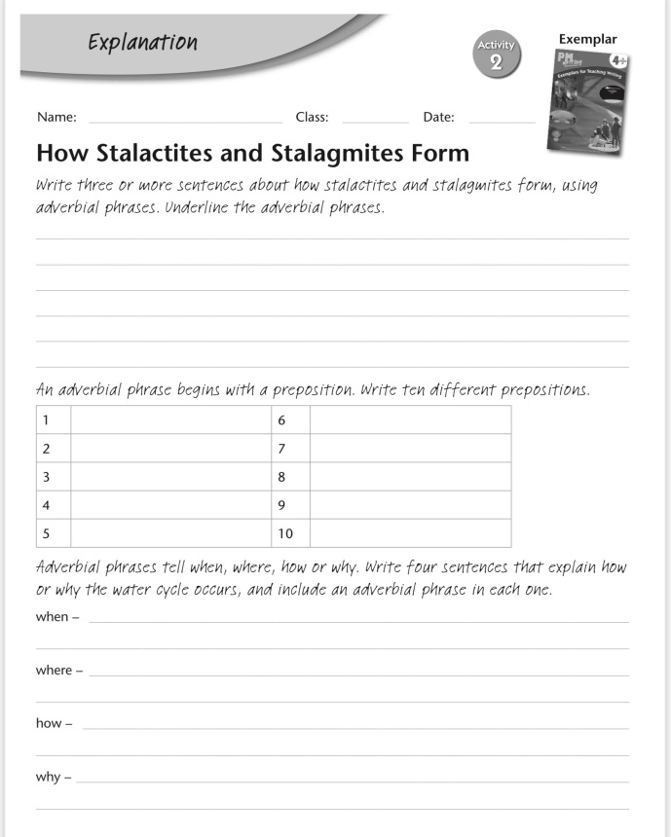
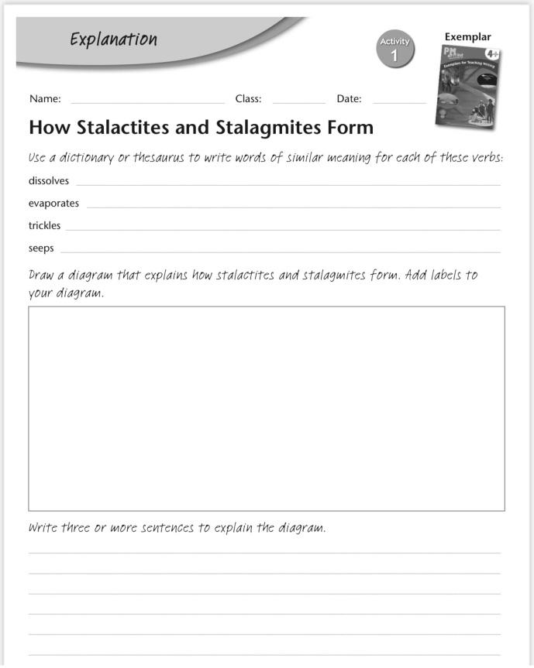
You do not need to submit these sheets to your teacher.

Task 4b - Modelled Planning & Writing of an Explanation Text
Watch the two Writing Teaching videos Planning an Explanation Text and Writing an Explanation Text
The first demonstrates how you would plan an Explanation text. Mrs Little has chosen the topic 'How diamonds are formed'.
The second video shows a modelled example of how to write an explanation text using the plan.
Here is a copy of the modelled text from the video. This is also available in Files.

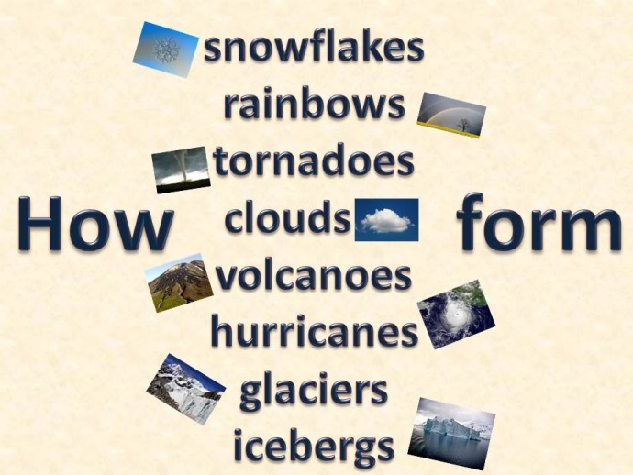
Task 4c - Research a topic for your own Explanation Text
Now it is your turn.
- Choose one of the topics opposite to research.
- Take notes under suitable headings (Remember: we did this last Block for our Information Reports).

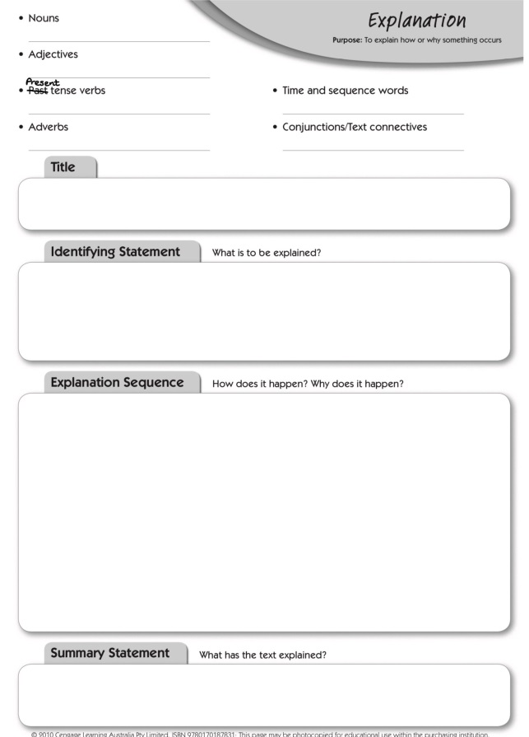
Task 4d - Planning your Explanation Text
Use the Planning sheet to plan your writing as demonstrated in the first video. Remember just to make notes at this stage - not full sentences.
The planning sheet can be found in the Files section of your Class Team.
**Please submit your plan to your teacher for Feedback**
Task 4e - Writing your Explanation Text
- Use your Planning Page to Write your text.
- Remember to follow the structure, write in the present tense and include appropriate punctuation and vocabulary.
- Choose one of the Self-Assessment Grids below to evaluate your work before you submit it (also available in Files).
**Please submit your finished piece of Writing and Self-Assessment grid to your teacher for Feedback**
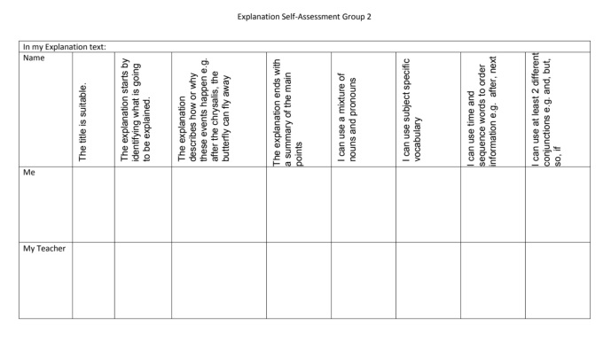
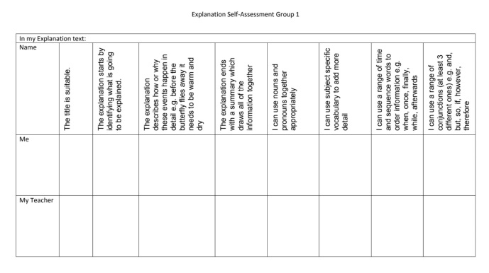
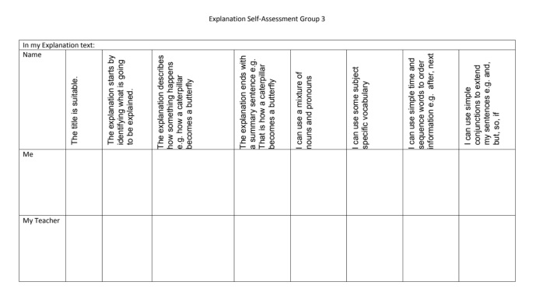
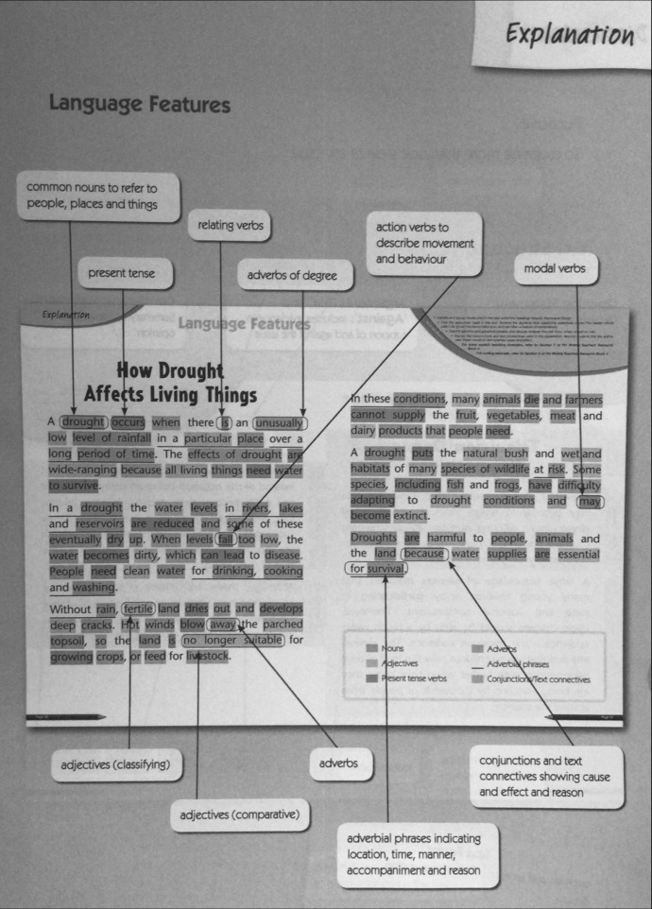

Task Five : Grammar **To submit to teacher please**

Apostrophes Continued

Complete the Practice and Extension sections from both the Textbook pages pictured. You will find a copy of these in the Literacy Section of Files on your Class Team page, General channel.
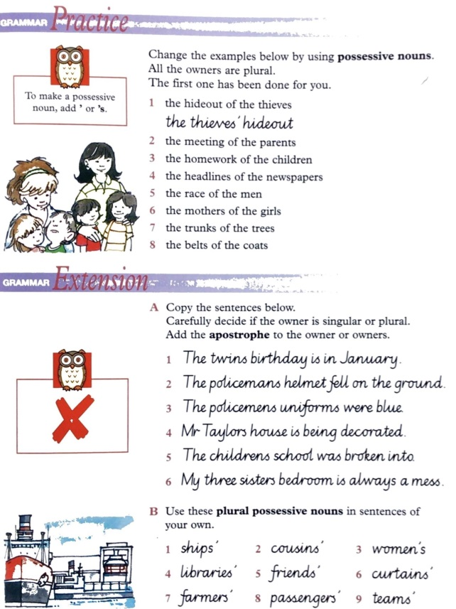
**Please email this work to your teacher for feedback**
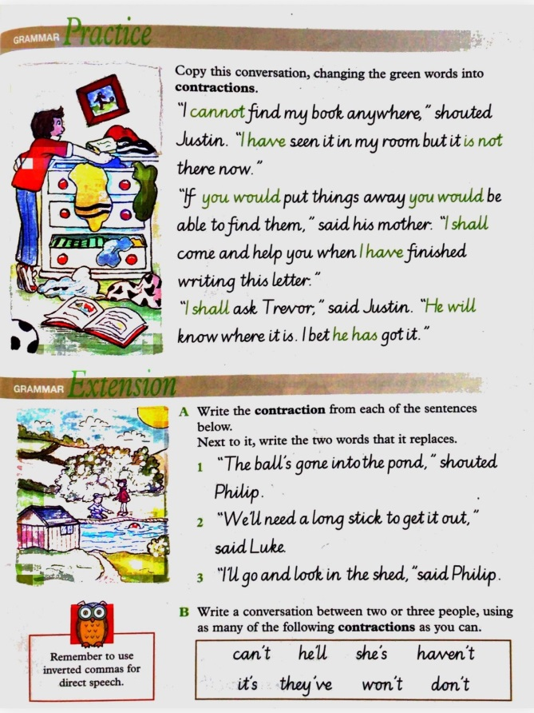
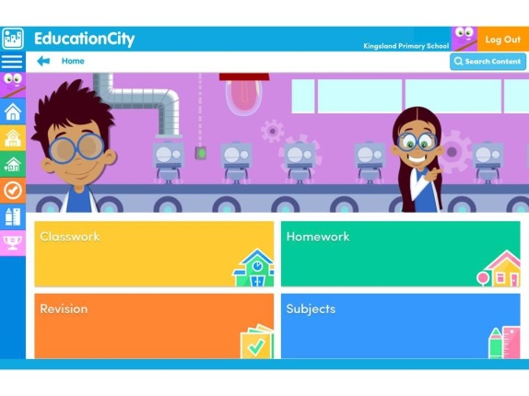
Possessive Apostrophes **Optional Tasks**
Log in to Education City and click on Classwork. You will find several games and activity sheets specially selected by your teachers to ensure you understand how to use possessive apostrophes correctly.
You do not need to submit anything from these tasks to your teachers as we will be able to see if you choose to complete them.

Numeracy

Task One: Fractions to Percentages

Watch the Fractions to Percentages Video to consolidate your understanding about converting fractions to percentages. Complete the starter and have a go questions as you watch. You may pause the video at any time.

Complete the worksheets which accompany the video. These are pictured below or you can find them in the Files section of your Class team page.

As this task is for consolidation, you do not have to send it to your teacher.
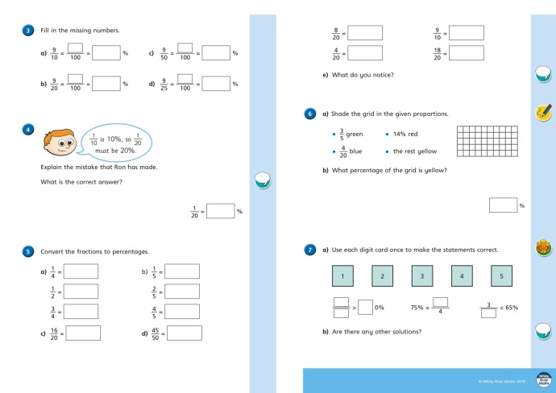
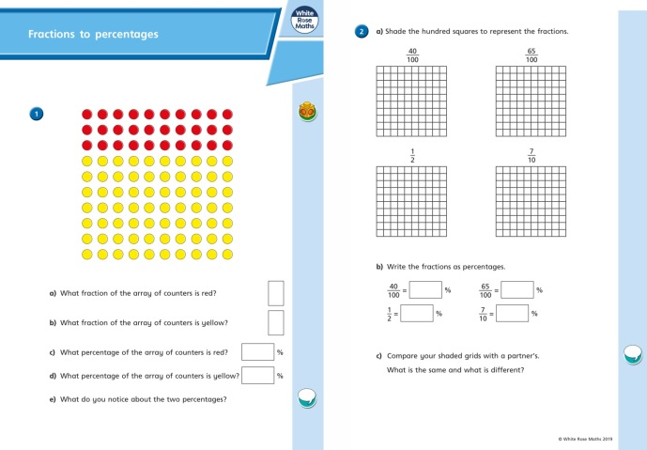

Task Two: Converting Fractions, Decimals and Percentages **To submit to teacher**

We have learnt about fractions, decimals and percentages separately. We are now going to think about how to link them. Watch the teaching video Equivalent FDP and complete the worksheets.

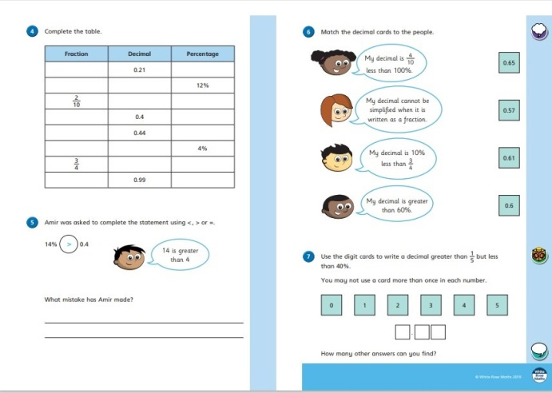
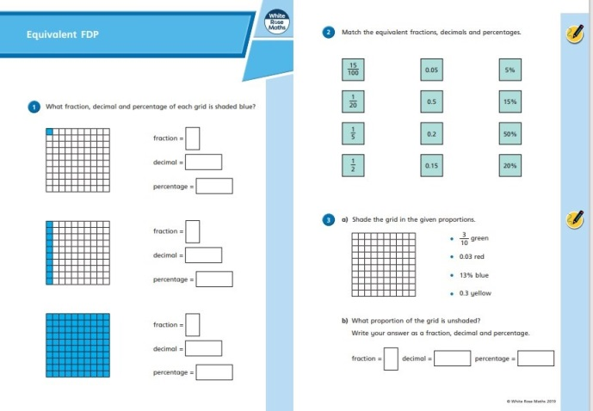

Task Three: Finding Percentages **To submit to teacher**
You often need to find a percentage of an amount when shopping, cooking, budgeting, measuring etc. We can use our knowledge of equivalent fractions, decimals and percentages to help us. Watch the video about finding a simple percentage and complete page 110. Then, watch the video about finding a trickier percentage using a calculator and complete page 111.
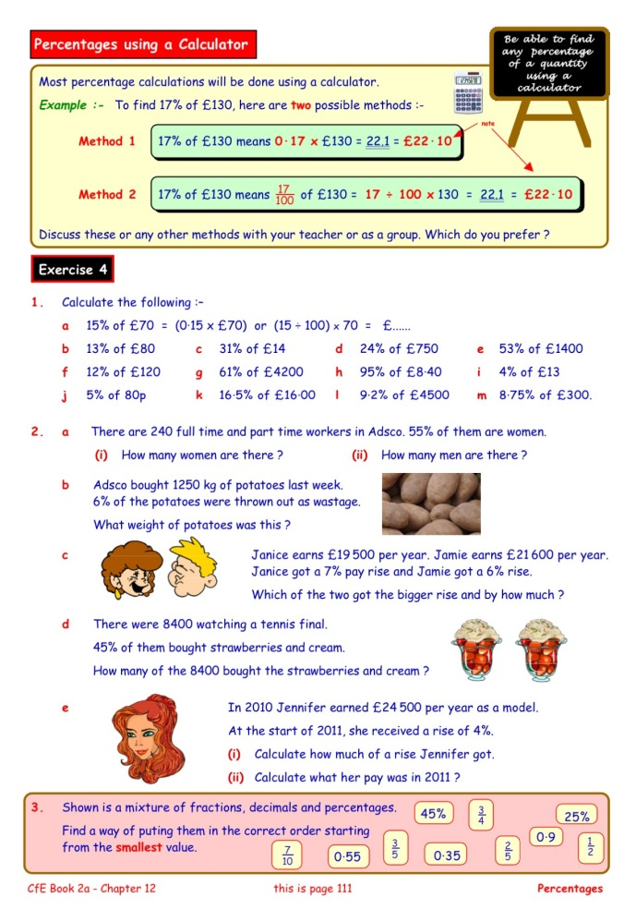
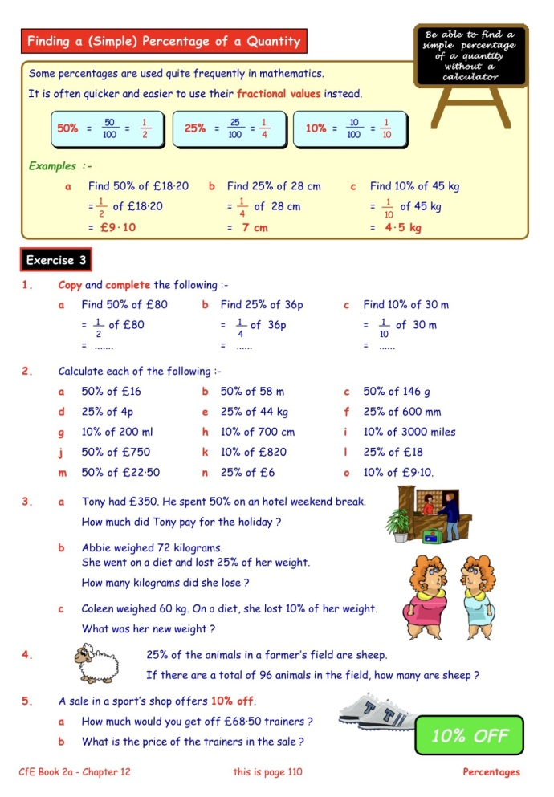

Task Four: Negative Number
We see negative numbers all around us in our lives. How many different places can you think of where you might see negative numbers?
Watch the Negative Numbers video and complete the tasks within it.
Then, have a go at the negative number thermometer textbook pages. Read the questions very carefully so you know if you are to count up or down.
**Please email the second textbook page (SHM7 p33) to your teacher for feedback**
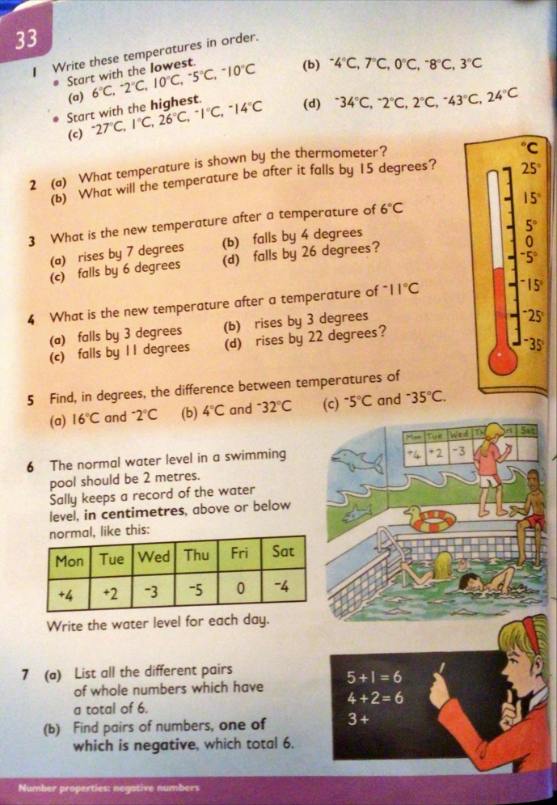
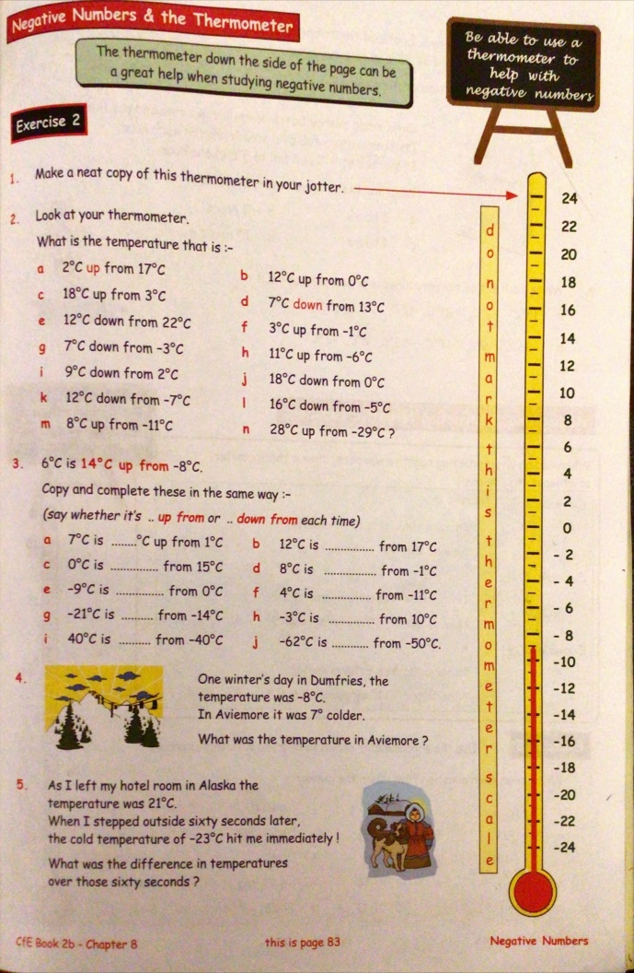

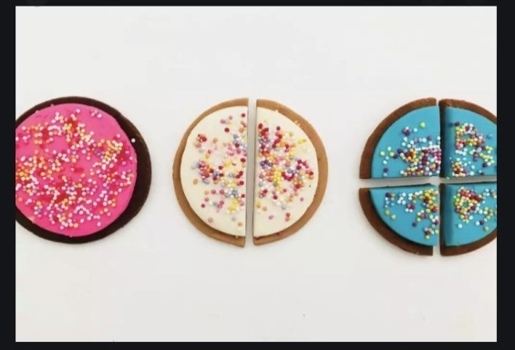
Task Five: Fractions of amounts - Word Problems

A fraction tells us how many parts of a whole there are.
To calculate a fraction of an amount, you have to work out how much that part is worth within the whole.
5a) Follow the links below and have a go at the activities on each page. Ask your teacher to email you the links if you need to.
Finding Fractions of an Amount
Fractions of Amounts in Applied in Contexts
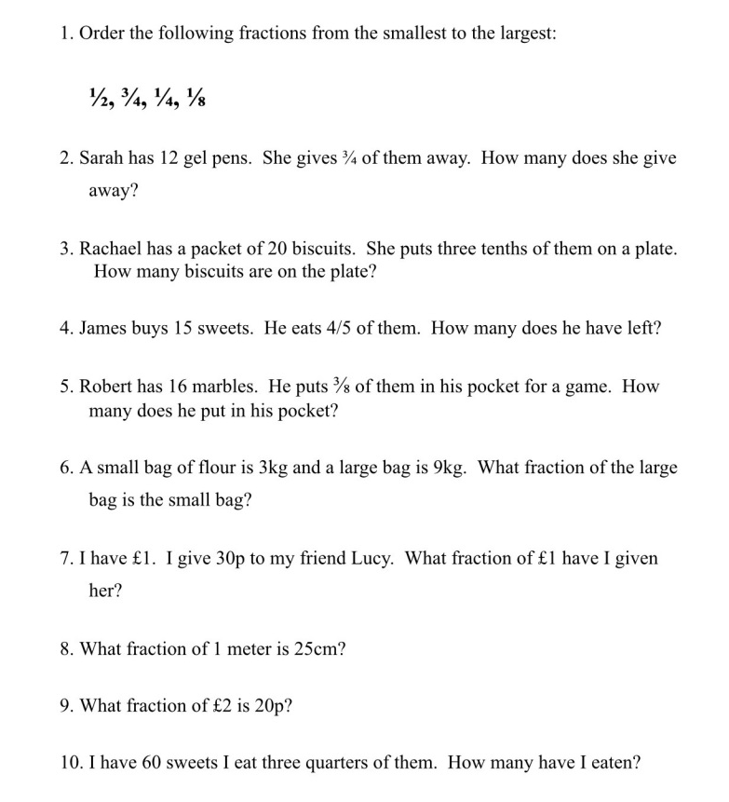
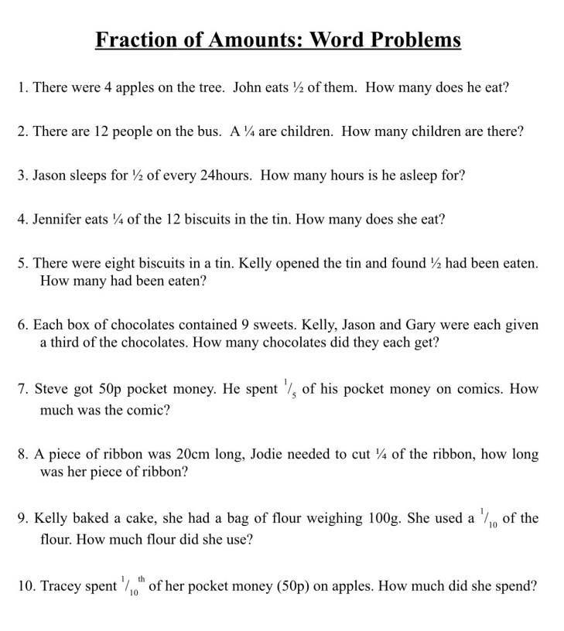
5b) Below are two different word problem tasks. You can choose which one you want to do but make sure you set yourself a challenge. Click on the audio files to hear Mrs Wilkinson read the problems. You do not need to send this task to your teacher.

Task Six: Problem Solving Chilli Challenge **To submit to teacher**

Choose one of the following activities to develop your problem solving strategies - Mild, Medium or Hot (or you can do all three if you really want to!!)

**Please send your completed task to your teacher for Feedback**

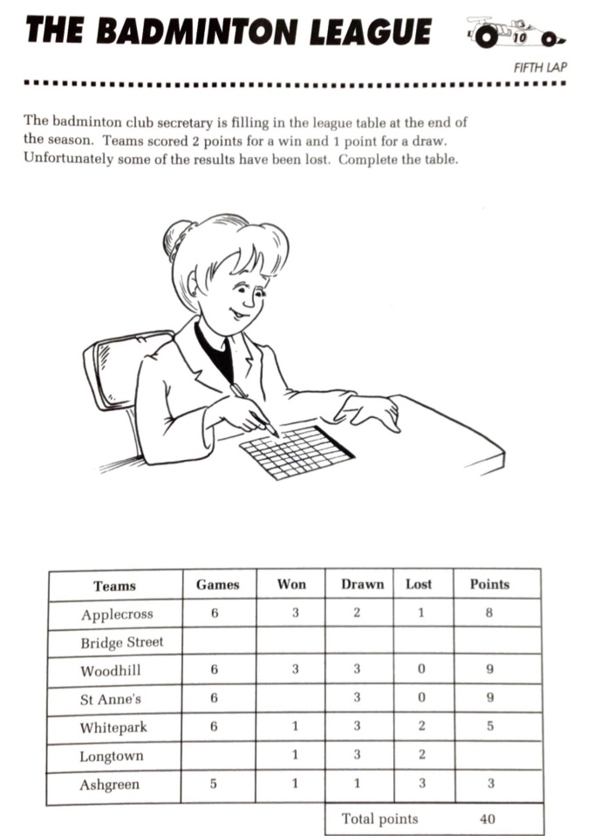
Mild - The Knapsack Problem
Read the task, choose a strategy, find a solution. Can you find a better one?

Medium - The Badminton League
Read the task. Think logically to complete the table. Which numbers are missing?

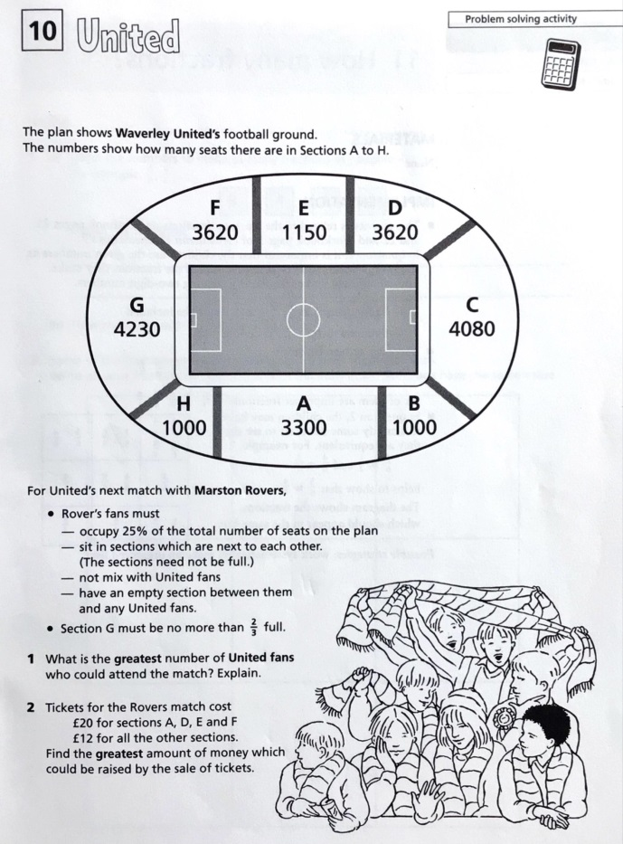
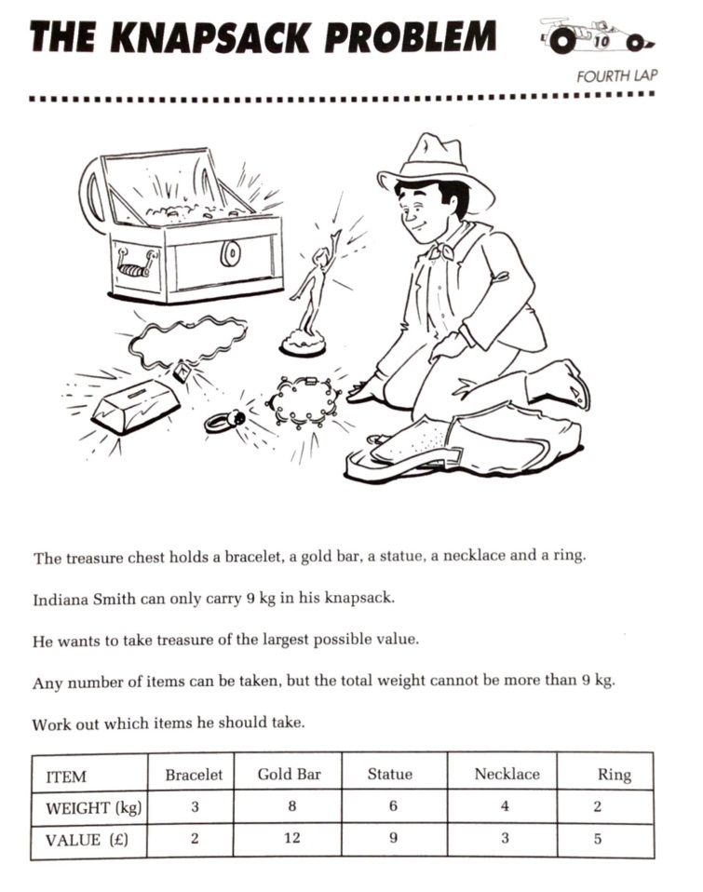
Hot - United
Read the information and consider the diagram carefully. You will need to apply your knowledge of fractions and percentages. Can you answer the questions?

Task Seven: Education City - Fractions, Decimals & Percentages
Check your understanding of Fractions, Decimals and Percentages with these Education City Games. You can use the links below or just log into Education City and look in Classwork.
Lofty Conversions
All the Fashion
Bargain Hunter
Play Your Carts Right

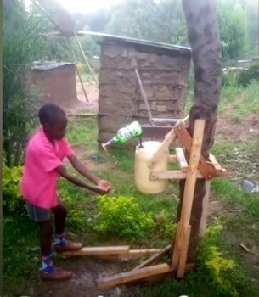
Health and Wellbeing

Task One: Skills for Life **Part B to submit to teacher**
Everyone has special skills and qualities which they can use to make their own and other people's lives better. Think about the skills and qualities that you reflected on after doing the Animal Me and World of Work quizzes. What are your special skills and qualities?
Our world relies on problem solvers, creative thinkers, kind gestures, confident individuals, collaborators and many more different types of people, to help the world keeping moving. This is particularly important during challenging times such as the pandemic we are currently experiencing.
Watch the Kenyan video (or ask your teacher to email you the link) to see how one boy in Kenya has used his creative and problem solving skills to invent a safer way for his family and friends to wash their hands. You need to click the link to watch the video.
Part A) Your task is to use your skills to either:
- design and/or build an invention
OR
- plan an event/project
to help people during the Coronavirus pandemic. You could think about communication between friends and family, delivering food to vulnerable people safely, helping doctors and nurses or simply making someone’s life happier or easier. The invention/project could be used in Scotland or a different country you have read or learned about.
Part B)
Report back on well you used your skills. Let us know what you decided to focus on and evaluate how well you used your skills. Include details of the design/project and personal reflections. **Please email this to your teacher for feedback**

Task Two: Have a Goal

Successful Person Interview
We all know people who have been, and are, successful in their lives. It is easy to take for granted or not consider how hard someone has worked to be where they are. When you set a goal in life, you don't automatically achieve it. To achieve goals, you must work hard and sometimes fail before you can achieve. Some goals change over time as people learn more about themselves.
Watch the video about Michael Jordan, one of the most successful basketball players of all time.
We would like you to think about someone you know who is successful at what they do. This doesn't have to be the same type of success as Michael Jordan! It might be someone who is successful at their job, successful at a hobby, or successful at being a good family member or friend.
Part A) Think of five interview questions that you would like to ask them and give them a phone/video call to discuss their answers. You might want to ask about failures they experienced before their success, whether this was always their goal or if their goal changed over time, and the sort of things they had to do in order to achieve success.
Part B) Carry out your interview.
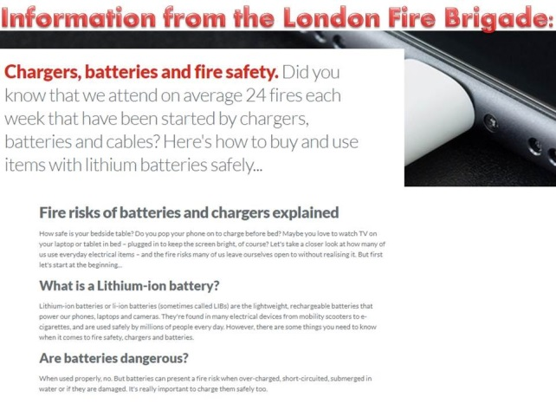
Part C) Write down your questions and a summary of the answers.

Task Three: Keeping Myself Safe - Electrical and Fire Safety **Part C to submit to teacher**
Part a)
Last week we thought about our Digital Safety online but how safe are we physically when using all our modern devices? Look at the following information from London Fire Brigade or click below to hear Mrs Little reading the information.
Consider the following questions:
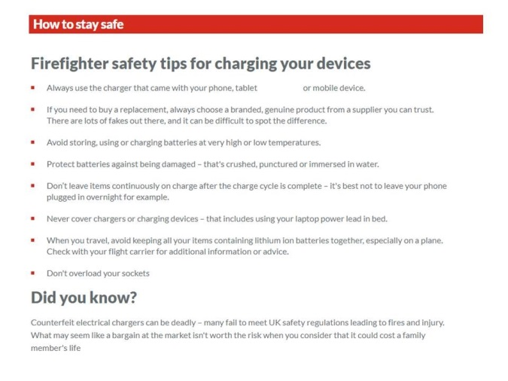
- Do you leave chargers plugged in overnight?
- Do you have cables on or near bedding?
- Do you use your devices while they are charging?
- Are you putting yourself or others at risk?

Part b)
Electrical Safety is so much more than chargers, batteries and cables though.
Look through this slideshow, read the information on the orange speech bubbles and have a go at spotting the dangers in the two pictures. You can find copies of the slideshow and the spotting pictures in the Files section.
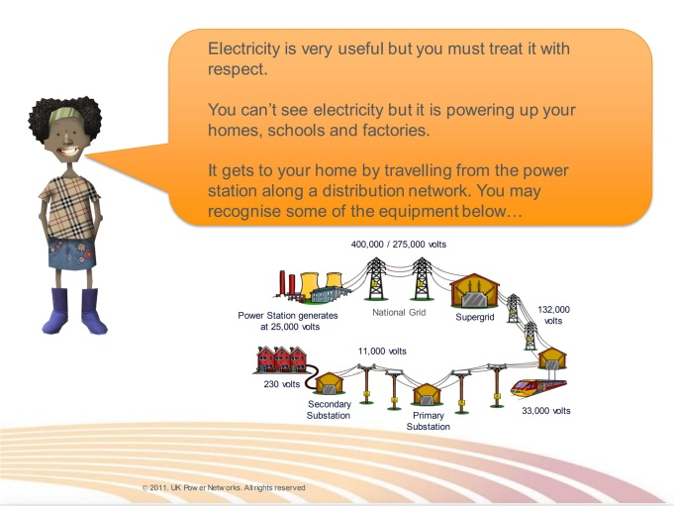 | 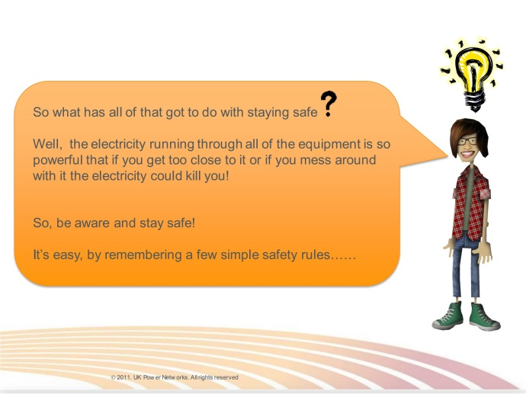
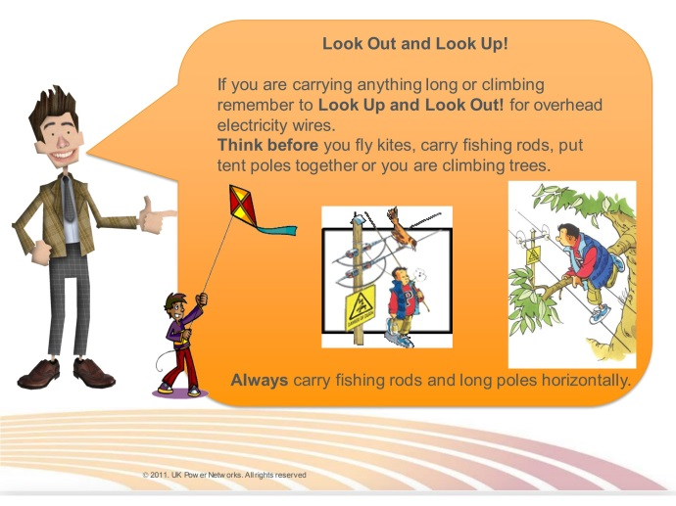 | 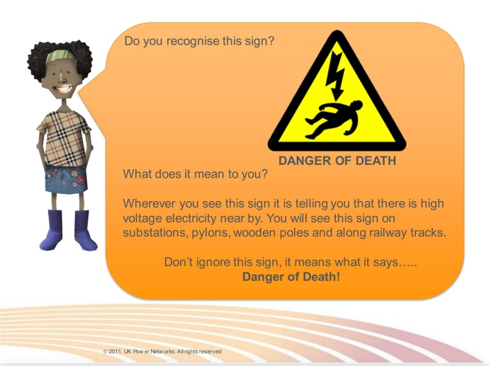
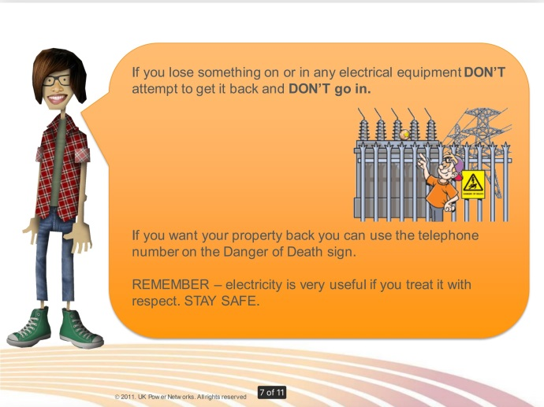 | 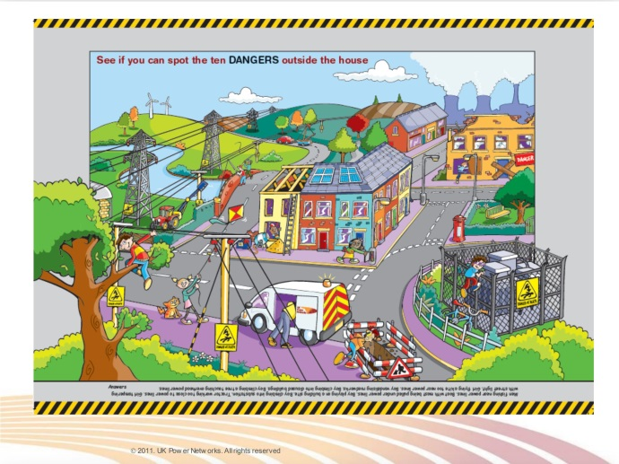

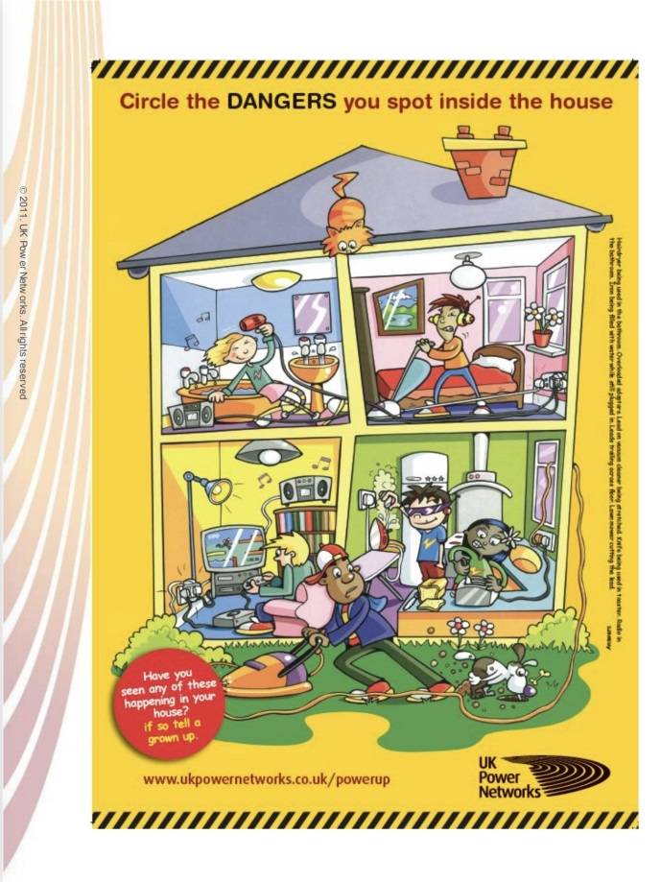
Part C) Task: Now that you have learned about Electrical Safety, create a Poster or Fact sheet to highlight the dangers and raise awareness of one or more aspects.
**Please email this to your teacher for feedback**

Task Four: Take a Moment

Valentine's Day Sketching

The Thistle in our last Sway was really popular so Mrs Little has had her Sketches App open again. This time we're using a smudged Acrylic Paint effect with a silhouette on top. The video has a Valentine's Day theme but you could use the same techniques to draw something totally different.
Have a go at your own version - we'd love to see the results but this is not a hand in task. Perhaps you could use the finished design to make an e-card for a friend or member of your family.
*Please note: if you haven't got an iPad/it's not working or you just prefer the traditional ways, you can do this task on paper using any drawing or painting materials you have available. A pencil sketch is fine!

If you choose to use Sketches as shown in the video you should be able to open Safari from your Dock in Slide Over view (on top of Sketches - split screen doesn't work here) so that you can watch the video while drawing. Email if you need help with this.

