Primary Seven Recommended Books 2020-21

There is no such thing as a child who hates to read; there are only children who have not found the right book. —Frank Serafini

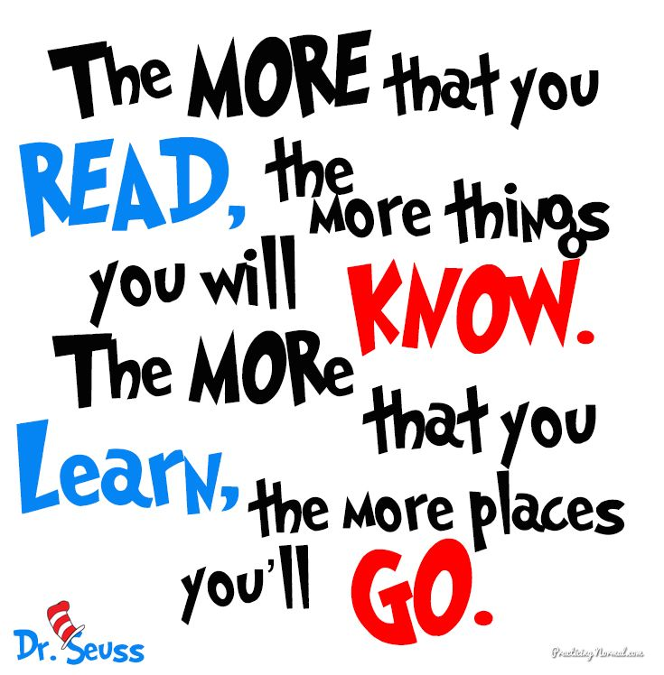
This is a list of recommended fiction books to be shared, read quietly, aloud, by yourself, or with a family member. We all have genres of books that we prefer but it is really helpful to read a range of books to help develop your reading understanding and your writing techniques and ideas. Most of these books are available in the Peebles library or can be borrowed from school.
Remember, reading helps us to understand the world and our place within it.

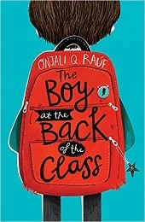
The Boy at the Back of the Class by Onjali Rauf
Told with heart and humour, The Boy at the Back of the Class is a child's perspective on the refugee crisis, highlighting the importance of friendship and kindness in a world that doesn't always make sense.

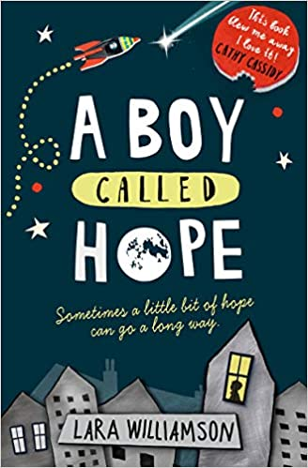
A Boy Called Hope by Lara Williamson
A look into the life of Dan Hope and his dysfunctional family. This is a though-provoking and touching book. It is perfect for those who have enjoyed Wonder. This story is a brilliant exploration of family, relationships and changing friendships.
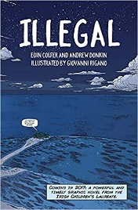
Illegal by Eoin Colfer
This is a powerful and timely story about one boy's epic journey across Africa to Europe, a graphic novel for all children with glorious colour artwork throughout. From the team behind the bestselling Artemis Fowl graphic novels. A great one for comic lovers.

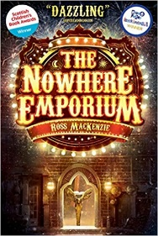
The Nowhere Emporium by Ross MacKenzie
The first in a series by Scottish author Ross MacKenzie. The Nowhere Emporium follows the story of Daniel as he stumbles into the mysterious Nowhere Emporium in Glasgow and opens the door to a world of breath-taking magic and looming danger.
What Not to Do If You Turn Invisible by Ross Welford
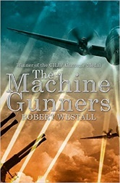
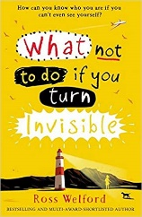
13 year-old Ethel Leatherhead turns herself invisible when she tries a combination of untested medicines and a sunbed to help cure her acne. It’s fun at first, being invisible. And aided by her friend Boydy, she manages to keep her extraordinary ability secret. Or does she…? When one day the invisibility fails to wear off, Ethel is thrown into a nightmare of lies and deception as she struggles to keep herself safe, to find the remedy that will make her seen again – and solve the mystery of her own birth…A clever, comical story full of twists and surprises. One of Mrs Brown’s favourites!
The Machine Gunners by Robert Westall
A gripping, dramatic novel set in World War II. Chas McGill has the second-best collection of war souvenirs in Garmouth, and he desperately wants it to be the best. When he stumbles across the remains of a German bomber crashed in the woods - its shiny, black machine-gun still intact - he grabs his chance. Soon he's masterminding his own war effort with dangerous and unexpected results . . .

The Viewer by Gary Crew
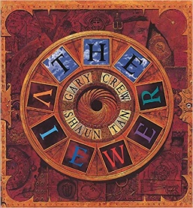
A young teen picture book, perfect for reluctant readers. Young Tristan, a curious boy who rescues all sorts of objects from the rubbish dump, finds an old Viewmaster in its elaborate box, complete with a set of disks. He finds that these represent the ages of humankind, seen as a cyclical structure in which patterns of growth and decay are repeated. Tristan becomes more and more drawn in to the world of the disks, and eventually disappears. The book is full of metaphors and symbols of seeing and watching, circularity and never-endingness, in a complex, fantastical tale.

Skellig by David Almond
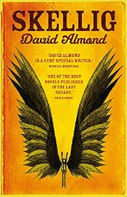
When a move to a new house coincides with his baby sister's illness, Michael's world seems suddenly lonely and uncertain. Then, one Sunday afternoon, he stumbles into the old, ramshackle garage of his new home, and finds something magical. A strange creature - part owl, part angel, a being who needs Michael's help if he is to survive. With his new friend Mina, Michael nourishes Skellig back to health, while his baby sister languishes in the hospital. But Skellig is far more than he at first appears, and as he helps Michael breathe life into his tiny sister, Michael's world changes for ever . . .

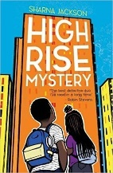
High Rise Mystery by Sharna Jackson
One of the most popular books of 2019! The detective duo everyone is dying to meet! Summer in London is hot, the hottest on record, and there's been a murder in THE TRI: the high-rise home to resident know-it-alls, Nik and Norva. Who better to solve the case? Armed with curiosity, home-turf knowledge and unlimited time - until the end of the summer holidays anyway. The first whodunnit in a new mystery series by Sharna Jackson. If you like this one, there are more in the series.

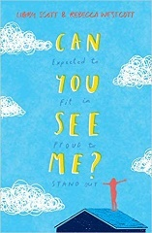
Can You See Me by Libby Scott
This is an eye-opening book looking at the story of eleven year old Tally who has Austism Spectrum Disorder. With diary entries written by eleven-year-old Libby Scott, based on her own experiences, this pioneering book, written in collaboration with esteemed author Rebecca Westcott, has been widely praised. It is an endearing, insightful and warmly uplifting book about empathy and kindness that will touch readers of all ages.
Keeper by Mal Peet
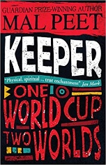
In a newspaper office, Paul Faustino, South America's top football writer, sits opposite the man they call El Gato "the Cat", the world's greatest goalkeeper. On the table between them stands the World Cup. In the hours that follow, El Gato tells his incredible story of how he, a poor logger's son, learns to become a World Cup-winning goalkeeper so good he is almost unbeatable. And the most remarkable part of this story is the man who teaches him: the mysterious Keeper, who haunts a football pitch at the heart of the claustrophobic rainforest...
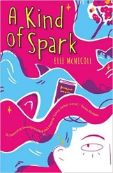
A Kind of Spark by Elle McNicoll
'A Kind of Spark' tells the story of 11-year-old Addie as she campaigns for a memorial in memory of the witch trials that took place in her Scottish hometown. Addie knows there's more to the story of these 'witches', just like there is more to hers.

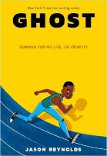
Ghost by Jason Reynolds
Running. That's all Ghost (real name Castle Cranshaw) has ever known. But Ghost has been running for the wrong reasons -until he meets Coach, an ex-Olympic Medallist who sees something in Ghost: crazy natural talent. If Ghost can stay on track, literally and figuratively, he could be the best sprinter in the city. Can Ghost harness his raw talent for speed, or will his past finally catch up to him?
Millions by Frank Cottrell-Boyce
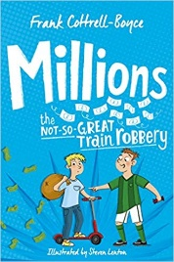
Brothers Damian and Anthony didn't mean to get caught up in a botched train robbery. But what would you do if a massive bag of cash dropped from the sky and you had only a few days to spend it before it became worthless? Buy a million pizzas? End world poverty? Not such an easy decision, is it? The boys soon find out that being rich is a mug's game. Not only is the clock ticking, the bank robbers want their money back . . .Mrs Brown loved this one when she was at school!

The final book is not a fiction book but is an excellent real life story that helps young people to understand and achieve their full potential.
You Are Awesome by Matthew Syed
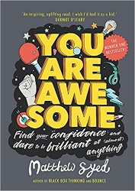
Matthew Syed is a former table tennis champion and one of the most successful and highly-acclaimed speakers on positive mindset in the UK. He is the author of three bestselling adult books on the subject of mindset and high performance. He works with sport stars to help them stay at the top of their game. You are Awesome is a children’s book that uses real-world examples across sport, business, education and politics to look at the inside story of how success really happens – and how we cannot grow unless we are prepared to learn from our mistakes. Mrs Brown loves this book, especially the really cool graphics!

