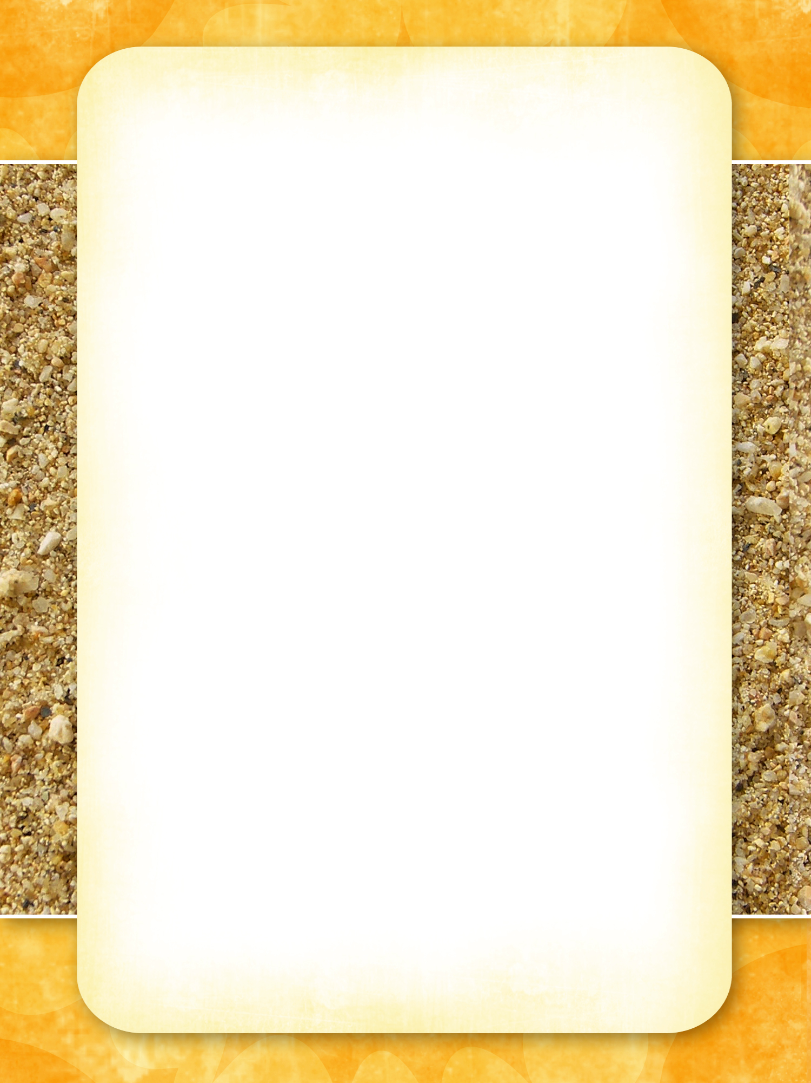

# *Pharaoh’s Café*

**Choose one starter, one main course and one dessert from the selection below.** If you want to try a different dish, ask your waitress (Mrs Little, Mrs Smith or Mrs Thomson)

**Menu**

## Starters

* Show your knowledge of shape by building a square based pyramid. Describe the properties of this shape (edges, faces, vertices)
* Cubit rods have been found in tombs. Find out how long one cubit is, make your own cubit stick and use it to measure things in your house.
* Create a tiling pattern inspired by an Egyptian design.
* Use the Egyptian Number system to create sums to test a friend.

## Main courses

* I can write an imaginary newspaper report based on a discovery of a new Egyptian tomb.
* Draw a picture of an Egyptian character – Write a short description of your chosen character, including adjectives and verbs.
* Draw a picture of an Egyptian scene – Write a short description of your chosen setting, including adjectives and verbs.
* Use question words to write a list of questions that you would ask an Egyptian Pharaoh.

## Desserts

* Research a Pharaoh, of your choice, and create a fact sheet.
* Find some gruesome facts about Egyptians and create a poster to show these.
* Make a short movie based on an aspect of Egyptian life.
* Dress up as someone from Ancient Egypt and bring in a photo of you wearing it.

## All ‘dishes’ must be completed on/before Monday 5th December 2016

Children will share their homework with the rest of the diners during this week.



# *Pharaoh’s Café*

**Choose one starter, one main course and one dessert from the selection below.** If you want to try a different dish, ask your waitress (Mrs Little, Mrs Smith or Mrs Thomson)

**Menu**

## Starters

* Show your knowledge of shape by building a square based pyramid. Describe the properties of this shape (edges, faces, vertices)
* Cubit rods have been found in tombs. Find out how long one cubit is, make your own cubit stick and use it to measure things in your house.
* Create a tiling pattern inspired by an Egyptian design.
* Use the Egyptian Number system to create sums to test a friend.

## Main courses

* I can write an imaginary newspaper report based on a discovery of a new Egyptian tomb.
* Draw a picture of an Egyptian character – Write a short description of your chosen character, including adjectives and verbs.
* Draw a picture of an Egyptian scene – Write a short description of your chosen setting, including adjectives and verbs.
* Use question words to write a list of questions that you would ask an Egyptian Pharaoh.

## Desserts

* Research a Pharaoh, of your choice, and create a fact sheet.
* Find some gruesome facts about Egyptians and create a poster to show these.
* Make a short movie based on an aspect of Egyptian life.
* Dress up as someone from Ancient Egypt and bring in a photo of you wearing it.

## All ‘dishes’ must be completed on/before Monday 5th December 2016

Children will share their homework with the rest of the diners during this week.