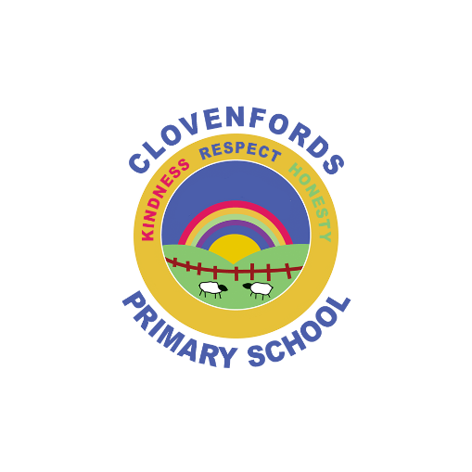**Clovenfords Primary School  
Kindness Respect Honesty  
Weekly Update – Friday 24th May 2024**

|  |
| --- |
| **Head Teacher’s Update**  Dear all,  Whilst it has been a soggy week weather wise, we are keeping our fingers crossed for a dry day tomorrow for our Spring Family Fun Day. The Parent Council have been working hard behind the scenes and we hope to see as many families as possible joining us. Please do come along if you can and support our wonderful school.  It’s not too late to bring along a donation for the raffle and tombola stalls if you can.  This week, despite the rain, our P3/4 class set off for Bowhill for some outdoor learning and butter making, our P7 children have been getting their enterprise projects underway in preparation for their end of session P7 treat and  P5 enjoyed the Borders Schools Countryside Day on Tuesday – first stop for them was the free ice cream! Next week our P1/2 class will venture off to Bowhill and they have told us they are very excited about their upcoming trip. Thank you to the Parent Council who helped to fund all our class trips this session by donating £2.00 per child towards the cost of transport – a great reminder of why events like our family fun days etc. are so important for all our children in supporting learning and our community.  The children’s suggestion to celebrate our school receiving the Digital Schools Award Scotland is to have a whole school hot chocolate and treat. We are currently organising this for the 7th June, after brunch. We will post photos of the children celebrating on their Showbie profiles for you to enjoy.  A blue circle with white text and a flower  Description automatically generatedWishing you all a safe and peaceful weekend.  Mrs Saxon |
| **Dates for the Diary**   |  |  | | --- | --- | | **Saturday 25th May** | Spring Family Fun Day 12.00pm-2.30pm | | **Monday 27th May** | P1/2 Class Trip to Bowhill | | **Monday 3rd June** | Local holiday – school closed to all | | **Tuesday 4th June** | All resume | | **Wednesday 5th June** | P6 Inspire Learning Festival | | **Friday 7th June** | Digital Schools Award Scotland Celebration | | **Tuesday 11th June** | P1-P7 Sports Day | | **Wednesday 12th June** | ELC Sports Afternoon | | **Thursday 13th June** | P7 visit to Galashiels Academy | | **Friday 14th June** | P7 visit to Galashiels Academy | | **Friday 21st June** | Pupil as a Learner reports issued | | **Tuesday 25th June** | ELC Graduation 2.00pm | | **Friday 28th June** | P7 Leavers Assembly – 11.00am – all P7 parents’ welcome. | | **Friday 28th June** | Last day of term | |
|  |
| **Wider Achievement**  **Lifelong Learner**  We were delighted to receive this photo from **Ronnie’s** family showing us how he is using his learning at home. Ronnie’s cherries have been labelled in the fridge and we know he is proud of being a successful learner.  **BGE Music Play Day**  It was great to chat with **Abigail**, **Connor**, **Ayla**, **Olivia** and **Katelyn** who attended the Borders Music Play Day last Saturday. The children reported that they had a great day and that they enjoyed listening to what a ‘real orchestra’ sounded like. They loved all the additional music instruction and fun that the day provided. Well done all! |
| **Parent Council Update**  **Spring Family Fun Day**  Tomorrow is our Spring Family Fun Day (25th May).  **You can still hand in/bring along raffle prizes and home baking.**  **All volunteers welcome – it’s not too late to sign up to help.**  Below is the link to sign up to help. Thank you for your support!  <https://volunteersignup.org/FLETM> |
|  |
| **Primary 1/2 Class Assembly**  Our P1/2 class took us on an adventure through the rainforest during their class assembly this week, showcasing their knowledge of food chains and how animals and plants adapt to different climates. We loved the green screen films and the singing.  Congratulations to the following children for showing our school vision, values and aims in action, as well as using their learning powers to continue to progress in their learning:   |  |  | | --- | --- | | ELC | Hope and Owen | | P1/2 | Robbie | | P2/3 | Anya | | P3/4 | Jude | | P5/6 | Angus | | P6/7 | Eliza |       We will have an additional hot chocolate celebration at the beginning of next week to celebrate with Jude, Daisy and Hope who have all been Star Achievers. |
| **School’s Out Clovenfords**  A reminder you can contact School’s Out at: admin@schoolsoutclovenfords  They offer care for children both before and after school. Please continue to use this great service where you can as it supports our community and is a wonderful asset to have in Clovenfords. |
| C:\Users\Alison.Saxon\AppData\Local\Microsoft\Windows\INetCache\Content.Outlook\AIVFTZHV\Clothingfords.jpeg **Clothingfords**  Clothingfords is available for you to come and browse across the school day as well as during after school and evening events. Please do not be shy about coming in to use this great facility! There is a great mixture of good quality, used items. Please pop along when you can to use this great facility.  **As we move into our summer term we would be very grateful for any donations of sun hats. Many thanks.** |
| **Communication**  If you child will not be in school, it is important that you inform the school office by 9.00am. You can report absence by phone or email.  **School office phone number:** 01896 662755  **School office email:** [clovenfordsps@scotborders.gov.uk](mailto:clovenfordsps@scotborders.gov.uk)  **School Twitter (X) :** @Clovenfords_ps  **School website:** [Clovenfords Primary School – Kindness, Respect, Honesty (glowscotland.org.uk)](https://blogs.glowscotland.org.uk/sb/clovenfordsprimaryschool/) |