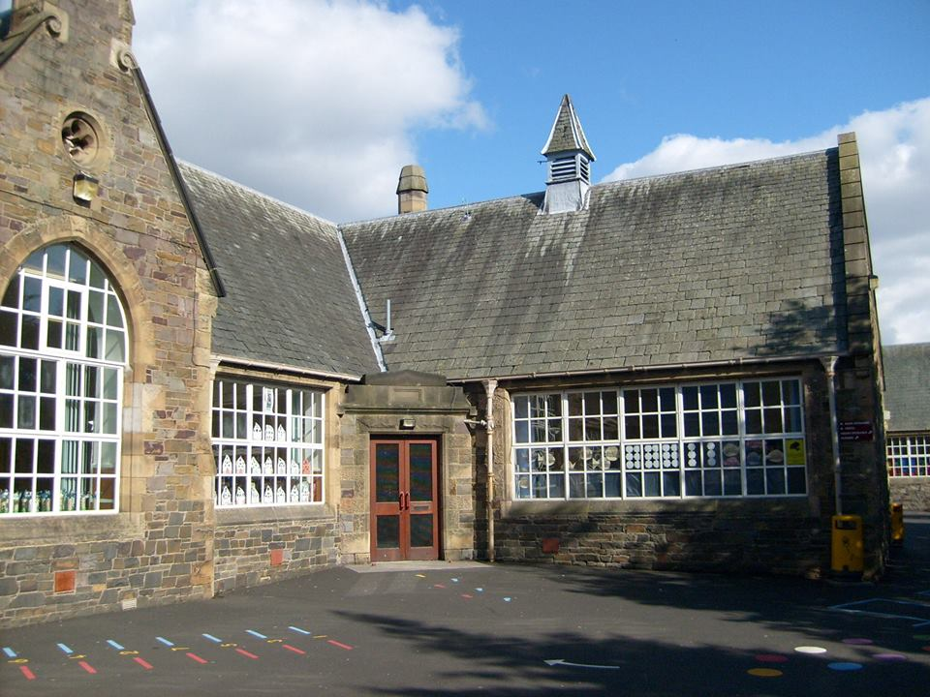
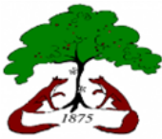

Numeracy & Maths
- Place Value
- Multiplication and Division
- Basic Maths Facts
- Measure
- Data Handling
- Reasoning and Explaining
- Addition and Subtraction
- Fractions, Decimals and Percentages

Literacy & English
- Tools for Writing
- Reading for enjoyment
- Exploring spelling patterns and strategies to spell unfamiliar words
- Our class novel for this block will be ‘Holes’.

- French- continuing to develop vocabulary linked to daily routines

Block 1

Technologies

- Use of iPads to support and enhance learning across the curriculum
- Online safety

Religious & Moral Education
- Develop our understanding of world religions and traditions

Science
- Vibrations and waves
- Explore how sound vibrations are carried by waves through air, water and other media.
- Properties of light

Expressive Arts
- Art & Design – Using a range of materials to produce specific effects

- Music will continue to be delivered by our music specialist, Miss Scott.

Social Studies
- Supporting the local community
- Equality and diversity
- Understand forms of discrimination against people in societies and consider the impact this has on people’s lives.

Health & Wellbeing
- Developing a range of skills in different invasion games
- Continue to be positive role models around the school and showing responsibility with P7 monitoring jobs.

Bright Futures
Blossom
at Burgh

