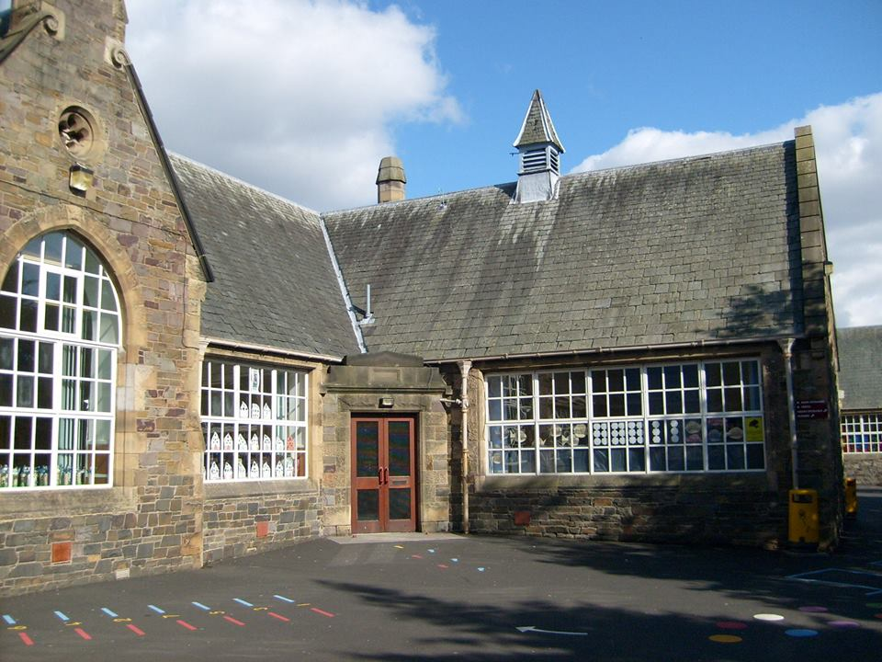
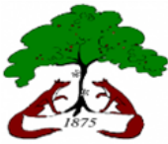

Literacy & English
In reading, we are undertaking a range of activities throughout the week to develop our reading skills.
- Comprehension cards for oral reading/fluency and for developing skills in answering questions on a text
- Novel study- enjoying reading a shared text
- Prim Ed comprehension scheme for learning key skills involved in comprehension such as understanding words, finding information and identifying the main idea of a text
In listening and talking, we are going to be developing our ability to communicate clearly by contributing and responding in class discussions. We will be playing a range of talking games and using talking points to help us develop confidence in speaking in front of others.
In writing, we are focussing on our ‘Tools for Writing’ skills and developing the skills needed for successful writing. We will learn:
- Types of sentences
- Sentence structure
- Sentence openers
- Sentence transitions
- Punctuation

Numeracy & Maths
With Mrs Walker
- Counting Development
- Estimation and Rounding
- Place Value
- Negative Numbers
- Addition and Subtraction

With Mrs White
- Mathematics – its impact on the world past, present and future
- 2D and 3D shape

Autumn Term

HWB
In HWB, we will create our ‘Class Charter’ as a class community using the UNCRC Rights of the Child as a basis for discussion. We will use our charter to create a safe, healthy and positive classroom environment so all children can experience success in their learning. We will spend time getting to know new routines in our classes and expectations for all transition times.

Religious & Moral Education
In RME children will be exploring ‘Christian Beliefs’ including:
- re-telling Christian stories
- understanding the meaning of Christian stories
- recognising important people in Christianity
- exploring similarities and differences between Christian beliefs and my own

Expressive Arts
Children will have music on a Thursday with Miss Scott where they will be exploring the skills involved with ukelele playing!
Children will create various artworks inspired by their learning about the rainforest.

Social Studies

Equality and Diversity
By the end of the topic, learners will be able to:
- identify different groups and organisations within the local community
- explain why different groups have different needs
- investigate how community groups are supported
- recognise different forms of discrimination and explain their impact
- understand the importance of fairness, equality, inclusion and respect
- explore the diversity of cultures, values and customs within Scotland

Science
Living things within the Rainforest
By the end of the topic, learners will be able to:
- identify and classify living and non-living things
- classify rainforest plants and animals
- explain how adaptations help organisms survive
- distinguish between endangered and extinct species
- explain how human behaviour can threaten biodiversity
- construct and interpret rainforest food chains and food webs
- investigate how rainforest animals communicate
- explain that sound is created by vibrations
- investigate plant and animal life cycles

Health & Wellbeing: PE

Basketball/ Hockey
This term, Primary 6/5 will develop the skills of basketball and hockey including:

- dribbling skills using basketballs
- dribbling skills using hockey sticks to control a hockey ball
- passing a basketball using chest and bounce pass
- passing a hockey ball using a push pass
- shooting a hoop in basketball
- accuracy and control when using the different equipment
- basic rules of both sports with small games played
- understanding the importance of teamwork in games
Bright Futures Blossom
at Burgh

