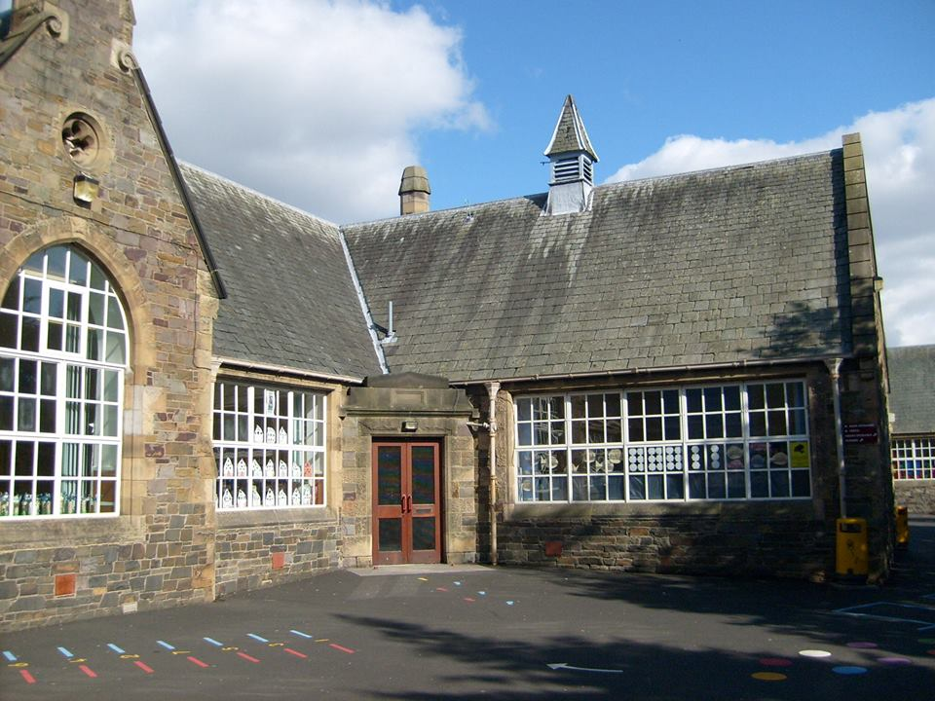


Literacy & English
In reading, we will undertake a range of activities throughout the week to develop our reading skills, with a particular focus on using the Super Six Reading Strategies to help us become confident and skilled readers.
- Class novel study – enjoying and discussing our shared class novel while developing the Super Six strategies such as predicting, questioning, visualising, making connections, summarising and inferring.
- Comprehension cards – developing oral reading, fluency and our ability to find, understand and discuss information from a text.
- Prim-Ed comprehension scheme – developing key comprehension skills such as understanding vocabulary, finding information, identifying the main idea and using evidence from the text.

In listening and talking, we are going to be developing our ability to communicate clearly by contributing and responding in class discussions. We will be playing a range of talking games and using talking points to help us develop confidence in speaking in front of others.
In writing, we are focussing on our ‘Tools for Writing’ skills and developing the skills needed for successful writing. We will learn:
- Types of sentences
- Sentence structure
- Sentence openers
- Sentence transitions
- Punctuation

Numeracy & Maths
With Mrs Paterson
- Counting Development
- Estimation and Rounding
- Place Value
- Negative Numbers
- Addition and Subtraction

With Mrs White
- Mathematics – its impact on the world past, present and future
- 2D and 3D shape

Autumn Term

Expressive Arts

Science
Living things within the Rainforest
By the end of the topic, learners will be able to:
- Identify and classify living and non-living things
- Classify rainforest plants and animals
- Explain how adaptations help organisms survive
- Distinguish between endangered and extinct species
- Explain how human behaviour can threaten biodiversity
- Construct and interpret rainforest food chains and food webs
- Investigate how rainforest animals communicate
- Explain that sound is created by vibrations
- Investigate plant and animal life cycles

HWB
In HWB, we will create our ‘Class Charter’ as a class community, using the UNCRC Rights of the Child as a basis for discussion. We will use our charter to create a safe, healthy and positive classroom environment where all children can experience success in their learning. We will also be learning about neurodiversity through the LEANS programme, developing our understanding of how everyone’s brains work differently and how we can support and respect one another. We will spend time getting to know new routines in our classes and expectations for all transition times.
Children will have music on a Thursday with Miss Scott where they will be exploring the skills involved with playing the ukelele.
Children will create various artworks inspired by their learning about the rainforest, We will focus on skills such as observational drawing, colour mixing, line, shape, pattern, texture, shading, composition and creating depth.

Religious & Moral Education
In RME children will be exploring ‘Christian Beliefs’ including:
- Re-telling Christian stories
- Understanding the meaning of Christian stories
- Recognising important people in Christianity
- Exploring similarities and differences between Christian beliefs and my own

Social Studies

Equality and Diversity
By the end of the topic, learners will be able to:
- Identify different groups and organisations within the local community
- Explain why different groups have different needs
- Investigate how community groups are supported
- Recognise different forms of discrimination and explain their impact
- Understand the importance of fairness, equality, inclusion and respect
- Explore the diversity of cultures, values and customs within Scotland

Health & Wellbeing: PE

Basketball/ Hockey
This term, Primary 6/5 will develop the skills of basketball and hockey including:

- Dribbling skills using basketballs
- Dribbling skills using hockey sticks to control a hockey ball
- Passing a basketball using chest and bounce pass
- Passing a hockey ball using a push pass
- Shooting a hoop in basketball
- Accuracy and control when using the different equipment
- Basic rules of both sports with small games played
- Understanding the importance of teamwork in games
Bright Futures Blossom
at Burgh

