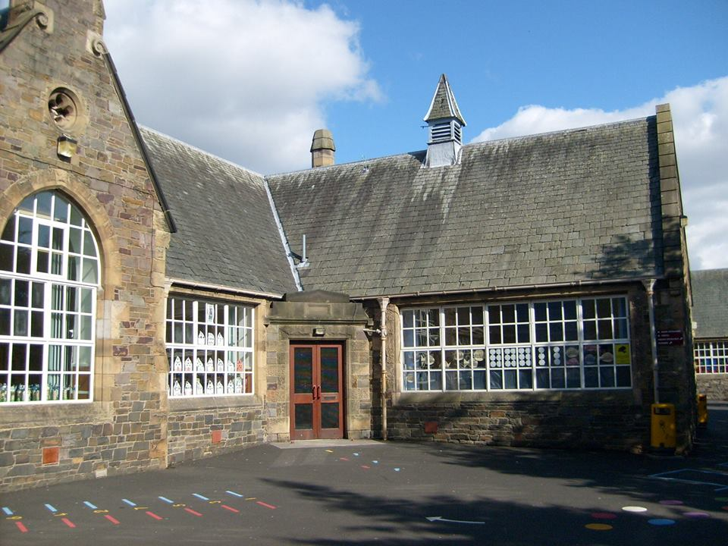
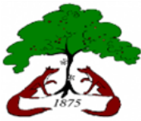

Literacy & English
- Class Novel (George’s Marvellous Medicine)
- Weekly Reading Book – RWI and Reading World
- Writing – tools for writing, handwriting, class novel writing and narrative writing.
- Talking & listening – getting to know each other, Newsround discussions and Pixar shorts conversations
- Weekly Spelling – starting w.c. 7th September

Term 1

Modern Languages
Introductions – hello, how are you? Good morning/evening, months of the year and birthdays, colours and classroom objects

Science & Social Studies
- Drugs and Substance Misuse (look at H&W)
- Human body – Pupil Choices

Technologies
- Responsible use of iPads to support and enhance learning across the curriculum.
- Use photo, video & audio functions on iPads

Expressive Arts

- Exploring using different materials and textures
- Using different lines/shape

Numeracy & Maths
- Place Value of 2- and 3-digit numbers
- Number Sense and Order
- 2D and 3D Shapes
- Estimating and Rounding
- Addition and Subtraction
- Maths and its impact on the World (Past, Present and Future)
- Mental Math Skills

Health & Wellbeing
- Drugs and Substance Misuse – keeping ourselves safe and relations to safety using class novel.
- Equity and Diversity – rights and responsibilities, needs and wants
- Care for My Body – related to Human Body (IDL)
Bright Futures
Blossom
at Burgh

