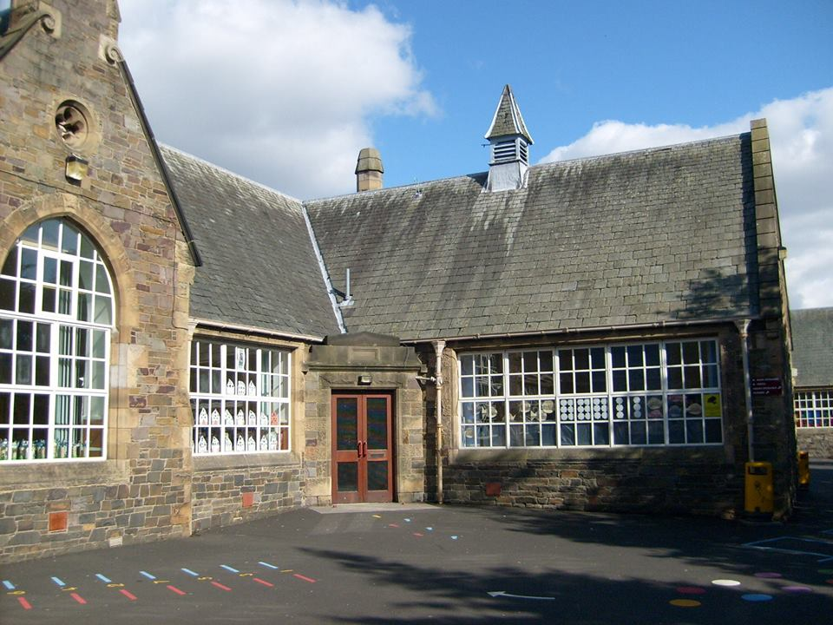
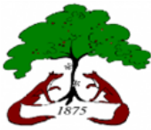

Literacy & English
- Tools for writing, handwriting and narrative writing.
- Weekly reading – Read Write Inc and Literacy World
- Exploring spelling patterns and strategies to spell unfamiliar words.
- French – We are learning the French vocabulary for classroom objects, family, friends, pets and food and drink.

Term 1

Science & Social Studies
- Senses and Body Systems
- Equality and Diversity

Religious & Moral Education
- Christian beliefs – using the context of Christmas

Technologies
- Responsible use of iPads to support and enhance learning across the curriculum.
- Use photo, video & audio functions on iPads

Expressive Arts

- Art, exploring using different materials and textures. Using different line/shape.
- Weekly music lessons
- Christmas show

Numeracy & Maths
- Counting development
- Place Value
- Estimation and Rounding
- Addition and Subtraction
- Properties of 2D and 3D objects.
- Mathematics and it’s impacts on the world past present and future.
- Multiplication & Division
- Angles symmetry and transformation.
- Patterns and Relationships

Health & Wellbeing
- Drugs and Substance misuse.
- Care for my body.
- Building resilience
- Large and small ball skills
- Swimming lessons (Primary 4)
Bright Futures
Blossom
at Burgh

