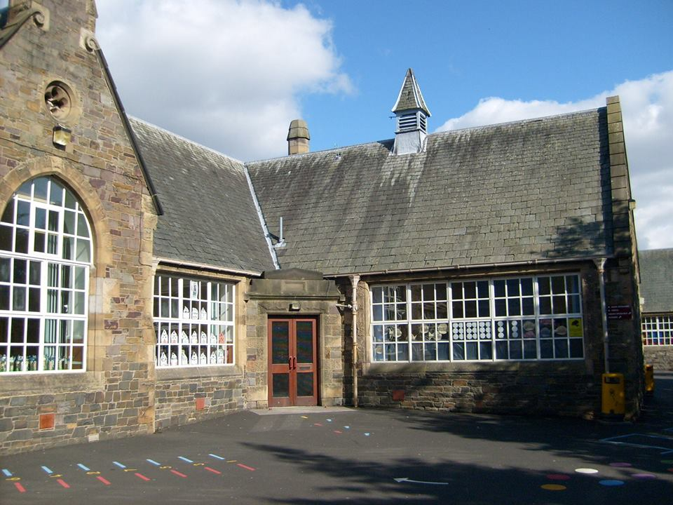
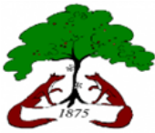

Literacy & English
- Story of the week.
- Tricky words.
- Formation of upper and lower-case letters.
- Set 1 and 2 sounds
- Sentence structure and punctuation.
- Use of Colourful Semantics to build sentences.
- Expanding sentences.
- Retelling stories in the correct order.
- Descriptive Writing.
- Tricky words and alien words.
- Using our sounds knowledge to decode words.
- French – how are we feeling, numbers, days of the week, months of the year and birthdays.

Numeracy & Maths
- Basic Maths Facts
- Place Value
- Counting Development
- Estimation and Rounding
- Addition and Subtraction
- Multiplication and Division
- Properties of 2D and 3D shapes
- Angles, Symmetry and Transformation.
- Patterns and Relationships.
Term 1

Health & Wellbeing

- Use of iPads to support and enhance learning across the curriculum.
- Taking and viewing photos on the iPad.
- Scanning QR codes to access websites and apps.

Technologies

- Use of pupil of the day to promote kindness.
- Learning about resilience and different strategies we can use when things are difficult.
- Zones of regulation
- Exploring life cycles.
- Discussing how we care for our body.
- Identifying safe and unsafe situations.
- Discussing what to do in an emergency or unsafe situation.

Religious & Moral Education
- Exploring Christian beliefs related to Bible stories.
- Exploring Christian practices and traditions.

Expressive Arts
- Art & Design – line drawing, use of pattern and shape, identifying primary colours and junk modelling.

- Drama – taking on the role of characters from our story of the week and drama games.

- Music – P2 will have a weekly music session with Miss Scott.

Physical Education
- Travelling in different directions with balance and control.
- Travelling at different speeds with control when using equipment.
- Throwing and catching skills.

Science
- Identifying different bones and organs in our body.
- Exploring the 5 senses.
- Learning about germs and the importance of handwashing.
Bright Futures
Blossom
at Burgh

