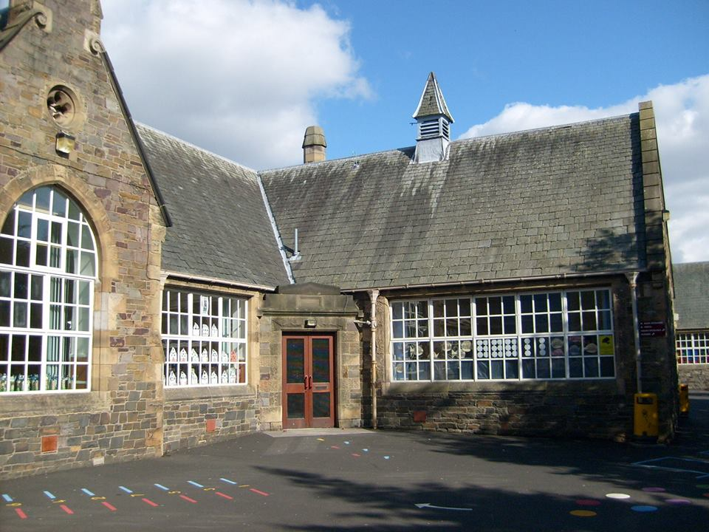

- All about numbers to 10
- 2D shape
- Data handling
- Sorting
- Symmetry
- Making patterns

Numeracy & Maths
- Pre reading skills
- Fine motor skills for writing
- Talking for writing
- Talking about stories
- Listening skills games
- Sharing experiences, feelings, and ideas.
- French – greetings

Literacy & English
Autumn Term: Block 1 & Block 2
B1: We all have rights/zones
We are learning about the UNCRC.
We are learning skills for P1 including daily routines, keeping ourselves safe and sharing and turn taking.
We are learning about resilience and different strategies we can use when things feel difficult.
Revisiting learning about the zones of regulation and talking about emotions.
PE: We are playing games to help us learn about following instructions and basic movement and how to move safely.

Health & Wellbeing

Other topics will be developed from children’s play and interests and will be shared via Showbie as they develop.
Responsive Topic
Autumn Topic
From observation the children have been talking about Autumn which will be the next topic.
Responsive Topic: Autumn
Transition topic
Using the inspiration of Mouse’s Big Day by Lydia Monks to support transition into Primary 1.

Mouse’ Big Day
Bright Futures
Blossom at Burgh

