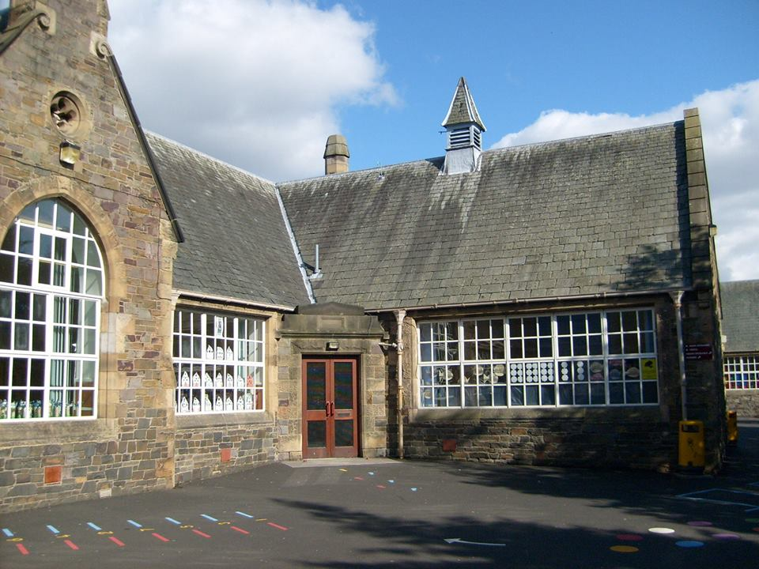
Block 2

Expressive Arts
- Music- We will be performing as a class band using a variety of tuned and un-tuned instruments to learn various parts in a piece of ensemble music. We will learn to follow written music notation, focus on our own parts when our peers are playing alternative parts and learn to listen and play music by ear.

Numeracy and Maths
- Problem Solving
- Decimals
- Measure
- Fractions and percentages
- Data Handling
- Multiplication and division
- 3D Shape

Health and Wellbeing
In PE we will be learning to:

- perform and repeat a sequence of at least 4 moves with changes of level, direction & speed, demonstrating quality movement
- use the apparatus to enhance performance & try new, challenging skills

Food and Hygiene:
- Explain which foods belong in each section of the Eatwell plate
- Describe the journey of food from source to plate
- Safe and hygienic preparation of food

Technologies
- Use of iPads to support and enhance learning across the curriculum
- Online safety
- Enhance knowledge of digital technologies to collect and analyse relevant information then organise it in an appropriate way.

Religious & Moral Education
- World Religions and Morality: Practices and Traditions

Science
- We will explore what air resistance, water resistance, friction, static and magnetic forces do to an object and make sure we know how to conduct a fair test.
Bright Futures
Blossom
at Burgh

Literacy & English
- Poetry
- Scots Language
- Informative writing
- Reading for information
- Exploring spelling patterns and strategies to spell unfamiliar words

- French –weather, the school day and hobbies

