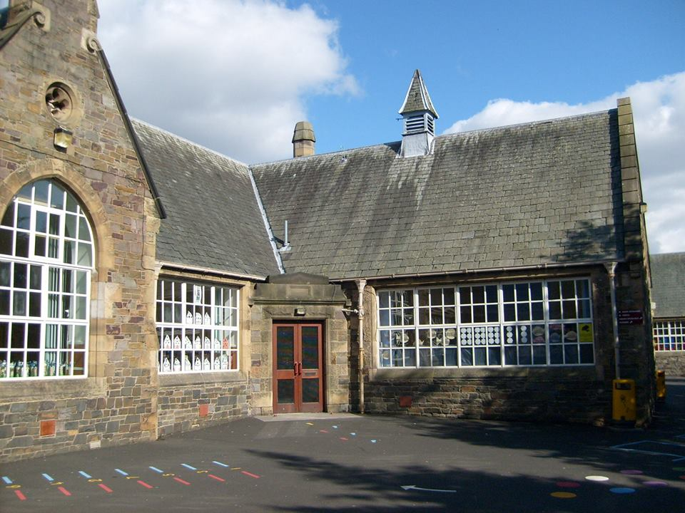

Literacy & English
- Poetry, a block of poetry covering all the different styles and building a bank of poems to showcase at end of block.
- Scots’ poetry around Burns night.
- Move into narrative and functional writing.
- Writing an adventure story.
- Continue to develop our writing in French.

Spring Term
Music
Continuing with music teacher on a Thursday.

Health & Wellbeing
- Food and Hygiene
- Zones of regulation.
- Relationships
- Resilience

HWB - PE
- Building confidence and skills through small sided team games.
- Throwing and catching
- Demonstrating resilience and determination
- Practice skills with development coordination and fluency.
- A block of gymnastics then leading into athletics.

Numeracy & Maths
- Counting development and mental maths.
- Problem Solving
- Fractions, Decimals
- Division and Multiplication
Bright Futures
Blossom
at Burgh

Technologies

- Use of iPads to support and enhance learning across the curriculum
- Children will learn what makes a fun and exciting quiz, then design and build their own multiplication quizzes in Scratch.
- They will explore different Scratch blocks and effects to make their quizzes interactive and visually engaging.
- This will be continued with Mrs Ainslie

Social Studies
Through the ages of Scotland.
Wars of independence.
Jacobites.
And current modern Scotland.
Comparing, diet, food, hygiene, architecture, religion and more. This will be an IDL topic as we will explore, HWB, Numeracy, RME and technology all intertwined within this social studies topic.

