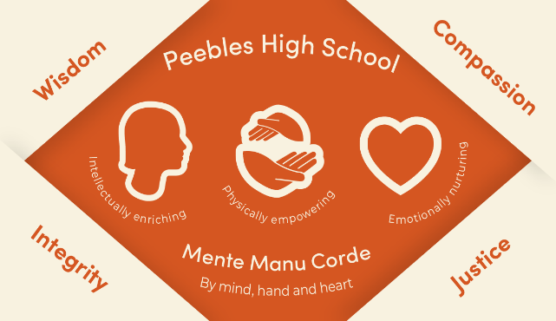

Peebles High School LGBT+ Policy

We strive to make Peebles High School a safe and inclusive school for all of our community. A place where diversity is not only respected but also celebrated. Schools have a duty to promote the safety and wellbeing of all young people in their care, including lesbian, gay, bisexual and transgender pupils and those experiencing homophobic, biphobic or transphobic (HBT) bullying.
We are committed to promoting a positive and diverse culture in which all people are valued and supported to fulfil their potential irrespective of their age, disability, race, religion or belief, gender-reassignment, sex or sexual orientation.
We recognise our responsibilities under the Equality Act 2010 and are committed to promoting the equality and diversity of all those we work with including our young people, staff, parents/carers and visitors.
We oppose all forms of unlawful and unfair discrimination, bullying and harassment and will make every effort to challenge this as we comply with the requirements of the Act and its subsequent provisions.

Equality Act 2010
Schools are required to eliminate discrimination on the grounds of sexual orientation and gender reassignment. This includes tackling HBT bullying. Schools are also required to advance equality of opportunity and foster good relations. This means that schools should go beyond tackling HBT bullying and take proactive steps to promote respect and understanding of LGBT+ people and issues.
Peebles High School aims to:
- provide an inclusive environment in which LGBT+ young people, families and staff are valued and respected
- promote understanding of and support the needs of LGBT+ young people, families and staff
- highlight LGBT+ awareness and issues through the provision of an inclusive curriculum
- tackle, monitor and record homophobic, biphobic and transphobic language and bullying.
The school seeks to achieve these aims by:
- Ensuring that school policies, protocols and practices are inclusive and supportive of LGBT+ people and explicitly state that HBT language and bullying are unacceptable
- providing training to staff to support LGBT+ young people, developing an LGBT+ inclusive curriculum and tackling HBT language and bullying
- providing support structures and information/resources to LGBT+ young people on LGBT+ issues and support services
- providing young people with LGBT+ inclusive Relationships and Sex Education (RSE), opportunities to discuss gender identity and sexuality, and including LGBT+ people and themes in the Personal and Social Education (PSE) and wider curriculum where relevant
- providing ways for young people to report HBT language and bullying, monitoring (including through young people and staff surveys) and recording HBT language and bullying, as well as ensuring that pupils are aware that HBT language and bullying are unacceptable
- ensuring that the school contains books with LGBT+ themes and that any assemblies, projects or displays which celebrate diversity or tackle bullying are LGBT+ inclusive
- maintaining an inclusive school dress code
- ensuring that gendered aspects of school life are avoided where possible

Identities and ‘Coming Out’
Being LGBT+ is not a child protection issue or wellbeing concern in itself. We will respect the confidentiality of a young person who may not have told their family about their sexual orientation or gender identity. Inadvertent disclosure could cause needless stress for the young person or could put them at risk. In this case it is best to not disclose information to parents/carers unless there is a clear safeguarding issue.
We recognise all LGBT+ identities at Peebles High School and we do not deny the existence of a valid identity. We will also not question an identity or regard it as a ‘phase’. In particular, we recognise the existence of people who are:
- Asexual
- Bisexual
- Cisgender
- Gay
- Straight/heterosexual
- Gender fluid
- Intersex
- Lesbian
- Non-binary
- Pansexual
- Queer
- Transgender
We also acknowledge that many people do not fit under specific labels. We recognise gender and sexual orientation as spectra.
See appendix 1 below for definitions of these terms

Transgender and Non-binary Young People
We recognise that young people who are transgender or non-binary can have specific needs. As with other identities, we do not deny existence, question an identity or regard it as a ‘phase’. Thus when any young person ‘comes out’ as transgender (including non-binary), we will consider:
- what they would like to happen
- how they would like to be known in school eg. which pronouns they would like to use
- what facilities they would like to use and what can be put in place to make them feel most comfortable (considering toilet, PE changing rooms etc)
- whether and how class teachers/school staff will be informed (with the permission of the young person)
- engagement with parent(s)/carer(s) and the young person’s wishes/ impact of sharing information
- signposting to relevant supports (GP, LGBT+ group, other agencies etc)
- name/identity changes on the school information management system (SEEMIS) and parent(s) and carer(s) consent for this change
- consider support for siblings and other family members if necessary.

In all cases, we will be led by the needs and views of the young person. The document ‘Supporting Transgender young people - Guidance for schools in Scotland’ will be used for further guidance if required.
In all our decision making we will seek to balance the needs of those with protected characteristics. If a complaint is raised, we will take time to be proportionate and reasonable in our response, considering the issue raised carefully and any evidence of risk/detrimental impact on young people.

Appendix 1 – Definitions of Terms
Asexual: A person who does not experience sexual attraction. Asexual people can experience platonic attraction but may have no sexual desire or need within their relationships.
Bisexual: A person who is emotionally and/or physically attracted to people of more than one gender or regardless of gender. Historically definitions of bisexual refer to ‘an attraction towards men and women’ however many bisexual people recognise that there are more than two genders. Some people use the term ‘Pansexual’ to more explicitly recognise more than one gender.
Cisgender: Individuals who have a match between the gender they were assigned at birth, their bodies and their personal identity. In other words those who are not, or do not identify as transgender.
Gay: Someone who is emotionally and/or sexually attracted to people of the same gender.
Gender Fluid: A person whose gender is not static and changes throughout their life. This could be on a daily/weekly/monthly basis and will be different for everyone.
Straight/Heterosexual: Someone who is emotionally and/or sexually attracted to people of the opposite gender.
Intersex: Someone whose biological sex is different in some way from what is traditionally considered clearly male or female. There are many ways to be intersex, it is not just about external genitalia. It can also be as a result of differences in reproductive systems, chromosomes, or hormones. This may be apparent at birth or become apparent later in life - often at puberty, or when trying to have a child. Some people never find out that they are intersex.
Lesbian: A girl or woman who is emotionally and/or sexually attracted to other girls or women.
Non-Binary: Gender identities that are not exclusively male or female. People can be both male and female, neither, or their gender may be more fluid (not fixed and changeable over the course of time). Many view gender as a one dimensional spectrum with male on one end, female on the other and non-binary in the middle – but the reality is that gender is often more complex.
Pansexual: A person who is emotionally and/or sexually attracted to anyone regardless of gender (see also “Bisexual”).
Transgender: An umbrella term for those whose gender identity or expression differs in some way from the gender assigned to them at birth and conflicts with the ‘norms’ expected by the society they live in. Included in the overall transgender umbrella are transsexual people, non-binary gender identities and cross-dressing people.
Queer: An umbrella term used for diverse sexual orientations or gender identities that are not heterosexual and do not fit within a gender binary. It may be used to challenge the idea of labels and categories such as lesbian, gay, bisexual or transgender. It is important to note that it is an in-group term and may be considered offensive to some people.

