Peebles High School
Child Protection and Safeguarding Policy

Child protection has to be seen in the context of the wider Getting it right for every child (GIRFEC) and the UN Convention on the Rights of the Child. GIRFEC promotes action to improve the wellbeing of all children and young people in eight areas. These wellbeing indicators state that young people must be: healthy, achieving, nurtured, active, respected, responsible, included and, above all in this context, safe. The primary indicator for child protection is to keep a child safe.
Scottish Government
Principles:

- The protection of young people in the care of Peebles High School is of paramount importance in all that we do as a school.

- A Child Protection Officer (CPO) shall be identified clearly and this should be made clear to all staff in the school. Our CPO is Mrs Donna Moretta.

- All staff shall receive training in Child Protection at regular intervals according to the recommendations of the SBC Child Protection Policy. Well maintained records of this training shall be kept by the Child Protection Officer.

Procedure at Peebles High School:

Any concerns about a young person’s welfare must be immediately discussed with the Child Protection Officer – Mrs Donna Moretta (Depute Headteacher). In her absence, report concerns to Mr Campbell Wilson (Headteacher).

If a young person makes a disclosure, the following must be adhered to:

- Reassure the young person that the school will support them
- Do not promise to keep the information confidential; explain that details must be passed on
- Listen, rather than ask direct questions. Do not ask any leading questions.
- Be calm and non-judgemental even if the information is serious and upsetting
- Make brief and accurate notes
- Act on the information immediately. Speak to Mrs Donna Moretta or (or Mr Campbell Wilson)
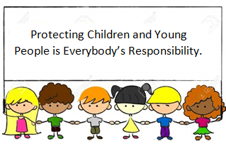
Not in school and concerned about a young person in the Scottish Borders community?
Phone 01896 662787
Out of hours, phone 01896 752111

