Every child is supported to achieve real success.

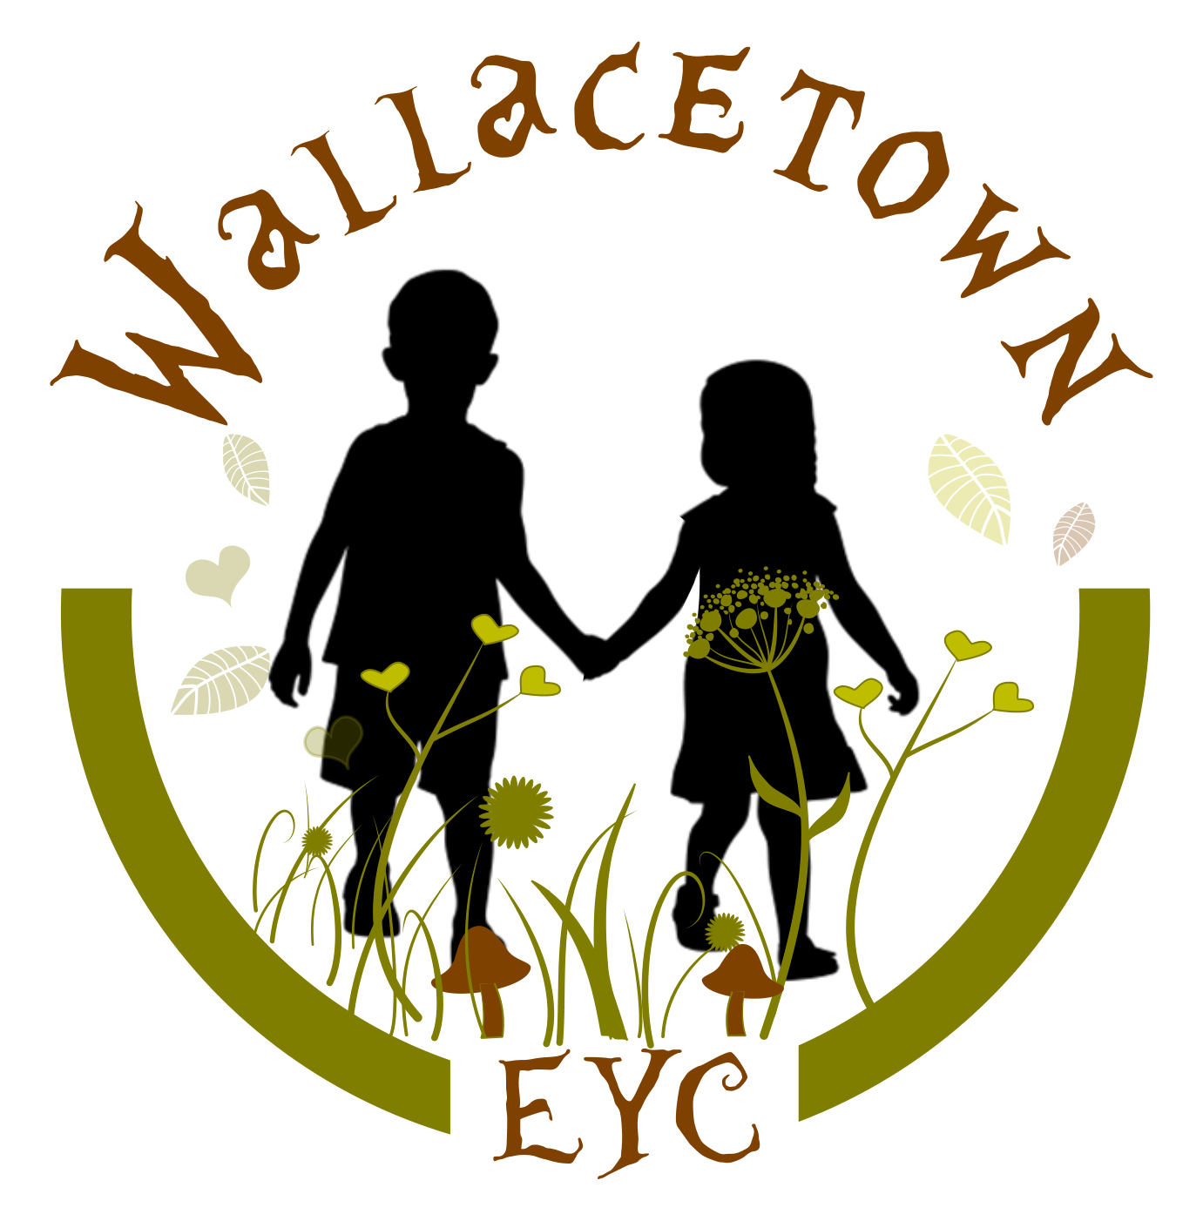

Wallacetown Early Years Centre

IMPROVEMENT PLAN: 2026-2027

Vision
At Wallacetown Early Years Centre we will strive to become an Early Years Centre capable of continuous improvement, renowned for the high quality of early learning, childcare, support and nurture that we provide for our children and families.
In all aspects of our work, we will: -

Inspiring all creative learners to make an impact on their world

Values
As part of our development work we have created ‘Learning Values’. Which we promote within the centre:
- Supportive
- Aspirational
- Nurturing

Aims
At Wallacetown Early Years Centre we aim to:
- Offer inclusive early learning and childcare of the highest quality.
- Provide a warm and caring environment in which every child feels safe, secure and happy.
- Provide high quality education and care where children can explore and investigate an imaginative and challenging environment.
- Provide carefully planned learning activities which meet the individual needs of each child enabling them to make progress and develop at their own pace.
- Value each child as an individual and to help them develop self-confidence and a sense of achievement.
- Establish close working relationships with parents and carers to enable them to feel fully involved in their child’s learning and development.
- Maintain the highest standards of education and care through a commitment to the professional development and ongoing training of all members of staff.

- Placing the human rights of every child and young person at the centre of education
- Improvement in children and young people’s health and wellbeing
- Closing the attainment gap between the most and least disadvantaged children and young people
- Improvement in employability skills and sustained positive school leaver destinations for all young people
- Improvement in attainment, particularly in literacy and numeracy

National Improvement Framework Priorities

Children's Services Plan

Education Services Priorities

South Ayrshire Council Plan
- Included, engaged and involved
- Delivering excellence in learning, teaching and assessment
- Transforming our curriculum
- Towards a self-improving education system

- Spaces and Places
- Live, Work, Learn
- Civic and Community Pride

- The Promise: Our commitment to Keeping the Promise
- Family: Promoting whole family wellbeing
- Included: Early help for children with diagnosed or undiagnosed additional support needs
- Healthy: Improving physical and mental health for children and young people
- Voice: Involving children and young people in local decision making
- People: Collaborative learning and reflection opportunities for the work force

Priority 1: To embed the Rights of the child across the EYC
What Outcomes Do We Want To Achieve? | How Will We Achieve This?  (Intervention Strategies) | Lead Person | Start and Finish Dates | How Will We Measure Impact On Children and Young People?  (Include Where Possible Current Measure and Target)
To embed a right-based culture where every child is recognised as a rights holder. | - Reinforce rights through the use of visuals, songs and stories.  - Consistently use rights-respecting language throughout practice.  - Children and families will feel safe, included and listened to. | Gillian  Barbara  Sarah | August-October  September 2026-June 2027 | Maintain Gold accreditation for RRSA.  Cultural pop-up café’s will provide opportunities to celebrate diversity.  Children’s voice captured through decision making and responsive learning opportunities across the EYC.  Number of children contributing to each planning cycle will increase.
To support children to participate in decisions affecting their learning and daily experiences | - Include children in decision-making processes throughout the session.  - Include parents/carers in consultation of experiences which affect children’s learning and daily experiences.  - Plan learning opportunities which promote participation, inclusion and equality.  - Engage in learning about rights through newsletters, displays and workshops and informal sessions.  - Continue to develop positive and nurturing relationships with all service users which result in improved outcomes for children and families. | Gillian  Barbara  Arlene |  | Consultation with children and partners, recognising feedback and suggested development opportunities – ‘You said, we did’  Displays capturing children’s engagement and voice.  Increase in family engagement through learning journals.  Playroom monitoring and timely feedback provided with identified next steps.  Attendance monitoring to ensure children are supported to achieve.

Priority 2:- To improve planning to support children’s holistic learning and development across the EYC

What Outcomes Do We Want To Achieve? | How Will We Achieve This?  (Intervention Strategies) | Lead Person | Start and Finish Dates | How Will We Measure Impact On Children and Young People?  (Include Where Possible Current Measure and Target)
Develop a consistent and high-quality approach to planning informed by children’s choice, interest, observation and assessment. | - Pilot 2-3 planning model in accordance with RTA and local authority.  - Provocations will enhance children’s interests and scaffold learning.  - Planning reflects children’s needs and interests  - Children’s planned group times will be evidenced and planned in line with identified next steps and individual targets.  - Quality assurance processes carried out to develop high-quality planning.  - Playroom observations.  - Planning will consider children’s interests and information noted in all about me.  - All about Me’s will be reviewed at each care plan meeting to ensure they are relevant and meaningful.  - New care and learning plan to be implemented in line with the authority model  - Timely identification of barriers to learning and staged interventions which may be required. | Julia  All staff  Leadership team | August 26 – December 26  August 26 – June 27 | Children’s voice will be recognised through planned opportunities and outcomes.  Padlet used to evidence experiences.  Monthly monitoring and tracking of children’s learning journals to quality assure experiences and opportunities.  Termly monitoring of planning to quality assure and timely feedback given.  Clear links to children’s personal care and learning targets.  Child and Parent feedback.  Data monitoring – Monthly tracking milestones to ensure progression and provide timely support.
Children are motivated in their play and learning through high-quality learning and teaching. | - Literacy and numeracy outdoor audit to provide baseline and evidence progress.  - Strengthen outdoor learning experiences. | Brenda/Arlene  All staff | August 26 – October 26 | Children’s learning observations will increase across the outdoor play spaces and wider community.
Increased family learning opportunities to support literacy and numeracy | - Parents included in the planning process  - Home learning bags to provide support and/or challenge | Arlene  SEYP’s | August 26 – June 27 | Parents voice will be gathered to inform the planning process.  Planning will be shared with children and families.

Priority 3 : To develop Leadership and Management
What Outcomes Do We Want To Achieve? | How Will We Achieve This?  (Intervention Strategies) | Lead Person | Start and Finish Dates | How Will We Measure Impact On Children and Young People?  (Include Where Possible Current Measure and Target)
High quality leadership visible across the EYC and considers leaders at all levels. | Management visible and accessible to children, families and staff team.  Robust induction processes  A welcoming environment  Feedback implemented meaningfully to evidence positive changes across the EYC.  Shared vision and values with service users. | Leadership team  All staff | August 26 – June 27 | Positive feedback from families and wider service users.  Consultation to inform self-evaluation process.
Strengthen leadership capacity by developing staff, enhancing quality assurance processes and ensuring positive outcomes for children and families. | Equity and Excellence Lead to undertake leadership training.  Clear roles and remits for all staff.  Leadership training opportunities  Staff included in the self-evaluation process and identification of next steps to support improvement.  Leadership roles which compliment improvement plan and evidence practice and impact.  Mentoring opportunities for staff.  Staff check in’s to support wellbeing and skills progression.  Regular team meetings to allow staff to share ideas and contribute views. | Arlene  Leadership team  All staff | September 26 – June 27  August 26 – June 27 | Share the learning opportunities with staff team.  Improvement priorities will be shared with families and ensure they are part of the ongoing improvement process.  Termly leadership evaluations and next steps identified.  Team meeting minutes will demonstrate increased staff participation in decision-making.

