]
Every child is supported to achieve real success.

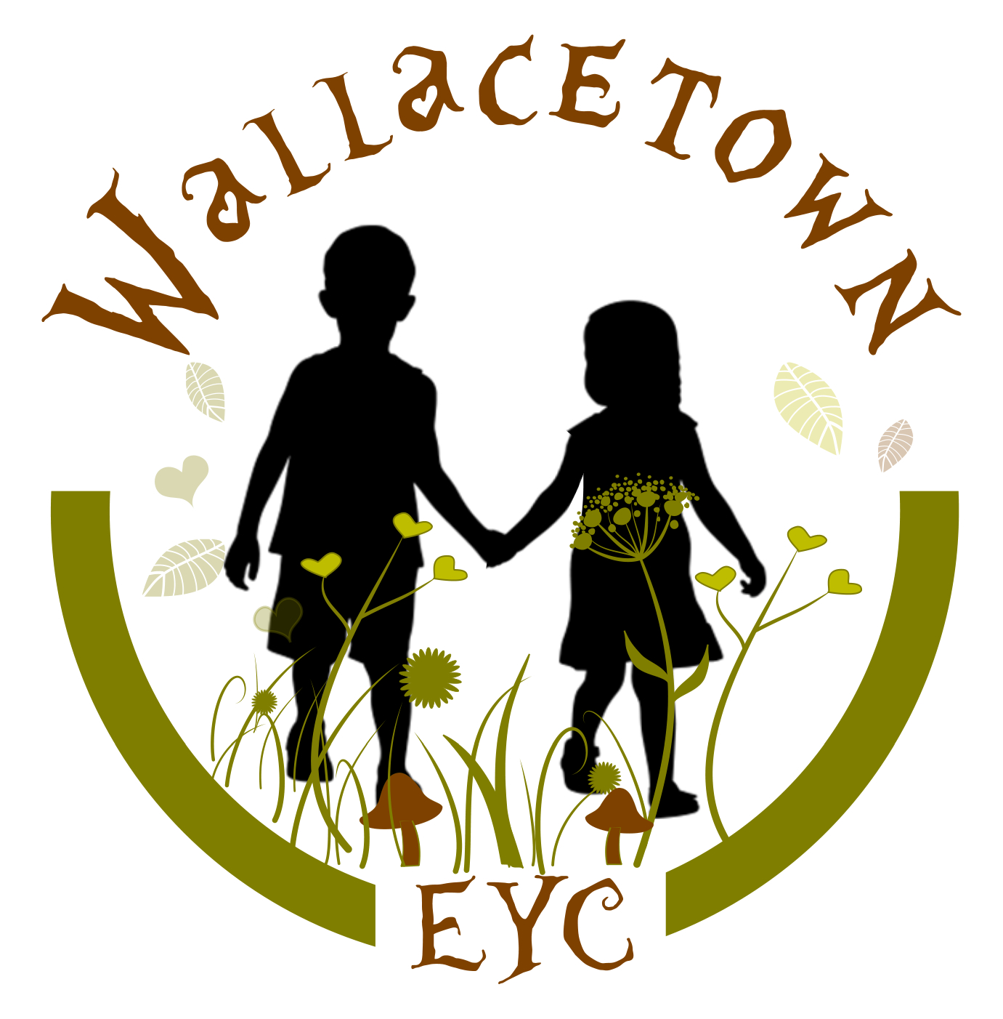

Wallacetown Early Years Centre

IMPROVEMENT PLAN: 2025-2026

Vision
At Wallacetown Early Years Centre we will strive to become an Early Years Centre capable of continuous improvement, renowned for the high quality of early learning, childcare, support and nurture that we provide for our children and families.
In all aspects of our work, we will: -

Inspiring all creative learners to make an impact on their world

Values
As part of our development work we have created ‘Learning Values’. Which we promote within the centre:
- Supportive
- Aspirational
- Nurturing

Aims
At Wallacetown Early Years Centre we aim to:
- Offer inclusive early learning and childcare of the highest quality.
- Provide a warm and caring environment in which every child feels safe, secure and happy.
- Provide high quality education and care where children can explore and investigate an imaginative and challenging environment.
- Provide carefully planned learning activities which meet the individual needs of each child enabling them to make progress and develop at their own pace.
- Value each child as an individual and to help them develop self-confidence and a sense of achievement.
- Establish close working relationships with parents and carers to enable them to feel fully involved in their child’s learning and development.
- Maintain the highest standards of education and care through a commitment to the professional development and ongoing training of all members of staff.
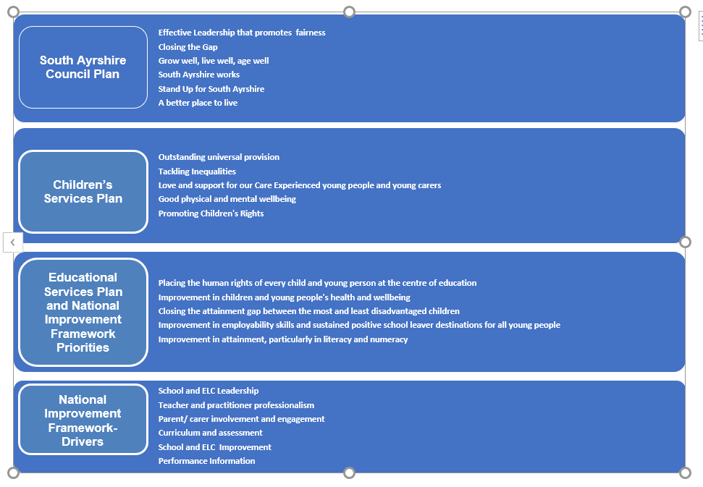

Priority 1: Empowering children to becoming global citizens to care for their planet
What Outcomes Do We Want To Achieve? | How Will We Achieve This?  (Intervention Strategies) | Lead Person | Start and Finish Dates | How Will We Measure Impact On Children and Young People?  (Include Where Possible Current Measure and Target)
To support children to develop economic skills to increase their knowledge and help them to support a sustainable future | - Increase outdoor learning to enable children to learn about nature and the impact we have as human beings  - Pop up cultural café to improve financial literacy  - Encourage entrepreneurial thinking and projects  - Provide experiences to engage children in learning across BGE  - Solar panel project |  |  | Increase % of children obtaining good using the 4 stages of progress from 60% to 80%  8 pop up cultural cafes
Improve community for families and children whilst improving children’s knowledge and understanding of caring for their environment and reduce the carbon footprint | - Solar panel project  - Development of community garden  - Grow own fruits and vegetables  - Litter picking events  - Funding to support community change  - Reduce and reuse waste  - Recycling opportunities |  |  | Increase usage of recycled materials  Decrease waste  2 litter picking events  Increase knowledge of sustainability for children attending – baseline data

- Priority 2:- Integrate creative activities into experiences for children to foster a holistic learning environment

What Outcomes Do We Want To Achieve? | How Will We Achieve This?  (Intervention Strategies) | Lead Person | Start and Finish Dates | How Will We Measure Impact On Children and Young People?  (Include Where Possible Current Measure and Target)
Through incorporating the arts, music, storytelling, etc children will engage in creative thinking and reinforce learning in literacy, creative writing, maths and health and wellbeing | - Film making  - Collaborative photography work  - Wallacetown band  - Music lessons children and families  - Wallacetown Community Arts festival  - Big production – link with partners  - Collaborative art projects and gallery displays  - Circus skills  - Increased sensory expereinces |  |  | Improved literacy (currently 77%) increase to 85%, maths (currently 60%) increase to 80% and HWB (currently 77%) increase to 85% for all pre school children obtaining good across 4 stages of progress  90% of children scoring 4 or above on Leuven scale for wellbeing
Improve literacy and numeracy through creativity for example music, drama, photography, arts and crafts | - Helicopter Stories  - Talk for writing  - Baking/cooking linked to multi-cultural pop up café  - Gardening and growing |  |  | Improved literacy, and maths with 80% of pre-school children obtaining good across 4 stages of progress

Priority 3 : Family learning and early intervention

What Outcomes Do We Want To Achieve? | How Will We Achieve This?  (Intervention Strategies) | Lead Person | Start and Finish Dates | How Will We Measure Impact On Children and Young People?  (Include Where Possible Current Measure and Target)
Promote family learning to support positive outcomes for children and families and increase confidence | - Focused stay and play sessions  - Support workshops to include toilet training, behaviours, language development, etc  - Maths and literacy workshops  - Work with speech and language to support pre-conception and ante-natal work  - Family wellbeing days  - Strategies blogs/vlogs  - Peep sessions  - Wee chinwag |  |  | 8 focused stay and play sessions  2 maths and 2 literacy workshops running for a 4 week period  Increase confidence of parents – establish baseline  Reduced RFA to SLT  2 x family wellbeing days  4-6 blog/vlogs sent out
Early intervention work to support child development and help to reduce the poverty and attainment gap | - Home visits before nursery commences  - Establish closer links with HV  - Poverty proofing strategies to support families build on existing work and partnerships  - Budgeting workshops  - Access funding through solar panel project  - Ensure attendance is promoted  - Solihull approaches  - Build on wider achievement work  - Secret Santa shop – links with Salvation Army, Night before Christmas  - Gift donations |  |  | All new 2 year olds home visit and new 3-5 year old  2 budgeting workshops  Family support projects supported via funding – baseline to be established  Increase confidence of parents – establish baseline  Baseline of any increased finances through income maximisation

