**Every child is supported to achieve real success.**

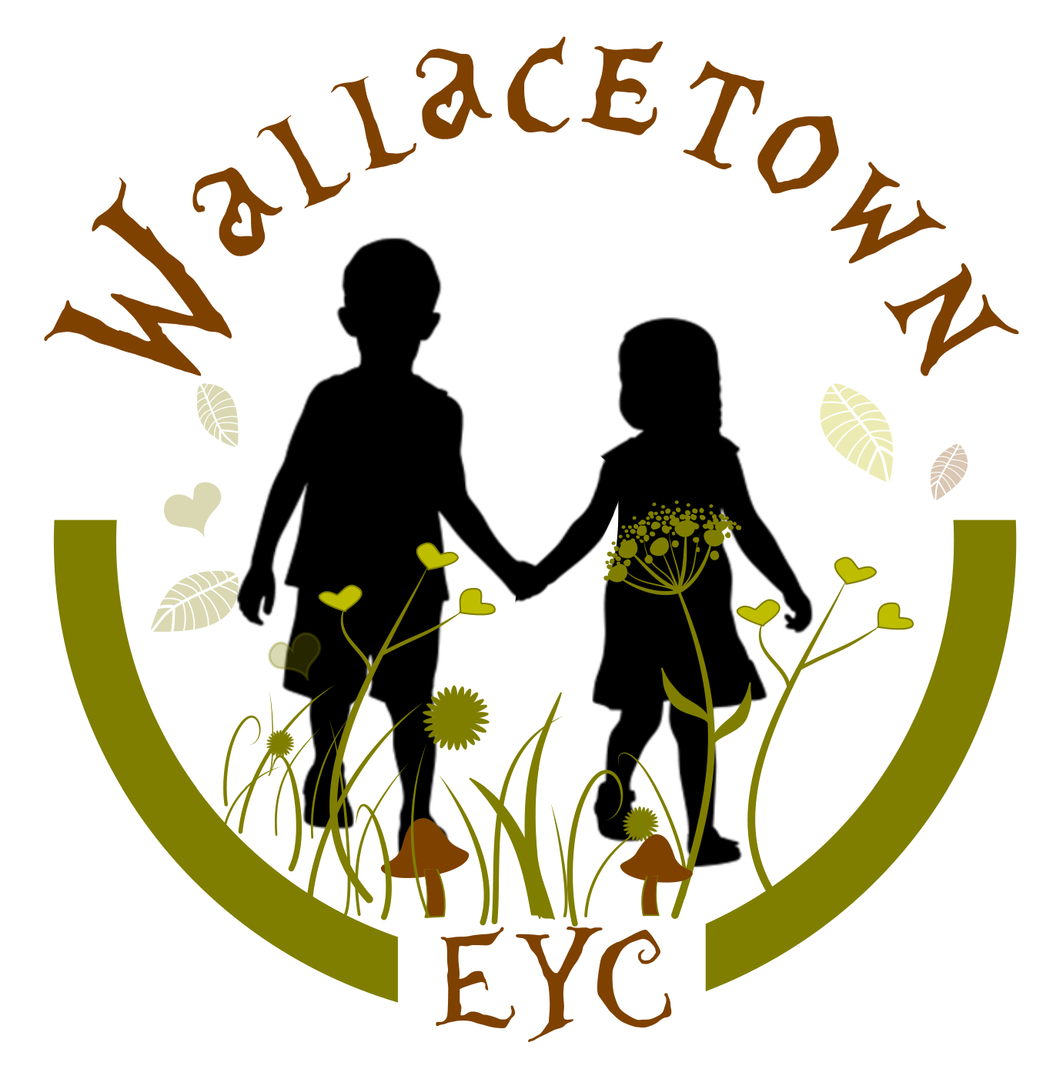



**Wallacetown Early Years Centre**

|  |
| --- |
| **IMPROVEMENT PLAN: 2024-2025** |

**Vision**

At Wallacetown Early Years Centre we will strive to become an Early Years Centre capable of continuous improvement, renowned for the high quality of early learning, childcare, support and nurture that we provide for our children and families.

In all aspects of our work, we will: -

***Inspiring all creative learning to make an impact on their world.***

**Values**

As part of our development work we have created ‘Learning Values’. Which we promote within the centre:

* Nurturing
* Aspirational
* Supportive

**Aims**

At Wallacetown Early Years Centre we aim to:

* Offer inclusive early learning and childcare of the highest quality.
* Provide a warm and caring environment in which every child feels safe, secure and happy.
* Provide high quality education and care where children can explore and investigate an imaginative and challenging environment.
* Provide carefully planned learning activities which meet the individual needs of each child enabling them to make progress and develop at their own pace.
* Value each child as an individual and to help them develop self-confidence and a sense of achievement.
* Establish close working relationships with parents and carers to enable them to feel fully involved in their child’s learning and development.
* Maintain the highest standards of education and care through a commitment to the professional development and ongoing training of all members of staff.

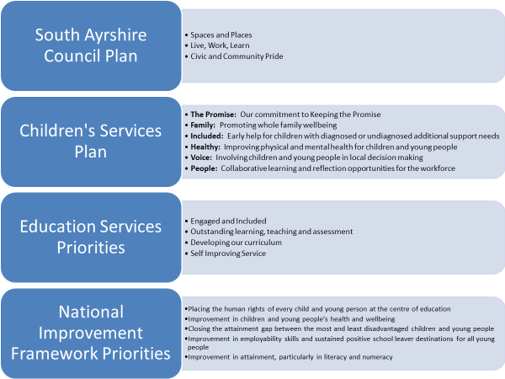

|  |  |  |  |  |
| --- | --- | --- | --- | --- |
| **Priority 1: Improvement in children’s health and wellbeing** | | | | |
| **What Outcomes Do We Want To Achieve?** | **How Will We Achieve This?**  **(Intervention Strategies)** | **Lead Person** | **Start and Finish Dates** | **How Will We Measure Impact On Children and Young People?**  **(Include Where Possible Current Measure and Target)** |
| To support and nurture children with a particular focus on **Nurture Principle 1** - Children’s learning is understood developmentally | * Share I am a reader. Learner, writer, counter, etc documents with families * Workshops/information sessions to support understanding of child development * Baseline of parental knowledge * Home link support to families | SIP Nurture Group |  |  |
| To support and nurture children and staff’s wellbeing **Nurture Principle 3- Nurture is important for the development of wellbeing** | * SIP nurture group and action plan | SIP Nurture Group |  |  |
| To ensure children are attending, engaged in learning and making progress | * Monitor attendance and lateness * Attendance hero records * Lateness video * Improvement Project SAM | EEL  DM  CM |  |  |

|  |  |  |  |  |
| --- | --- | --- | --- | --- |
| **Priority 1: Improvement in children’s health and wellbeing** | | | | |
| **What Outcomes Do We Want To Achieve?** | **How Will We Achieve This?**  **(Intervention Strategies)** | **Lead Person** | **Start and Finish Dates** | **How Will We Measure Impact On Children and Young People?**  **(Include Where Possible Current Measure and Target)** |
| To support and nurture children with a particular focus on **Nurture Principle 1** - Children’s learning is understood developmentally | * Share I am a reader. Learner, writer, counter, etc documents with families * Workshops/information sessions to support understanding of child development * Baseline of parental knowledge * HV support to families | Barbara Bell | June 2024 – June 2025 | Baseline knowledge of child development  3 x workshops  60% of families accessing the documents  20% families accessing support services HV |
| To support and nurture children and staff’s wellbeing **Nurture Principle 3- Nurture is important for the development of wellbeing** | * SIP nurture group and action plan * Questionnaire to staff * Implement and develop resilience alphabet * Develop children’s knowledge, understanding and growth of their own personal target * Wellbeing activities/voice for children and staff | Barbara Bell  SIP Nurture Group | Sept 24 – June 25 | Baseline measure of wellbeing for children and staff  70% amount of children accessing and understanding their PCP targets  5 x wellbeing sessions |
| To ensure children are attending and engaged in learning | * Monitor attendance and lateness * Attendance hero records * Lateness video | Diane  Whole team |  | 90% attendance (current measure 83%) |
| *All staff will support learners with experience of care to provide improved wellbeing and in turn work towards improved educational outcomes.* | Staff training and implementation of The Promise  Monitor and track attendance  Monitor and track wider achievement  Monitor and track milestones | Martin | Aug 2024 – June 2025 | *Staff within school will develop an awareness and understanding of The Promise and all that is included within the national guidance and local authority initiatives, this will be enhanced by completing The Promise Education Award by June 2025.*  *80% of LAC/LAAC children will achieve 8 milestones across HWB, Literacy and Numeracy*  *LAC/LAAC children will have 90% attendance* |

|  |  |  |  |  |
| --- | --- | --- | --- | --- |
| **Priority 2:- Improvement in attainment – Mathematics and Numeracy, closing the attainment gap**    | | | | |
| **What Outcomes Do We Want To Achieve?** | **How Will We Achieve This?**  **(Intervention Strategies)** | **Lead Person** | **Start and Finish Dates** | **How Will We Measure Impact On Children and Young People?**  **(Include Where Possible Current Measure and Target)** |
| Improve children’s maths and numeracy experiences | * Nurturing maths training for 2 additional staff * Whole centre approach to nurturing maths including environments, experiences * Work with families to support understanding of maths and numeracy * Improve maths through digital learning | Arlene Mercer | Sept 2024 – June 2025 | QA focus  95% of all pre-school children will obtain 8 milestones in maths and numeracy (current measure 89%)  Baseline staff confidence to increase by 30%  Baseline parent confidence in maths and numeracy to increase by 60%  5 x maths sessions delivered |
| To continue to focus on closing the attainment gap by identifying and supporting children who are vulnerable learners. | Focused stay and play maths and numeracy  Monthly update and review of progress on developmental milestones  Day to day milestones tool  Digital learning experiences in maths and numeracy | Arlene Mercer | August 2024 – June 2025 | **90%** of pre-school children in Quintile 1 & 2 achieved 8 M & N milestones (current measure 82% |

|  |  |  |  |  |
| --- | --- | --- | --- | --- |
| **Priority 3 : Improvement in children’s Communication and Language, closing the gap**    | | | | |
| **What Outcomes Do We Want To Achieve?** | **How Will We Achieve This?**  **(Intervention Strategies)** | **Lead Person** | **Start and Finish Dates** | **How Will We Measure Impact On Children and Young People?**  **(Include Where Possible Current Measure and Target)** |
| To improve phonological skills in children | CLPL - phonological awareness, early speech sound development, word aware (SARS)  South Ayrshire’s phonological toolkit (SARS)  Moderation of milestones across cluster  Parent workshops on phonological awareness, attention and listening and how to support progress at home  SLT drop in sessions for families  Improvement methodology project – see PDSA  Communication audit | Martin Gilmour  Cluster Project |  | 80% of pre-school children will meet milestone,  “I can identify words that start with the same sound” (current measure 54%)  80% of children will achieve milestone, “I can recognise letter symbols” (current measure 61%)  Communication friendly environments level 3, 4 & 5 |
| To continue to focus on closing the attainment gap by identifying and supporting children who are vulnerable learners. | Monitoring and tracking children’s progress with a focus on children in SIMD focus on Q1 and Q2  Monthly meetings to review children’s’ milestones progress using individual milestone data  BGE holistic tracker  Targeted group tracker  Day to day milestone activities supporting communication and language | Arlene | Aug 2024 – June 2025 | 87% of pre-school children in Quintile 1 & 2 will meet 8 milestones in communication and language (current measure 82%) |

|  |  |  |  |  |
| --- | --- | --- | --- | --- |
| **Priority 4 : Improving wider achievement and skills for lifelong learning and work**    | | | | |
| **What Outcomes Do We Want To Achieve?** | **How Will We Achieve This?**  **(Intervention Strategies)** | **Lead Person** | **Start and Finish Dates** | **How Will We Measure Impact On Children and Young People?**  **(Include Where Possible Current Measure and Target)** |
| Ensure all children have access to wider achievement skills to prepare them for lifelong learning and work | Establish a baseline of wider achievement being accessed by all children  Work with partners, communities to provide wider achievement skills within nursery  Develop a skills tracker for wider achievement  Establish staff skills and what skills/talents staff have to enhance wider achievement | Diane Hodge | Aug 2024 – June 2025 | Baseline created.  Monitor and track wider achievement.  80% of children access wider achievement |