]
Every child is supported to achieve real success.

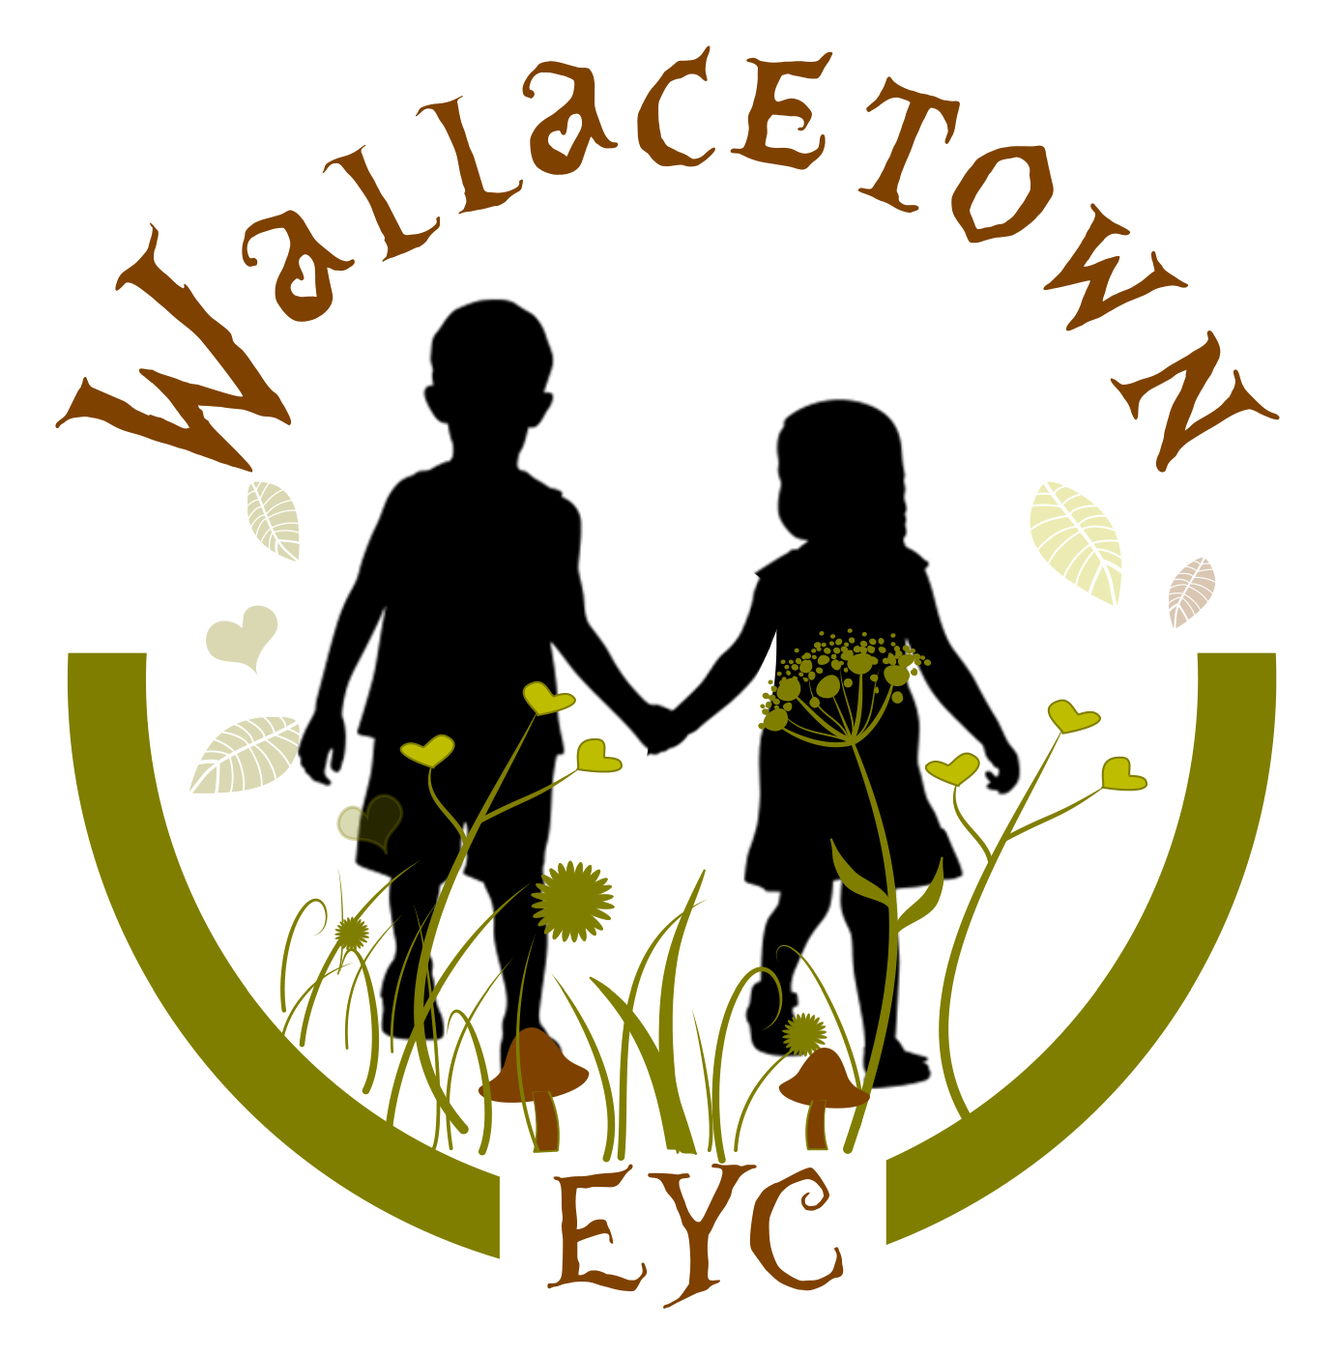
Wallacetown Early Years Centre

IMPROVEMENT PLAN: 2023-2024

Vision
At Wallacetown Early Years Centre we will strive to become an Early Years Centre capable of continuous improvement, renowned for the high quality of early learning, childcare, support and nurture that we provide for our children and families.
In all aspects of our work, we will: -

Be a centre of inclusion that supports all families and their needs. We will offer a caring, nurturing and welcoming, fun space where children can learn, develop and reach their full potential. Engage with children, families and the wider community to learn and grow together. Be the best we can be to ensure our children thrive.

Values
As part of our development work we have created ‘Learning Values’. Which we promote within the centre:
- Respect
- Honesty and trust
- Engagement
- Happiness and Wellbeing
- Inclusive

Aims
At Wallacetown Early Years Centre we aim to:
- Offer inclusive early learning and childcare of the highest quality.
- Provide a warm and caring environment in which every child feels safe, secure and happy.
- Provide high quality education and care where children can explore and investigate an imaginative and challenging environment.
- Provide carefully planned learning activities which meet the individual needs of each child enabling them to make progress and develop at their own pace.
- Value each child as an individual and to help them develop self-confidence and a sense of achievement.
- Establish close working relationships with parents and carers to enable them to feel fully involved in their child’s learning and development.
- Maintain the highest standards of education and care through a commitment to the professional development and ongoing training of all members of staff.
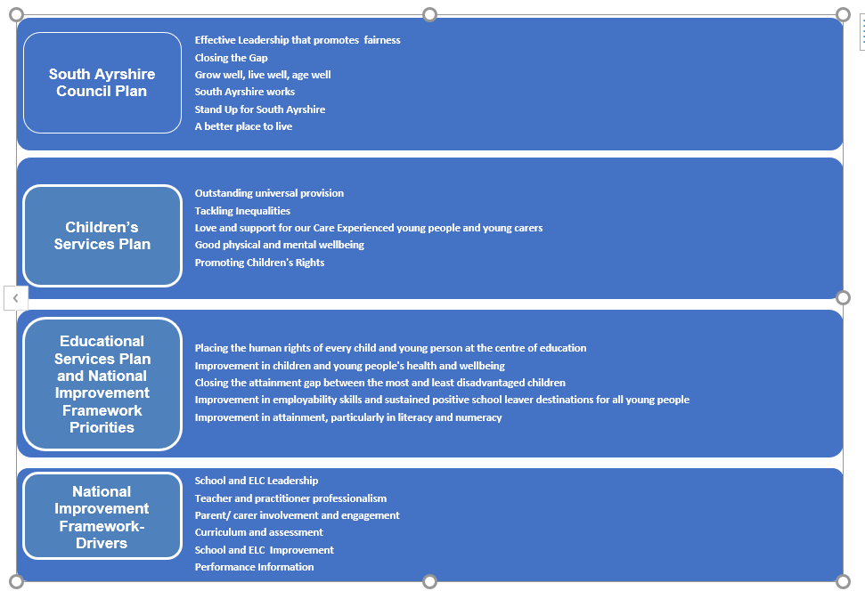

Priority 1: Improvement in children’s health and wellbeing
What Outcomes Do We Want To Achieve? | How Will We Achieve This?  (Intervention Strategies) | Lead Person | Start and Finish Dates | How Will We Measure Impact On Children and Young People?  (Include Where Possible Current Measure and Target)
To support our children to understand and implement their rights | Continue work of RRS working Group and create a new action plan  Include additional partnerships e.g. Working for Wallacetown, global links  Obtain Gold status  Develop children and parent’s rights group to improve involvement of children and families in development of centre  3 staff on training for rights gold award | RRS Group  Gillian & Barbara leading  All staff  Community partners | Sept 23 – April 24 | Gold status achieved  SIP action plan  3 staff trained RRS gold status  All staff ensure almost all children’s voices are embedded in LJ
To support and nurture children with a particular focus on Nurture Principle 1 - Children’s learning is understood developmentally | SIP nurture group and action plan  Develop milestones and learning pathway for children with ASN  CLPL on developmental needs of all children  Language pathway to supports parents and children’s language development | SIP nurture group  Partners – Nurture team, EPS | Oct 2023 – June 2024 | Action plan  All children with ASN will be tracked and assessed effectively  All children with ASN will have milestones tracked showing progress  Baseline for ASN milestones  80% of children with ASN will achieve 8 milestones
To support children’s emotional regulation with a specific focus on Nurture principle 5 “All behaviour is communication” | - Implement Improvement methodology project  - Use Nurture tools developed by centre including restorative practice framework  - PATHs  - Music sessions | SIP nurture group  KW |  | 95% of pre-school children will have the capacity to understand and control emotions through meeting milestones, “I can express my emotions appropriately” (Current measure 91%)

Priority 2:- Improvement in attainment – Mathematics and Numeracy, closing the attainment gap

What Outcomes Do We Want To Achieve? | How Will We Achieve This?  (Intervention Strategies) | Lead Person | Start and Finish Dates | How Will We Measure Impact On Children and Young People?  (Include Where Possible Current Measure and Target)
Improve children’s maths and numeracy experiences | CLPL  Stay and Play session to support maths and numeracy for parents  Home link opportunities  Day to Day milestones tool  Monthly audit of milestone progress  Quality assure planning of maths and numeracy  Digital learning experiences in maths and numeracy | CM/DCM  Karen (Centre Numeracy Lead)  All staff  Digital leads | Sept 2023 – June 2024 | 90% of pre-school children will meet milestone,  “I can understand information in simple graphs and charts” (previous measure 81%)  “I recognise ‘how many’ without having to count” (previous measure 78%)  “I can recognise numerals 0-10 “ (previous measure 75%).
To continue to focus on closing the attainment gap by identifying and supporting children who are vulnerable learners. | Focused stay and play maths and numeracy  Monthly update and review of progress on developmental milestones  Day to day milestones tool  Digital learning experiences in maths and numeracy | CM/DCM  Karen (Centre Numeracy Lead)  All staff  Digital leads | August 2023 – August 2024 | 90% of pre-school children in Quintile 1 & 2 achieved 8 M & N milestones (current measure 85%)

Priority 3 : Improvement in children’s Communication and Language, closing the gap

What Outcomes Do We Want To Achieve? | How Will We Achieve This?  (Intervention Strategies) | Lead Person | Start and Finish Dates | How Will We Measure Impact On Children and Young People?  (Include Where Possible Current Measure and Target)
To improve children’s language skills | CLPL - phonological awareness, early speech sound development, word aware (SARS)  South Ayrshire’s phonological toolkit (SARS)  Parent workshops on phonological awareness, attention and listening and how to support progress at home  SLT drop in sessions for families  Improvement methodology project  Communication audit | Martin, Arlene, Alexis  SLT |  | 90% of pre-school children will meet milestone,  “I can identify words that start with the same sound and I can recognise letter symbols” (current measure 88%)  95% of children will achieve milestone, “I can talk about my learning” (current measure 81%)  80% of 16 children identified will score 4 or above using the Leuven scale (no previous data)  Communication friendly environments
To continue to focus on closing the attainment gap by identifying and supporting children who are vulnerable learners. | Monitoring and tracking children’s progress with a focus on children in SIMD focus on Q1 and Q2  Monthly meetings to review children’s’ milestones progress using individual milestone data  BGE holistic tracker  Targeted group tracker  Day to day milestone activities supporting communication and language | Diane/Martin  Karen, Alexis | Oct;Feb;May | 90% of pre-school children in Quintile 1 & 2 will meet 8 milestones in communication and language (current measure 75%)

Priority 4 : Family Learning

What Outcomes Do We Want To Achieve? | How Will We Achieve This?  (Intervention Strategies) | Lead Person | Start and Finish Dates | How Will We Measure Impact On Children and Young People?  (Include Where Possible Current Measure and Target)
Improve parent confidence and involvement in their children’s learning | Survey to all families gathering views on needs of the local community  Partnership open day – building community links  Family workshops  Action plan | Martin Gilmour | August 23 – May 24 | Survey results – parents’ confidence and involvement  Data for attendance from families  Case studies

