Elaine Marshall, Centre Manager  A message from the Centre  Our commitment to Learning Journals allows staff to communicate with families in a safe and meaningful way about children’s progress.  I hope that our information leaflet has answered any questions you may have but please contact us at the centre if you wish to discuss learning journals further.  You can visit the Learning Journals website for more information. | Who We Are  About Us  Wallacetown Early Years Centre provides early learning and childcare provision to families within South Ayrshire.  Contact Us  Phone: 01292 612164  Email: Wallacetown.mail@south-ayrshire.gov.uk  Web: https://blogs.glowscotland.org.uk/sa/wallacetowneyc/  Learning journals Parent information Leaflet  Find out more online  learningjournals.co.uk | Learning journals Parent information Leaflet  - Copyright property of Learning Journals
What are Learning Journals?  A virtual world…  Learning Journals are a more interactive way for your child’s key worker or key workers to share your child’s progress with you. It has many wonderful features and is already successfully used within nurseries and early years centres across Ayrshire, where it has gained positive feedback from parents and carers. | How do I use it?  It couldn’t be easier. Once you have given permission for your child’s profile on Learning Journals we will set up their profile and send you a link to access it via email, click on the link in the email and download the Learning Journals app on to your phone. You can then view your child’s profile any time.  “Keeps me completely up to date with what he’s doing.”  Parent Testimonial  Is it just for viewing?  Not at all, you can like and comment on your child’s work and progress and interact with their learning. You can also post pictures to your child’s profile of their progress at home and share their achievements.  Is it safe?  Your child’s profile is completely safe. Two family members, agreed between parents and staff, can access the profile. | 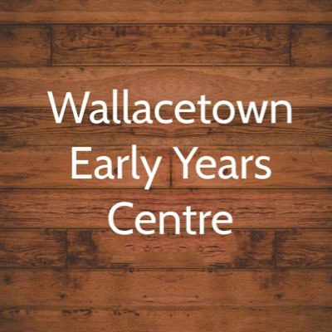  Brochure created by Wallacetown EYC  What if I don’t want to use Learning Journals?  This brochure gives you useful information about Learning Journals, however the choice is yours and we respect and accept your decision.  Will I get their profile another way?  There is another option another but you not through regular emails showing your child’s progress as it happens. As we are now offering 1140 hours, Learning Journals will keep you updated in a safe and meaningful way on your child’s progress at nursery.

