Supporting children to be all they can be

**What does this mean for my child? Cont ..**

5. Where support is required we will then have a meeting with other professionals along with the family, this is called a TAC (Team around the Child) meeting.

4. A TAC meeting normally called by the named person or lead professional, allows your family and other professionals to discuss an action plan for your child.

5. Following a TAC meeting a minute of the meeting will be forwarded to all attendees.

Should you have any further questions or queries please speak to Diane or Elaine

**Wallacetown Early Years Centre**

**Queen Street**

**Ayr**

**KA8 0DW**

**Tel: 01292 612164**

**Centre manager—Elaine Marshall**

**Depute manager—Diane Hodge**

**Article 6**

“I should be supported to live and grow”

**Article 29 –**

“I have the right to an education which develops my personality, respect for others’ rights and the environment.”

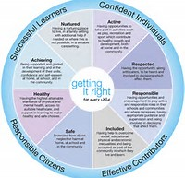

**Wallacetown Early Years Centre**

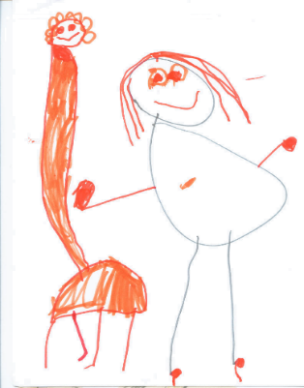

“intervening early and as soon as possible to tackle problems emerging for children, young people and their families.

Early intervention may occur at any point in a child or young person’s life”.

**What happens if my child needs help at nursery?**

**Staged Intervention** is the assessment and planning framework used both in South Ayrshire and widely across Scotland to identify and plan interventions for children to ensure that they receive the earliest, most inclusive and least intrusive response to their needs.

Stage 1 (a) - support within the nursery

Stage 1 (b) - additional support is required for your child

Stage 2 - support from a universal service e.g. health, education, educational psychology

Stage 3 - specialist support from a multi-agency team

Stage 4 - a specialist placement within or out with the authority for your child

**What does this mean for my child?**

1. Staff observe children when in nursery to ensure they are meeting all their developmental needs.

2. If any concerns are raised by parents or staff the child will be observed and regular discussions will take place

3. Following these discussions staff will discuss what services are available to support if required and a request for assistance will be completed.

4. Once the request for assistance is completed you will be invited in to input your views and sign the request for assistance before it is sent to the requested service. Management will then explain the process and what staged intervention means for your child

**Why might my child need support?**

Children may require additional support for a variety of reasons and may include those who:

¨ have motor or sensory impairments

¨ have experienced a bereavement

¨ have a learning disability

¨ are looked after by a local authority

¨ are living with parents who are abusing substances

¨ are living with parents who have mental health problems

¨ have English as an additional language

¨ have emotional or social difficulties

¨ are on the child protection register

Please note that this list is not exhaustive