TROON PRIMARY SCHOOL

AND EARLY YEARS CENTRE

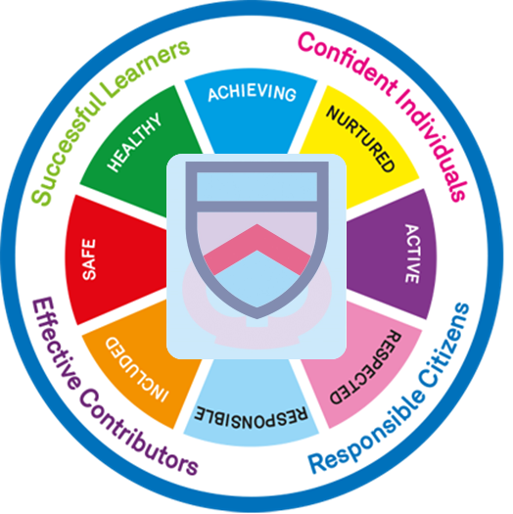

digital learning and ICt POLICY

OCTOBER 2021

Success through effort

TROON PRIMARY SCHOOL & EYC

Digital Learning and ICT POLICY

'Scotland’s learners live in a world that is changing at a rapid pace. We know that many of our children and young people will be employed in jobs that do not exist yet, and that the need for digital skills will only become more pronounced in the future.'
Consultation on the development of a Digital Learning and Teaching Strategy for Scotland, Sep 2016.

RATIONALE

At Troon Primary School we are fully committed to the use of Digital Learning and Technologies to develop, support, supplement and enhance the learning and teaching experience for our pupils. We aim to develop pupil's digital capabilities and ensure that they are given opportunities to develop the knowledge and skills needed for learning, life and work. As technology is ever evolving and changing our vision at Troon Primary School is to ensure that our learners have the skills necessary to use and work with the digital technologies of the 21st century.

At Troon our aim is to:
- Use the potential of Digital Technologies to support learning and teaching across the curriculum.
- Support pupils in developing confidence and skills in using digital technologies.
- Encourage pupils to be aware of and be informed about the applications and implications of ICT in society.
- Ensure all learners are educated about cyber resilience, cyber security and internet safety.
- Embrace new developments in digital technologies and use these in an innovative and imaginative way.
- Our Relationships Policy is centred on our school rules and vision and values:

READY – RESPECTFUL - SAFE

VISION
Together we will create a positive environment to nurture, support and challenge everyone to fulfil their potential

RESPECT, RESPONSIBILITY, EQUALITY, HONESTY, HAPPINESS
OUR DIGITAL VALUES

LEARNING AND TEACHING

At Troon Primary School all planning strives to address the Experiences and Outcomes outlined for digital technologies within the Curriculum for Excellence. Our scheme of work is progressive and challenging. It builds on the pupils’ prior learning and further extends their knowledge and understanding. Teachers plan and assess learning and teaching in accordance with the Curriculum for Excellence Experiences and Outcomes, Benchmarks and using our Progression Pathways and our school created Digital Skills booklets.

Digital technologies are used by teachers to present work, support and enhance learning and teaching, and to consolidate and assess knowledge and skills of all pupils, with appropriate support and differentiation built in. A thorough and careful approach to teaching skills and allowing children and young people to apply these skills in everyday contexts is essential in what we do. Use of digital technologies permeates all curricular areas and is an essential tool in effective learning and teaching, with children and young people developing progressive skills throughout their school career and promoting 21st Century Learning Design.

Both our long term and weekly planning are digitally stored on the staff shared area, allowing for collaborative planning across a stage and a level and ensuring we move towards paperless planning.

ADDITIONAL SUPPORT NEEDS

Pupils with Additional Support Needs will use appropriate technologies to support and enhance their learning across the curriculum. These support interventions include hardware and software packages, learning apps, and accessibility tools. Identified pupils also have access to laptops across the curriculum. This is detailed in their individual StInt paperwork.

DIGITAL DEPRIVATION

Pupils or families identified as having insufficient access to digital devices or connectivity will be supported by the school and the local authority with the loan of a Chromebook or iPad. These devices are managed centrally with the school’s Digital Champion acting as coordinator between the authority and families. Please refer to the digital deprivation documentation from South Ayrshire Council for further information. (Appendix 1)

HOMEWORK
All pupils from P1 to P7 access homework via Teams with P1-3 posting their homework via the Sharing the Learning Channel and P4-7 submitting homework via the assignments tab. (Appendix 2)
CAREER-LONG PROFESSIONAL LEARNING

All staff have access to the Microsoft Educator Center and therefore have the skills and knowledge to pass onto the pupils. All members of staff are given opportunities through CLPL to continually develop and enhance their knowledge and skills in this continually developing and changing area.

This is done through external and internal training events, and through sharing good practice within our school and cluster. All staff undertake appropriate and up to date Data Protection and Cyber Security training annually through Coast Modules.

PARTNERSHIP AND COMMUNICATION

We are committed to enhancing our communication with parents / carers and partner agencies through the use of Digital Technologies, our school website and our Twitter feed. Paper communication is at a minimum. The majority of information and communication is through email, Groupcall, newsletters, shared through Twitter, the school website and our YouTube channel. Our EYC also communicate through SeeSaw.

INTERNET SAFETY AND CYBER RESILIENCE

All pupils are made aware of issues related to online safety, sharing personal information, Cyber Bullying and safe use of social media. Our progressive Digital Skills booklets focus on internet security and Cyber Resilience skills. The whole school take part in school, local and national events related to safe and appropriate use of Digital Technologies.

Internet Safety and Cyber Resilience permeates our daily teaching. Annually we have a whole school focus on Safer Internet Day in February, Cyber Scotland week and National Digital Learning week in May. All staff undertake appropriate and up to date Data Protection training through Coast Modules. We have also created a bank of resources to support families with cyber security and keeping safe online which is shared with all families annually. (Appendix 3)

PUPIL DIGITAL LEADERS

Pupil Digital Leaders represent the school at local and national learning events. They are responsible for organising and leading whole school events, sharing skills and knowledge and supporting peers in the use of digital technologies.

ASSEMBLIES AND CELEBRATING SUCCESS

Our celebration assemblies take place once per month, where one child from each class is chosen for the ‘Ready, Respectful, Safe’ certificate. This child will have consistently gone ‘over and above’ in our school rules and values linked to digital learning.

The children are announced at the beginning of the assembly and receive a certificate and a golden house point, they can then take their seat on ‘the best seats in the house’ for the duration of the assembly. The children will then attend ‘Hot Chocolate Friday’, sharing a hot chocolate and a chat with the Head/Senior Leadership Team.

RESOURCES

Each classroom has two networked computers and an ActivPanel. Our Early Years Centre, ICT suite, General Purpose Room and Pupil Support Rooms also have an Activpanel We have a full Class ICT Suite which all pupils access weekly with an additional 15 laptops and 30 iPads which are used to enhance learning and teaching.
Both gym halls are equipped with an ActivPanel and a sound system.

At Troon Primary, children are encouraged from an early age to understand and work with:
- Computers (desktops and laptops)
- Promethean ActivPanels
- Digital cameras
- Beebots, Earls and Code-a-pillars
- The internet
- iPads
- Button recorders and Easi-Speak microphones
- We also access the councils Digital Library, where we have access to 360° cameras, Spheros, class VR kits
- Full use of Microsoft Accessibility tools
- Teams for virtual learning and homework
- Glow
Support for Learning
- Talking pens
- Individual Laptops for identified pupils
- Access to laptops to support interventions on a daily basis
- Full use of Microsoft Accessibility tools
- Software packages to support and enhance learning

All Digital devices are managed by the Digital Champion and maintained by South Ayrshire Council

ACCEPTABLE USE POLICY
Please refer to South Ayrshire Council’s Acceptable Use Policy. (Appendix 4)

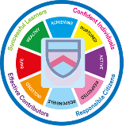

APPENDICES

Appendix 1
Digital Deprivation Policy
Appendix 2
Troon Primary Homework
Appendix 3
Cyber Security and internet safety
Family ICT Support
Appendix 4
Acceptable Use Agreement

TROON PRIMARY SCHOOL AND EYC
DIGITAL LEARNING AND ICT POLICY
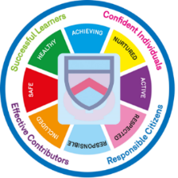

sUCCESS THROUGH EFFORT

