
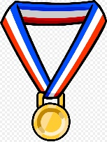
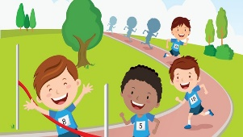
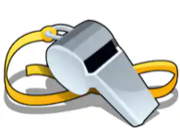


TROON PRIMARY SCHOOL & EARLY YEARS CENTRE

Home Learning: Primary 3 and 4

Literacy
Reading | Writing
We are learning to select an unfamiliar text to read for enjoyment.  We are learning to answer literal and inferential questions about a text. | We are learning to gather information and write a report
Task: Reading Comprehension & Listening and Talking  Reading Challenge  - Read for enjoyment for at least 20 minutes each day. Try and select a non-fiction text about a sport or sporting event.  - Discuss this book with a family member at home or on your class Teams page.  Read – Task: Reading Comprehension (Select 1 or 2 tasks)  Mild- Read ‘Sports Day’ then answer the comprehension questions in your ‘work-from-home’ jotter or use the worksheet provided.  Or  Medium- Read ‘The Terrible Trip Up’ then answer the comprehension questions in your ‘work-from-home’ jotter or use the worksheet provided.  Or  Spicy- Read ‘Andy Murray’ then answer the comprehension questions in your ‘work-from-home’ jotter or use the worksheet provided.  Rocket Challenge- Reading & Spelling  Using your local environment find and read as many words related to Sport. You may wish to do this on your daily walk. Look at buildings, sign posts and other facilities in the town.  Write a list of the sporting words you find or take a picture.  For example:  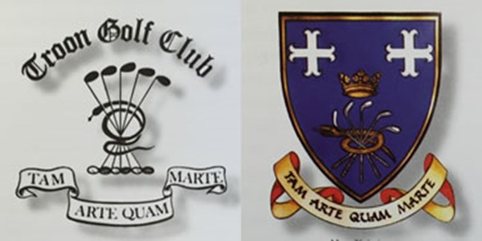  Share your list or pictures on your class Teams page. | Task:  Interview a friend or member of your family about a sport you know they play or enjoy watching. Take a note of their answers and write a short report about their sport. You can choose your own questions but here are some ideas.  - How did your interest in this sport start?  - How long have you enjoyed playing/watching ________?  - What is it you enjoy about it?  - What skills or qualities do you need for this sport?  - How would you sell this sport to others?  Your report should  - Be written in full sentences with capital letters and full stops  - Be written in 3rd person. For example, My dad started going to football games because his Dad used to take him when he was little.  - Have answers to at least 3 questions but no limit.  - Include at least 1 question not given above.  For a challenge  - Write a few sentences for each answer and take a new paragraph for each question.  - Try and vary how you start your sentences.  Now you have finished, decorate your report with some drawings of the sport. We look forward to reading your sport reports.
Numeracy | Nutrition/Healthy Eating
We are learning to estimate how long or heavy an object is, or what amount it holds, using everyday things as a guide, then measure using appropriate instruments and units. I can name some 3D objects. I am beginning to develop a sense of how long tasks take. | We are learning to Investigate the range of foods available I can discuss how they contribute to a healthy diet. We are learning to experience a sense of enjoyment and achievement when preparing simple healthy foods and drinks.
Complete the Weights and Measure Sports Scavenger Hunt on the sheet below ticking each item as you go.  Work through the tasks on the sheet below using different instruments such as a ruler or measuring jug to work out your answers.  Measuring your pulse: Ask someone to help you find your pulse on your wrist, neck or chest – whichever is easiest for you to feel and count. Set a timer for 1 minute and count how many times your heart beats in a minute and record on the sheet.  Next you are going to complete the table by estimating how many star jumps, squats and hops you think you could do in one minute. Then you are going to do each activity counting how many of each you can do in one minute and then in the final column you are going to say whether or not you thought it was a good guess.  All that exercise should have got your heart pumping quickly so take your pulse rate again and record it straight after your exercises. What do you notice? | Task: Fruit and Vegetable Characters  Create a ‘fruity or fun vegetable character’. Use your imagination to bring your food to life. Experiment with healthy snacks to create a character of your choice! Please use the following pictures to inspire your ideas.  This activity can also be done through drawing! Please remember to share your wonderful creations on class teams!  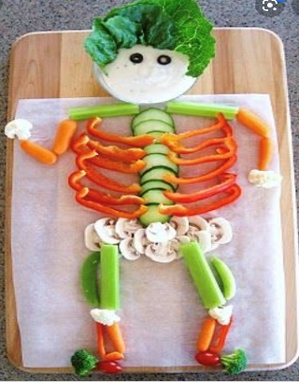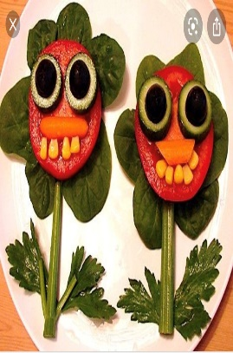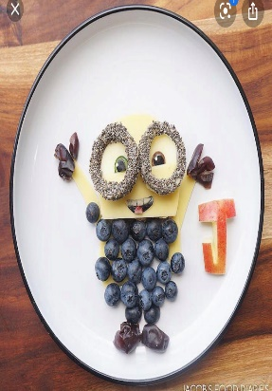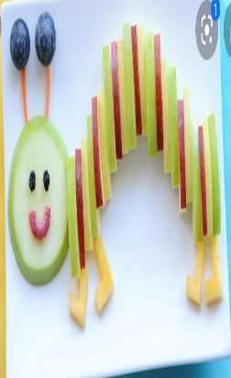  Task: Healthy Eating  Eating well is a huge part of keeping healthy. Can you complete the Eatwell Super Hero challenges below? Included are some healthy recipes you can have fun making: Easy Peasy Pizza and Rainbow Fruit Skewers! You can use the recipe or be creative! Share your creations on Teams.
Sports Week Project | Health and Wellbeing
We are learning to research and gather information.  We are learning to select media, materials and objects based on their suitability for specific tasks. | We are learning to keep ourselves physically and mentally fit.
Project: Cycling/Bicycles  Research Task – can you complete a Fact-File (templates attached below) with information about a famous British cyclist? You can use books, leaflets, websites, parents and other family members or TV documentaries to help you with your research.  Design Task – Imagine you have travelled 100 years into the future. Can you design and label a concept for a bike that might be used 100 years from now? What would a bike look like in 2120? What new features would it have? Be imaginative as possible!  Challenge Quiz – Answer the quiz questions all about bikes or cycling!  Art:  Task: Design A Sports Day Medal  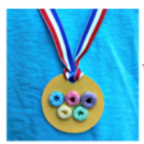  Use the template below or your own resources to design a sports day medal.  Task: Design a Sports T-shirt for Troon Primary  Design a t-shirt that you would like to wear for P.E. at Troon Primary. Can you link the school colours and motto – Success Through Effort?  Task: Sports Craft Activity  Choose your favourite sport. Using materials found around the home, create a model or picture that illustrates that sport. Please find some ideas below. | Task: Sports Week Activity Cards  Have a go at the activity cards for Sports week. You have 20 different 60 second challenges to work on this week. Try to improve on your score by practising daily from Monday until Thursday. On Friday you will be sent a Microsoft Form with the 8 challenges you will compete in over the week. Don’t forget by competing you are earning points for your House - Good luck!  Task: Fitness Bingo  Improve your fitness by challenging yourself to complete our Fitness Bingo challenge. This is just for fun    Task: Family Quiz  As a family work together to complete the quiz. Complete the Microsoft Quiz in the Assignments tab by Friday!  Task: Sports Day Word Search  Can you complete the Word search, finding all the different words relating to Sports Day?  Task: Mindfulness Colouring  Take some time to relax and focus the mind whilst completing one of the colouring sheets. Perhaps take it outside and listen to the birds sing or listen to some relaxing music.  Sports Day    Don’t forget that Friday is our Virtual Sports Day. Please dress in House Colours if possible and watch out for your Sports Day Challenges coming through via ‘Group-call’ on Friday morning. If you can’t take part on Friday, please compete over the weekend, you can still complete your Sports Day Form until Sunday 14th June.

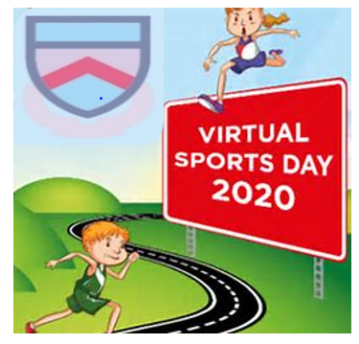
Troon Primary School
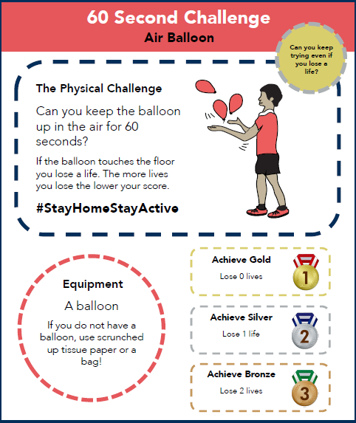

Troon Primary School
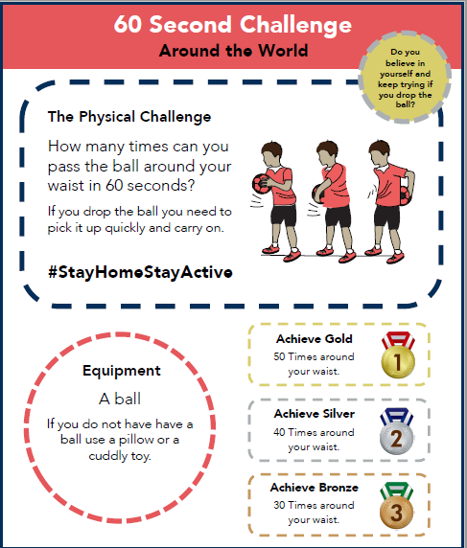

Troon Primary School
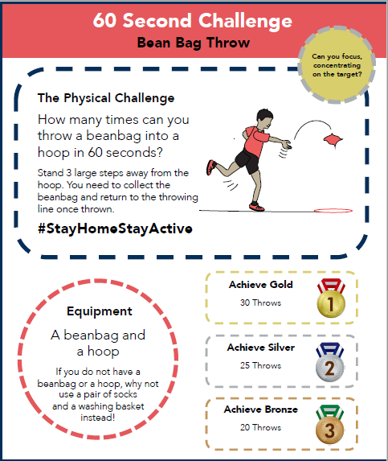

Troon Primary School
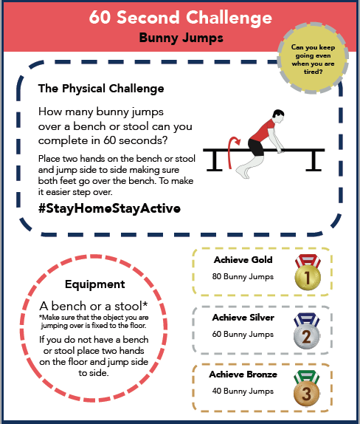

Troon Primary School
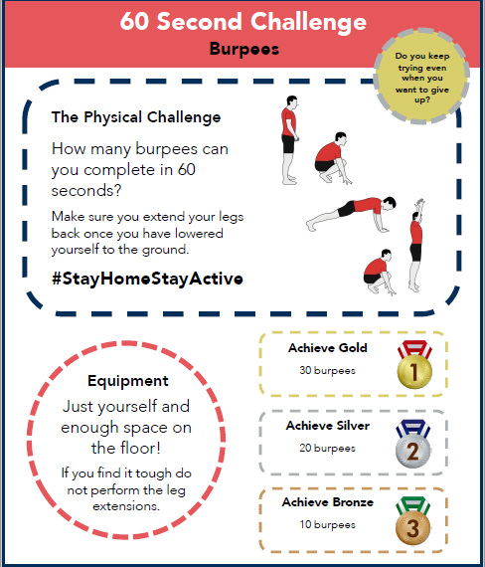

Troon Primary School
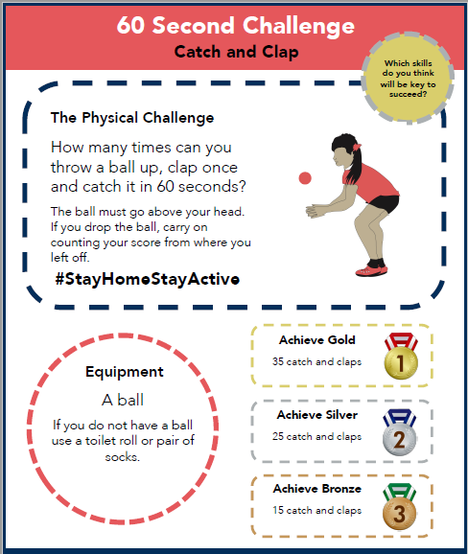

Troon Primary School
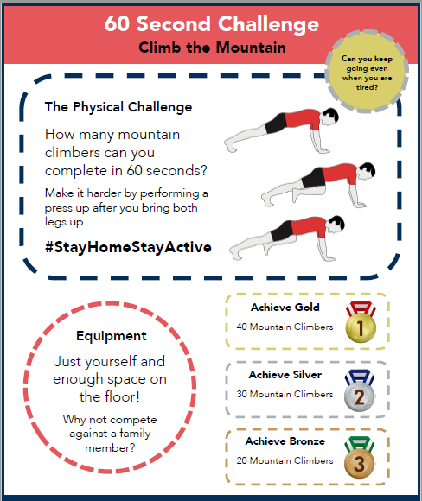

Troon Primary School
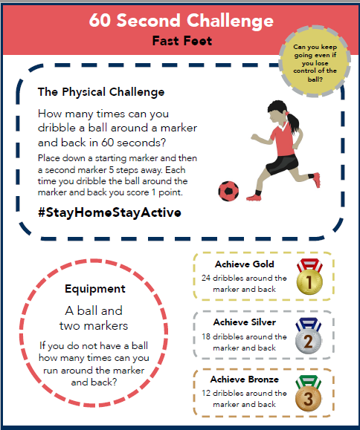

Troon Primary School
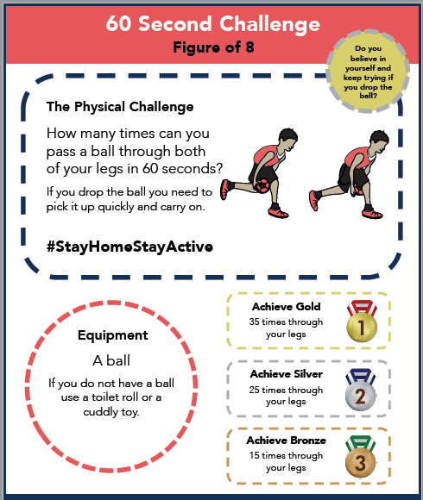

Troon Primary School
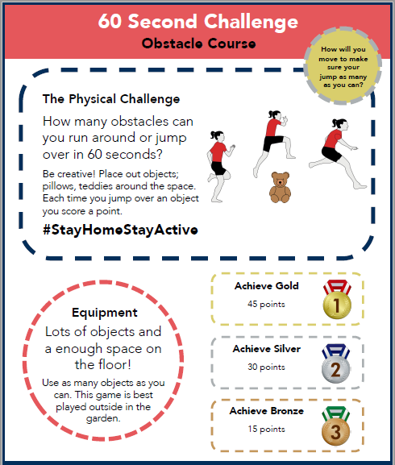

Troon Primary School
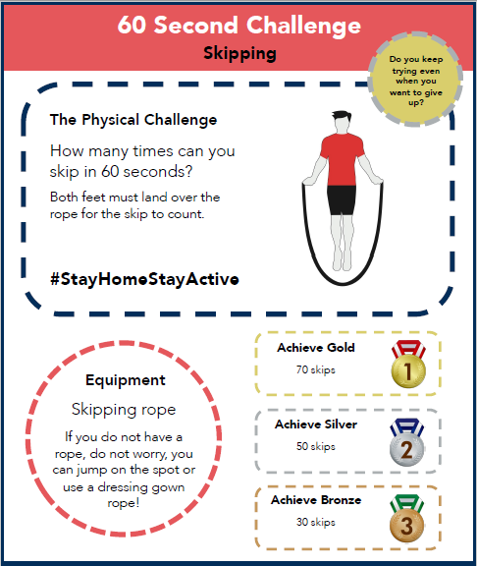

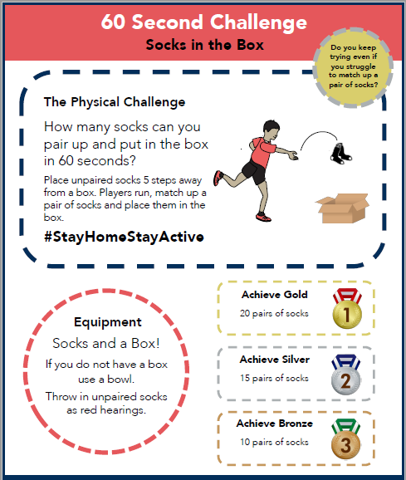
Troon Primary School

Troon Primary School
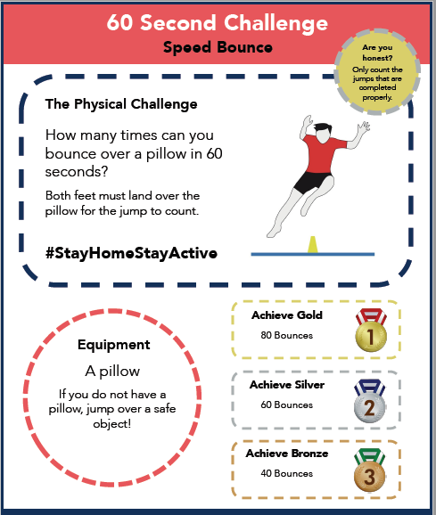

Troon Primary School
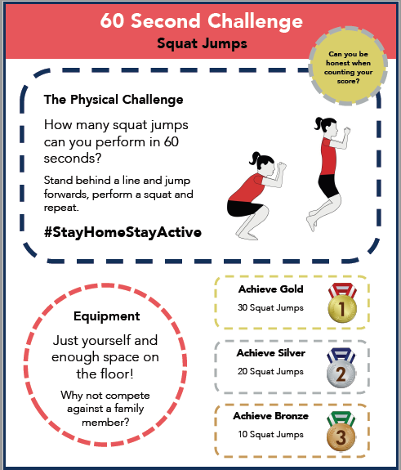

Troon Primary School
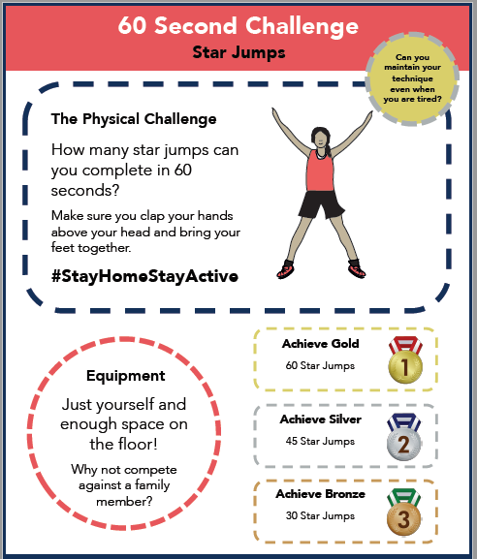

Troon Primary School
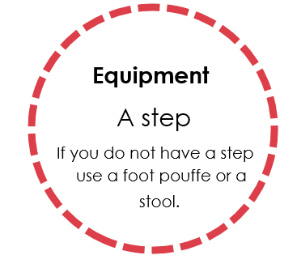
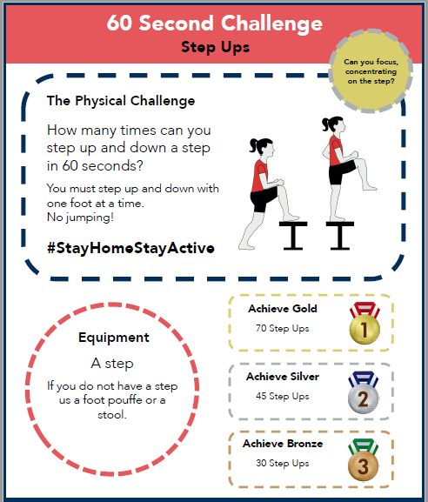

Troon Primary School
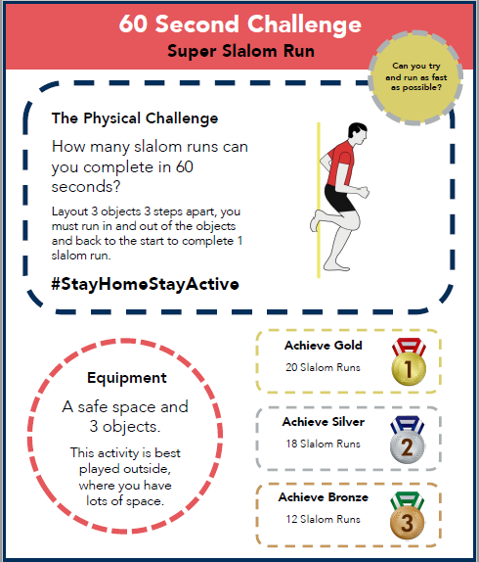

Troon Primary School
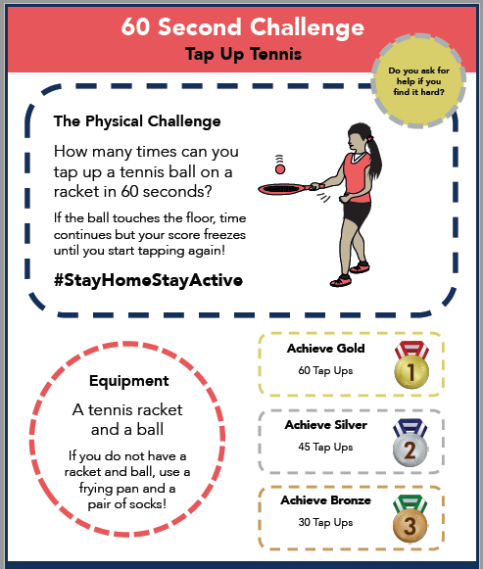

Troon Primary School
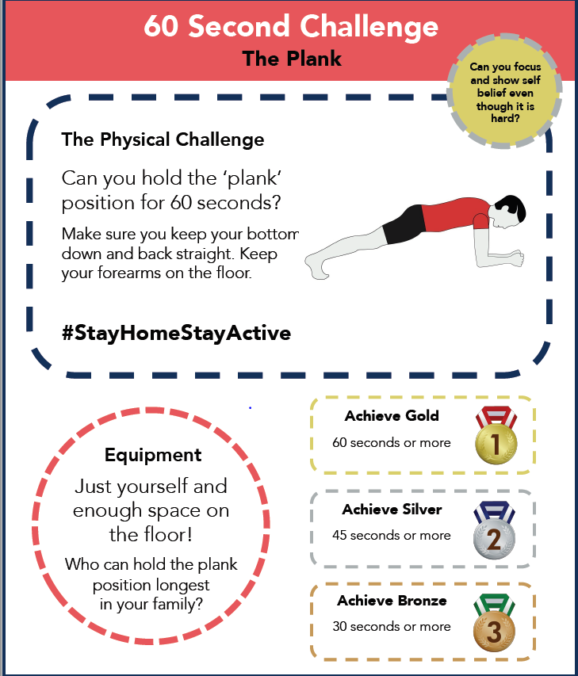

Troon Primary School
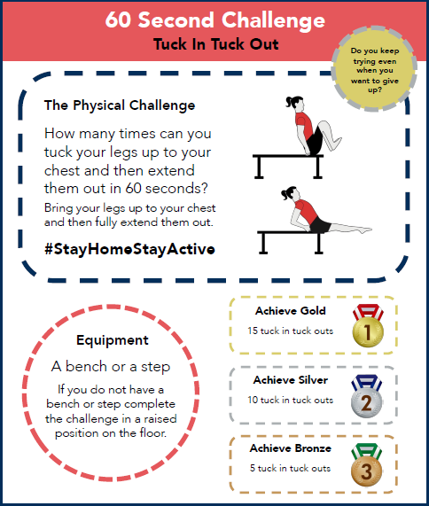

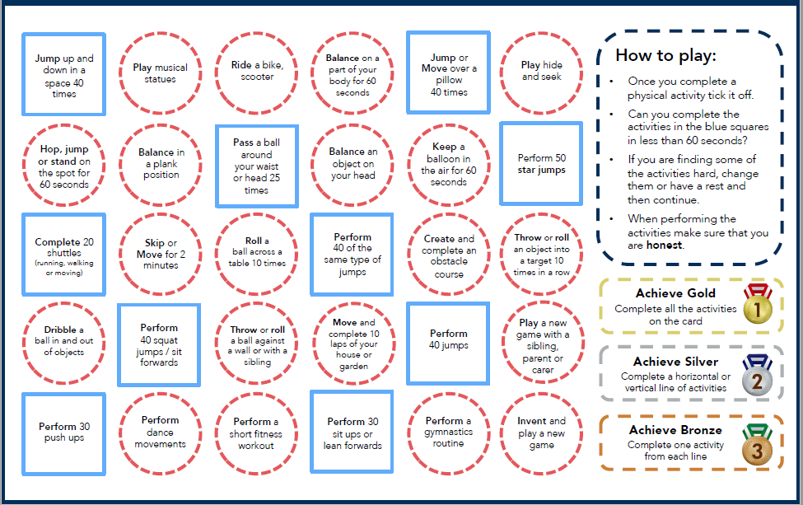
Troon Primary School

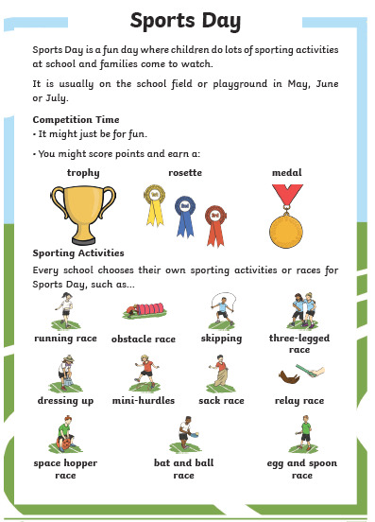

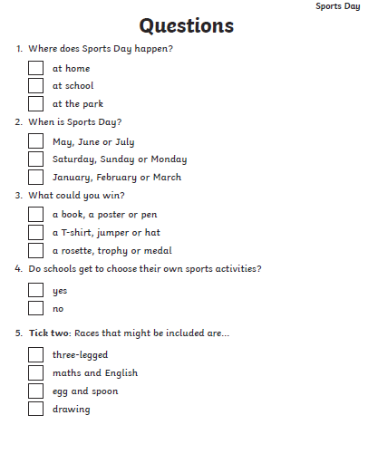

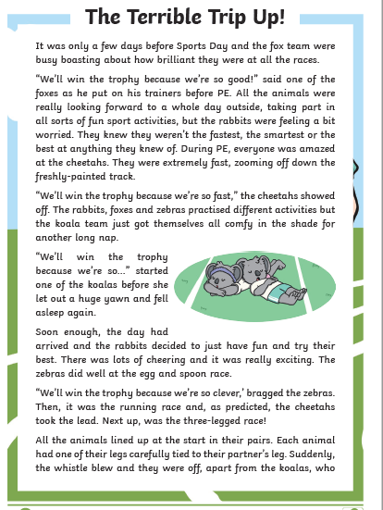
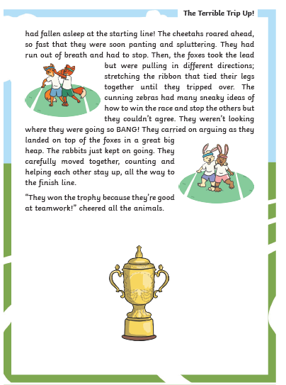
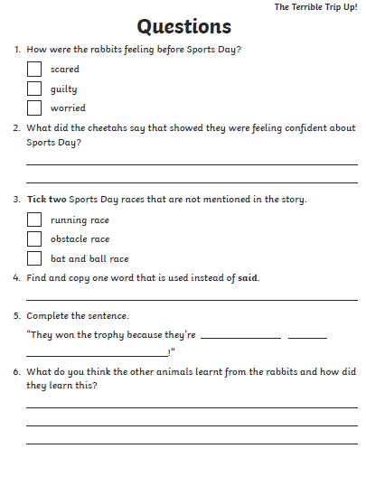
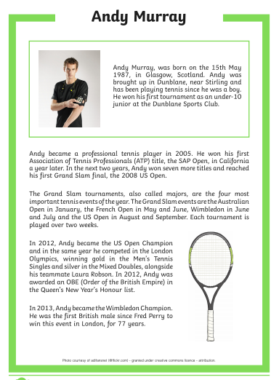

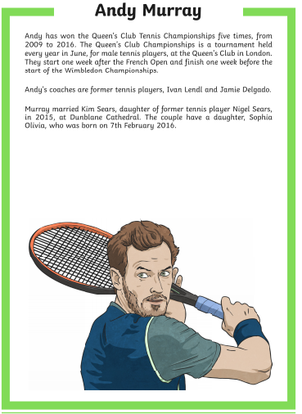
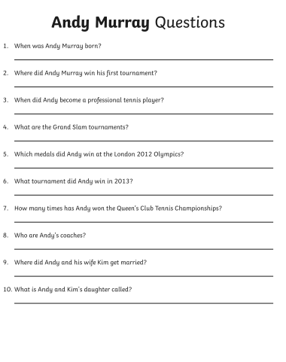
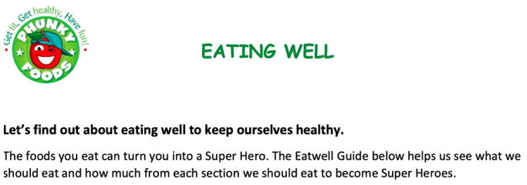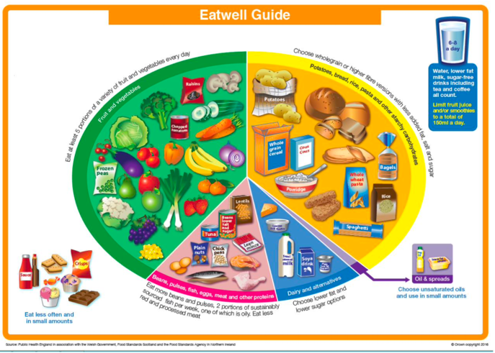

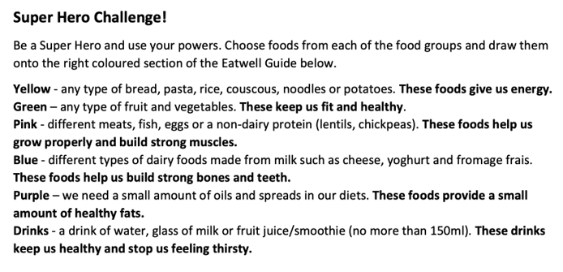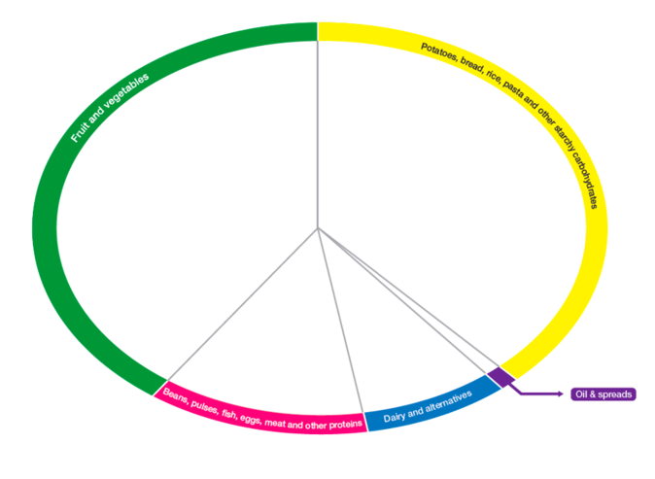


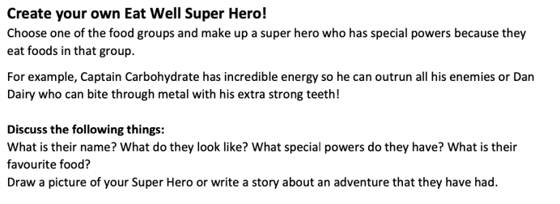

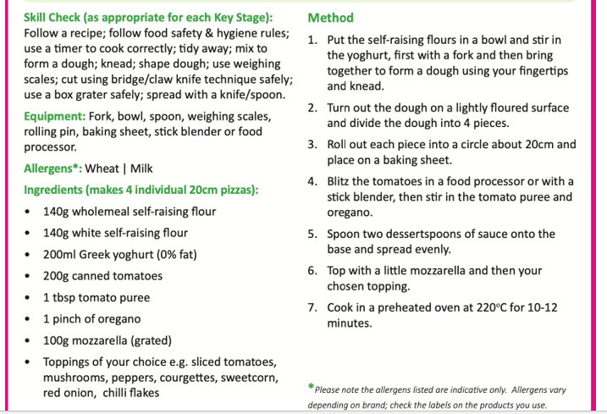
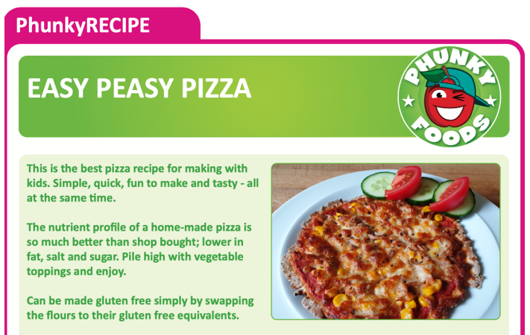

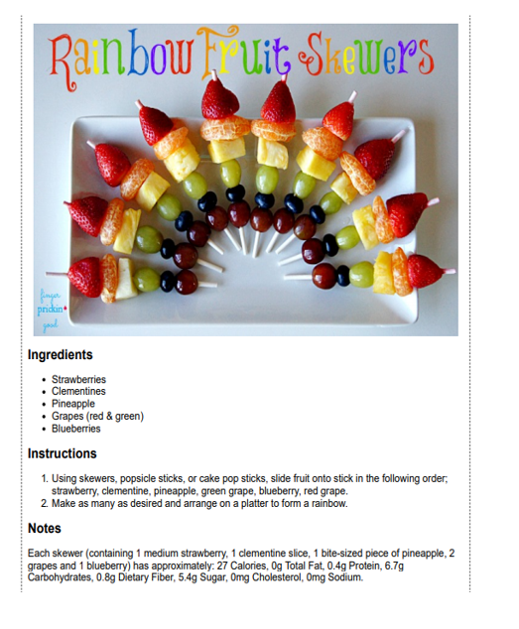
You can use the recipe above to make the Rainbow Fruit Skewers or use fruits of your own to create the rainbow colours:
red orange yellow green blue indigo violet
Can you now create a recipe for Rainbow Vegetable Skewers?

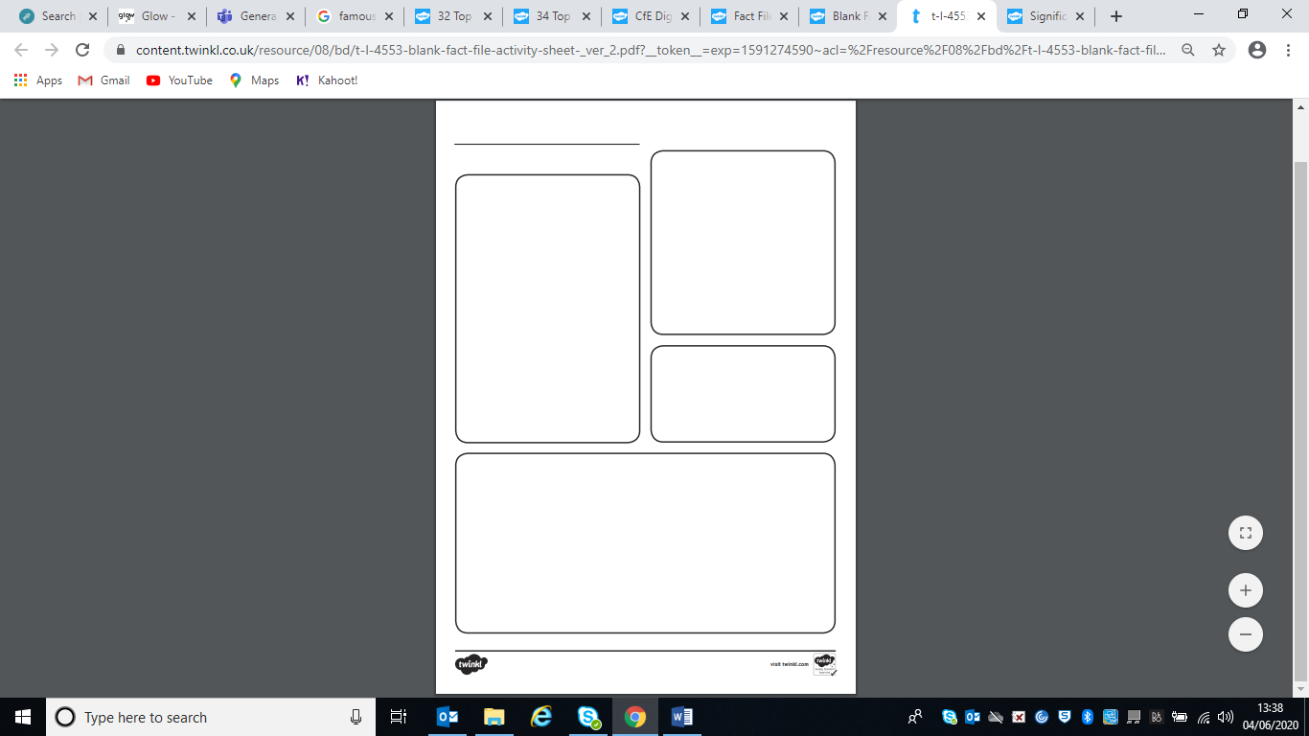
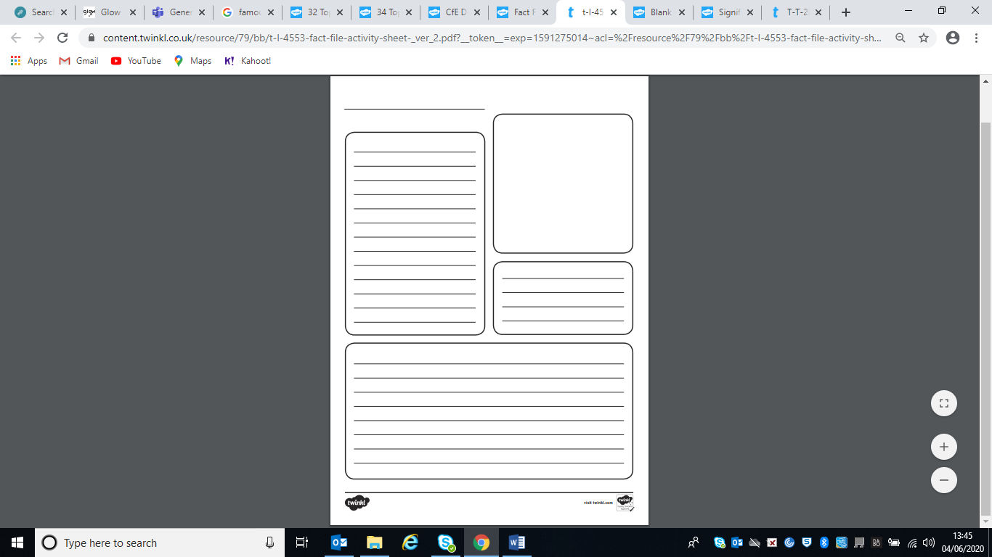
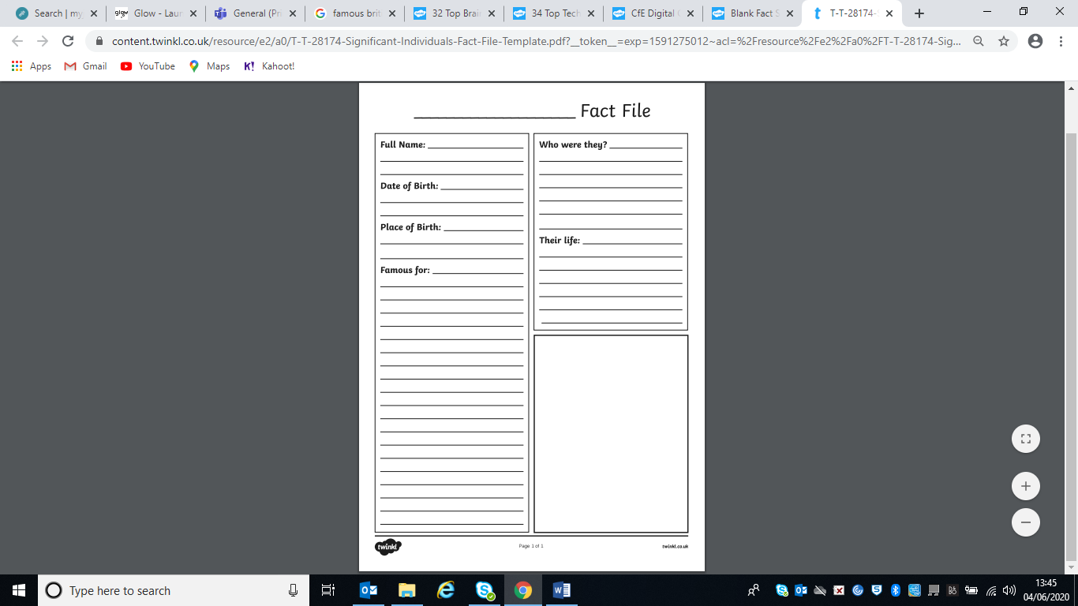

New Bike Design
Imagine you have travelled 100 years into the future. Can you design and label a concept for a bike that might be used 100 years from now? What would a bike look like in 2120? What new features would it have? Be imaginative as possible!

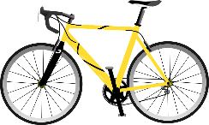
Cycling/Bicycles Quiz

1. True or False, it is a good idea to wear flip-flops when riding your bike?

2. Where were bicycles first introduced?

3. What was the name given to early bicycles that featured huge front wheels and small rear wheels?

4. One of the most famous road cycling races is the Tour de France – a race with many different stages. What colour jersey does the ‘King of the Mountains’ wear?

5. What does the letter BMX stand for?

6. What is the word used to describe the main group of riders in a road cycle race?

7. How many Olympic Gold Medals has Sir Chris Hoy won?

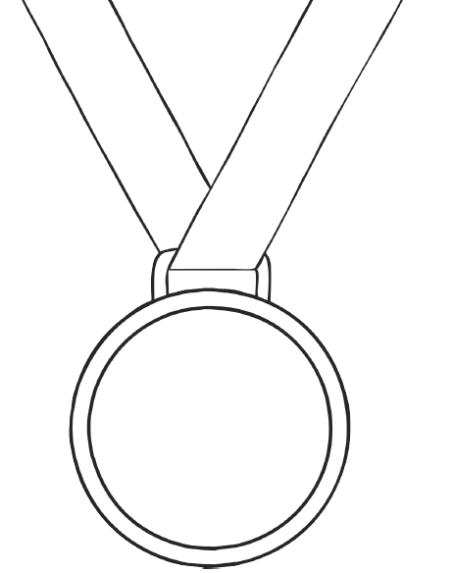


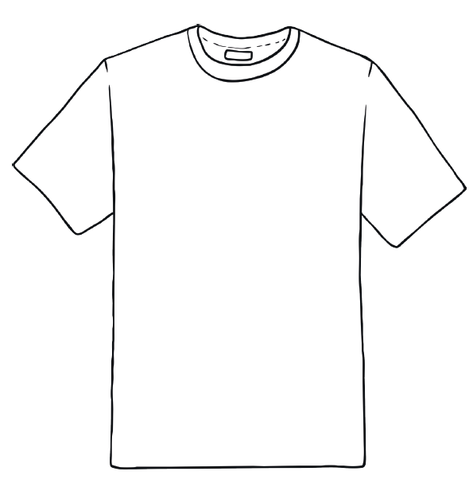
Can you design a T-shirt for Troon Primary? Think of colours, patterns and designs.
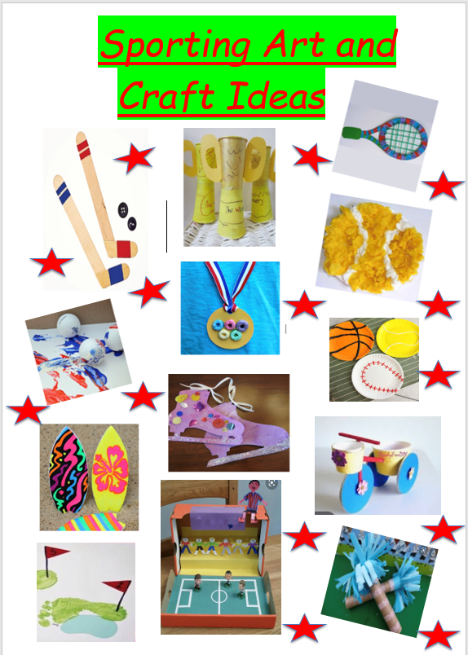
Mindfulness Colouring
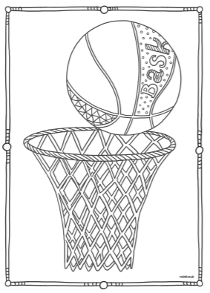
Mindfulness Colouring
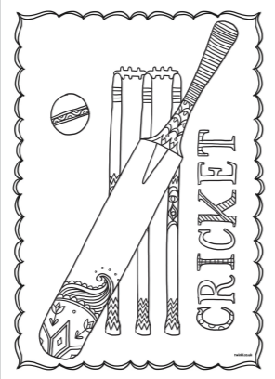
Mindfulness Colouring
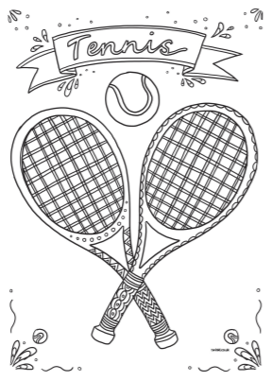

Sports Day Word search
