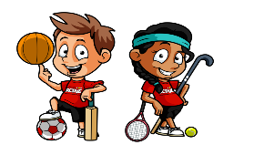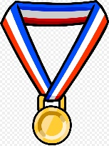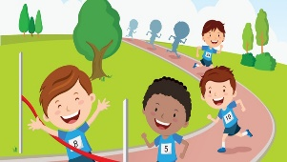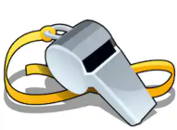**TROON PRIMARY SCHOOL & EARLY YEARS CENTRE**

**Home Learning: Second Level**

|  |  |
| --- | --- |
| **Literacy** | |
| **Reading** | **Writing** |
| **We are learning to use a range of reading skills and strategies to read and understand texts, e.g. skimming, scanning, predicting, clarifying and/or summarising.** | **We are learning to select ideas and relevant information to create an eye-catching information leaflet.** |
| Thoroughly read the Chilli Challenge PowerPoint of your choice. When you are looking through each slide, try to develop your note-taking skills, by picking out the important words or relevant information and making bullet points to support you with the three tasks below. Each PowerPoint has the Chilli Challenges listed on the last slide. The task sheets below are there for you to use to complete your activity.  **Task 1:**  Using the task sheet provided and possibly the internet, sort the events from the Ancient Greek Games and the Modern Olympics into the Venn diagram.  **Task 2:**  Using the PowerPoint and possibly the internet if required, answer the questions provided.  **Task 3:**  Pick a variety of events from the Ancient Olympics or Modern Olympics depending on the Chilli Challenge and create your own Top Trumps cards.  Look at the example provided. You can use skills of your choice and create your own scores for each one! | **Task:**  Read through the PowerPoint provided on ‘Information texts.’  The Greeks started the Olympic Games almost 3000 years ago in 776 BC. They were held nearly every four years for over a thousand years until they were stopped in 393 AD.  Using websites on the handout below, and what have learned from the reading tasks this week, create an information leaflet for a day at the Ancient Olympics.  **Special Music Task** – We’re all in this Together!  Use the information in your class Team to join the **YMI #together** Team and work on Singing, Percussion, Guitar or Brass. We only have two weeks to work on this project and we need you! |
| **Numeracy** | **Nutrition/Healthy Eating** |
| **We are learning to use our personal target setting and self-assessment to choose a focus for this week’s numeracy and maths which will help us progress in either…** | **We are learning to Investigate the range of foods available and I can discuss how they contribute to a healthy diet. We are learning to experience a sense of enjoyment and achievement when preparing simple healthy foods and drinks.** |
| Image result for math olympics (With images) | Math, King logo ...**Learning Intentions: choose one or more**   * Maths Olympics: **Information handling:** reading a table to construct a graph, remembering key information and presentation, including use of a ruler! * **Times tables**: Chilli challenges to improve mental agility and tables knowledge * **Time**: Chilli challenges to make sure you’re moving on to your new class (or school!) with a secure understanding of what you have covered already in telling time, duration and changing between analogue and digital   **Task:** See attached **PowerPoint** to choose your challenge and level of spice! | **Task 1**  Many people follow a special diet for medical, religious or personal  reasons. These may include:  Many people follow a special diet for medical, religious or personinclude:  · vegetarian or vegan  · food intolerances and allergies  · diabetes  · coeliac disease  · Kosher  · Halal  Research/Presentation - Find out about at least one of these and write  about it on a poster, PowerPoint or Sway. Think about what food restrictions  **Research/Presentation** - Find out about at least one or more of these and write  about it on a **poster or PowerPoint**. Think about what food restrictions people may have, and why they follow a special diet.  **Task 2**  Watch this video about the Eatwell Plate: [Video Link](https://www.youtube.com/watch?v=8aWqZd9RScQ)  Watch this video about the Eatwell Plate. The plate is also shown below:  Using the eatwell plate, **plan/create** a healthy, balanced meal for yourself or  someone in your family. It must include all 5 food groups.  **Additional Task 2**  ‘**Create a healthy recipe**’ – You can either type or write a healthy recipe for a snack or meal of your choosing. The recipe must include a **title, list of ingredients, descriptive method** and should be **illustrated** to show an example of the final product! Following on from this, you may wish to make your dish and try out your recipe! Please remember to share your finished work on class teams!  **Task 3**  Have a look in your cupboards, fridge and freezer and see if you can  identify where your food comes from. Using the information you have found from your labels, can you figure out how far each product has travelled. Using Google Maps, **search** for the country name and then right click. Click 'Measure Distance' and then click back on Scotland. Note down the distances for each of the products you have found. Which one has travelled the furthest? Which one has travelled the least? Are you surprised by any of the journeys your food has made? Share you findings on Teams.  **Task 4**  Healthy food tasting challenge - try a brand new healthy food. It should be one you have not tasted before. Let us know what you tried. Maybe you will discover a new favourite! Find out where your new healthy food comes from and calculate the distance from Scotland.  **Additional Task 4**  **C:\Users\sa14alcroftk\AppData\Local\Microsoft\Windows\INetCache\Content.MSO\68CAC047.tmp**Choose at least 3 healthy snacks to eat. As you eat each one take your time and complete the chart provided to show how each item **looks, smells, feels, tastes** and **sounds**. If your mind begins to wonder, remember to bring it back to the task! |
| **Sports Week Project** | **Health and Wellbeing** |
| **We are learning to create our own sport** | **We are learning to keep ourselves physically and mentally fit.** |
| **Project**  **Can you create your own sport or game? What type of sport will it be? What equipment will you need? Will there be teams?**  Have a look at the list of everything you will need to consider when creating your own sport:   * A set of clear rules * Type of equipment you will be using if any * Where your sport will be played (indoors, outdoors, gym hall, anywhere). * If your sport is played against someone else or if it is just played by one person. If it is played against other people, are you playing in teams? * Skills required to play the sport.   **Additional challenge: Can you create a sport that can be played against or with someone else while following current social distancing rules? Remember you must stay 2 metres apart at all times and not touch any of the same equipment?**  **Additional challenge: Create a short demonstration of your sport and upload it to Teams for other members of your class to try.**  **Art**  **Task 1:** Read the Olympic Games pdf and watch the YouTube clip. <https://www.youtube.com/watch?v=B7Y1Jn9rLLE>  **Task 2:** You are to create a NEW Olympic Games logo for 2021.  Your design must include:   * A clear and eye catching logo. * Your logo must be sports related. * You can use any medium to create your design – paints, pens, pencils, collage, computer… be as creative as you can! * You must include at least 2 of the design tools mentioned in the YouTube clip.     **Additional Task:**  Choose your favourite sport. Using materials found around the home, create a model or picture that illustrates that sport**. Please find some ideas below.** | **Task: Sports Week Activity Cards**  **Have a go at the activity cards for Sports week. You have 20 different 60 second challenges to work on this week. Try to improve on your score by practising daily from Monday until Thursday. On Friday you will be sent a Microsoft Form with the 8 challenges you will compete in over the week. Don’t forget by competing you are earning points for your House - Good luck!**  **Task: Fitness Bingo**  Improve your fitness by challenging yourself to complete our Fitness Bingo challenge. This is just for fun  **Task: Family Quiz**  The 2019 BIG SPORTS QUIZ - how's your 2019 sporting knowledge ...As a family work together to complete the quiz. Complete the Microsoft Quiz in the Assignments tab by Friday!  **Task: Les sports d’intérieur**  Look at the PowerPoint about indoor sports. Try saying the words and try to remember them. Next complete the activity sheet without looking at the PowerPoint! Bonne chance!  **Task: Sports themed Crossword**  Can you complete the crossword? All the answers are sports related!  **Sports Day**  **C:\Users\sa14alcroftk\AppData\Local\Microsoft\Windows\INetCache\Content.MSO\64AF7A72.tmpDon’t forget that Friday is our Virtual Sports Day. Please dress in House Colours if possible and watch out for your Sports Day Challenges coming through via Groupcall on Friday morning. If you can’t take part on Friday, please compete over the weekend, you can still complete your Sports Day Form until Sunday 14th June.** |

**Reading Chilli Challenge**

**From the Tasks below, select the set that will challenge you at an appropriate level:**



|  |  |  |
| --- | --- | --- |
| **Mild** | **Medium** | **Hot** |
| Task 1: | | |
| **Task 1**  Sort the sports in the images from the Ancient Greek Games and the Modern Olympics into the Venn diagram.  **\*Remember\***   * If the sport only happened during the Ancient Olympic Games, it will **go to the left**. * If the sport only takes place in the Modern Olympics, it will **go to the right**. * If the sport is in both, stick it **in the middle where the circles cross**. | **Task 1**  Using the PowerPoint provided and possibly the internet, sort events from the Ancient Greek Games and the Modern Olympics into the Venn Diagram.  **\*Remember\***   * If the event only happened during the Ancient Olympic Games, it will go to the left. * If the event only takes place in the Modern Olympics, it will go to the right. * If the event is in both, write it in the middle where the circles cross. | **Task 1**  Using the Venn Diagram provided and possibly the internet, sort the events from the Ancient Greek Games and the Modern Olympics into the Venn diagram.  **\*Remember\***   * If the event only happened during the Ancient Olympic Games, it will go to the left. * If the event only takes place in the Modern Olympics, it will go to the right. * If the event is in both, write it in the middle where the circles cross.   **\*\*Challenge\*\***  Write a description of each event you have included. |
| Task 2: | | |
| **Task 2**  Using the PowerPoint, answer the comprehension questions provided below.  **\*Remember\***   * Read the text carefully to help you find the information needed to answer your questions correctly. * Answer your questions in full sentences, using full stops and capital letters | **Task 2**  Using the PowerPoint, answer the comprehension questions provided below  **\*Remember\***   * Use your reading strategies to help you find the information needed for each question e.g. skimming and scanning the text. * Answer your questions in full sentences, using wording from the question itself. * Read the questions carefully. | **Task 2**  Using the PowerPoint and possibly the internet if required, answer the questions provided below.  **\*Remember\***   * Use your reading strategies to help you find the information needed for each question e.g. skimming and scanning the text. * Answer your questions in full sentences, using wording from the question itself. * Read the question carefully. Think about the wording. Is it looking for facts or your opinion?   **\*\*Challenge\*\***  Create some of your own questions based on the Olympics. You could maybe set them as a task for someone else in your household! |
| Task 3: | | |
| **Task 3**  Pick **3**  events from the Ancient Olympics and create your own Top Trumps cards.  Look at the example provided. You can use skills of your choice and create your own scores for each one! | **Task 3**  Pick **5**  events from the Ancient Olympics and create your own Top Trumps cards.  Look at the example provided. You can use skills of your choice and create your own scores for each one! | **Task 3**  Pick **3**  events from the Ancient Olympics and **4** events from the Modern Olympic and create your own Top Trumps cards.  Look at the example provided. You can use skills of your choice and create your own scores for each one!  **\*\*Challenge\*\***  Create your own Top Trumps design cards instead of the template below! |

Task 1: Sorting Activity

Mild Chilli Challenge

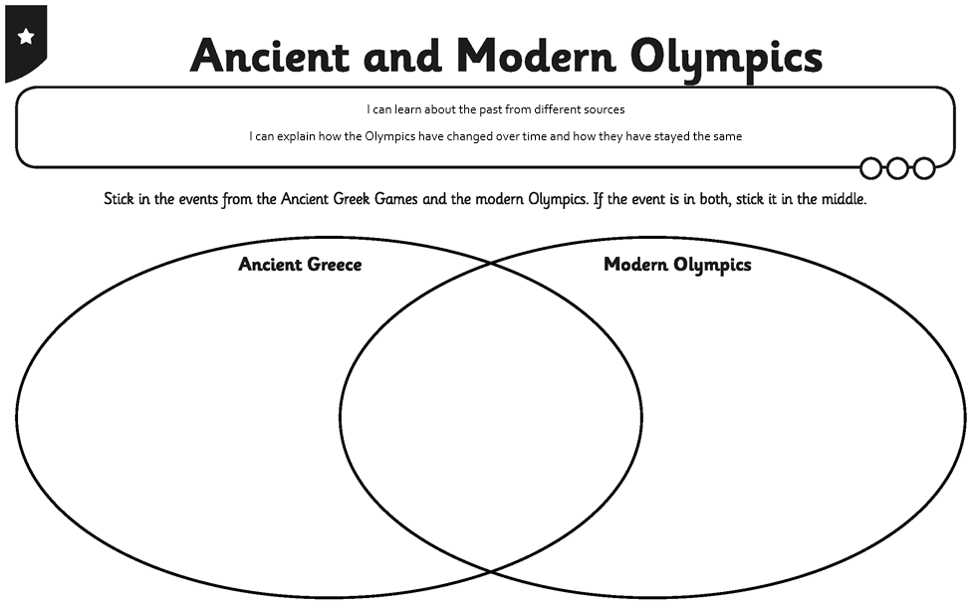

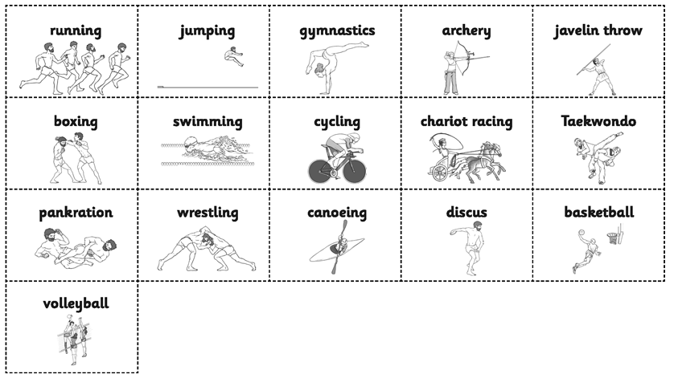

Medium Chilli Challenge

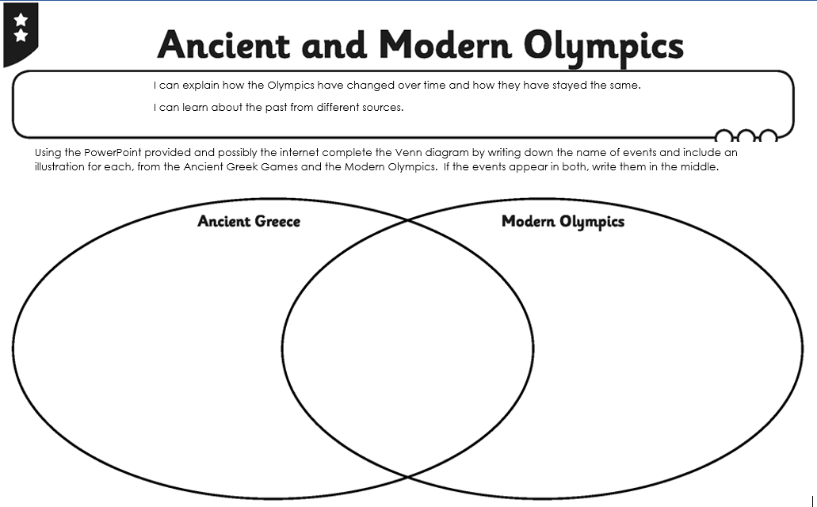

Hot Chilli Challenge

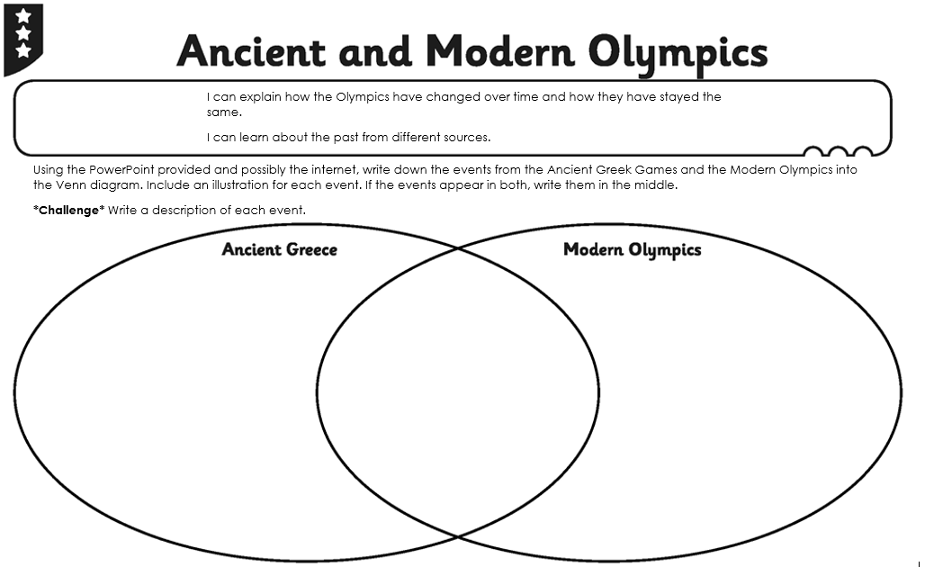

Task 2: Reading Comprehension

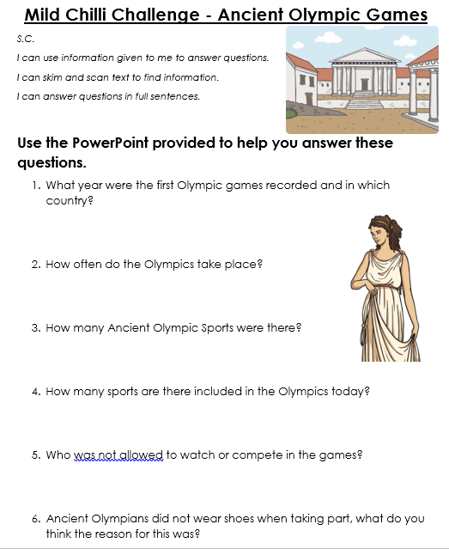 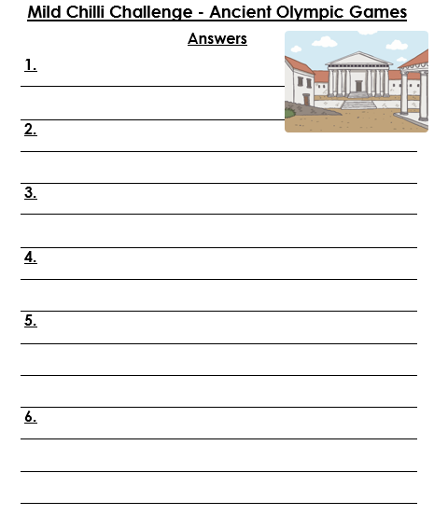

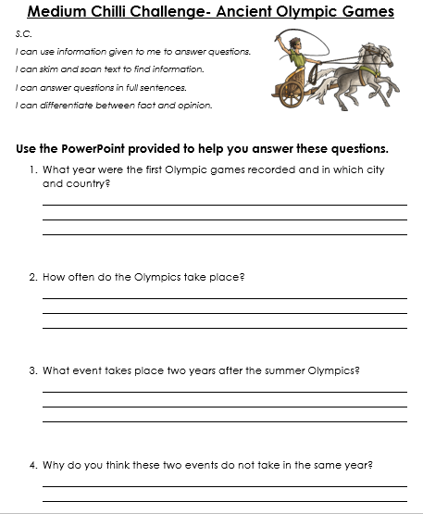 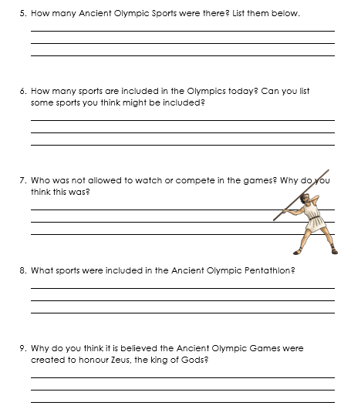

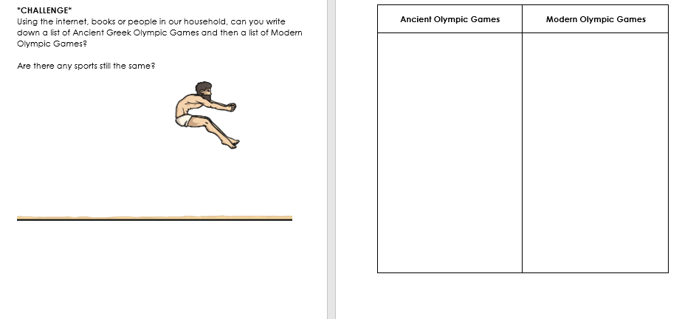

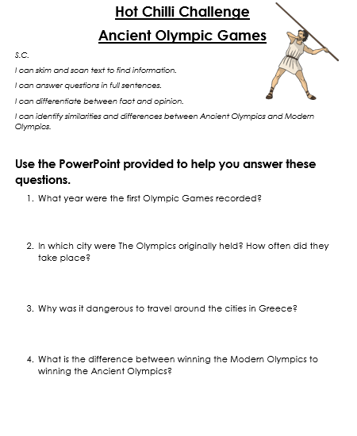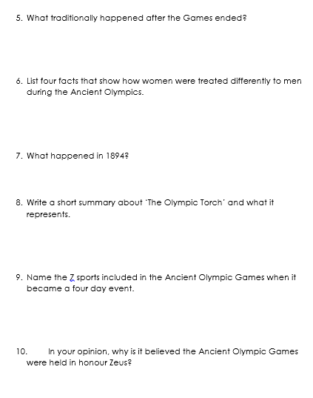

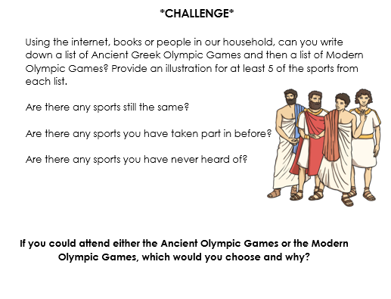

Task 3 – Top Trump Cards

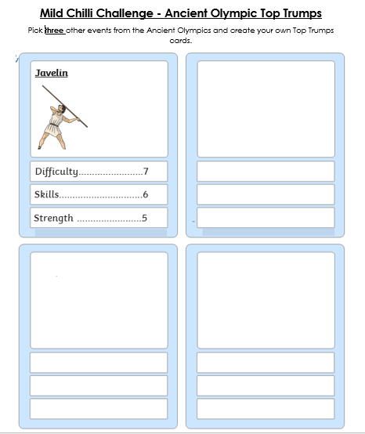

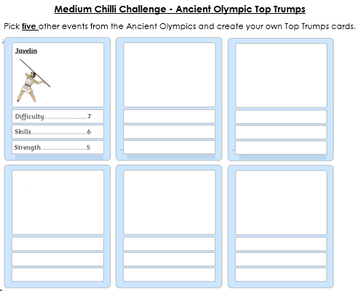

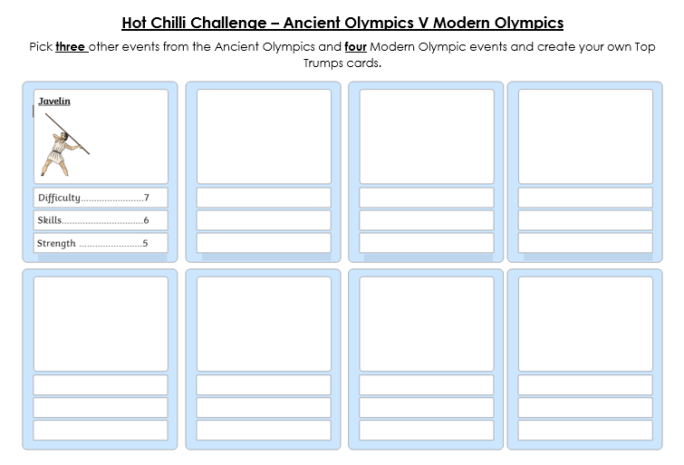

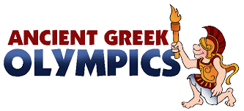

**Writing Task**

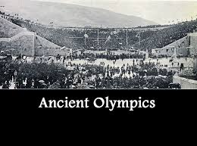

**Suggested websites:**

<https://www.ducksters.com/history/ancient_greek_olympics.php>

<https://www.historyforkids.net/ancient-greek-olympics.html>

<https://www.bbc.co.uk/bitesize/topics/z87tn39/articles/z36j7ty>

<https://www.olympic.org/ancient-olympic-games>

Read through the PowerPoint given on ‘Information texts.’

The Greeks started the Olympic Games almost 3000 years ago in 776 BC. They were held nearly every four years for over a thousand years until they were stopped in 393 AD.

Using websites below, and what have learned from the reading tasks this week, create an information leaflet for a day at the Ancient Olympics.

Your leaflet should contain information on:

**Who** could attend the Olympics?

**What** would you see at the Olympics?

**Where** would the Olympics take place?

**When** would the Olympics take place?

**Why** should people attend the Olympics?

**Writing**



|  |  |  |  |
| --- | --- | --- | --- |
| **Mild** | **Medium** | **Hot** | **Extra Hot** |
| **Success Criteria**   * I can include an interesting title. * I can include sub-headings. * I can use interesting adjectives in my writing. * I can write in sentences, punctuating my work accurately. | **Success Criteria**   * I can include an interesting title. * I can include an introduction that grabs the reader’s attention and clearly explains the topic. * I can include appropriate sub-headings. * I can include a wide range interesting adjectives. * I can write in paragraphs that include one main idea. * I can read over my own writing to check that it makes sense. | **Success Criteria**   * I can organise information in a logical way. Eg. Title, sub-headings, images. * I can use short and long sentences to engage the reader. * I can use emotive language throughout my writing. * I can use topic sentences to make the idea of each paragraph clear. * I can include figurative language in my writing.   For example, similes and metaphors.   * I can check over my work carefully, and correct any spelling and grammar errors before submission. | **Success Criteria**   * I can choose an appropriate layout to engage the reader and include, headings, bullet points, graphics and captions. * I can include an introduction that makes the topic clear and a conclusion that rounds off the writing. * I can use sentences of different lengths and vary   sentence beginnings.   * I can use a range figurative language to engage the reader.   For example, similes, metaphors, alliteration and onomatopoeia.   * I can paragraph my work accurately. |

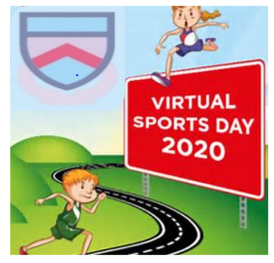

Troon Primary School

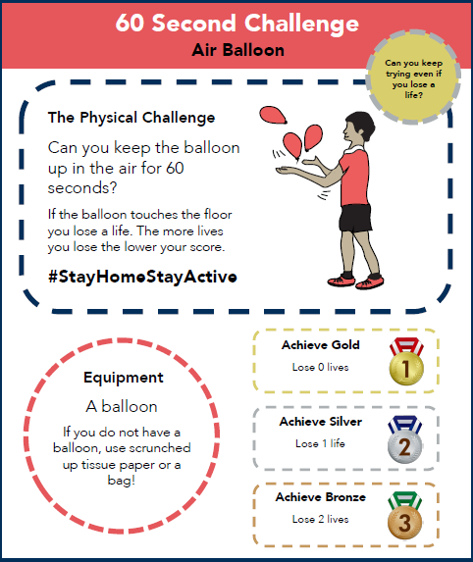



Troon Primary School

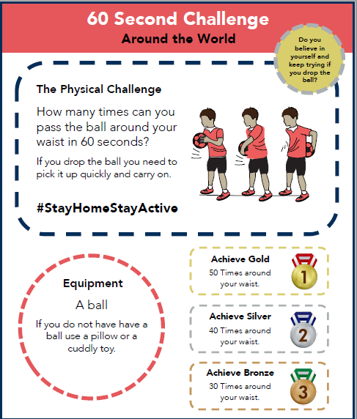



Troon Primary School

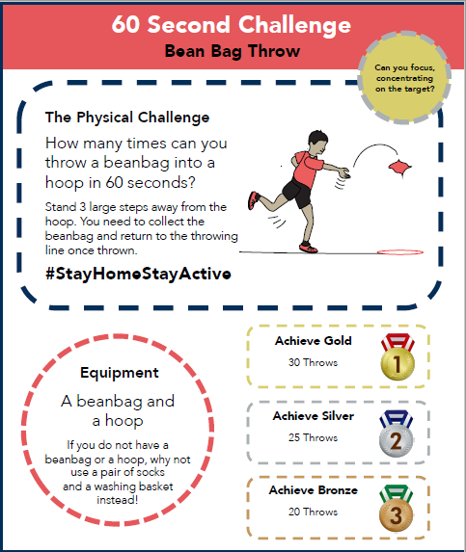



Troon Primary School

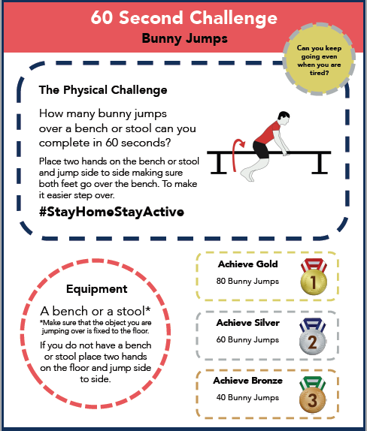



Troon Primary School

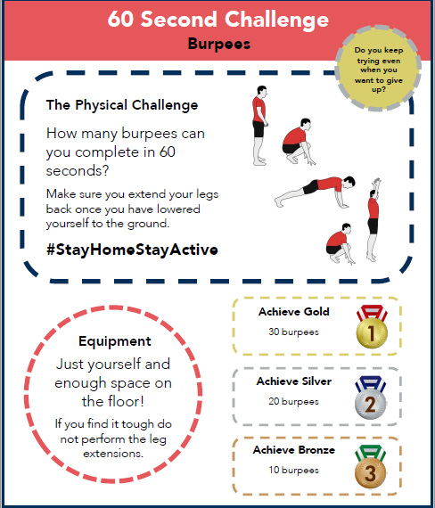



Troon Primary School

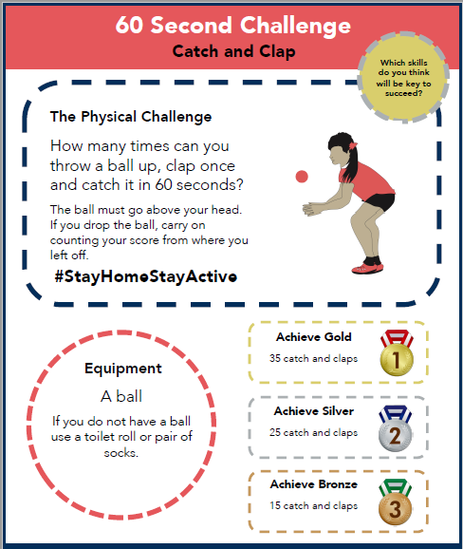



Troon Primary School

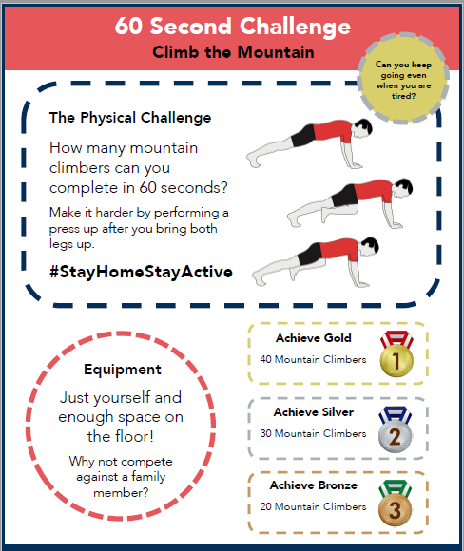



Troon Primary School

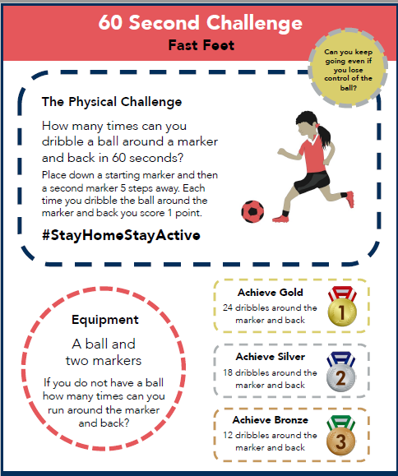



Troon Primary School

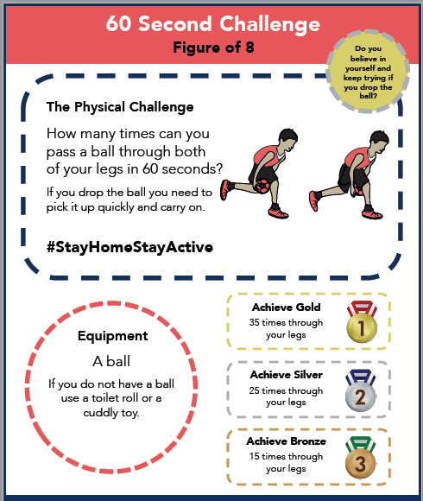



Troon Primary School

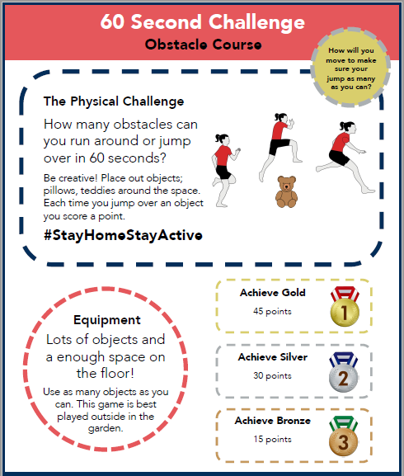



Troon Primary School

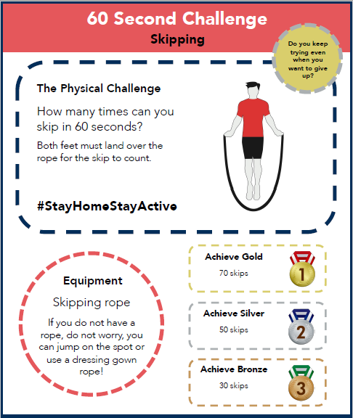



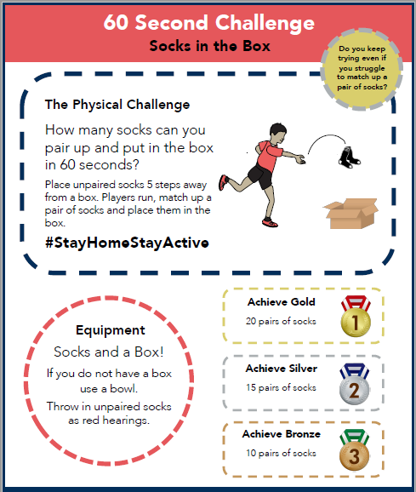Troon Primary School



Troon Primary School

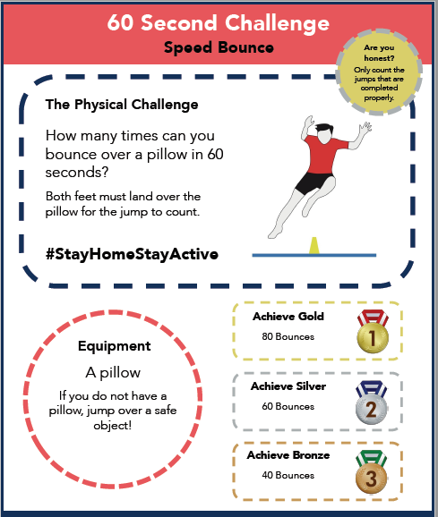



Troon Primary School

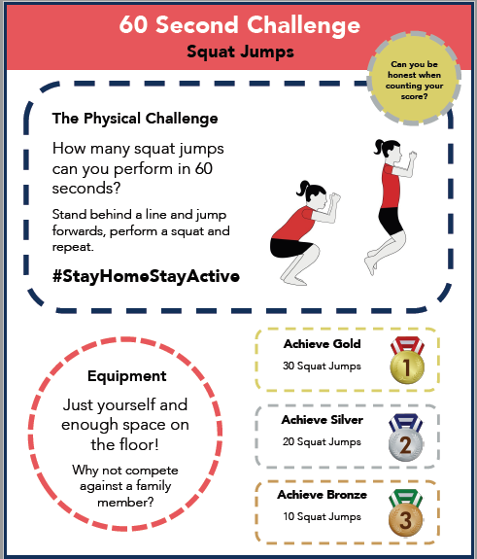



Troon Primary School

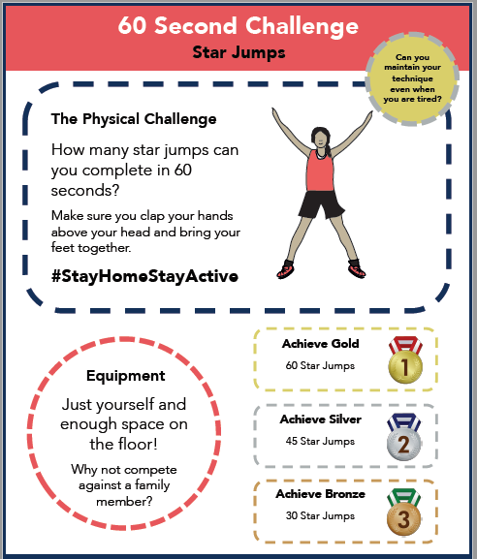



Troon Primary School

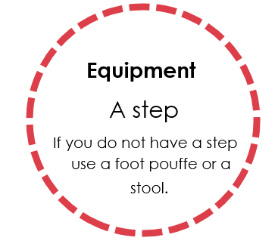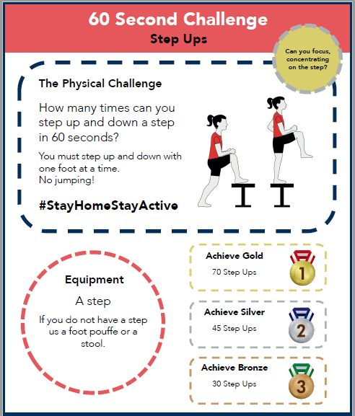



Troon Primary School

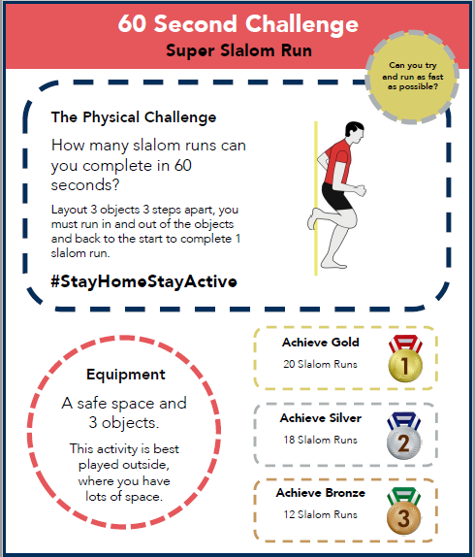



Troon Primary School

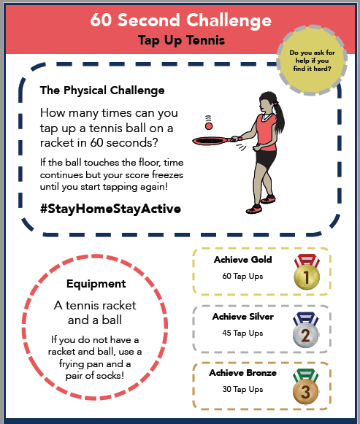



Troon Primary School

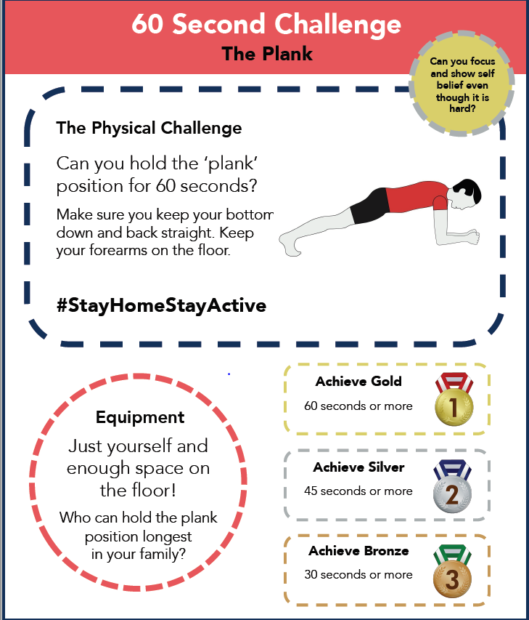



Troon Primary School

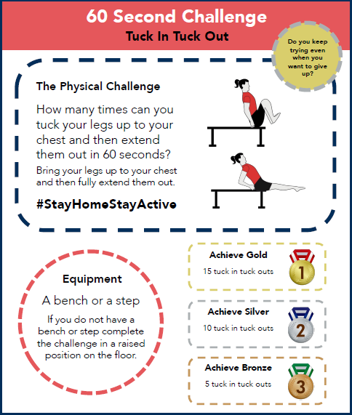

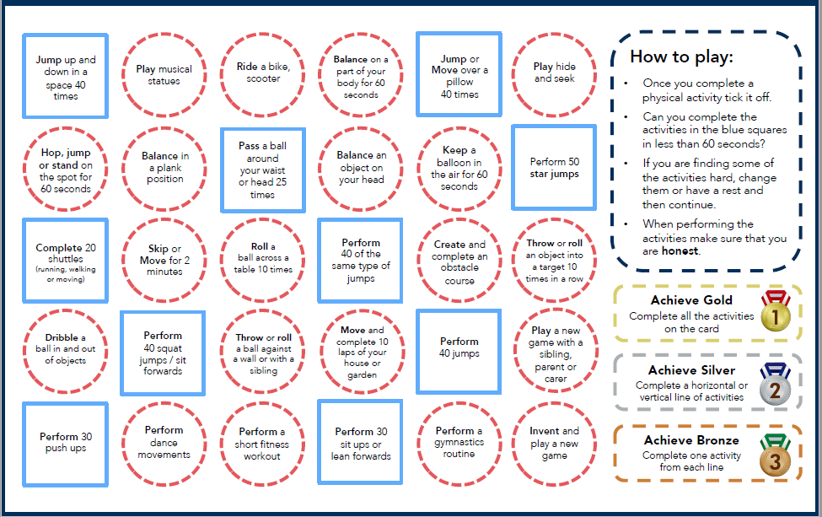Troon Primary School

Mindful Eating Activity

|  |  |  |  |  |  |
| --- | --- | --- | --- | --- | --- |
| Name of Food | Looks like….. | Smells like….. | Feels like….. | Tastes like….. | Sounds like….. |
| 1. |  |  |  |  |  |
| 2. |  |  |  |  |  |
| 3. |  |  |  |  |  |
| 4. |  |  |  |  |  |

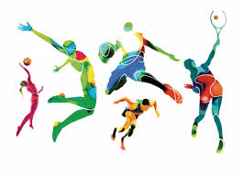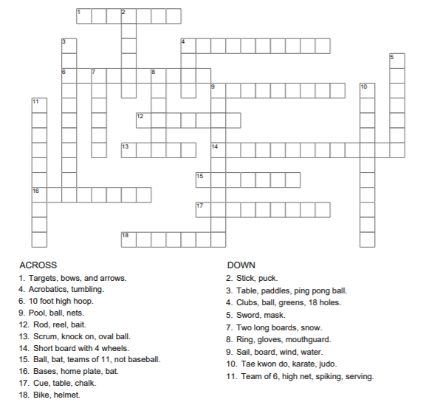Sports Crossword

