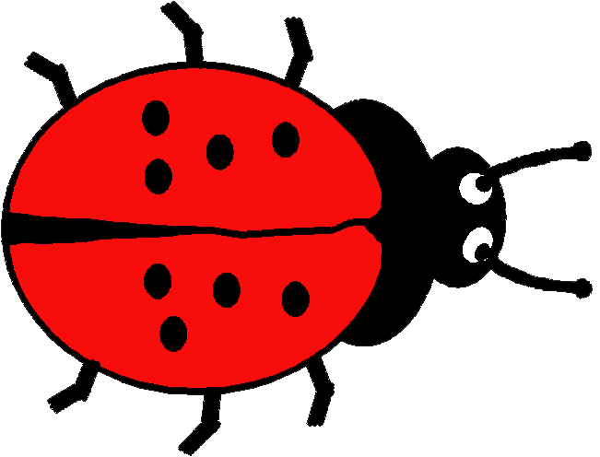**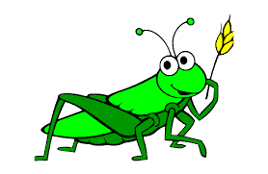****TROON PRIMARY SCHOOL & EARLY YEARS CENTRE**

**Home Learning: Early Years Centre**

|  |  |
| --- | --- |
| **Literacy & English** | **Numeracy & Maths** |
| **We are learning to identify characters, sequence events and say what we think happens next in a story.**  **We are learning to control our pencil with correct grip and pressure.** | **We are learning to explore symmetrical shapes in our environment.  We are learning to create our own symmetrical pattern.** |
| **Suggested Activities**   * Read or listen to the suggested stories or a story of your own. Use the Early Reading Prompts to ask questions about the book. * The Hungry Caterpillar <https://www.youtube.com/watch?v=75NQK-Sm1YY&spfreload=10>. * Waiting for Wings <https://www.youtube.com/watch?v=tqjuak1R5g4> * The Very Quiet Cricket <https://www.youtube.com/watch?v=YdiGEjz5b0Q> * Pencil control – learn to draw minibeasts. Copy the steps below. * Continue to practise writing your name. Make a name caterpillar. * MAKATON – Mrs Law has recorded a video with Makaton signs for different minibeasts. Play a game of Minibeast bingo using the signs. | **Suggested Activities**   * Look for symmetrical objects in your home or when you are out for a walk. * Create simple symmetrical patterns using Lego or bricks (see below). * Create symmetrical butterfly wings using paper and paint or use the template provided (see below). * Make playdough butterflies with symmetrical wings or make salt dough ladybird or butterfly decorations and try to paint the same spots or patterns on both sides. * Ladybird Spot counting activity (if you can do this easily, make a number sentence and add instead e.g. ‘3+4=7 3 spots add 4 spots equals 7 spots’) <https://www.topmarks.co.uk/learning-to-count/ladybird-spots> |
| **Health & Wellbeing** | **Other Curricular Areas** |
| **We are learning to cope with new situations.**  **We are learning that being active every day keeps us healthy.** | **We are learning to create a picture using different materials and concepts.**  **We are learning to be creative using a variety of materials.** |
| **Suggested Activities**   * Friendship activity – all children will be in groups or classes with some new faces as they move to pre-school or into primary 1. Use the friendship activity as a starting point for discussing friendship skills, or cut and paste the qualities into the sheet. * Get ready for P1 by practising getting yourself dressed and undressed quickly. Maybe you could have a race with your siblings or your mum or dad, or perhaps someone could time you. * Minibeast Moves - Wiggle like a worm, crawl like a caterpillar, jump like a grasshopper and fly like a butterfly to get moving. Can you think of any more minibeast moves? | **Suggested Activities**   * Download the Seek app to identify minibeasts. * Be a minibeast detective and go on a bug hunt. * Channel your inner Spider-Man and go on a web hunt. * Make a Bug Hotel or, like in Miss Malone’s story, a Bug School! * Use potatoes to make potato print bugs. Be creative and send photos to Mrs McClure. * Plant a butterfly garden with wildflower seeds. * Bake butterfly cakes or celebrate the bees with a honey cake.   <https://www.bbcgoodfood.com/user/23650/recipe/simple-butterfly-cakes> |

**What are minibeasts?**

Information about minibeasts <https://www.bbc.co.uk/bitesize/topics/z6882hv/articles/z9fkwmn>

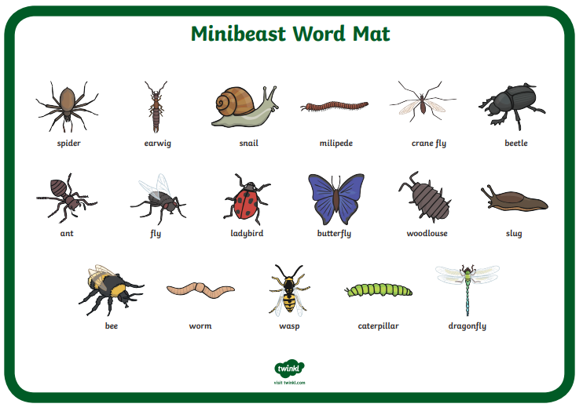

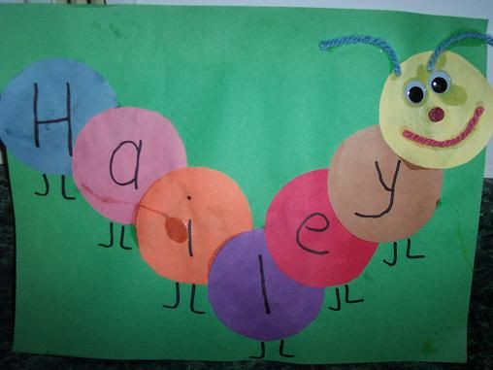

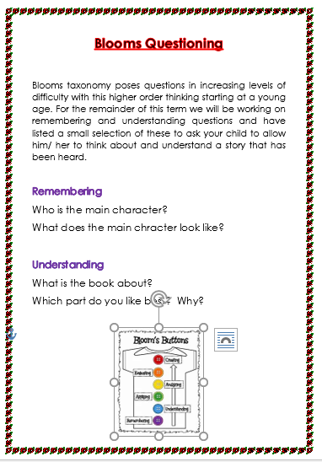**Early Years Reading Prompts**

**Pencil control – Learn to draw minibeasts**

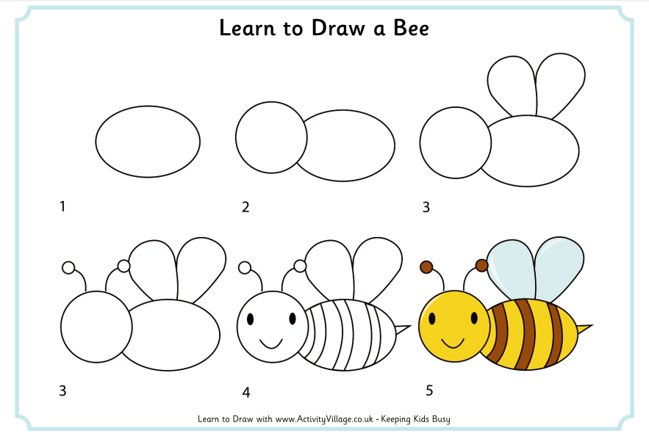

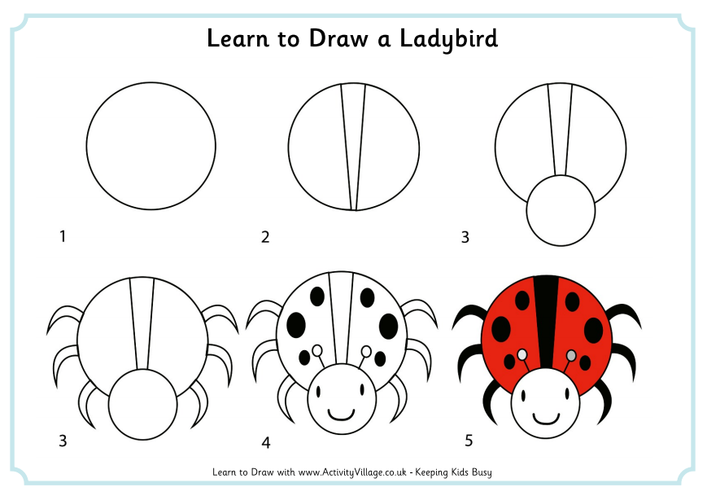

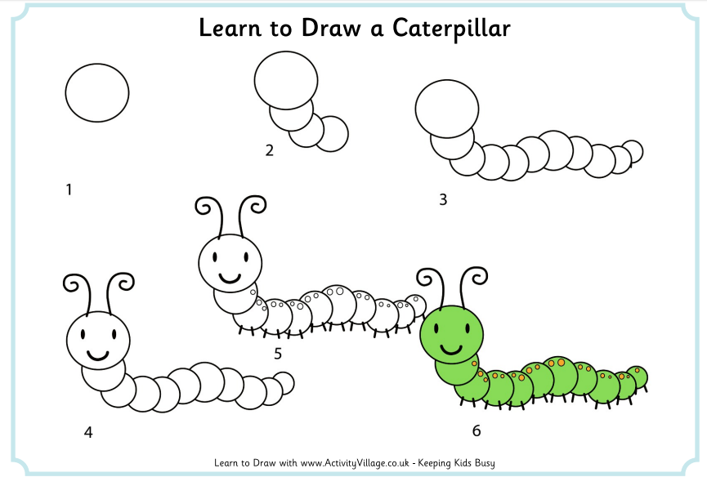

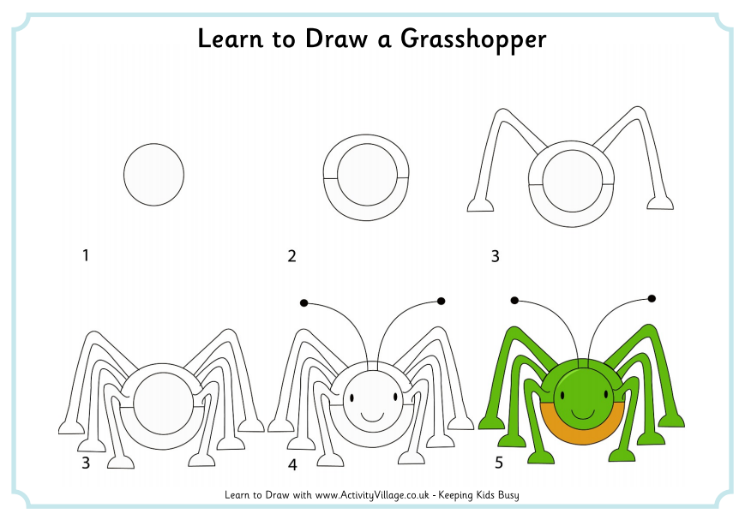

**MAKATON Minibeast Bingo**

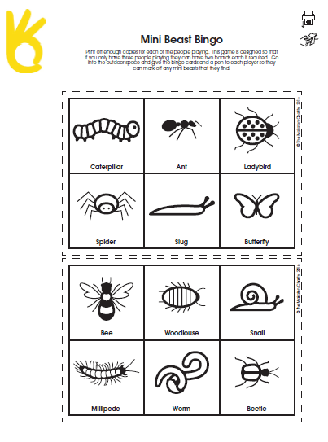

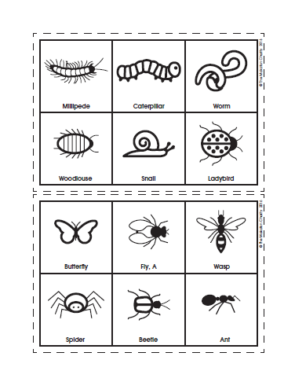

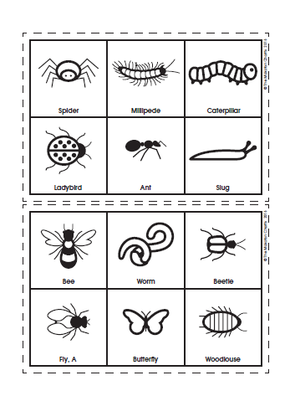

**Symmetry with Lego**

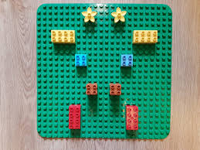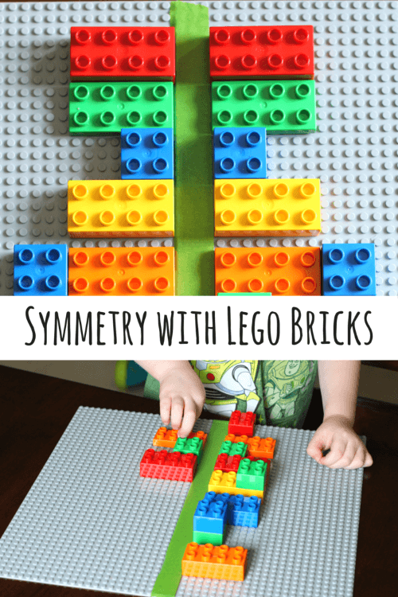

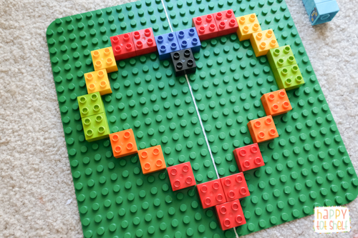



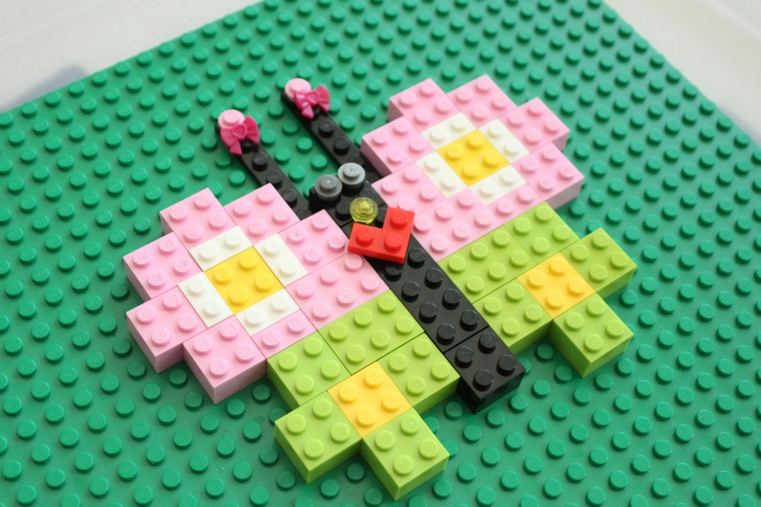

**Symmetrical butterfly wings**



**Symmetrical salt dough/painted stones**

**Playdough recipe**

***Play dough***

***You will need***

*8 tbsp plain flour*

*2 tbsp table salt*

*60ml warm water*

*food colouring*

*1 tbsp vegetable oil*

***Method***

*1. Mix the flour and salt in a large bowl. In a separate bowl mix together the water, a few drops of food colouring and the oil.*

*2. Pour the coloured water into the flour mix and bring together with a spoon.*

*3. Dust a work surface with a little flour and turn out the dough. Knead together for a few minutes to form a smooth, pliable dough. If you want a more intense colour you can work in a few extra drops of food colouring.*

*4. Store in a plastic sandwich bag (squeeze out the air) in the fridge to keep it fresh.*



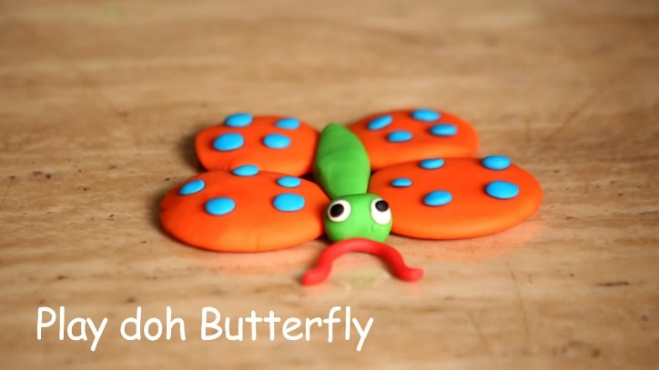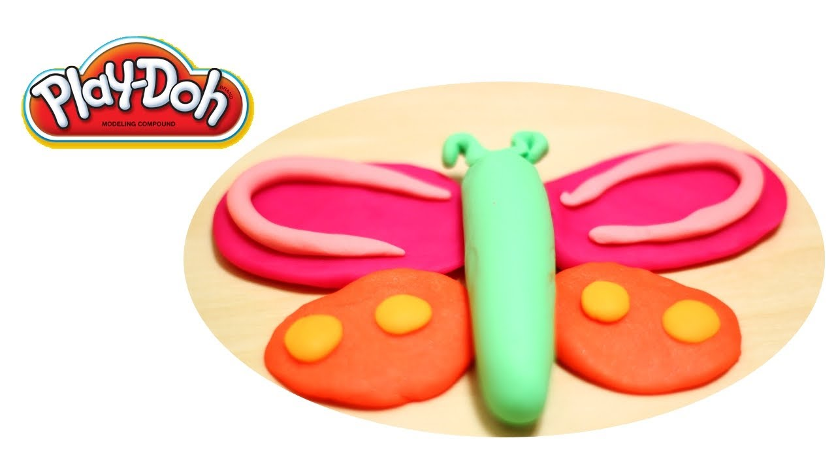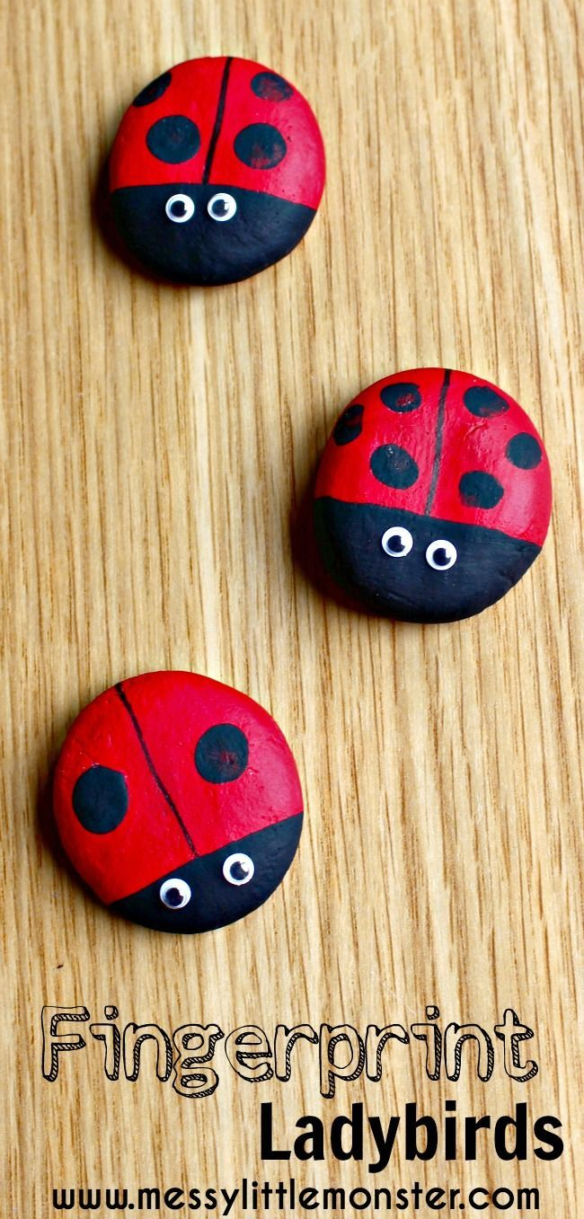

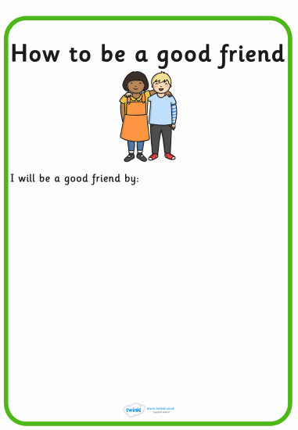**Making new friends**

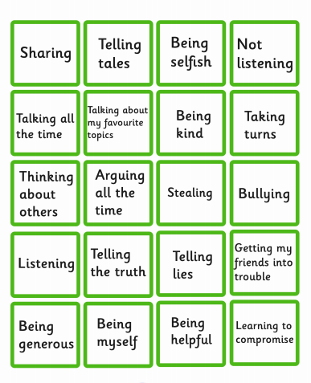

**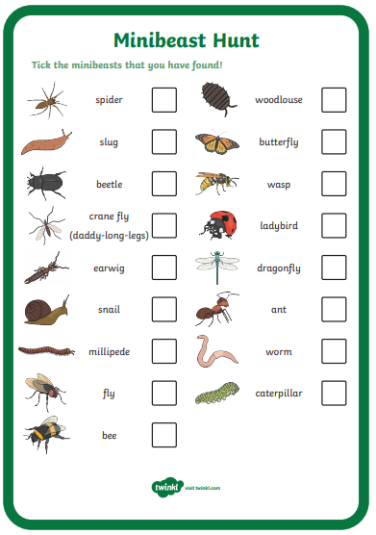****Minibeast Detective – Bug Hunt**

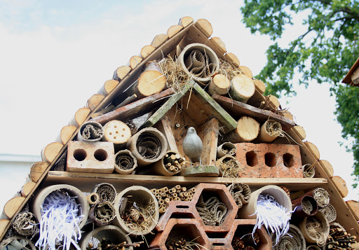**Bug Hotel examples**

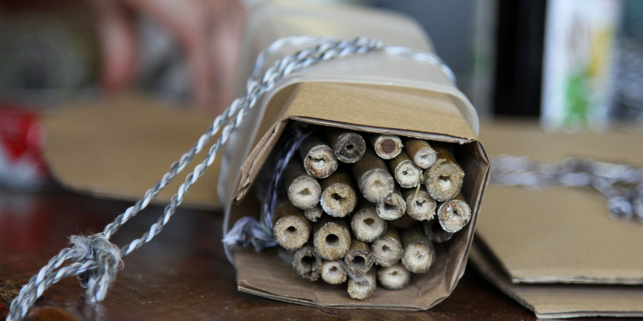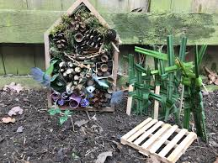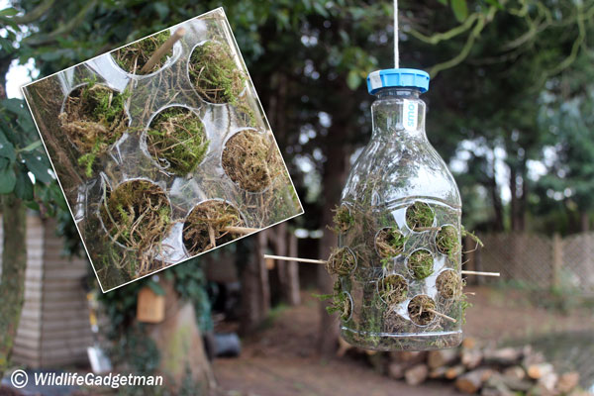

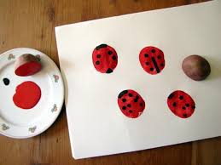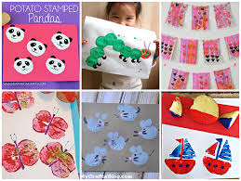**Potato Print Bugs**