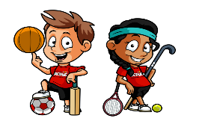

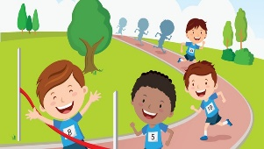
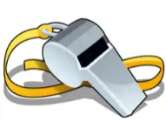


TROON PRIMARY SCHOOL & EARLY YEARS CENTRE

Home Learning: Primary 1 and 2

Literacy
Reading | Writing
We are learning to recall events and characters in stories and link them to our own experiences. | We are learning about ways to keep safe on our bike and show this information in a variety of ways.
Task: To listen to or read a story and recall information.  Listen to the story of Duck on a Bike by David Shannon. Click on the links.  Story read aloud: https://www.youtube.com/watch?v=pmAzhohAeIs  Animated story: https://www.youtube.com/watch?v=wJvx5Oc9k6E  Whilst listening to the story pay considerable attention to what all the animals were thinking as Duck passes them on a bike. Choose a ‘Duck on a Bike’ reading sheet below at your own level to complete. Chillies indicate level.    - Mild: Using your sound knowledge read the animal noises inside the speech bubbles. Complex sounds are indicated in bold. Draw a line to match each bubble to the correct animal.    - Medium: Read the shortened text in the think bubble and match it by drawing a line to the animal who thought it.  - Medium/hot: Read the full text in the think bubble and match it by drawing a line to the animal who thought it.    - Hot: Write a sentence about what each of the animals were thinking in your own words. Complete the sentences that have been started for you. Finally write what you think Duck was thinking as he was riding the bike past all the animals.  Task 2: To reflect on your own experiences when learning to ride a bike  Listen to the story ‘Bike on, bear’ by Cynthia Liu. Click on the link. https://www.youtube.com/watch?v=450WhyM0Ubo  Learning to ride a bike can be a very tricky thing to do and like most of us, Bear had a few problems to overcome along the way, but with persistence, he got there in the end.  - Have a think about when you were learning to ride a bike; you may even be doing that right now. Make a list in your head or on paper of the things you found hard and the things you found easy.  - Listen to the story again and compare each of Bear’s problems with your own. Are they similar? Did you encounter other difficulties?  - Bear knew that there were information (non-fiction) books in the library that can help you with most things. Do you think information books are useful when you are learning new things? What information books have you looked at and what have you learned from them?  - Bear read the bike book but still he couldn’t ride the bike. Why do you think this was? Can reading an information book alone make you good at something? What else must you do to succeed at an activity?  - After helping Goat and her Kid, Bear finally learned to ride his bike. It is scary learning new things and there is sometimes a fear of getting hurt. Did Bear think of his worries when helping Goat? Why do you think this was?  - Extension: At the end of the book, Bear could ride his bike but then he was faced with a new challenge – to swim!!! Life is full of challenges that we need to overcome. Have a think about any physical activity you had to keep practising but you got it in the end and when you did you felt great pride and satisfaction. Choose ‘My Personal Challenge’ sheet at your level to complete.  *Having courage and not over thinking things can help us achieve in most activities* | During this lovely weather lots of us have been out enjoying the fresh air on our bikes.  It’s a great way to keep healthy and enjoy the fresh air.  Watch the video clip  https://www.youtube.com/watch?v=0HTi8ZI6l04( ignore Bike Week at the end)  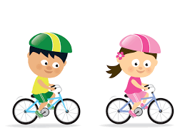  Discuss ways in which cycling is good for us and our environment.  Keeping safe on our bikes is extremely important.  Talk about ways to keep safe when you are cycling.  Use ideas from the video clip https://readysetride.co.uk/doyouknow and the leaflets attached to discuss all the different ways to keep safe when riding your bike and how to make sure your bike is in safe working order. There are a range of leaflets. Please choose some at your own level from the selection to help you gather information.  Look carefully at the tasks below and choose one to complete.  Task 1 Functional Writing- To create a leaflet or poster to show the importance of keeping safe on your bike.  - Look at the leaflets and discuss the different ways to keep safe on your bicycle.  - Choose some important rules to follow and create a poster ( mild/ medium) or leaflet( medium/ hot) that clearly shows an importance aspect of bike safety.  Success Criteria  Mild and Medium- Create a Poster  You may wish to choose one/two aspect(s) such as wearing a helmet, clothing, a safe bike etc.  - use different font for your poster and capital letters in a title  - use different colours of pens or pencils  - use pictures or diagrams  - you can make a slogan if you wish  - make it eye catching with a clear message or messages  Medium and Hot- Create an information Leaflet about Bike Safety  - choose 3 to 4 important ways to keep safe on your bike  - write in sentences using a capital letter and full stop  - illustrate each important point with a picture or diagram  - neat handwriting and presentation  When printing the leaflet print the two pages double sided and fold into a leaflet.  Task 2 Challenge and Extension Write a Tweet about a place to Cycle  Write a Tweet sharing one of your favourite places to cycle. It would be great to share this on Teams with everyone in Primary1 and Primary 2.  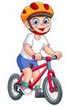  Remember all these safety rules and checks and keep safe when cycling!  Think Bike Think Helmet!
Numeracy | Nutrition/Healthy Eating
We are learning to use our counting or addition and subtraction skills to help us solve worded problems | We are learning to Investigate the range of foods available and can discuss how they contribute to a healthy diet.  We are learning to experience a sense of enjoyment and achievement when preparing simple healthy foods and drinks.
Task: Complete a maths task sheet at a suitable level of challenge for you (you may wish to complete 2 sheets i.e. mild and medium)  - Mild: Count the items then think about what numbers you need to use to complete your sums.  - Medium: Use your addition skills to find the totals. Always start with the biggest number in your head. Solve the worded problems by finding the correct information from the table.  - Medium/Hot: You will need to use addition and subtraction to find the missing totals. Fill in any rows with only one blank first then use the clues to solve the remaining blanks in the table.  - Hot: Use addition and subtraction to solve these problems mentally; do not write out a calculation. Strategies – start with the biggest number/count the units together, then the tens then add together i.e. 56+23= 6+3=9, 50+20=70, 70+9=79/try counting in tens, fives or twos along your fingers.  Task: Maths Challenge Cards – solve these worded problems mentally; do not write down any calculations. (Medium to Hot only)  - Medium: Choose at least 4 of the green cards to solve  - Medium/Hot: Choose at least 6 from a mixture of the green and black cards.  - Hot: Choose at least 10 cards to solve. | Task: A Healthy Lunch Box  Design a healthy lunch box filled with some healthy foods and a drink that will give you the energy you need for Sports Day.  - Use your knowledge of healthy foods and drink that provide you with energy to design your own lunch box  OR  - Use the food templates in the resource area to cut and stick the healthy foods you wish to choose.  Task :A Healthy Meal  Design another meal of your choice for example for dinner to make sure you cover all of the food groups that you need in your diet to be healthy and energetic.  Task: My Family Meal  Create a meal of your choice with a family member using all of your healthy choices which give you the most energy, take pictures of you making your meal and share them with us. I have included pictures of the Eatwell plate to help you.  Task: Healthy Food Wordsearch  Complete the word search of healthy foods for fun.  Additional Task: Food Rainbow  Create a ‘healthy eating food rainbow’. This can be done with a selection of different healthy foods. Please have a look at the following pictures and this may help to inspire your ideas . Alternatively, you may wish to complete this task through painting or drawing! If possible, please share your colourful rainbows in class teams!  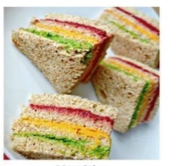  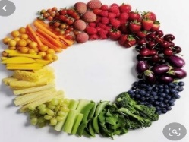  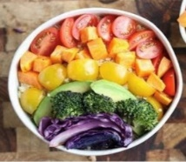  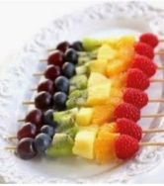
Sports Week Project | Health and Wellbeing
We are learning to research different athletes  We are learning to use a range of materials and textures in our art activities | We are learning to keep ourselves physically and mentally fit.
Sports Project  Have a think about the different sports you enjoy watching or taking part in. It could be anything; football, rugby, dancing or gymnastics. Can you research an athlete who takes part in your favourite sport and create a fact file about them?  If you aren’t sure who to pick you could choose one of the athletes below:  - Usain Bolt – Running  - Michael Jordan – Basketball  - Cristiano Ronaldo – Football  - Serena or Venus Williams – Tennis  Using the fact file inserted below can you research the following;  *Name  *Date of Birth  *Age  *The sport they are famous for  *Where they live  Also, find out some fun and interesting facts about them to share with us.  You could draw or print out a picture of them or a picture of them taking part in their sport. Remember the detail in your drawings and to colour it in! I have added a separate template for Primary 1 and Primary 2 below.  Art  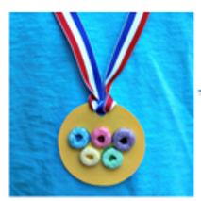  Task: A Medal for Sport Day  Design your own medal to celebrate your Sports Week Success!  1. Use the template in the resource bank to create a medal for your achievements during sports week.  2. Use craft materials of your choice e.g. card, ribbon, pasta etc to make a medal that you can wear to celebrate your achievements during sports week.  There are lots of ideas attached to help you. Happy Crafting!  Task: My Favourite Sport  Choose your favourite sport. Using materials found around the home, create a model or picture that illustrates that sport. Please find some ideas below. | Task: Sports Week Activity Cards  Have a go at the activity cards for Sports week. You have 20 different 60 second challenges to work on this week. Try to improve on your score by practising daily from Monday until Thursday. On Friday you will be sent a Microsoft Form with the 8 challenges you will compete in over the week. Don’t forget by competing you are earning points for your House - Good luck!  Task: Fitness Bingo  Improve your fitness by challenging yourself to complete our Fitness Bingo challenge. This is just for fun    Task: Family Quiz  As a family work together to complete the quiz. Complete the Microsoft Quiz in the Assignments tab by Friday!  Task: Mindfulness Colouring  Take some time to relax and focus the mind whilst completing one of the colouring sheets. Perhaps take it outside and listen to the birds sing or listen to some relaxing music.  Task: Sports Day Word Search  Can you complete the Word search, finding all the different words relating to Sports Day?  Task: Sports Day Word Search  Can you complete the Word search, finding all the different words relating to Sports  Day?  Task: Design a Mascot  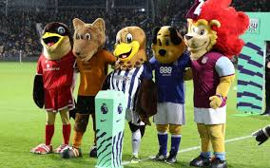  Mascots are characters often used in sporting events. They can be people, animals or objects. Many football teams have their own club mascot. Do you know any? Mascots are used to help build team spirit and offer good luck.  Can you design a mascot for our Virtual Sports Day?  We would love to see your ideas on your Teams feed.  Sports Day    Don’t forget that Friday is our Virtual Sports Day. Please dress in House Colours if possible and watch out for your Sports Day Challenges coming through via Groupcall on Friday morning. If you can’t take part on Friday, please compete over the weekend, you can still complete your Sports Day Form until Sunday 14th June.

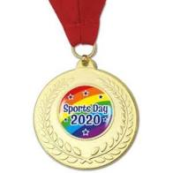

Mild
Sports Day

Ben, Katy and Jack are at their sports day.

Ben had to throw balls into the hoop. How many balls did Ben throw in?
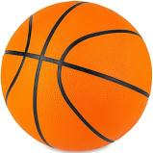

Katy jumped over hurdles. How many did she jump over?
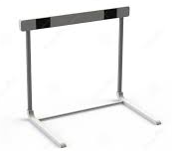

Jack hit balls into a basket. How many balls did he hit?
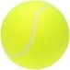

How many more balls did Jack use than Ben? Can you make a sum?

- =

How many pieces of equipment did Ben and Katy use altogether? Can you make a sum?

+ =

Medium
Sports Day

These are the medals won by Primary 1 and 2 at their Sports Day. Can you fill out how many each class won in total?

Class |  | 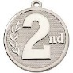 |  | Total
1d | 2 | 5 | 4
1e | 5 | 1 | 2
2d | 2 | 7 | 8
2e | 4 | 6 | 5

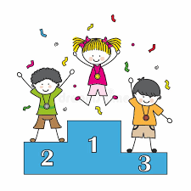
Which class won the most medals?
Which class won the least medals?
How many silver medals did Primary 2 win altogether?
How many bronze medals did Primary 1 win altogether?
How many gold medals were won by the 4 classes?
Primary 1d hoped to win 15 medals in total. How many less than their target were they?
Primary 3d were the overall winners with 22 medals in total. How many more than 2d did they have?

Medium/Hot
Sports Day

These are the medals won by Primary 1, 2 and 3 at their Sports Day. Can you fill in the missing numbers in the medals table? You will need to use addition, subtraction and the clues at the bottom of the table.

Class |  | 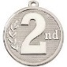 |  | Total
1d | 3 |  | 8 | 16
1e | 6 | 9 | 4
2d |  | 7 | 8
2e | 4 |  |  | 22
3d | 9
3e |  | 3

2d won 4 more gold medals than 1d.
3e won the second highest number of gold medals.
2e won less silver medals then 1e but more than 2d.
3e hoped to beat 2e but they won 2 medals less in total.
3d beat the 2nd placed team by 2 medals in total but were disappointed to win 1 less silver medal than 1d.
Challenge - Were there more gold or silver medals won by the 6 classes? Total gold ______________
Total silver ______________
Answer _________________
Hot (2pages)
Sports Day

The table shows the equipment needed for Sports Day.
hoops | ropes | beanbags | balls | skittles | racquets | cones
54 | 22 | 30 | 65 | 18 | 15 | 44

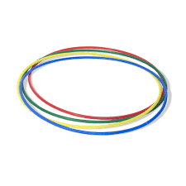
Calculate the following answers mentally.
Mrs Smith is going to bring the hoops and ropes. How many pieces of equipment will she carry? ___________
Primary 3 are going to bring the balls. 3c are able to carry 50 of the balls. How many will 3d carry? ____________
Mr Low can carry exactly 45 pieces of equipment. Which 2 items will he bring? ____________________________________
Primary 1 can bring half the cones. How many will they bring? ____________
6 hoops get broken during sports day. How many are not broken? _____________
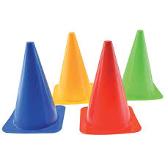
51 cones were actually needed. How many more did they need? ____________

This table shows the different activities.

skipping | beanbag  hop | running | ball  dribble | hoop  throw | tennis
5 minutes | 2 minutes | 13 minutes | 9 minutes | 4 minutes | 7 minutes

4d are able to do 2 activities while 4c are at the running station. Which 2 activities can 4d do?
________________________________________________________
3c are able to do 2 activities while 3d are at the ball dribble station. Which 2 activities can 3c do?
________________________________________________________
Molly only managed to complete the running, beanbag hop and tennis before she hurt her leg. How many minutes was she active for? _____________________________

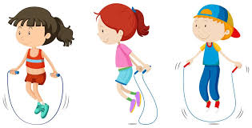
If it takes 30 seconds to complete one lap of the skipping, how many laps can a pupil manage in their 5 minutes? ___________________

2d had a double turn at the running station. How long were they there for? ___________________
Challenge
How long will it take 1 class to complete all 6 activities?
________________________
Primary 1 complete their sports day in the morning, Primary 2 after playtime and Primary 3 after lunch. What is the total time needed for the 3 sports days? Answer in hours _____________

Maths Challenge Cards
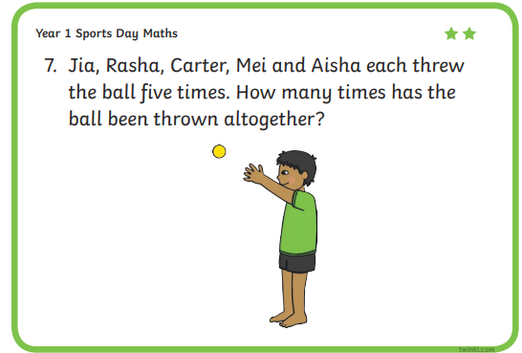
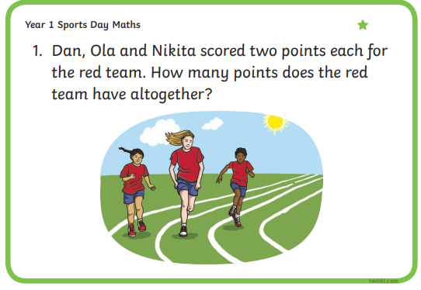
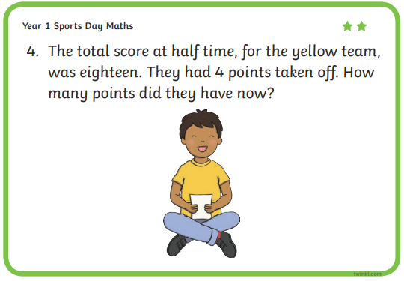
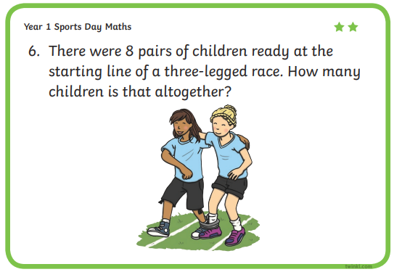
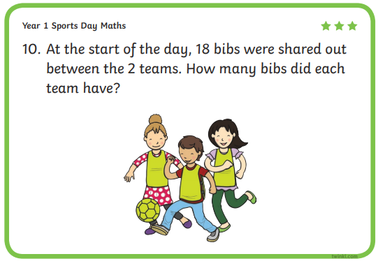
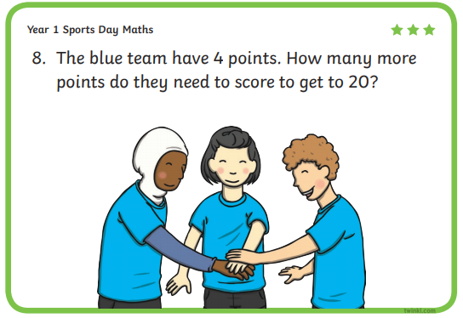
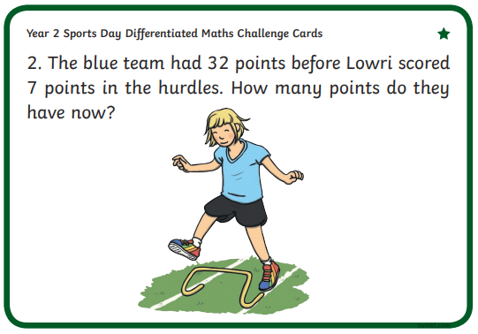
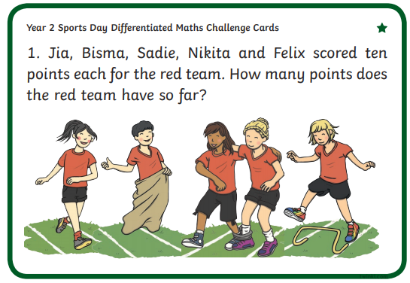
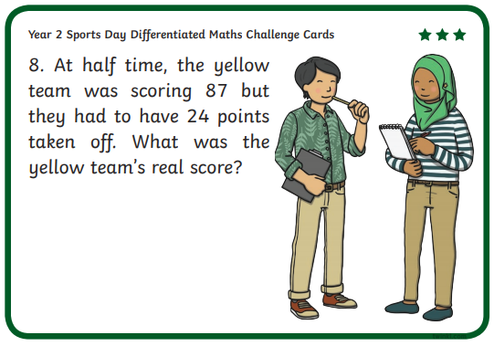
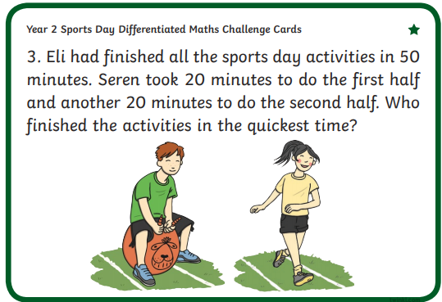
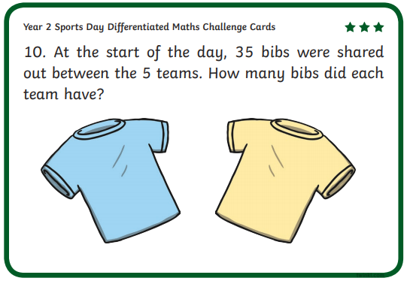
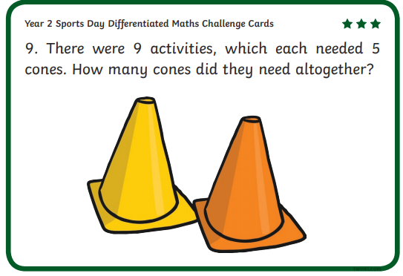
Sports Day Mascot
Can you design your own mascot to bring you good luck during sports week?
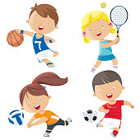


This Photo by Unknown Author is licensed under CC BY-SA

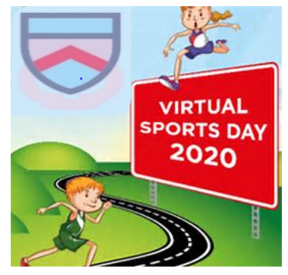
Troon Primary School
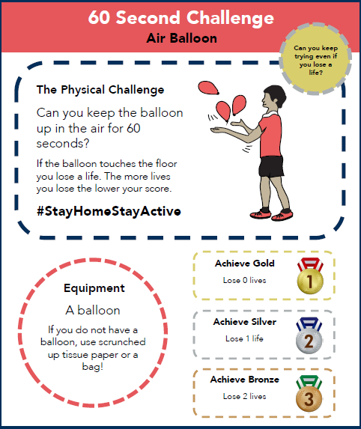

Troon Primary School
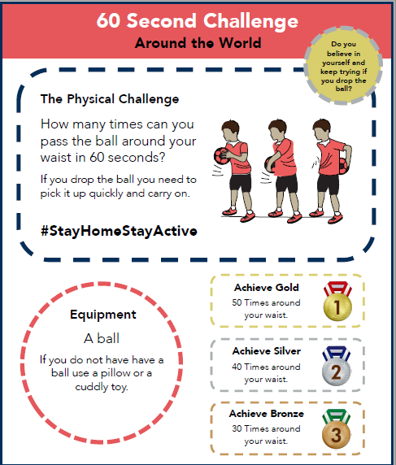

Troon Primary School
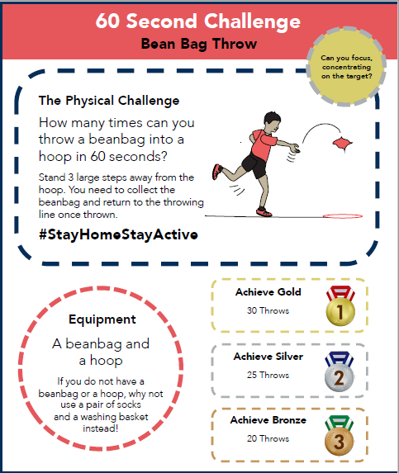

Troon Primary School
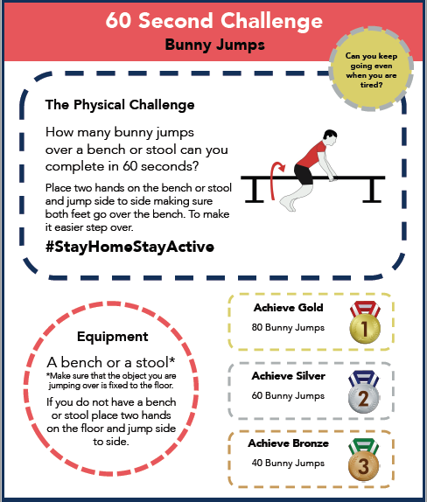

Troon Primary School
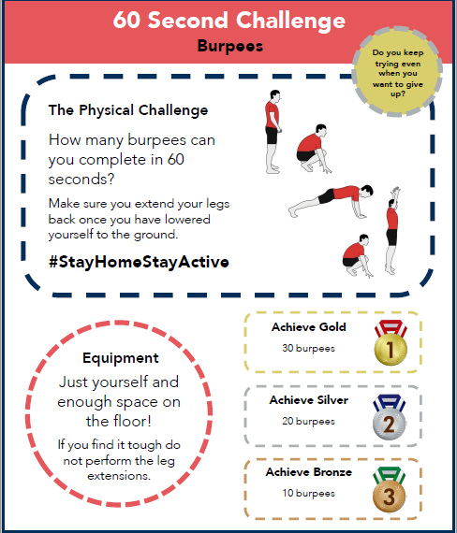

Troon Primary School
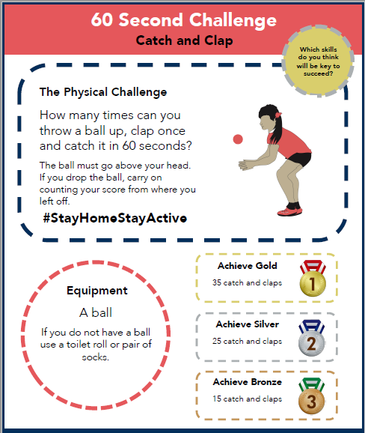

Troon Primary School
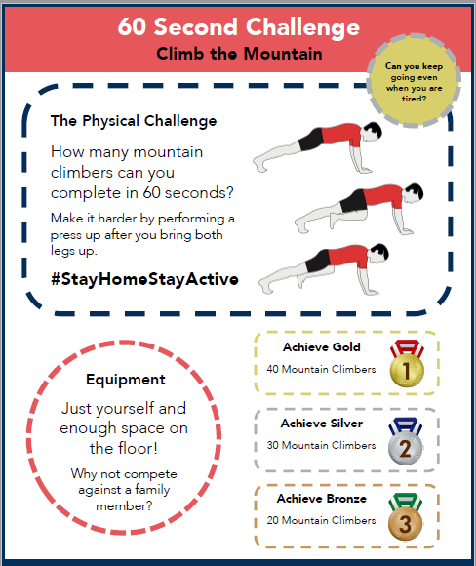

Troon Primary School
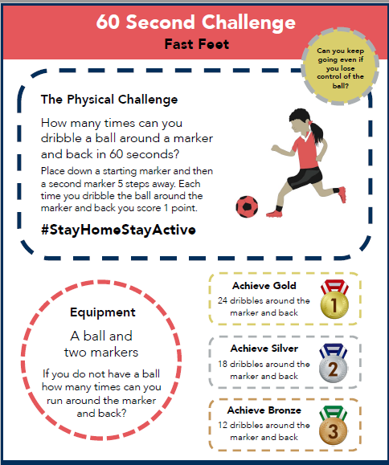

Troon Primary School
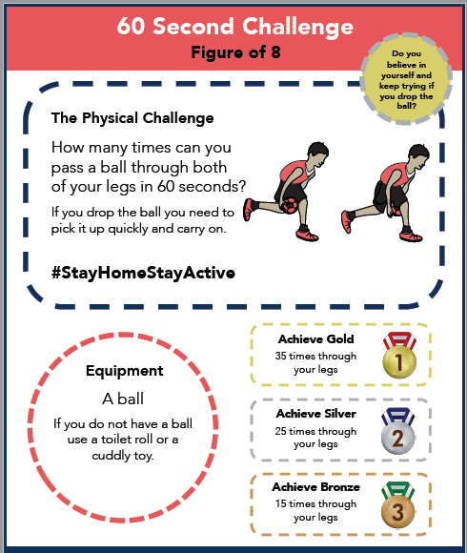

Troon Primary School
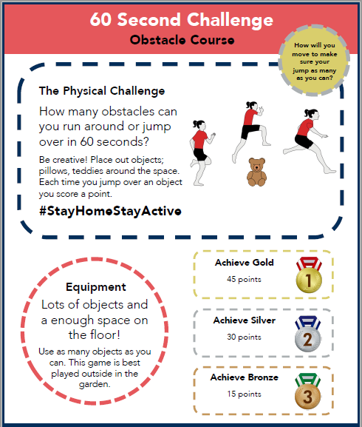

Troon Primary School
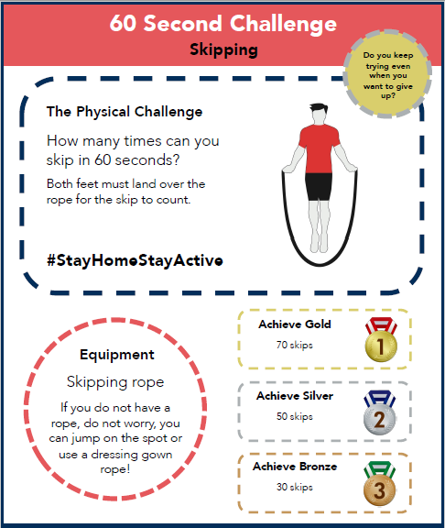

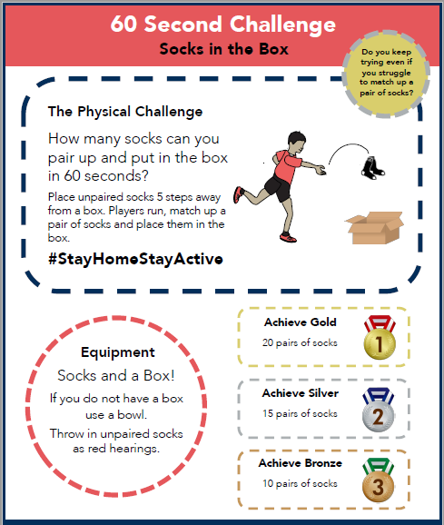
Troon Primary School

Troon Primary School
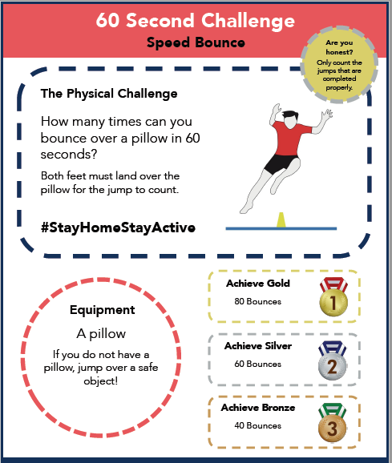

Troon Primary School
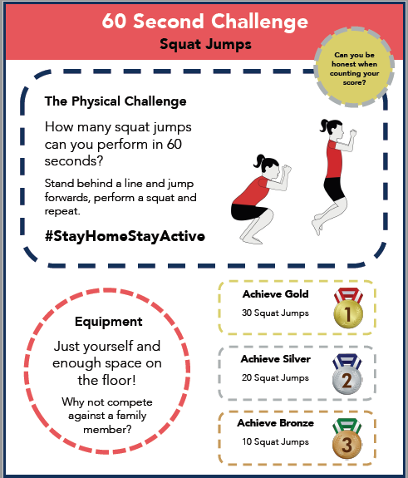

Troon Primary School
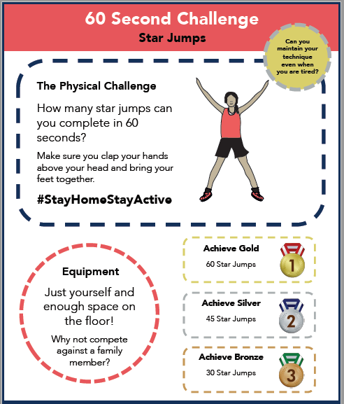

Troon Primary School
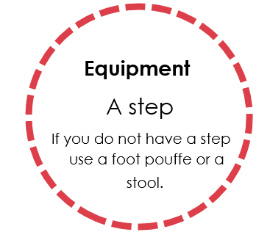
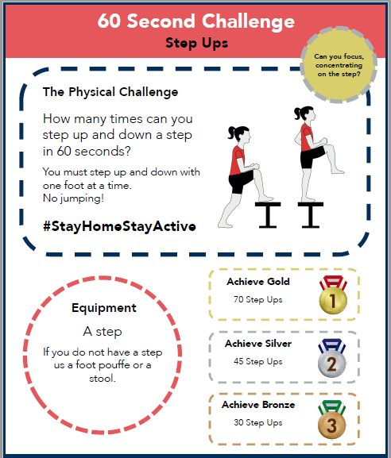

Troon Primary School
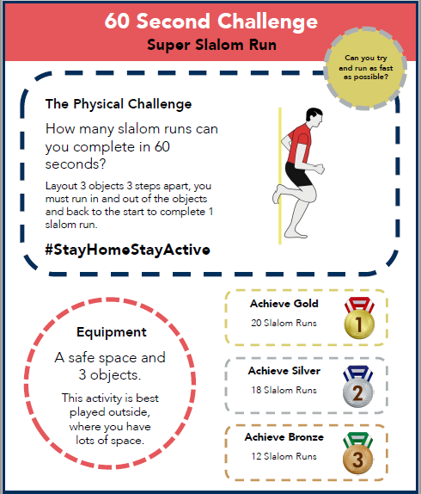

Troon Primary School
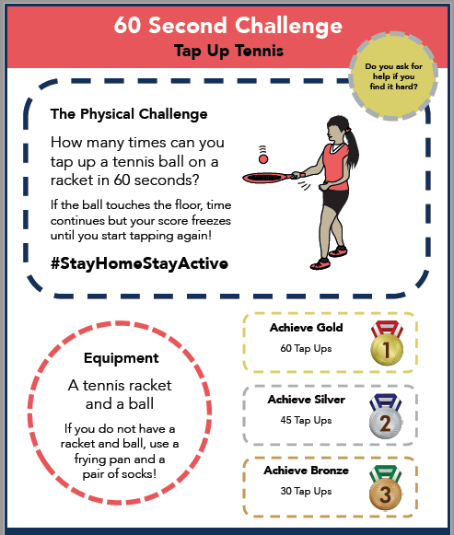

Troon Primary School
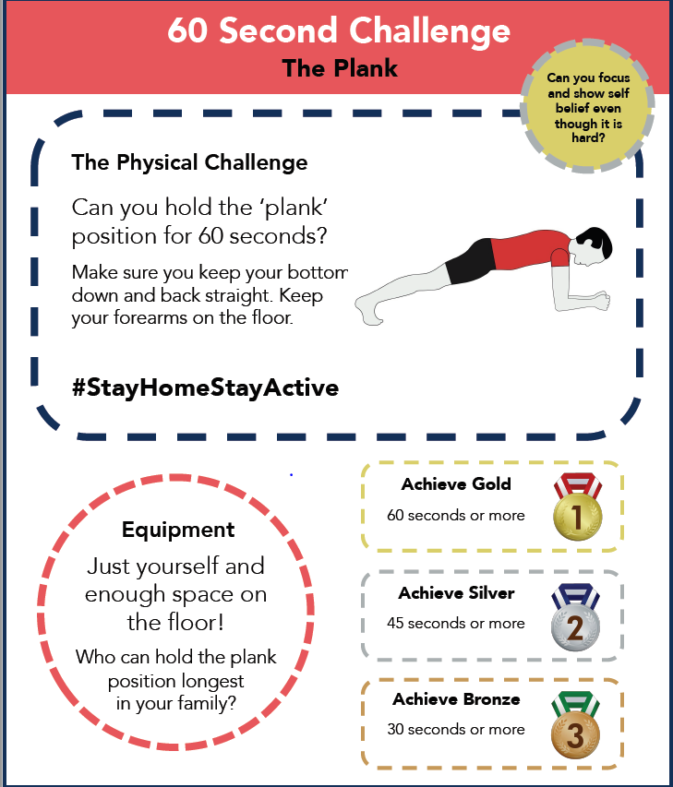

Troon Primary School
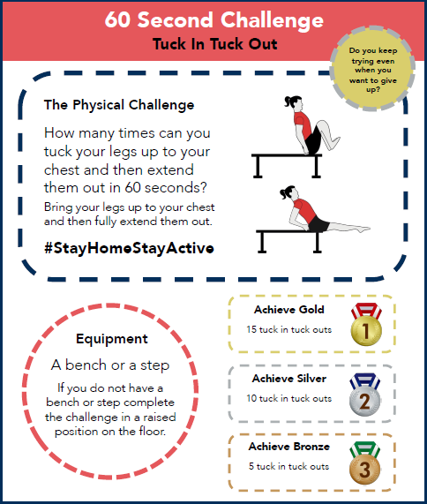

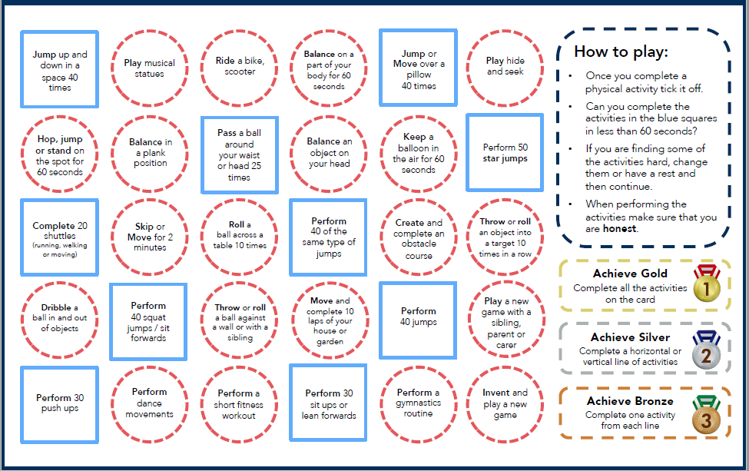
Troon Primary School

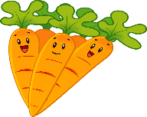

A Healthy Lunchbox
Choose some healthy foods and a drink to put in the lunchbox. Remember your 5 a Day and your different food groups.
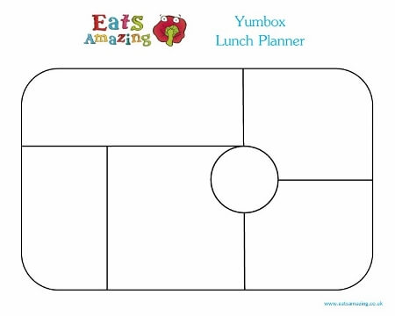

Cut and Stick Food

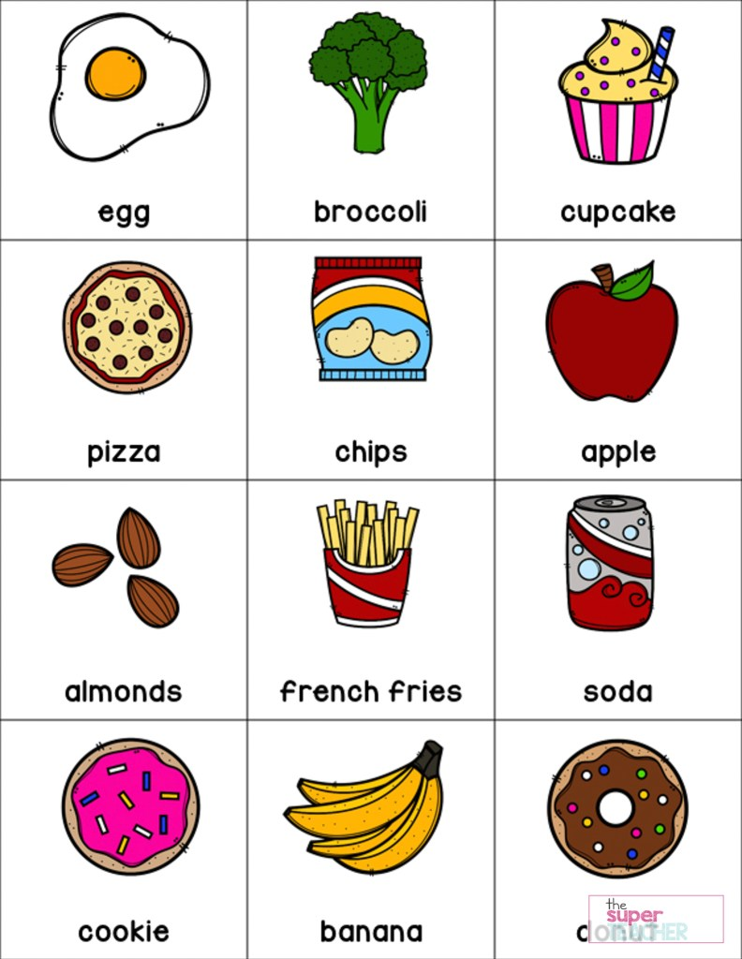
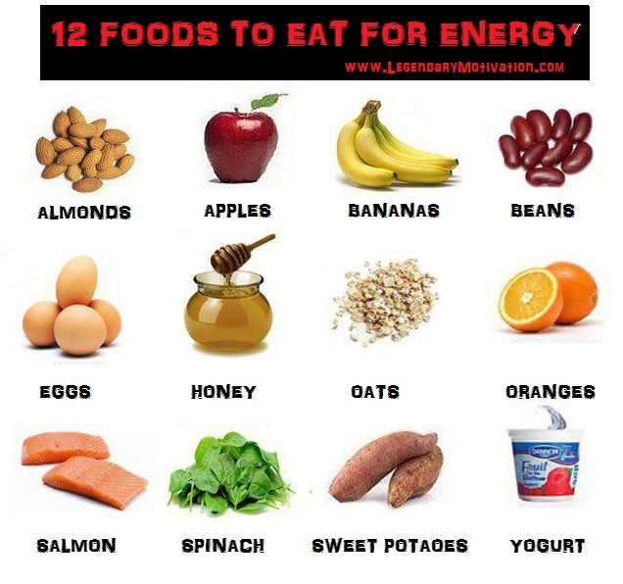
A Healthy Meal

Create a healthy meal for your family.
Draw some healthy food or cut out some pictures from magazines or leaflets you have at home.
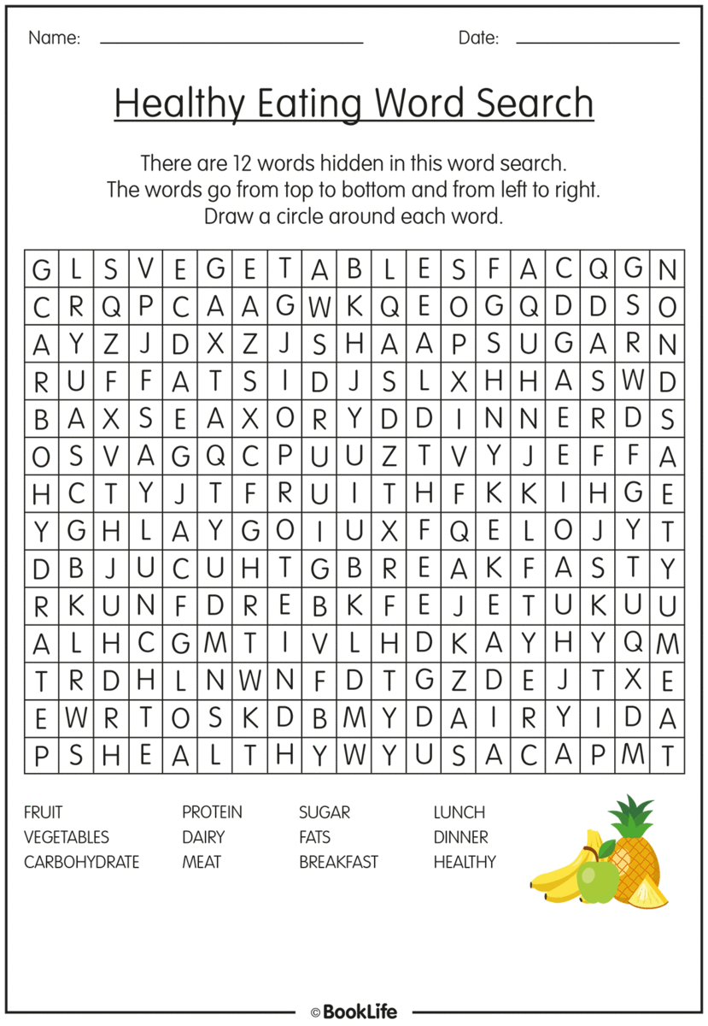
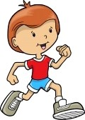

A Medal for Sports Day

Design your own medal for your achievements in
Sports Day.
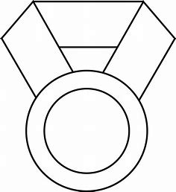

Medal design examples
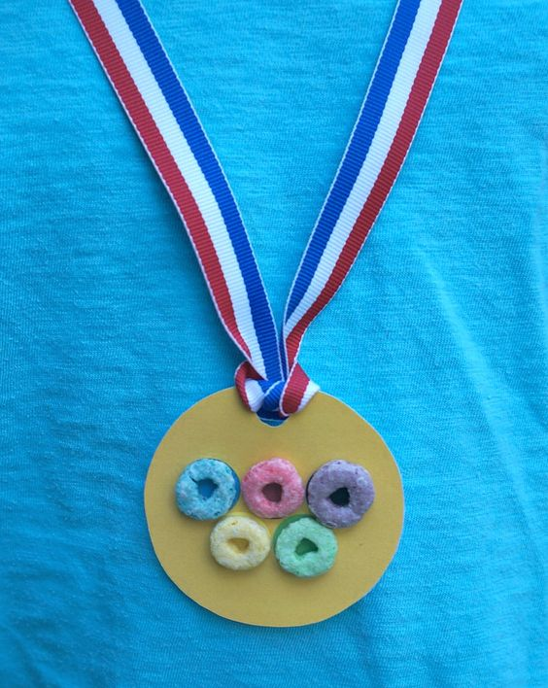

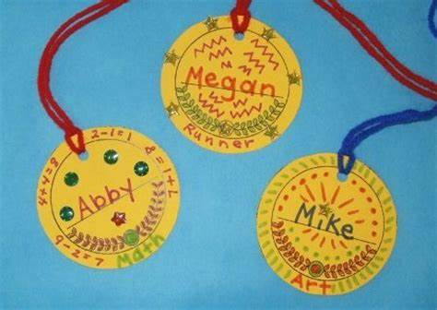
Some ideas to help with making a medal
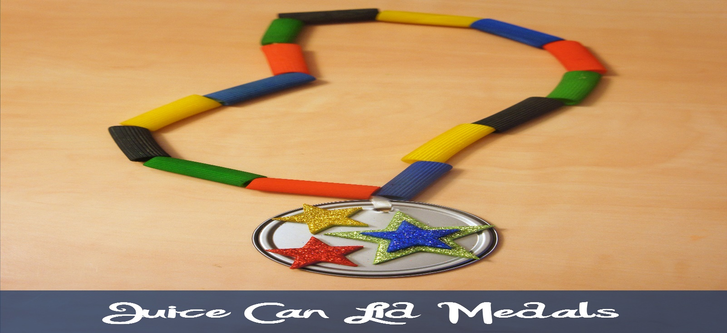

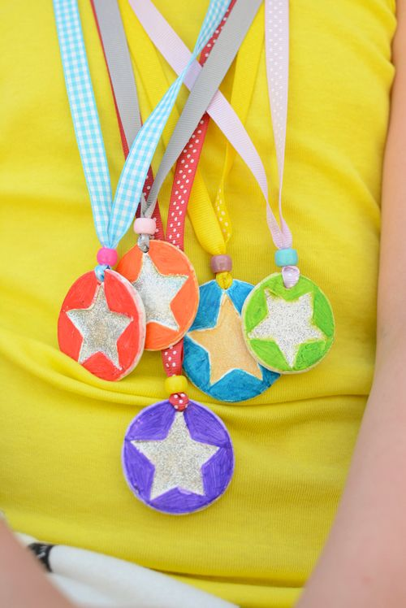
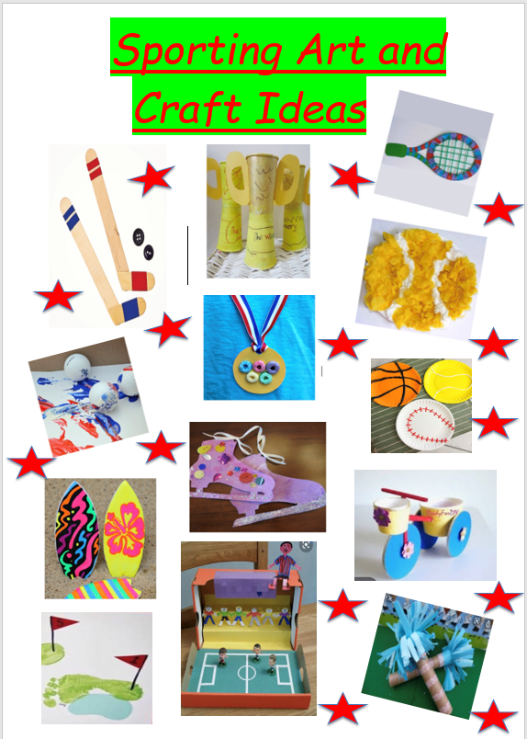

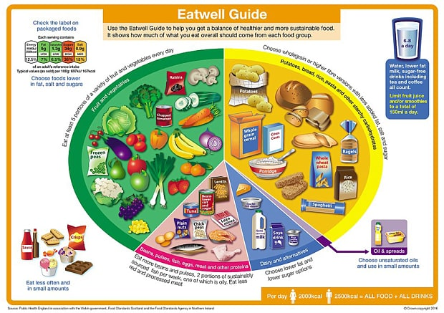
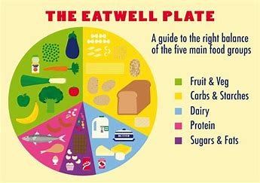

My Athlete Fact File
Insert or draw a photo of your chosen athlete here
Name: _____________________
Date of Birth: ______________
Sport: _____________________
Age: ______
Where they live: ____________

My Facts I have researched:
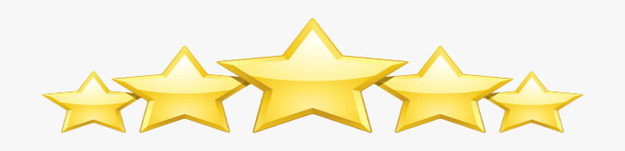
___________________________________________________________________________________________________________________________________________________________________________________________________________________________________________________________________________________________________________________________________________________________________________________________________________________________________________________________________________________________________________________________________
P2
My Athlete Fact File

Name: _____________________
Date of Birth: ______________
Sport: _____________________
Age: ________
Where they live: ________________
Three Facts I have found out about my athlete are:
- ________________________________________________________________________
- ________________________________________________________________________
- ____________________________________________________________________
Insert or draw a photo of your chosen athlete here

P1
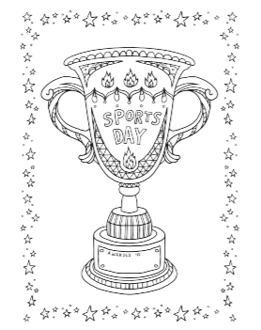
Mindfulness Colouring

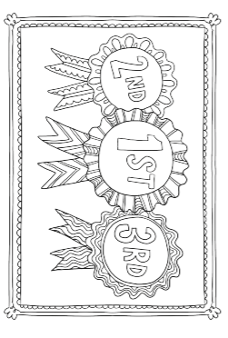
Mindfulness Colouring

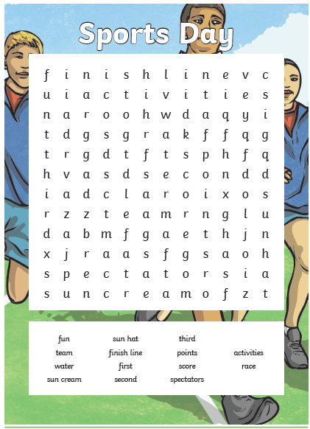
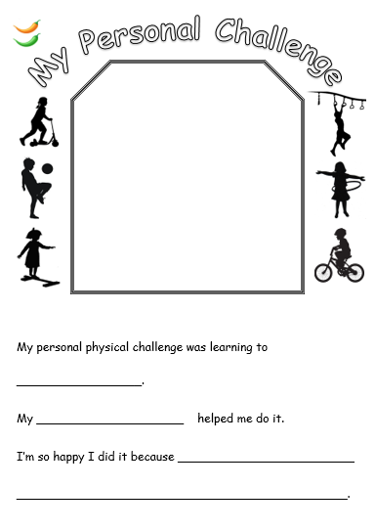
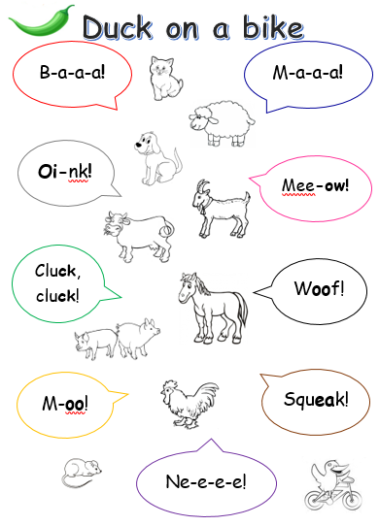
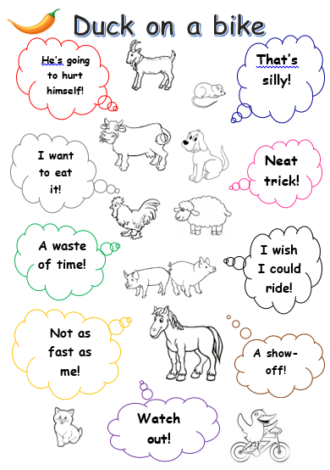
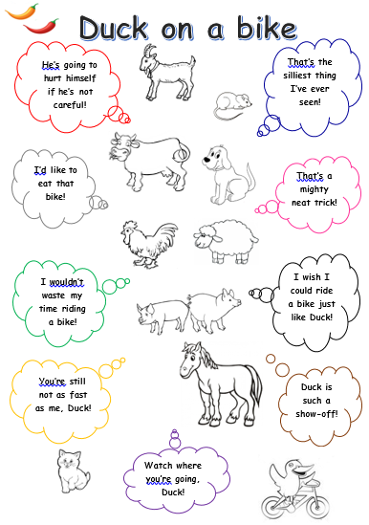
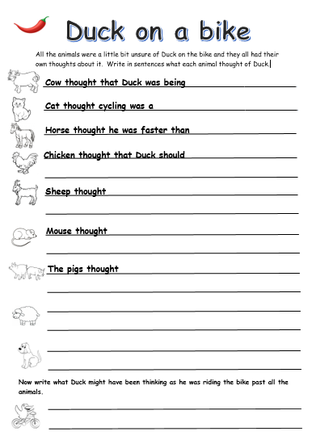
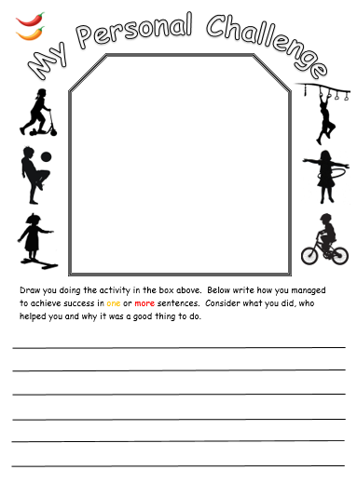

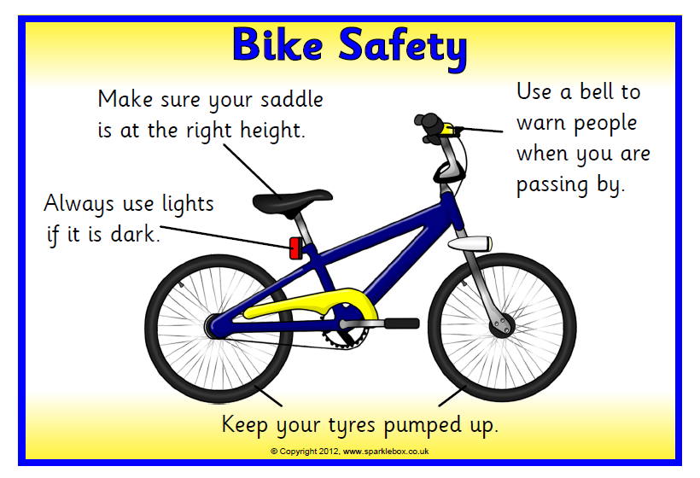
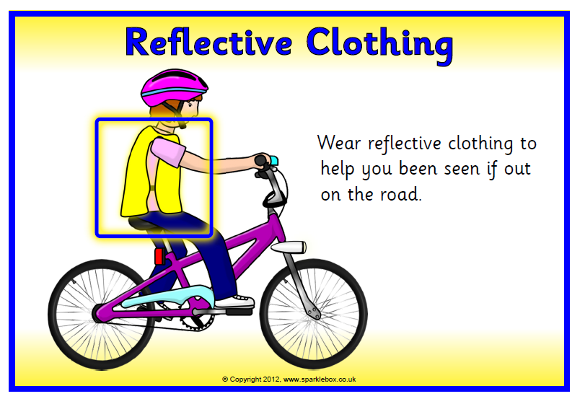
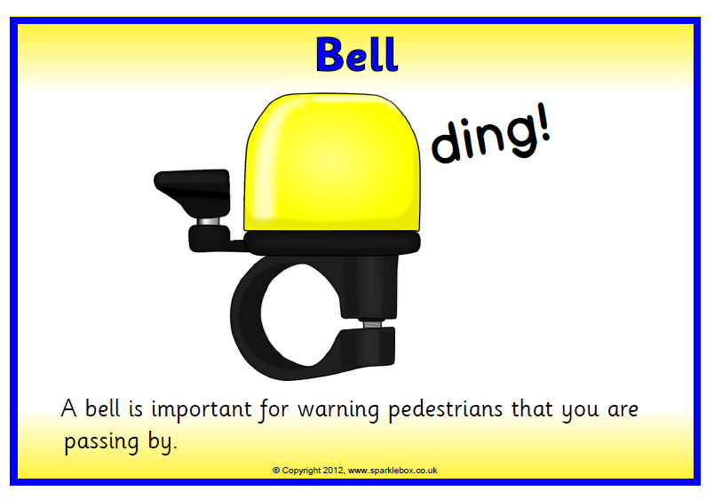
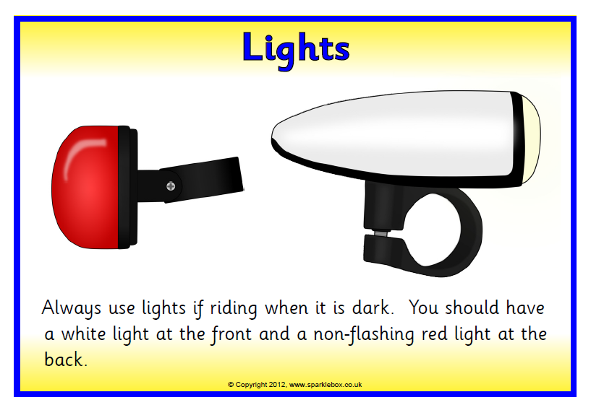
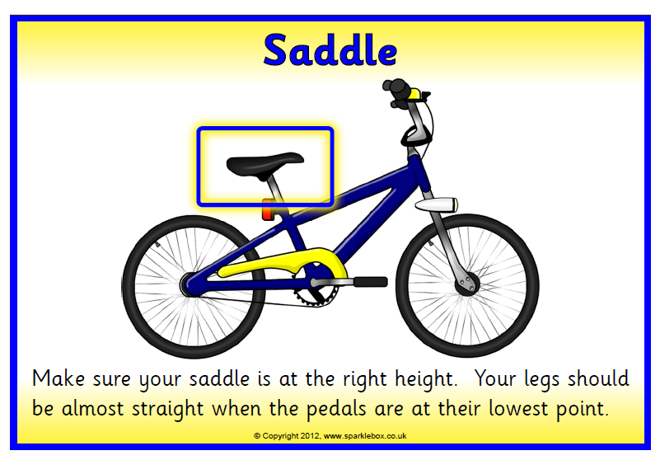
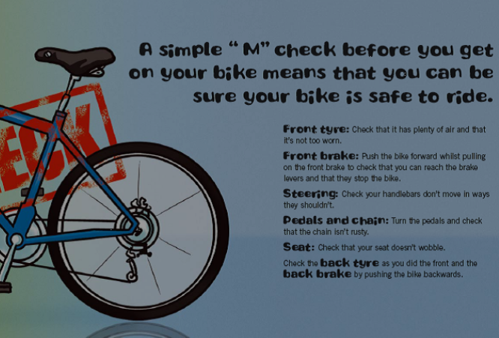
Medium and Challenge
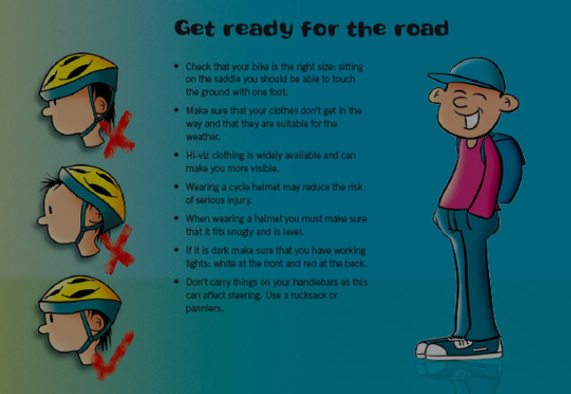
Medium and Challenge

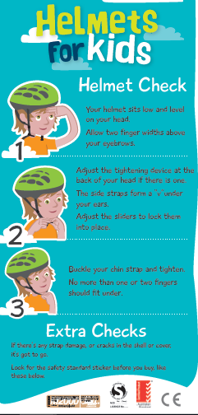
Medium and
Challenge
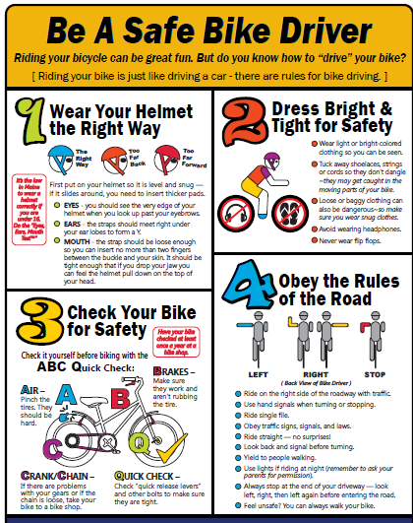
Challenge

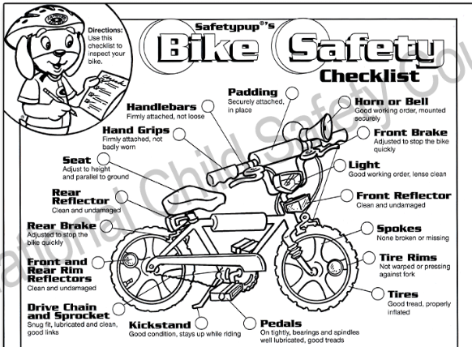
Challenge

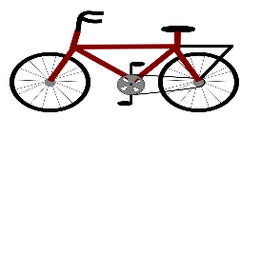
Design your Bike Safety Poster

Bike
Safety

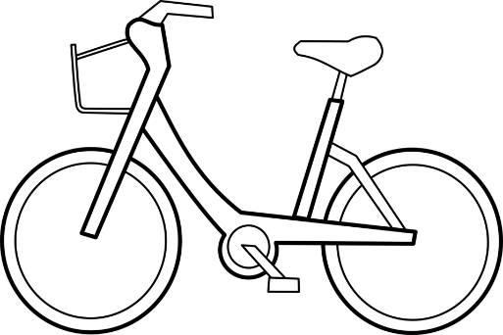

A Place to Cycle

Choose a place you love to cycle and write a tweet
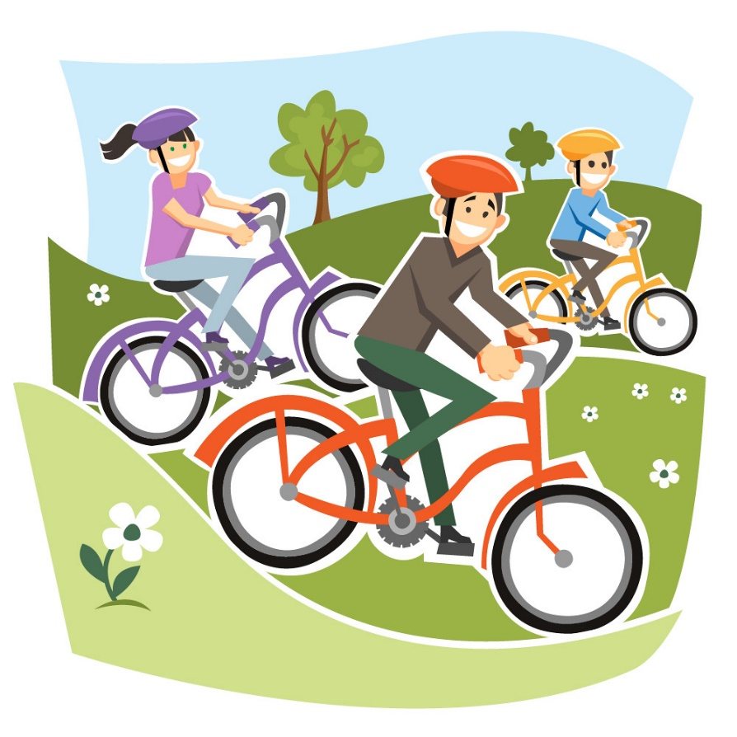
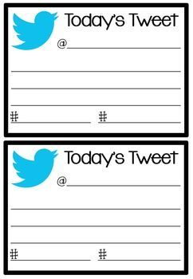
in the template below.
Remember to post this on Teams to share with everyone.

