
St Patrick’s Primary School

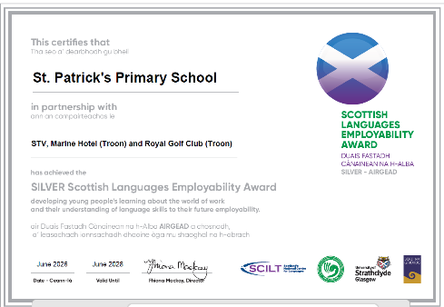
SCHOOL IMPROVEMENT PLAN 2026-2027

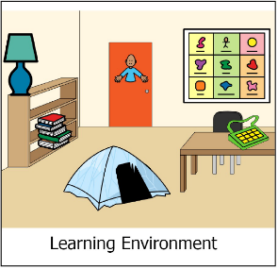

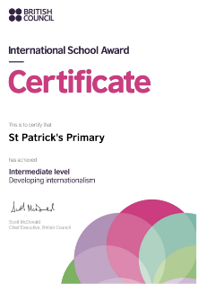




Article 28: Every child has the right to an education
Article 3: The best interests of the child must be a top priority in all things that affect children.

OUR VISION, VALUES AND AIMS
Vision

In St Patrick’s Primary we strive to provide a secure, happy, caring school in which each child is nurtured and empowered to achieve his/her full potential through effective learning and teaching experiences of the highest quality. We are inspired by our Patron Saint, St Patrick:
Inspire me to shine in all I say, all I do and all I am.

Values
- As a Catholic school, our Christian Faith and Gospel Values permeate all aspects of our school life. Having revisited our Values in session 18/19 and in consultation with parents, pupils, staff and our local community our new school values are:
- Achievement Community Faith Inclusion Respect
AIMS
At St Patrick’s Primary we strive to;
- Acknowledge each child and adult as a unique individual, created in the image of God, and consistently strive to address their spiritual, emotional, physical, social, and academic needs.
- Set and uphold high yet achievable standards and expectations for everyone, nurturing a passion for learning in both learners and adults. Support each member of our school community to become a confident individual who takes ownership of their own learning.
- Deliver high quality learning and teaching across the curriculum, ensuring all learners become literate, numerate, and healthy. Equip them with the knowledge, skills, and attributes needed to thrive as lifelong learners in a constantly evolving society.
- Offer meaningful opportunities for learners to deepen their knowledge and understanding of the Catholic faith, engage sincerely in religious observance, and actively practice their faith. Encourage them to be responsible citizens and effective contributors within St Patrick’s Primary School, as well as in the local and global community.
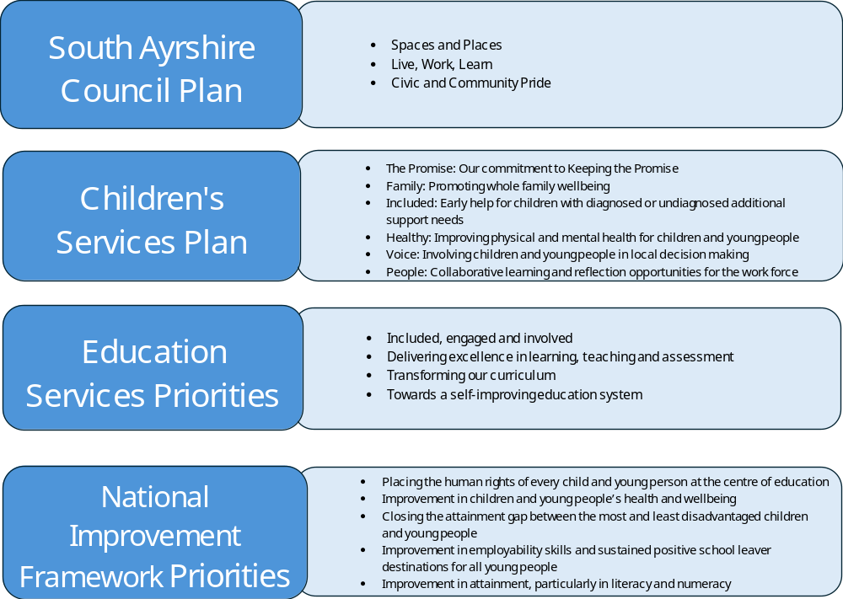

Leadership of Change
Cluster Approach to promoting Gospel Values
RE Lead – Amelie Davidson

Family Learning and Partnerships
National Numeracy Programme – Lynsey May
Parent Communication Strategy – Lynsey May and Parent Council

The Curriculum
Curriculum Lead – Tricia McFadyen
SAR – Kerry Gardiner
Profiling – Tricia McFadyen / Lynsey May
Young Leaders of Learning – Eilidh Wightman
Talk for Writing – Lynsey May

Improving wellbeing, equality and Inclusion
The Connected School – Jaye McKeown
Attendance – Lynsey May

2026-2027 St Patrick’s School Improvement Plan Priorities

[Grab your reader’s attention with a great quote from the document or use this space to emphasise a key point. To place this text box anywhere on the page, just drag it.]

Improvement Planning 2026-2027 PHASE 2 SCHOOL St Patrick’s Primary

Education Services Improvement Plan Priority 2: Outstanding Learning, Teaching and Assessment Educational Services Improvement Plan 2023 - 2026
SAR Strategic Plan Priority: To raise attainment in literacy and to significantly reduce the reading attainment gap between the most and least disadvantaged children and young people in South Ayrshire South Ayrshire Reads Strategy Document
PHASE 2 SOUTH AYRSHIRE SCHOOLS
2026-2027
SAR Strategic Aim | Actions | Intended Impact | Resources | SAR Lead | Completion  Date
To develop confident and skilled readers in South Ayrshire with a lifelong love of reading and the confidence to access all aspects of education, culture and society  To support and develop all education staff in South Ayrshire to implement best practice through a culture of shared knowledge, collaboration and enquiry  To promote the implementation of an excellent reading curriculum which prioritises best practice, challenge and adapted teaching for children with additional support needs  To gather, use and analyse data effectively to drive change and improvement in children’s reading skills, reading confidence and reading attainment | By June 2026, ALL Phase 2 schools will have reviewed the role of their reading leader and, in collaboration with the South Ayrshire Reads team, planned how this role will be used to support reading development over the coming year. | The aims of South Ayrshire Reads continue to be embedded across Phase St Patrick’s Primary focussing on building capacity and sustainability.  The values, vision and aims of  South Ayrshire Reads  is consistent and clear to all stakeholders | - Role of reading leader reviewed at planning meeting.  - Reading Leader meeting dates shared and agreed.  - Reading leader workshop dates agreed.  - RL MS TEAM accessed for updates, relevant information and collaboration. | SAR PTs | June 2026
 | By June 2027, ALL Phase 2 schools will have participated in at least two Reading Leader-led workshops within their own setting, with Reading Leaders taking full responsibility for identifying workshop needs, planning these sessions and leading them to support the ongoing embedding of reading practice. |  | - All Reading Leaders may attend four sessions (September 2026, November 2026, February 2027, and April 2027) focused on building capacity and providing the knowledge and skills needed to lead impactful change.  - All Reading Leaders will plan, create and deliver reading workshops within their own schools - both with staff and with parents -as part of a wider drive to raise attainment in reading. | LW  Kerry Gardiner | June 2027
 | By June 2027, ALL Phase 2 schools will have had the opportunity to engage in collaborative activity, selecting the approaches that best suit their context, through:  - Partnership CLPL  - Stage-Specific ‘Spotlight’ sessions  - ‘Learning Live’ sessions  - Peer school visits  strengthening collective efficacy, promoting an outward-looking approach to improvement and embedding practice. |  | - Bespoke partnership CLPL responsively planned and reviewed in line with contextual needs.  - Meeting & discussion with SLT around peer school visits  - Peer visit pre-workshops/discussion/observation guides  - Term 3 Stage-Specific ‘Spotlight’ sessions  - ‘Learning Live’ offerings. | SAR PTs | June 2027
 | By August 2026, ALL Phase 2 schools will work with the SAR Team to identify new or returning staff requiring catch-up support, plan how to close gaps drawing on in-school knowledge, and will have the opportunity to:  - Send staff to ‘Fast Track’ sessions  - Access additional CLPL at peer schools  ensuring all staff are equipped with the knowledge and skills to support reading development effectively. |  | - Meeting & Discussion with Phase 2 schools to identify new/returning members of staff and their stages  - Existing members of staff in Phase 2 schools to support, through coaching, modelling and collaborative discussions  - Fast Track sessions agreed & planned by SAR Team  - Additional CLPL sessions identified at peer schools | SAR PTs | August 2026
 | By June 2027 ALL Phase 2 education staff will have had the opportunity to engage in additional high-quality CLPL in an area of interest. |  | - Additional online sessions planned, created and delivered by SAR Team in response to need  - Additional sessions will be advertised through the monthly CLPL Bulletin and Reading Leader channel on MS Teams. | SAR Team | June 2027
 | By June 2027 ALL Phase 2 education staff will have had the opportunity to engage in bespoke high-quality CLPL. |  | - All CLPL will be grounded in the Science of Reading, with a particular focus on language comprehension and its connection to other areas of literacy development, while continuing to embed previous work on word recognition (phonics and morphology) and fluency. | SAR PTs | June 2027
 | By June 2027, ALL Phase 2 education staff will have had the opportunity to further develop their practice in collaboration with the SAR Team. |  | - Collaboration activities, including workshops and professional discussions as requested | SAR PTs | June 2027
 | By June 2027 ALL Phase 2 schools will have had the opportunity to engage with assessment implementation, data analysis and self-evaluation, using HGIOR (How Good is Our Reading) to drive teaching and learning. |  | - Reading Leader- Led Workshops focused on the interpretation, analysis, and evaluation of learner attainment to measure impact and inform next steps.  - Reading Leader-Led Workshops using HGIOR as a self-evaluation tool. | HMcB  JW  Kerry Gardiner | June 2027
 | By June 2027 ALL Phase 2 schools will have had the opportunity to engage with and access support to implement and embed additional related SAR priorities. |  | - Reading Schools Accreditation  - Communication Friendly Environments  - Developing Writing through SAR  - Giglets  Lending Library | JM  HMcB  SL | June 2027
 | By June 2027 ALL parents will have had further opportunity to engage with workshops and learning sessions based on supporting their child’s reading development. |  | - Support for RL, as required, from SAR team for workshop and parent events | Kerry Gardiner  SAR PTs | June 2027

South Ayrshire Service Plan Priority
Priority: Improving Our Curriculum

ALL SOUTH AYRSHIRE SCHOOLS 2025-2026
Aims | Actions | Intended Impact | Resources | Measures | Completion  Date
To increase all teacher understanding of the purpose and relevance of the CIC and the rationale behind curriculum reform. | - The school will identify a curriculum lead (T.McFadyen) to support the implementation of curriculum reform and act as a link with authority-wide developments.  - The curriculum lead will participate in authority Train-the-Trainer professional learning to ensure consistent messaging and build internal capacity.  - All staff will engage in planned CLPL to build understanding of curriculum reform during the two allocated twilight sessions using materials created by Curriculum PTs. | Staff are clear on the key terminology around curriculum and educational reform.  Staff can clearly articulate why curriculum change is being made.  All staff are clear on the national timeline for implementation of the CIC | Presentation created by Curriculum PTs | Staff survey (pre and post twilight sessions)  Evaluation | August 2026  September 2026  January 2027
To provide clear and consistent communication for all staff and stakeholders in relation to Scotland’s Curriculum | - Staff will access the authority’s central digital hub for curriculum resources, exemplars and professional learning materials.  - All staff will attend the relevant authority curriculum conference.  - Content will be created centrally to raise awareness of the CIC and used by schools to engage wider school community.  - The Curriculum PTs will offer support with parental engagement as requested.  - School leadership team will receive regular CIC information via director’s education update.  - All Head Teachers will attend two authority HT Curriculum Conferences. | Staff will feel supported during the early stages of transition.  Staff feel well informed and confident in discussing curriculum changes with colleagues, learners and families.  Parents and stakeholders will better understand Scotland’s curriculum and the future changes. | Central digital padlet  Exemplars and professional learning materials  Schools preferred media platforms | Analytics from shared online space (comments, resources, access to the toolkit and materials | June 2027  May 2027  December 2026  June 2027
To establish an understanding of a concept-based curriculum and to introduce the Know-Do-Understand model. | - ‘Curriculum of Hope’ professional reading distributed during the ‘Train-the-Trainer' session fo key leads.  - Values from the ‘Curriculum of Hope’ text shared with all staff during twilight sessions .  - Key leads to gather staff feedback at the beginning of the first twilight.  - Key leads to repeat the staff survey at the end of the second twilight to gauge progress. | All staff understand the principles of a concept-based curriculum.  All staff will have had opportunities to engage with the values and principles of ‘A Curriculum of Hope’. | ‘A Curriculum of Hope’ professional reading  Microsoft form for twilight | Pre/Post Survey Data | October 2026  February 2027

Priority 1: 2.2 The Curriculum
Links to South Ayrshire: Live, work, Learn
Links to Children’s Services Plan: Included
Links to Education Services Plan: Outstanding learning, teaching and assessment / developing our curriculum
Links to National Improvement Framework: Improvement in attainment/ Closing the gap between most and least disadvantaged

In 2026/27 we will focus of Curriculum Design

Strategic Aims | Actions | Intended Impact | Resources | Measures | Key Personnel | Completion Date
Implement approaches to profiling that enhance young people's self-awareness as learners and support them in recognising and developing skills for learning, life, and work. | Create ‘Magic Moment’ time within timetables and group children – no more than 8 to an individual teacher.  Encourage students to create and regularly update their Personal Learning Plans, reflecting on their strengths, areas for improvement, and goals.  Use PLPs to track progress and set actionable steps for skill development.  Implement reflective journaling where students can document their learning experiences, challenges, and achievements.  Regular reflection sessions to help students articulate their learning journey and recognise their skills.  Conduct skills mapping exercises where students identify and map out the skills they have acquired through various activities, both inside and outside the classroom.  Use tools and resources from "My World of Work" to help students understand how their skills align with different career paths.  Facilitate regular career conversations.  Utilise "My World of Work" to explore different career options, understand the skills required.  Organise workshops focused on skills for learning, life, and work.  Use "My World of Work" resources to provide insights into various industries and the skills needed for success | Pupils will gain a deeper understanding of their strengths, areas for improvement, and learning styles, enabling them to become more effective and self-directed learners.  By identifying and mapping their skills, students will be better equipped to recognise and develop essential skills for academic success, personal growth, and future careers.  Utilising resources like "My World of Work," pupils will explore various career options, understand the skills required, and make informed decisions about their future paths.  Personalised learning plans, reflective journals, and portfolios will foster a sense of ownership and pride in their learning journey, increasing overall engagement and motivation.  With a clear understanding of their skills and goals, pupils will be better prepared to achieve academic success and navigate life challenges, leading to improved overall outcomes.  By embedding these profiling approaches, we aim to create a supportive and empowering educational environment that nurtures well-rounded, confident, and capable individuals ready to succeed in learning, life, and work. | My World of Work Profiles P5-7  Create Personal Learning Plans for P1-P4 | Conduct surveys to gather pupils self-reported data on their self-awareness, skill recognition, and career readiness.  Review pupils’ reflective journals and portfolios to track their progress in self-awareness and skill development over time.  Assess the quality and depth of reflections to gauge pupils' understanding and growth.  Monitor the completion and updates of PLPs to ensure students are actively engaging in the process.  Evaluate the goals set and achieved by pupils to measure their progress.  Analyse changes in academic performance and engagement as indicators of the effectiveness of profiling approaches.  Compare grades, attendance, and participation rates before and after implementation.  Use pre- and post-assessments to measure improvements in skill recognition.  Gather feedback from parents and teachers on pupils’ development and engagement.  Track pupils’ usage of the "My World of Work" platform to see how often they engage with the resources. | L.May  T.McFadyen | June 2027
   | 25/26 | Aim
  The information I receive about how my child is doing reaches me at the right time. | 78% agree or strongly agree | 84% agree or strongly agree
By June 2027, all P6 and P7 will undertake a defined Young Leader of Learning role linked to school improvement priorities.  By June 2027 almost all P7 pupils will demonstrate increased understanding of leadership, pupil voice and HGIOS 4.  By June 2027, almost all pupils will demonstrate increased confidence in leading learning conversations and contributing to school self – evaluation. | Provide professional learning for staff on the Young Leaders of Learning programme and pupil lead self evaluation.  Deliver structured training for pupils on;  - Leadership skills  - Pupil Voice  - Consultation  - Evaluating learning using HGIOS 4  Allocate all P7 learners a defined Young Leaders of learning role linked to school priorities.  Plan regular opportunities for contributions to inform self evaluations and improvements in learning and teaching.  Evidence of meaningful pupil leadership is recorded and embedded across the school  - Lead discussions with peers  - Gather views on Learning and Teaching  - Contribute to improvement activities.  Support pupils to record contributions in leadership logs and share findings with staff. | Almost all P7 pupils actively contribute to school improvement as Young Leaders of Learning.  Identified pupils demonstrate increased confidence in leading discussions and gathering pupil voice. | Education Scotland Young Leaders of Learning programme materials and guidance  Staff CLPL time (inservice, staff meetings, WTA allocation)  Time within timetable for pupil leadership activities and meetings  Leadership log materials | Surveys  Self-evaluation activities linked to SIP | E.Wightman and T.McFadyen | Oct 2026 – Dec 2026  Jan 2027 – June 2027
To implement and sustain a consistent Talk for Writing approach that improves pupil attainment, supports progression in writing, and increases engagement and enjoyment across all stages.  Writing for enjoyment culture established  To create a shared understanding of high quality learning and teaching of writing where pupils are confident about the purpose of the lesson and can evidence what has been learned resulting in increased attainment. | Staff to attend 4 Talk for Writing CLPL (online sessions) to provide coherent system for teaching writing.  Photo Friday to be reintroduced to encourage writing for enjoyment, creativity and having an audience to present to (assembly).  Ensure that by the end of Term 1 the following non-negotiables are embedded across every class: - Planning and delivery of the Talk for writing process:  Imitation, Innovation, Independent Application and Invention  - Daily shared reading (at least x3 a week)  - Daily shared writing – to model key aspects of the genre of writing and other features such as spelling, vocabulary, grammar and punctuation.  - Use of frequent formative assessment with the feedback record being used consistently  - Awareness of the key language features per year group (as per the toolkit overview)  - Increase and deepen reading, with a strong reading spine from P1 – P7  – to continue to add to this spine with further books on diversity.  - Introduce ‘Magpie’ books across all classes, so children act and feel like writers  - Introduce spelling cards that link to the current topic and display core spellings for units of work around the classroom  - Classrooms which support and celebrate writing, with role-play areas, learning walls/washing lines, easels, all the time toolkits displayed, specific genre toolkits  - Embedded DIRT (Dedicated Improvement Reflection Time)  – ensure that all teachers build in a focused editing session at the end of a hot write or mini write to teach pupils the skills of proof reading, amending errors, improving features and evaluating their own writing | Improved attainment in writing across all identified stages, with a higher proportion of pupils achieving expected and beyond expected levels.  Increased consistency of high-quality pedagogy in writing across the school, resulting in equitable learning experiences for all pupils.  Enhanced pupil engagement and motivation, with learners actively participating in writing lessons and demonstrating positive attitudes towards writing.  Improved learner confidence, with pupils able to discuss their writing and apply taught strategies effectively. | Talk for Writing online CLPL  Yvonne Daubney | 100% of staff to feel confident teaching and assessing writing– staff survey.  Writing Attainment:  Pupil survey on attitude to writing pre and post.  Pleasure in writing. As a result, the proportion of children and staff reporting positive attitudes to writing increases.  Pre and post staff survey on the confidence of teaching writing  Planners with accessible resources | L.May | CLPL COURSES  Sept 2026  June 2027
  % secure at Writing 2026 | Target May 2027
  P1 82 | 92
  P4 78 | 80
  P7 81 | 92

Priority 2: 3.1 Improving wellbeing, equality and inclusion

Links to South Ayrshire: Live, work, Learn
Links to Children’s Services Plan: Healthy: Improving physical and mental health for children and young people
Links to Education Services Plan: Included, engaged and involved
Links to National Improvement Framework: Improvement in children and young people’s health and wellbeing

 | Strategic Aims | Actions | Intended Impact | Resources | Measures | Key Personnel | Completion Date
 | To implement The Connected School as a whole school approach, in line with SAC positive relationships policy. | The school will identify a connected school champion to support whole school implementation. | The school nurtures a culture of mutual respect, strong relationships, and calm, consistent authority so every learner feels safe, valued, and ready to learn.  Relationships between pupils, parents, and school staff are strengthened through consistent communication, shared expectations, and increased collaboration, leading to a more supportive, trusting, and connected school community.  School staff are empowered, supported and confident in supporting pupils who display dysregulated behaviours.  Classroom disruption is significantly reduced, resulting in improved engagement with learning.  Improved behaviour across the school community, including reduced violence and aggression. | L.May | Questionnaires  Focus groups  Data | J.McKeown 18th August 2026 | To implement The Connected School as a whole school approach, in line with SAC positive relationships policy.
 | Embed a whole-school culture where attendance is a core driver of wellbeing, safeguarding and attainment. | Share a strategic attendance message termly  Refresh and publish Attendance Policy  Embed relational practice | Consistent understanding of expectations  Improved relationships  Attendance embedded in inclusion and safeguarding culture | Leadership time  Policy review time  Professional learning  Communication platforms  Education Scotland – Keeping Trauma in Mind PL Module  Attendance Management Guidance  Gaining the voice of the Child tools | Attendance trends  Learning walks  Pupil/Parent feedback  Policy review  Staff feedback regarding attendance links to wellbeing, safeguarding and attainment | L.May  SLT  Inclusion Co-ordinator – Suzanne George  Pastoral Team  Educational Psychologist | Sept 26 – June 27
 | Build strong, trust‑based partnerships with families. | Solution‑focused communication  Early‑stage meetings (pupil voice on agenda/minutes)  Practical family supports | Improved parental engagement and faster resolution of concerns  Stronger consideration of GIRFEC and holistic view of the child/family | Family First Team  School Welfare Officers  Community links  Training on solution oriented practices and meetings | Parent feedback  Improved attendance following meetings  Pupil and staff feedback throughout engagement | Pastoral Team  Family First Team  School Welfare Officers | Aug 26 – June 2027
Priority 3: Family Learning and Partnership

Links to South Ayrshire: Live, work, Learn
Links to Children’s Services Plan: Family: Promoting whole family wellbeing
Links to Education Services Plan: Included, engaged and involved
Links to National Improvement Framework: Improvement in attainment, particularly in Literacy and Numeracy

Strategic Aims |  | Actions | Intended Impact | Resources | Measures | Key Personnel | Completion Date
To work in partnership with families through the National Numeracy programme to enhance pupil attainment, increase confidence in numeracy, and support learning beyond the classroom. |  | Staff Professional Learning  CLPL for all staff on the principles of the National Numeracy programme.  Baseline & Tracking  Establish a baseline of pupil numeracy attainment and confidence (using assessments and pupil voice).  Use termly tracking and monitoring to measure progress and identify gaps.  Identify target groups (e.g. SIMD, ASN, maths anxiety) for focused support.  Embed daily numeracy routines and real-life contexts across all stages.  Promote use of mathematical language and reasoning skills in lessons.  Family Engagement  Deliver numeracy workshops for parents/carers (in-person or online).  Share simple, practical strategies and resources to support numeracy at home.  Provide regular communication (e.g. newsletters, videos, home tasks) to build family confidence.  Pupil Confidence & Engagement  Introduce activities that reduce maths anxiety and build a growth mindset.  Promote positive numeracy experiences through games, challenges, and real-life problem solving.  Use pupil voice regularly to adapt approaches and increase engagement.  Monitoring & Evaluation  Carry out learning visits, jotter monitoring, and moderation focused on numeracy.  Gather feedback from pupils, staff, and families to evaluate impact.  Review progress at set intervals (e.g. termly) and adjust actions accordingly. | Improved numeracy attainment across all stages, with an increased proportion of pupils achieving expected and higher levels.  Increased pupil confidence in numeracy, with learners demonstrating a more positive attitude towards maths and reduced maths anxiety.  Enhanced pupil ability to apply numeracy skills in real-life contexts, showing improved problem-solving, reasoning and use of mathematical language.  Closing of the attainment gap for identified groups through targeted support and inclusive approaches.  Family Learning & Engagement Impact  Increased family confidence in supporting numeracy at home, evidenced through participation in workshops and feedback.  Stronger partnerships between school and families, with regular engagement in numeracy learning activities.  Improved consistency between school and home approaches to numeracy, supporting reinforcement of key skills.  High-quality learning and teaching of numeracy evident across the school, observed through learning visits and monitoring.  Greater use of engaging, real-life numeracy contexts, leading to improved learner engagement. | National Numeracy Programme | Class Observations  Parent and Pupil Surveys | L.May  T.McFadyen | June 2027
  % secure at Numeracy 2026 | Target May 2027
  P1 92 | 92
  P4 91 | 91
  P7 100 | 100
School will co-create with parents, a Parent Communication Strategy which outlines the ways school and parents communicate information |  | School will consult and collaborate with parents on creating a Parent Communication Strategy showing the methods the school uses to communicate, how often and how parents can access information on a particular topic. | Parents will know what communication they can expect from the school, where to find out information they need and how they can contact the school. | Working Group to be created | Parent Communication Strategy Co created | L.May  Parent Council | June 26
School to support Parent Council to meet |  | School support Parent Council to meet and use the forum to consult | Families in school more aware of the work of the Parent Council | Parent Council  Connect | Increase in Parent Council numbers and those answering survey feeling they are informed. | l.May  Parent Council | June 27
   | 24-25 | 25-26 | 26-27 (aim)
  I am kept informed about the work of the Parent Council and/or Fundraising Group. | 63% | 73% | 80%

Priority 4 QMA CLUSTER : Promoting Gospel Values

NIF
Improvement in children and young people’s health and wellbeing
Improvement in employability skills and sustained, positive destinations
Aim | ACTIONS | LEAD | DATE COMPLETED BY | MEASURE & TARGET | RESOURCES
Senior Leadership Team  The provision of RE programmes which will enable young people to develop their understanding of Gospel values and how to apply them to life. | Update key policies to refer explicitly to the promotion of gospel values.  Promote positive behaviour to maximise children’s potential through activities such as restorative practice, promotion of Respect for All, buddy systems, playground friends, peer mediator approaches.  Protected time from WTA given to teachers to participate in relevant CLPL which supports their teaching (min 2 twilights and half Feb In-service Day)  SLT to meet to discuss new Curriculum Improvement cycle and approaches to implementation. | RE Lead in all schools across the cluster.  Class Teachers | June 2027 | - Establish sustained partnerships with at least three local Christian denominations, evidenced through planned engagement and collaboration.  - Increased use of restorative approaches by all staff - Positive feedback from pupils showing improved relationships and feeling listened to (e.g. through surveys or focus groups)  - Reduced bullying incidents recorded in SEEMIS.  - Deliver a minimum of two purposeful engagements and one joint community project annually with local church partners.  - Gospel Values are explicitly embedded in The Child Protection and Relationships school policy and practice.  - Achieve a measurable improvement in pupil wellbeing and behaviour, including a reduction in bullying incidents and a 10% increase in positive pupil survey responses.  - Most staff demonstrate increased confidence in delivering RERC, including Sacramental preparation.  - Probationer demonstrates increased confidence in delivering RERC, including Sacramental preparation.  - Almost all SLT confident in initial plans for new RE curriculum. | SLT protected time at cluster meeting.  Communication friendly buddy training for senior pupils.  Pupil surveys  Re advisor sessions agreed as part of the WTA.  RE advisor to support with bespoke sessions.
A Commitment to ecumenical action and the unity of Christians  . | SLT to develop relationships with leaders within local community Churches of different denominations supporting service to the local community.  Schools to invite representatives of local Christian communities to school events.  As part of the RERC programme, pupil visits to Christian churches and significant places of Christian worship should be arranged at least once in the year. | Senior Leadership Team  School staff  School staff | December 26  April 27  June 27 | - SLT to establish links with at least 1 different local Christian denomination within the year  - A minimum of 1 planned engagements/meetings with church leaders annually  - At least 1 joint community service project per year (e.g. charity, outreach, community event)  - Evidence of collaboration reflected in school improvement planning and ethos  - Positive feedback from partners and increased community visibility of the school  - Representatives of local Christian communities are invited to at least one school event.  Senior children will have at least one visit to a significant place of Christian worship across the year. | Leaders from other churches.  Transport costs.  Materials
The Promotion of respect for different beliefs and cultures for inter-faith dialogue. | Work with schools in our own towns to promote inter-faith dialogue e.g. in anti-sectarian and anti-racist education programmes.  Support teachers to ensure that the other world religions are taught in line with This is Our Faith.  Across the school displays we display languages other than English reflect traditions of other cultures  Our attendance monitoring and demonstrate respect for other faiths in school dress code and possible provision of prayer space during Ramadan.  Promote pupil voice by encouraging children to share and celebrate their own faiths, beliefs and cultural traditions through assemblies, class discussions and whole-school events. | RE Lead for school  SLT  All staff | December 26  April 27  June 27 | - Most Catholic teachers are confident in delivering other world religions in line with This is Our Faith  - 100% of classes engage in at least one inter-faith learning experience annually  - Most pupils can confidently articulate respect for other faiths (via surveys / discussions)  - Reduction or no incidents relating to prejudice-based behaviour  - All staff engage with anti-sectarian/anti-racist CLPL  - Increased pupil participation in assemblies, class discussions and events (e.g. at least one planned opportunity per term for each class to share beliefs/cultural traditions) | Professional learning  - Display materials and digital tools to showcase pupil contributions (e.g. boards/ presentations)  - Guidance or CLPL for staff on facilitating inclusive and respectful dialogue
2025-2026 St Patrick’s School Improvement Maintenance Agenda.

Maintenance Agenda | Actions | Lead Person
Numeracy and Maths | Refresher training to staff for CPA  Training for SAs on how to support learners around mathematical concepts.
Digital Technologies | Continued CLPL on the use of Assistive Technologies to support learners with additional support needs.  Upskill support staff through bespoke training linked to individual children they are working with.
Health and wellbeing | Refresh Zones of Regulation (whole school) and 5 point scale (targeted pupils)  Continue with wide range of interventions including Hive
Clubs and wellbeing groups. | Continued commitment to no cost to the school day.
Tracking and Monitoring | Continue to use assessment calendar and tracker effectively to secure improved outcomes for all learners.

