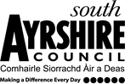

Educational Services
Director of Education: Scott Mulholland

Head Teacher: Lynsey May
St Patrick’s Primary School
24 Academy Street, Troon, KA10 6HR
01292 690070
StPatricks.mail@south-ayrshire.gov.uk
Our Ref: LM/KK
Your Ref:

Date: 19th January 2026


“Inspired to shine in all I say, all I do and all I am!”



Dear Parents/Carers,
We are delighted to share two important dates in your child’s sacramental journey:
- Rite of Enrolment:
This will take place on Sunday, 1st February, during the 11:15am Mass.

- First Holy Communion:
The celebration of First Holy Communion will be held on Sunday, 17th May, at 11:15am Mass, together with the parish community.

These are very special occasions, and we look forward to celebrating them with you and your family. Thank you for your continued support in preparing the children for this important step in their faith.

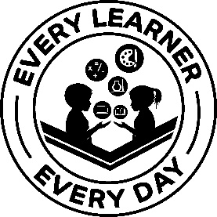
Kind Regards

Lynsey May
Head Teacher

