

Educational Services
Director of Education: Scott Mulholland

Head Teacher: Lynsey May
St Patrick’s Primary School
24 Academy Street, Troon, KA10 6HR
01292 690070
StPatricks.mail@south-ayrshire.gov.uk

Date: 13th January 2026


“Inspired to shine in all I say, all I do and all I am!”



Dear Parent/Carer
Primary 7 are hosting a Burns Supper on Thursday 5th February at 10.45am-11.45am in the Gym Hall. We would like to invite you to join us where you will enjoy some Scottish snacks. Our talented children will also be performing some fabulous Scottish entertainment such as poems, songs, and musical interludes.
We really look forward to seeing you there and would ask that you complete the tear-off slip below and return to school by Friday 30th January. Please advise of any specific dietary requirements/allergies.
Kind Regards
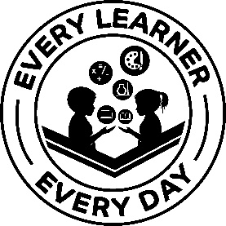

Lynsey May
Head Teacher
…………………………………………………………………………………………………………………………………………………………………………………………
Primary 7 – Burns Supper 5th February 2026

I/We will be attending the P7 Burns Supper (please delete as appropriate). Max 2 adults per family.

Please note any dietary requirements or allergies. ………………………………………………………………………………………………….

Child’s Name………………………………………………………………………. Class…………………………..P7……………………………………

Parent/Carer Signature………………………………………………………… Date…………………………………………………………………….

