

Educational Services
Director Of Education: Scott Mulholland

Head Teacher: Lynsey May
St Patrick’s Primary
24 Academy Street, Troon, KA10 6HR
01292 690070
StPatricks.mail@south-ayrshire.gov.uk
Our Ref: LM/KK
Your Ref:

Date: 23rd October 2025


“Inspired to shine in all I say, all I do and all I am!”



Dear Parent/Carer
One of our parents Mrs Johnson along with a member of staff will be running choir sessions for children in P4-7. They will meet on a Thursday from 3-4pm.
The choir intend to visit some of the local nursing homes in December to sing Christmas Carols to the residents. The choir members will also be expected to sing at the Cluster Carol Service at St Margaret’s Cathedral in Ayr in the evening of Thursday 9th December at 6.30pm
The first meeting of the choir will take place on Thursday 30th October and run every Thursday until 18th December.
If your child would like to take part in this enjoyable activity, please indicate on the slip below.
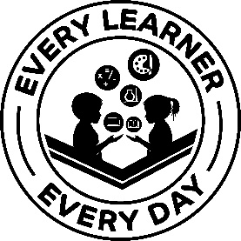
Yours sincerely
Lynsey May
Head Teacher
……………………………………………………………………………………………………………………………………………………………………………………..
P4-7 Choir
My child would like to attend the after-school choir.

My child will be collected from school at 4pm. (we would prefer for our children to be collected and not walk or cycle home during the darker months)

My child will be able to attend the Cluster Carol Service in the evening of Tuesday 9th December at St Margaret’s Ayr.
Child’ s Name……………………………………………………………………………………. Class………………………………………………………….
Parent/Carer Signature …………………………………………………………………… Date…………………………………………………………….

