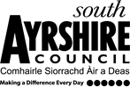

Educational Services
Director of Education: Scott Mulholland

Head Teacher: Lynsey May
St Patrick’s Primary School
24 Academy Street, Troon, KA10 6HR
01292 690070
StPatricks.mail@south-ayrshire.gov.uk
Our Ref: LM/KK
Your Ref:

Date: 30th October 2025


“Inspired to shine in all I say, all I do and all I am!”



Dear Parents/Carers,
Sacrament of First Reconciliation
The following arrangements have been made:
Monday 8th December 2025 at 2pm in school.
Please can you indicate on the tear off slip if your child will be receiving the Sacrament of Reconciliation, in order that they can be included in preparations.
……………………………………………………………………………………………………………………………………………………………………………………
Reconcilation
I wish my child to be put forward for the Sacrament of Reconciliation on the above date.

I do not wish my child to be put forward for the Sacrament of Reconciliation on the above date.

Child’s Name ……………………………………………………………….. Class …………P3………………………………………..

Kind Regards
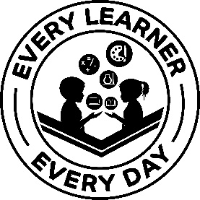

Lynsey May
Head Teacher

