**Educational Services**

# Head Teacher: Lynsey May

St Patrick’s Primary School   
 24 Academy Street, Troon, KA10 6HR

01292 690070

StPatricks.mail@south-ayrshire.gov.uk

Our Ref: LM/KK

Your Ref:

Date: 3rd September 2025

** “Inspired to shine in all I say, all I do and all I am!”**



MC900437763[1]

Dear Parent/Carer,

**Macmillan Coffee Morning**

Primary 7 are holding their annual coffee morning to raise money for Macmillan Cancer Support. The event will take place from 10.30am-11.45am on Friday 26th September in our school Gym Hall. Entry will be 50p per person or £1 per family which will give you a cup of tea or coffee and some home baking. There will be home-baking for sale and other competitions too.

If you can help us by donating home-baking and/or can help on the day serving tea/coffee, please indicate on the slip below. Your help and support are always so greatly appreciated.

We look forward to seeing you, your family and friends at our coffee morning!

Yours sincerely,

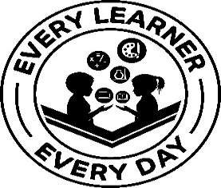

Lynsey May

Head Teacher

…………………………………………………………………………………………………………………………………………………………………………………….

**Macmillan Coffee Morning – Friday 26th September 2025**

I can help with home baking. I can help serve tea/coffee.

I will be coming along to support the event on the day.

Child’s Name ……………………………………………………………………………………………… Class ………………………………………………

Parent/Carer Signature …………………………………………………………………………. Date ………………………………………………