

Educational Services

Head Teacher: Lynsey May
St Patrick’s Primary School
24 Academy Street, Troon, KA10 6HR
01292 690070
StPatricks.mail@south-ayrshire.gov.uk
Our Ref: LM/KK
Your Ref:
Date: 29th May 2025


“Inspired to shine in all I say, all I do and all I am!”



Dear Parent/Carer,
Your child will be attending a Soccer Aid event at Marr Astro on Friday 13th June from 11.30am until 2pm. The children will walk to Marr with a staff member and walk back to St Patrick’s after the event to travel home in the normal way. Please provide your child will a water bottle that they can refill and a packed lunch. Please wear clothing suitable for the weather on that day.
The children will be issued with a St Patrick’s t-shirt which they should wear to school with sports clothes on the day. After the event please take the t-shirt home and return it by no later than Monday 16th June.
For the event we require 1 parent helper, please indicate on the slip below if you can help.
If you wish to order a packed lunch from the kitchen, please do so on the slip below.
Kind Regards
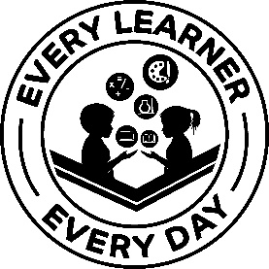

Lynsey May
Head Teacher
…………………………………………………………………………………………………………………………………………………………………………………………………………
P6 – Soccer Aid 13th June 2025
I wish to order a packed lunch from the kitchen for this event.

I wish to be a parent helper for this event.

Child’s Name ………………………………………………………………………………………………. Class ………………………………..
Parent/Carer Signature………………………………………………………………………………. Date…………………………………

