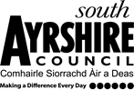
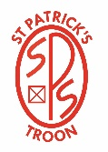
Educational Services

Head Teacher: Lynsey May
St Patrick’s Primary School
24 Academy Street, Troon, KA10 6HR
01292 690070
StPatricks.mail@south-ayrshire.gov.uk
Our Ref: LM/KK
Your Ref:

Date: 10th January 2025


“Inspired to shine in all I say, all I do and all I am!”



Dear Parents/Carers,
Sacraments of First Reconciliation and First Holy Communion
Firstly, thank you for your patience, we have just met with Fr Willie to discuss Sacramental dates.
The following arrangements have been made:
The Sacrament of First Reconciliation:
Saturday 22nd February 2025 at 10am in Our Lady of the Assumption and St Meddan.
The Sacrament of First Holy Communion:
Saturday 10th May 2025 at 10am in Our Lady of the Assumption and St Meddan.
The Sacrament of Confirmation:
The date and time have still be arranged with the Bishop. It will be held in St Quivox, Prestwick.
Please can you indicate on the tear off slip which Sacraments your child will be receiving. If you do not wish your child to receive the Sacraments there is no need to return the slip.
……………………………………………………………………………………………………………………………………………………………………………………
Sacraments
I wish my child to be put forward for the Sacrament of Reconciliation on the above date.

I wish my child to be put forward for the Sacrament of First Holy Communion on the above date.

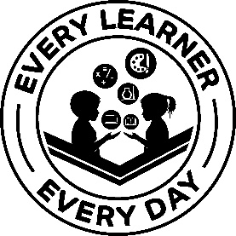
Kind Regards

Lynsey May
Head Teacher

