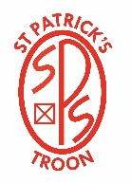
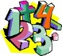
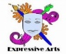
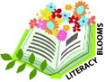
Primary 5/6 Term 2 (Jan. – Mar.) Session 2023/2024
Numeracy and Mathematics
We will continue to develop skills in Mental Maths calculations
and in problem solving by using a variety of mathematical strategies through Number Talks. We will continue our programme, focusing on addition, subtraction, multiplication and division strategies using the Concrete, Pictorial, Abstract (CPA) approach.
Beyond Number learning will take place as part our Interdisciplinary topic (Europe). We will develop our knowledge and skills within angle, symmetry and transformation by using our knowledge of the coordinate system to plot and describe the location of a point on a grid. We will also investigate where, why and how scale is used and apply this understanding to interpret maps. We will also be learning how to manage money, compare costs from different retailers, and determine what we can afford to buy.
Article 28 - right to education

St. Patrick’s Primary – Curriculum Snapshot

Expressive Arts
As part of our IDL topic, ‘Europe’, we will be learning about European artists. We will be able to name some European artists, talk about their most famous work and will then create a piece of artwork which is inspired by the work of a European artist. We will also be creating and presenting scripted or improvised drama to role play as travel agents and news reporters.
Article 31 – leisure, play and culture

Literacy and English

We will read ‘Eurospies’ by Lyndsey Littleson as a novel study. Through this novel study, we will develop our reading comprehension skills as well as building knowledge of European countries, linking to our topic.

We will continue to use spelling strategies to be able to spell common words, tricky words and topic related vocabulary. We will be learning new spelling rules, exploring prefixes, suffixes and spelling rules and will be applying our knowledge to our written work to spell words correctly.

As part of our Talk for Writing, we will be learning to; persuade, argue, explore issues or express an opinion using relevant supporting detail and/or evidence.

We will continue to access a variety of books to become confident and motivated readers. We will be encouraged to use myON in school and at home and to complete the quizzes to build motivation and enjoyment of reading.

Article 28 - right to education Article 29 – goals of education
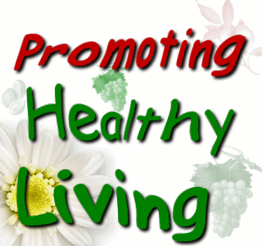
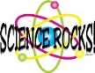
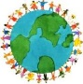
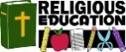
Health and Wellbeing
We will continue to set weekly targets for literacy, numeracy and health and well-being and will evaluate these at the end of each week. We will continue to follow the Emotion Works programme and will have the chance to explore each cog and relate them to our own experiences.
In PE we are developing our balance, flexibility and co-ordination skills within gymnastics. We will also be using rebound games to practise, consolidate and refine our skills to improve our performance. We will work and learn with others to demonstrate tactics and achieve goals.
We will continue to develop our understanding of children’s rights through article of the week and embed a rights respecting attitude in our classroom. Article 24 - best possible health

Article 24 - best possible health

S.T.E.A.M
This term, we will participate in ‘Discovery time’ where we will have the opportunity to discover and explore aspects of our Europe topic. This time provides us with more opportunities to develop our meta skills. Resources will be available for us to participate in a variety of STEAM opportunities, for example; building, measuring, role play, creating art, digital technology and more. We will also be considering the architecture of European landmarks and will use a variety of materials to build them. Article 31 – leisure, play and culture Article 12 – respect for the views and thoughts of the child

Interdisciplinary Topic
Our topic for this Term is Europe. Listed below is some of the skills and knowledge which we will be developing as we explore this topic.
Social Studies -Researching the countries of Europe, stating facts about some of them and locating them on a continent map. -Identifying rivers, mountains, seas and other features of the land in Europe. -Comparing our country to other European countries to investigate the main features of weather and climate. -Investigating the work of representatives at European level to develop our understanding of how democracy works.
Languages -We will be learning some common words and phrases in four languages (German, Spanish, Italian and French). We will compare them to each other to identify any similarities and differences. -We will be developing our listening skills by tuning into podcasts in these languages and identifying words or phrases that we recognise so help us understand the context of the podcast.
Religious Education Primary 6 We will be beginning our Pope Francis Faith Award journey where we will learn about the Gifts of the Holy Spirit, we will reflect on the times that we are aware of these gifts and we will share ideas of how our actions can show others what we know. Primary 5 We will be focusing on inequalities in society and how Christians are called to the dignity of every human being, created in the image and likeness of God. We will interpret Bible passages to identify inequalities and how Jesus reached out to people, offering them acceptance and healing and invited them into the Kingdom of God. As a school community, we will also be preparing for Lent. Article 14 – Freedom of thought, belief and religion

Article 14 – Freedom of thought, belief and religion

Article 14 – Freedom of thought, belief and religion

