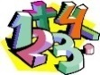
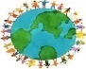
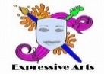
Class: Primary 4/5 Term: 2 Session: 2023/2024
Numeracy and Mathematics
We will continue to look at a range of addition and subtraction strategies to help us carry out calculations as well as build our knowledge and confidence in times table recall, looking at the pattern between multiplication and division to help us solve calculations. We will learn to find key words to help us answer word problems using the correct operation. We will then move onto fractions learning to use fraction walls, fraction wheels and number lines to find and compare fractions. We will learn the mathematical language equivalent, equal to, simplify and simplest form and use taught rules to find the simplest and equivalent fraction. Additionally, we will be able to convert common percentages to fractions and decimals.

Beyond Number - Identify regular and irregular shapes with none, one or two lines of symmetry. Create shapes with 2 or more lines of symmetry. Use acute, right, obtuse, straight and reflex to describe an angle. Measure angles using degrees; use protractors; name angles using capital letters. Read times to the nearest minute, use 12 and 24 hr clock. Investigate and interpret calendars and timetables. Article 28 - right to learn

Interdisciplinary Topic
During the month of January, we will focus on all things Scottish to celebrate our history and heritage. For homework, we have the opportunity to learn a Scots poem to recite to our peers using our best Scots accent as well as using appropriate expression and actions. In class, we will learn about Robert Burns through reading passages and online sources, we will put this information into a fact file. Later, we will begin learning about Ancient Egypt identifying significant people to that era, exploring key events and placing them on a timeline using appropriate vocabulary such as decade, BC and AD. We will look at what life was like for people living in that period and choose an aspect of life from the past to describe and explain any similarities and differences we find. We will look at real life sources of clothing as well as online sources and books to help us. Additionally, we will study the importance of the River Nile to Egyptian life and also learn some key words and physical features of a river. UNCRC Article 28 – right to learn

.

Expressive Arts
In music, we will listen and appraise a well-known pop song and learn about its structure whilst learning the lyrics. We will play a variety of games to develop our sense of rhythm and beat to help us play the glockenspiel in time to the music. In Art, we will continue to develop drawing skills within the context of buildings; experiment, using a variety of media, with the use of line, shape, colour, texture and pattern; introduction to tone. Moving onto painting, we will continue to develop Secondary Colour mixing skills and will focus on tone. Article 31 – leisure, play and culture
St Patrick’s Primary – Curriculum Snapshot

Religious Education
This term we will learn about some of the miracles Jesus performed and how through them He showed His love for God and divine power. We will explore how Jesus called his Disciples and how we show that we are a Disciple too through our actions. We will look at the Jewish place of Worship, the Synagogue, some of its features and how it compares to the Catholic Church. Finally, we will prepare for Easter and discuss the importance of showing repentance and forgiveness during Lent. Article 14 – Freedom of thought, belief and religion

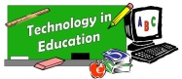
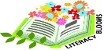
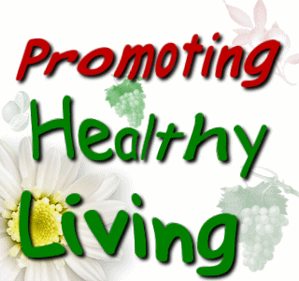
Literacy
Through our book study, This Morning I Met a Whale by Michael Morpurgo, we will continue to develop our comprehension skills and complete a range of tasks using what we have read to support our answers. We will develop our oral reading skills through texts through our guided reading books as well as have opportunities for personal reading of our own choice of books and online through MyOn. We will continue to progress through the Single Word Spelling List to consolidate and learn new spelling rules. In writing, we will learn the effective techniques used in poetry to create our own pieces, do some research on bottlenose whales to create an information report and, following a model text, write our own wishing tale story. Article 28 - right to education

Health and WellBeing
In Health and Wellbeing, we will continue to develop our social and emotional wellbeing including how to talk about how we are feeling and the important values needed to maintain positive relationships.
We will also investigate the range of foods available and discuss how they contribute to a healthy diet and their nutrition content. We will experience a sense of enjoyment and achievement when preparing some simple foods and show awareness of the journey food takes from source to consumer.
This term in P.E we will focus on gymnastics skills including rolls, balances and jumps and using them in a sequence, build our arm strength through different exercises and use apparatus such as a springboard, vault and wall bars safely.
Article 24 – right to the best possible health
Technologies

We will continue to extend and enhance our knowledge of digital technologies to collect, analyse ideas, relevant information and organise these in an appropriate way.
Whilst learning about the food groups in HWB, we will have the opportunity to develop our cooking skills getting the opportunity to weigh and measure ingredients, prepare food correctly, using equipment safely and show awareness of hygiene. Article 13 – respectfully sharing thoughts
Article 27 – right to nutritious food

Science
We will have opportunities to construct and describe food chains showing relationships between the sun, plants and animals for energy using a flowchart/pyramid and be able to tell the difference between them and a food web. We will be able to explain that food chains begin with energy from the sun and that green plants use light from the sun and carbon dioxide and water to make food. We will learn appropriate vocabulary such as consumer, predator and prey when interpreting and creating food webs. Article 28 - right to education

